Moses 1 September 27, 2020

Bible Verses: Exodus 3:1-15
Spark Story Bible: pages 72 to 75
--------------------------------------------------------------------------------------------------

Overall Lesson Takeaways

- God cares about what happens to people, so we should too.
Although we are skipping over the common starting place for this story (Baby Moses placed into a basket in the Nile, taken in by Pharaoh’s daughter), the theme of that passage, of the Burning Bush, and the Exodus out of Egypt are the same: God cares what happens to us. Life was incredibly difficult for the Hebrew people – Exodus 1 and 2 make that clear – but God provides Moses as a leader for the people to fulfill the covenant promise of a new land made all the way back to Abraham. But knowing and trusting in God’s care is only part of what we can take away; we believe that because God cares, we should too. Whenever anyone is suffering, in bad situations, or feels like they don’t have hope, part of our Christian faith is to try to alleviate others’ pain, or to intervene, advocate for, and assist those in need. This is a big and heavy calling sometimes – in part because it is much bigger than any of us can do alone – but we believe that is part of what God expects of us as disciples of Jesus, and as leaders.
- God wants us to be leaders and will help us lead.
- God asks Moses to lead the people out of Egypt in this passage… which is, of course, a monumental task! We see Moses immediately be filled with self-doubt. “Who am I that I should go to Pharaoh?” Moses asks in Exodus 3:11, later pushing back that he is “slow of speech and slow of tongue” in 4:10. But this doubt leads to a greater trust in God to guide and provide, because clearly such a thing would not be possible for Moses alone. The almighty God, the great I AM, will watch over Moses, just as God had been with all those who went before him – and the same is true for us today. Even though we all experience moments, or perhaps even seasons, of self-doubt in our ability to make an impact in the lives of those around us, I believe we are called and empowered to lead and do big things through God’s help.
- God is bigger than we can fully understand.
Even though this is one of the few times in the Bible that we read about someone having an extended conversation with God, the biblical text makes clear that God is still holy and beyond our full comprehension. The symbol of the burning (and yet, not burnt up) bush is part of that – but nowhere is it more clear than the name that God gives to Moses – “YHWH” (pronounced “Yaa-way”), aka “I AM”, or “I am what I am”. One of the great paradoxes of our faith is that God is bigger than we can imagine, but we believe God knows us and cares for each of us deeply – something that is just as true today as it was back in Moses’ time over 3,000 years ago.
Checking In

Before the reading:
- Check in with the kids –practicing names and learning about them
  - Names, what’s one of your favorite things about Fall?
  - Younger kids: Show and Tell – go and grab your favorite book!
  - Older kids: Highs and Lows from their past week
- Has anyone here ever seen God before? What do you think God would look like? How would you know if you were talking to God?

Bible Lesson / Discussion

Reading the Bible:
- Some of you may remember Moses floating down the Nile as a baby, but here he’s all grown up… and God has something big to tell him!
- Read the text together, either in the Bible, or the Spark Story Bible.
  - You’ll need to screen share the passage for the day in Zoom.
  - Feel free to stop and ask questions during the reading, if helpful.
  - Afterwards, take time to explore what that passage might mean, and know there's no one correct way to read these passages!

Questions About the Passage
- How would you have felt if you were Moses and you heard a voice talking to you from a burning bush? Confused? Scared? Surprised?
- God sees how poorly people are being treated in Egypt and sends Moses to lead them out. Why do you think God chose Moses to be a leader?

Connections to Our Lives
- Later on in the passage, Moses argues with God that he’s not the right choice to be leader – Moses says he’s not a good public speaker. Have you ever felt nervous about doing something because you didn’t think you’d be good at it? What did you learn about yourself after you tried doing it?
- God saw that the Egyptians weren’t treating the Hebrew people very well – can you think of people who aren’t treated very well today? What might God want us to do for them? How can we be leaders who help them?

Biblical/Church Connections
- Late in the passage, when Moses asks for God’s name, God says “I AM who I AM”. What do you think that means? Some believe that name God shares (‘YHWH’ in Hebrew) means God is, was, and always will be.
People of Faith

In addition to reading our weekly Bible story, I'd love for our older grade school students to learn more about people whose lives were changed by their faith in Jesus. We'll lift up a new person each Sunday, trying to connect their story to our Bible passage as much as possible!

Saint Francis of Assisi (uh-see-see)
Sometimes a message from God can change our lives in unexpected and amazing ways: Moses’ life was never the same after God asked him to be a leader. Same goes for other prophets and apostles. But few people had a more dramatic transformation that that of Saint Francis of Assisi.

Born as Giovanni di Pietro di Bernardoni in 1181, but nicknamed “Francesco” by his father, Saint Francis initially lived a life of luxury. His father was an extremely wealthy silk merchant and that meant that Francis had money to travel, dress in fine clothes, and party… and he did a lot. But when he was 24, Francis had a series of dreams in which he heard a strange voice talking to him, first calling him back to his hometown of Assisi, then a voice saying “Go, Francis, and repair my house, which you see is falling into ruin”.

Francis began to distance himself from his former life, giving away a great deal of gold to a local church and to anyone who begged from him. This infuriated his father and led to him forcing Francis to renounce his entire inheritance!

Broke and homeless, Francis began to beg in the neighborhoods around Assisi and eventually found his way to a monastery, where he became deeply involved. In 1209, Francis founded a new religious order – the Franciscans – and insisted on a vow of poverty for all of its members while deeply caring for others’ needs.

The Franciscan Order grew rapidly, and Francis would also become known for his blessing of animals, for his deep care for nature and the natural world, and for his love of Communion. He also is attributed with creating the first ever live nativity with animals in 1223.

Just like Moses growing up wealthy in Pharaoh’s court, I’m sure that no one would have guessed that Francis would grow up to be a religious leader – but God’s call in his life led to a ministry that would change the world!
Crafts / Activities

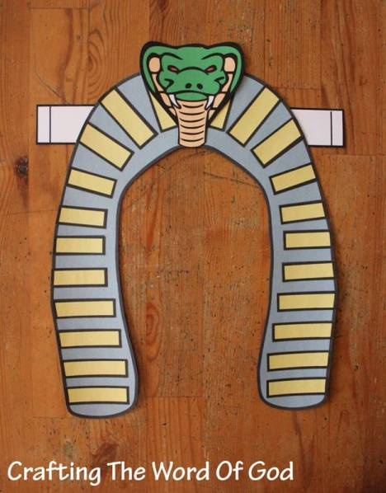
Pharaoh’s Headdress
(Ages 3+ with help, 10 mins)

Supplies Needed:
- Headdress Template
- Scissors
- Glue/Tape
- Crayons/Markers

Instructions:
- Have kids color and cut out the various components of the headdress. Start by attaching the snake head, then two strips of paper to the back.

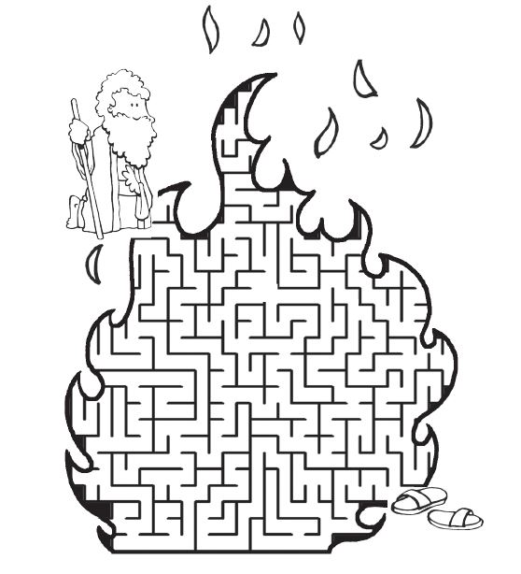
Burning Bush Maze
(Ages 5+, 5 mins)

Supplies Needed:
- Printed Handout
- Pen/Pencil

Instructions:
- You’ll need families to print out the maze ahead of time, but this is a great activity for those in the Kindergarten to 1st Grade range.

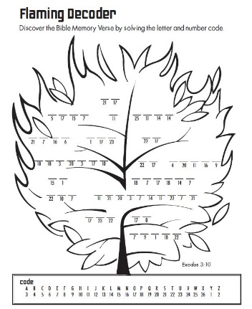
Burning Bush Decoder
(1st through 5th Grade, 5-10 mins)

Supplies Needed:
- Handout
- Pen/Pencil

Instructions:
- You’ll need families to print out the decoder ahead of time, but this might be a fun activity for those in older grades.
Biblical Background – Exodus 1-15

There is clearly some time that elapses between Joseph's time in Egypt (Genesis 37-50) and the situation described in Exodus 1. The biblical text is vague about the timeframe, but studies of biblical genealogies suggest that in between Genesis and Exodus was a gap of somewhere around 215 to 430 years.

So, when does Exodus take place? It's impossible to know for sure, but most scholars place Exodus during the reign of Rameses II (1279 – 1213 BCE). The first reference to Israel comes from Rameses II's successor, Merneptah – and the timeline broadly fits within other Ancient Near East dates that are more certain.

Regardless, the Moses account is the start of the era that will dominate the rest of the Pentateuch: God's people are being led out of Egypt towards a Promised Land, while receiving the Law and divine instruction along the way. Our curriculum will only spend time in the Book of Exodus, which primarily deals with Moses leading the people out of Egypt – however the second half of Exodus, and the following books of Leviticus, Numbers, and Deuteronomy, are largely written to establish what the laws, norms, and religious practices will be in this new land.

These first five books – also known as the Torah – are foundational for Judaism – but they continue to hold great value and resonance for us as Christians today, even if we may not observe particular practices (eating kosher, for example). God watching over Moses and the Hebrew people is a continuation of the covenant promises that we learn about in Genesis – and people around the world, particularly those who have experienced oppression or who are experiencing it currently, have seen a great connection and affinity for the hope of a new day represented by Moses leading the people out of Egypt.

To learn about Moses is to learn about hope – as well as the courage to stand up for what we believe in, bolstered by a deep faith that God will be with us every step of the way.

Your ability to share this info with kids will vary depending on their age – this section is mainly written for teachers and parents to learn a bit more about the background to each week's passage!

