Noah’s Ark September 26, 2021

Bible Verses: Genesis 7:1-24
Spark Story Bible: pages 20 to 25
--------------------------------------------------------------------------------------------------

Overall Lesson Takeaways

- God’s grace is bigger than our mistakes.
While the early chapters of Noah and the flood are theologically challenging, by the time we reach chapter 9 there is a clear change in the relationship between God and humanity: rather than continuing to be punished for mistakes, there is an understanding that God's forgiveness and grace will ultimately supersede our individual and corporate sin (something that will be returned to again and again in the biblical text, culminating in Jesus Christ). This promise does not mean that human behavior is unimportant, but it does represent a shift in human beings' understanding of who God is. God's grace and love are bigger than we can even imagine – and that understanding of God will continue to expand throughout the biblical text.
- God has a special relationship with us.
The establishment of the covenant with Noah, Noah's descendants, and every living creature on the earth is a critical moment that returns to the very act of creation, with God's words in Genesis 9:1-7 echoing Genesis 1:26-28 – both in the charge to be fruitful and multiply, but also in the reminder that we were created in the image of God. Covenants were mainly just legal promises in the ancient world, but the covenant that God gives is different because it wasn't contingent on how people acted; it was an eternal covenant established by God without condition. In order words, God loves and forgives us no matter what! That is an amazing thing worth celebrating.
- Following God sometimes means being different.
Although we don't get a window into what was going on in Noah's life prior to God's command to build the ark, I don't feel like it's a stretch to assume that Noah was acting differently than his neighbors – the biblical text describes Noah as "righteous" in a time when "the earth was corrupt in God's sight" (Genesis 6:9-11). While we shouldn't stake out that sort of moral high ground for ourselves today – I do think there's an interesting discussion to be had about what it's like to hold beliefs that others around us don't share. We are increasingly living in a "post-Christian" culture and that occasionally means that others will be puzzled about why we think/believe what we do. Why do we see it as important to follow Jesus, even when others in our life don't? What difference does our faith make in our life?

Checking In

Before the reading:
- Check in with the kids – welcoming any newcomers warmly.
  - Younger kids: Share a highlight from the first month of school!
  - Older kids: Highs and Lows; any prayers that they bring today
- If you could choose two animals to bring with you on a boat, what would they be? What two animals would you NOT choose?

Bible Lesson / Discussion

Reading the Bible:
- We are continuing to read in the first book of the Bible – one last time: what is that book’s name? We’ll be learning about something many, many years after creation – about a man named Noah and lots of animals!
- Read the text together, either in the Bible, or the Spark Story Bible.
  - Feel free to stop and ask questions during the reading, if helpful.
  - Afterwards, take time to explore what that passage might mean, and know there's no one correct way to read these passages!

Questions About the Passage (see next page for PreK/K questions)
- Have you ever been on a boat before? What was it like? Could you imagine living on that boat for several weeks?
- Noah must have been pretty confused and scared during this time – what do you think helped him and his family trust in God?
- The passage ends with God making a promise to never harm the earth with a great flood again – and it is an unbreakable promise called a covenant. What are some promises that you have made to others?

Connections to Our Lives
- The Bible talks about how other people were doing bad things in Noah’s time – do you think it was hard for him to follow God?
- God’s promise at the end is a reminder that God’s forgiveness and love are bigger than our mistakes. How does it feel to be forgiven?

Biblical/Church Connections
- God’s covenant with Noah is just the first of many covenants that God makes with human beings. Why do you think God has made so many promises to us? What can we do to thank God?

Alternate Preschool and K/1st Questions
Younger ages, particularly those in our preschool class, may have a hard time discussing the biblical text for very long (if at all). My hope is that these questions (and especially the activity) can help with engagement!

Opening Questions
- We’ve been learning a lot about God’s creation these past two weeks – and today all those animals end up on a boat. Have you ever been on a boat before? Could you imagine living on that boat for several weeks?

Fun Warm-Up Activity – Two People Charades
- Our Bible passage today is about Noah’s Ark – and one of the things it talks about is how every animal there is came onto a boat in pairs of two. We’re going to play a game where we guess what animals people are!
- Anyone who wants to play can raise their hand – pick pairs of two to come forward and give them an animal they need to act out (no noises!)
- Fun animal ideas could include: eagle, ostrich, snake, giraffe, butterfly, wolf, mouse, etc. etc. (you can also have pairs pick an animal themselves)

Reading the Bible:
- We learned about Creation last week, and we’re still reading from the first book of the Bible. Does anyone remember what that book is called?
- Read the text together, either in the Bible, or the Spark Story Bible.

Bible Discussion/Questions
- What do you think it would have been like to be on a boat with so many animals on it? What would have been fun? What would have been hard?
- Noah must have been pretty confused and scared when the flood was happening. What do you do when you’re feeling scared?
- God makes a promise to Noah and all people at the end – what does it mean to make a promise? God promised to love every single one of us no matter what – even if we make mistakes. How does that make you feel?

People of Faith

In addition to reading our weekly Bible story, I'd love for our older grade school students to learn more about people whose lives were changed by their faith in Jesus. We'll lift up a new person each Sunday, trying to connect their story to our Bible passage as much as possible!

Antoinette Brown Blackwell
The early chapters of Genesis can sometimes feel like a tension between faith and science, but today we’ll be learning about a remarkable woman who was quite accomplished in both fields – as well as a great deal more!

Antoinette Brown was born in New York in 1825 – and from a young age her family was involved in a local Congregational Church. It was extremely uncommon for women to lead worship at that time, but Brown was so bold as a child that she would sometimes stand and lead the church in prayer – and she even preached a sermon at the age of 16!

After saving money for a handful of years, Brown enrolled in Oberlin College at the age of 20 and finished a literature degree within a year. She immediately began to petition the school board to allow her to study theology and ministry – both of which were completely off-limits to women. The school agreed to let her study but stated they would not give her a degree or a preaching license.
Nonetheless, Brown persisted. After completing her studies, she soon found herself involved in several important causes: writing for the abolition of slavery, speaking at a Women’s Rights convention, and pursuing her preaching license. A few years later, she was successful – in 1852 she became the first woman to be ordained as a minister, a position she held for 3 years.

After facing frequent prejudice and discrimination in her role, though, Brown left the ministry and invested herself in women’s rights and her growing interest in Darwin’s evolutionary theories – publishing two books that affirmed Darwin’s theory but criticized how he focused exclusively on species’ rivalry rather than cooperation – receiving a positive response from Darwin himself and other scientific magazines. Brown continued to advocate for women for the rest of her life – speaking at the Parliament of World Religions in 1893 and even living long enough to vote in the 1920 Presidential Election when women were allowed to vote for the first time!
Crafts / Activities

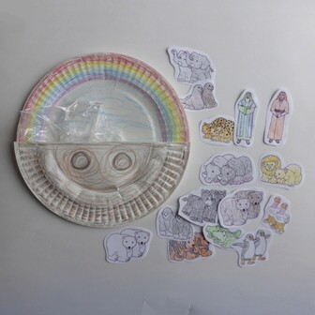
Paper Plate Ark
(Ages 5+, 10 mins)

Supplies Needed:
- Template
- Scissors
- Stapler/Tape
- Two paper plates
- Markers/Crayons

Instructions:
- This craft is a two-parter: making an ark out of a half plate stapled to a full plate, followed by filling the ark with Noah and the animals.

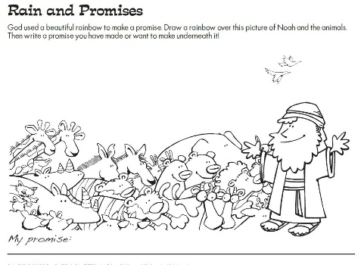
Noah’s Ark Making Promises
(Ages 5+, 5 mins)

Supplies Needed:
- Printed Handout
- Pen/Pencil/Crayons

Instructions:
- This handout works as a coloring sheet, but the main idea is reminding kids of God’s promise – and think of a promise they’d like to keep.

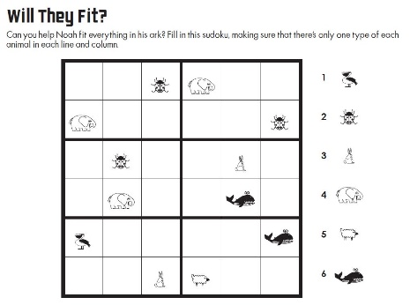
Noah’s Ark Sudoku Puzzle
(Ages 7+, 5-10 mins)

Supplies Needed:
- Printed Handout
- Pen/Pencil/Crayons

Instructions:
- This puzzle might be a little tricky for some, but anyone who knows Sudoku will enjoy the challenge of trying to fit these animals in the ark!
Biblical Background – Noah’s Ark

Noah’s Ark has been beloved by Sunday School classes for generations thanks to its vivid imagery and the presence of animals, two by two – but when you start digging deeper into the biblical text, most of the questions and observations that arise are unfortunately extremely difficult ones. There is the frightening theological problem of God causing a mass extinction. There is the bizarre conclusion of Genesis 9:18-29 right on the heels of this beautiful covenant relationship with God. And there is also the strong possibility that Noah’s Ark was heavily influenced by other creation myths from the Ancient Near East.

Noah's Ark is certainly the best-known, but numerous flood narratives do exist in far-flung cultures around the globe: Atrahasis in ancient Mesopotamia, Deucalion in Greek mythology, and the Great Flood of Gun-Yu in China – not to mention similar sorts of destructive events in Norse mythology, Hinduism, and Mayan writings. Archeologists haven't been able to find specific evidence of the sort of worldwide destruction that Genesis and other accounts speak of, but the widespread prevalence of these accounts in cultures that would not have interacted with one another has sparked many theories.

Particularly noteworthy, though, is the Epic of Gilgamesh – a Babylonian epic perhaps dating back before 2,000 BCE. In this story, a character is warned by a god of a great flood, is told very specific dimensions to build a boat, boards the boat with all the animals of the field, there is an epic storm (only 6 days though), the boat becomes lodged on a mountain, the character releases a raven and dove to find dry land, and concludes with a sacrifice to the gods – all of which have direct parallels to Genesis 6-8.

Despite these thorny questions surrounding God’s destruction of the world – as well as how much texts like the Epic of Gilgamesh may have influenced these chapters of Genesis – it should be noted that concluding the flood with God’s covenant promise is completely unlike any other flood narrative. That this covenant would be unconditional rather than based on human behavior would have been equally shocking. God’s relationship with humanity is now markedly different – and it will become even more so as we learn about Abram/Abraham.

Your ability to share this info with kids will vary depending on their age – this section is mainly written for teachers and parents to learn a bit more about the background to each week's passage!

