Ten Commandments September 25, 2022

Bible Verses: Exodus 20:1-17
Spark Story Bible: pages 94 to 101
--------------------------------------------------------------------------------------------------

Overall Lesson Takeaways

- Commandments are a gift from God, even when they’re hard to follow!
In general, following the rules isn’t exactly the most exciting or fun thing in the world. Sometimes it feels like the rules that our parents, teachers, or church set for us are unreasonable or just plain hard to follow – but there’s almost always a good reason why those rules exist (outside of the infamous “because I said so”). When Moses receives ten commandments from God on Mount Sinai, it’s easy to look at them as being limitations (after all, 9 of the 10 are telling us not to do something) – but they actually are helping us live a better life! Part of loving God and loving our neighbors is making sure that we are thinking about them and what they might want, not just what we want – and these commandments often help us do just that.
- We are called to love God and love our neighbors.
Over 2,000 years later, Jesus would simplify the 613 commandments in the Old Testament down to two: love God with all your heart, strength, and mind – and love your neighbor as youself. But if you study the 10 commandments given to Moses, you can see those two things were already there – Jesus was just making it clearer! The first four commandments all deal with loving God: putting God first, no other gods, keeping God’s name holy, and setting aside a special day for God. The final six all deal with our relationships with other people: respecting our moms and dads, not hurting others, being loyal to our family, not stealing, not lying, and not being jealous of what other people have. There are obviously many more rules that we could add to this list, but these ten have long served as a basis for how God wants us to act/behave.
- Even when we make mistakes, God loves us still.
Although the vast majority of the lesson will be spent talking about commandments and rules and how it’s good to follow them, it’s also important to stress to kids that all of us make mistakes sometimes – but that doesn’t mean that God loves us any less. One of the things we believe in our church tradition is that none of us are perfect, or ever could be perfect – we are all going to fall short of what God wants from us from time to time. But rather than see that as a bad thing and a reason to stop trying, we think that can inspire us to try again, to learn, and to grow. Part of why we celebrate baptisms at church is a reminder that God’s love is going to be with us no matter what, even when we make mistakes – and, because of that, we can be inspired to forgive and love others as well, even when they might disappoint us.
Checking In

Before the reading:
- Take the time to get to know the kids a little!
  - Names, Conversation Cubes for warm-up, Highs and Lows
- Do you think that rules and laws are a good thing or a bad thing? What might life be like without any rules?

Bible Lesson / Discussion

Reading the Bible:
- Last week, God helped Moses to lead the people out of Egypt – but now they needed to learn how to live together and how to follow God’s laws as they prepared to move to a new place!
- Read the text together, either in the Bible, or the Spark Story Bible.
  - Feel free to stop and ask questions during the reading, if helpful.
  - Afterwards, take time to explore what that passage might mean, and know there's no one correct way to read these passages!

Questions About the Passage
- Why do you think that God gave these 10 Commandments to the people? Are they still important for us today? Why or why not?
- Are any of these commandments hard for you to follow sometimes? Even if we make mistakes, we always try again and trust that God loves us still.
- As a leader, Moses was asked to help people follow these commandments. What do you think would be the best way to share or teach them?

Connections to Our Lives
- Do you have any special rules in your family, or at your school?
- If you could create one rule for everyone to follow, what would it be?
- Following God, or following the rules, can be difficult sometimes – especially if we see others ignoring them. What can help you make good choices about how to act or behave, instead of bad choices?

Biblical/Church Connections
- Take some time with your class to create a list of rules (which you can also call a “classroom covenant”) where you think about how you should treat one another while you are in Sunday School. If you’d like, write those rules on a poster and you can hang it on the wall of your room!

Alternate Preschool and K/1st Questions
Younger ages, particularly those in our preschool class, may have a hard time discussing the biblical text for very long (if at all). My hope is that these questions (and especially the activity) can help with engagement!

Opening Questions / Activity
- Take some time to welcome / get to know the kids!
  - Share names, what their favorite movie/TV show is
- Warm Up Game – if you’re looking for a fun way to warm kids up, you can play a game of “Would You Rather?”. Give kids a topic with two choices… for example, “Would you rather have vanilla ice cream OR chocolate ice cream?” Those who say vanilla go to one side of the room, those who say chocolate go to the other. Other ideas include: Dogs or cats? Zoo or museum? Summer or winter? Pizza or pasta? Once you’re done, transition into the Bible lesson for the day.

Bible Discussion/Questions
- Raise your hand if you have rules in your family or at your school…
- Today's reading is about some very important rules God shared with Moses and the Hebrew people so they knew how to treat each other! Last week we learned about Moses leading the people to a new place, and God wanted to help them be kind to one another so people didn’t get hurt.
- Read the text together, either in the Bible, or the Spark Story Bible.
  - Feel free to stop and ask questions during the reading, if helpful.
  - Afterwards, take time to explore what that passage might mean, and know there's no one correct way to read these passages!

- Do you have any special rules in your family, or at your school? What are some of the rules you are supposed to follow?
- Is it hard to always follow the rules? What do you do or say when you make a mistake?
- Why do you think that God gave these 10 Rules, or “Commandments” to the people? Are they still important for us today?

People of Faith

In addition to reading our weekly Bible story, I'd love for our older grade school students to learn more about people whose lives were changed by their faith in Jesus. We'll lift up a new person each Sunday, trying to connect their story to our Bible passage as much as possible!

Harriet Tubman
Leading people out of slavery and into a new land takes a lot of courage and strength – Moses needed God’s help every step of the way, and so did one of the most important figures in the abolitionist movement: Harriet Tubman.

Tubman was born into slavery in Maryland in 1822, forced to be a babysitter for other children by age 6, and made to plow fields and haul logs when she got older. During this time, she was punished frequently by the slaveowners and was often sick or injured even while she was working.

Tubman’s family was Christian and her mother told her stories from the Bible often – and Tubman became inspired by the story of Moses leading the Hebrew people out of Egypt and into a new land. Tubman tried to run away frequently, but when she was 27 she managed to escape for good, travelling 90 miles north on foot to get to Pennsylvania (a state where slavery was outlawed).

Most people would have chosen to remain free and safe, but Tubman felt a sense of responsibility to all those who continued to be enslaved. Over the next decade, Tubman would make around 13 trips to rescue slaves – helping lead around 70 people to freedom over the course of those 10 years. She did this by using the “Underground Railroad” – a series of houses, barns, and hiding places that fellow abolitionists made available to escaping slaves.

These journeys were incredibly dangerous; if captured, Tubman could have been re-enslaved, beaten, or even killed. But she continued to risk her life because she believed that that’s what God wanted her to do – escaping slaves eventually nicknamed her “Moses” because she was leading people out of slavery and into a new land just like he had. Tubman prayed to God often throughout their journey, and when she crossed into Pennsylvania with escaped slaves she was known to say, “Glory to God and Jesus too, one more soul is safe!” Her faith inspired her to do amazing things, and we’re inspired by her!
Crafts / Activities

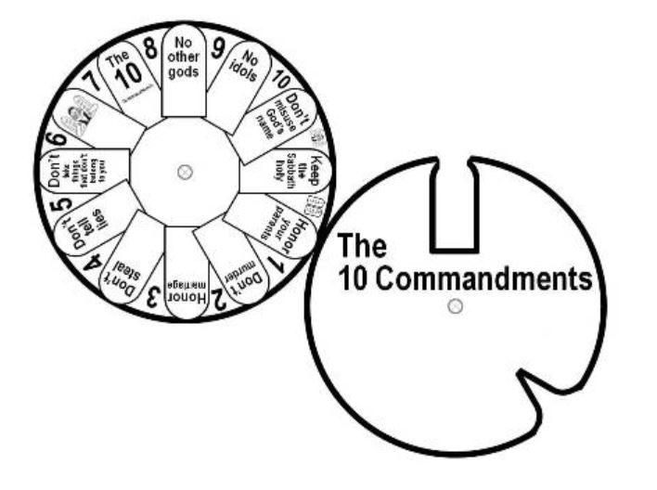
Ten Commandments Wheel
(Ages 3+, 5-10 mins)

Supplies Needed:
- Wheel Template
- Scissors
- Brad/Fastener
- Crayons/Markers

Instructions:
- Have kids color and/or decorate the two wheels. Cut out each wheel, and then attach the two wheels in the center using a brad or a paper fastener.

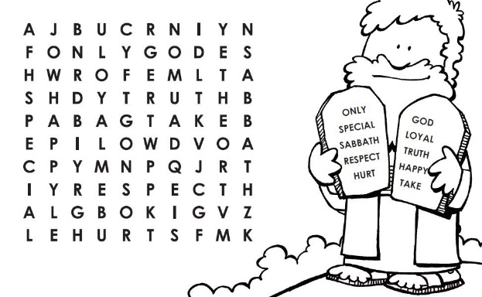
Ten Commandments Word Search
(Ages 5+, 5 mins)

Supplies Needed:
- Printed Handout
- Pen/Pencil

Instructions:
- You’ll need families to print out the word search ahead of time, but this is a great activity for those in grade school.

Create Your Own 10 Commandments
(Ages 5+, 5-10 mins)

Supplies Needed:
- Printed Handout
- Pen/Pencil

Instructions:
- You’ll need families to print out the handout ahead of time (although they can also just use paper) – encourage them to think of the rules they’d set!
Biblical Background – Ten Commandments

After escaping from Egypt, the vast majority of the Book of Exodus (and subsequent books of Leviticus, Numbers, and Deuteronomy) deals with getting the Hebrew people ready to enter into a new land – establishing laws and rules, and instructions on how to pass them down to subsequent generations.

We are primarily focusing on the Ten Commandments today, but there are actually 613 mitzvot (“mitts-vote”; Hebrew for ‘commandments’) that make up Jewish Law. The instructions of these mitzvot are varied, but one of the easier ways to think about them is that there are some dealing with a “vertical” relationship (us and God) some that are focused on a “horizontal” relationsip (us and other people). Both of these are crucial for creating the land that God envisions the Hebrew people having: indeed, we later hear Jesus make a similar (and simpler) formation of this in the famous: “Love the Lord your God with all your heart, strength, and mind – and love your neighbor as yourself”.

The Ten Commandments, apart from “honor your father and mother”, are mostly a series of prohibitions. In Hebrew, the word ‘lo’ (no, not) appears along with the imperative form of each verb – drawing a clear line about unacceptable behavior. These types of commandments weren’t entirely unknown in the Ancient Near East – some scholars believe they hold similarities to Hittite treaties – but what is unique is that there were not any listed punishments for disobeying them. Instead, these commandments represented a new era in the relationship between God and humanity – one defined by covenant rather than a behavioral contract.

This idea of God’s ongoing covenant with the people is one of the most important threads through much of the Old Testament, and we will see this idea returned to again and again, even though the times and leaders may change. Moses unfortunately never made it to the Promised Land (see Deuteronomy 34), but the leadership that he provided helped the Hebrew people come closer to following and trusting in God – and it also meant that new leaders would need to emerge, like Joshua, or Deborah (who we’ll be learning about next week)!

Your ability to share this info with kids will vary depending on their age – this section is mainly written for teachers and parents to learn a bit more about the background to each week's passage!

