Adam and Eve September 19, 2021

Bible Verses: Genesis 2:15 to 2:25, 3:1 to 3:13
Spark Story Bible: pages 8 to 19
--------------------------------------------------------------------------------------------------

Overall Lesson Takeaways

- People make mistakes sometimes.
Although our Reformed background typically causes us to read these chapters as a reminder that all of us are fundamentally flawed (see Biblical Background on p.6), some ancient Jewish interpreters saw this account as a reminder of the good and bad that exists within all of us – competing desires to follow and disobey God. Rather than talk with kids about how all of us are deeply sinful creatures, this passage can be a good opportunity to talk about the existence of rules and how we don’t always follow them – but it is also an opportunity to be reminded that we all make mistakes sometimes, but we are still loved by God and by others in our lives – just as Adam and Eve were even at the end of this passage.
- We were created for partnership and community.
Although we often jump to the end point of the Adam and Eve story, we shouldn't blow past the actual act of God creating them – namely God's intention that human beings aren't meant to be alone. It's important to name that Eve was not created to serve Adam (a common misogynistic reading of this text) but is an equal partner – "bone of my bones and flesh of my flesh" (Genesis 2:23) – and equally important is God's pronouncement in verse 18 that it is not good for Adam to be alone. Loneliness is one of the most common challenges in our country – particularly in this time – and I think that's something that we as Christians are called to change. You can perhaps engage with kids: What do you do when you're feeling lonely? Where do you see loneliness, and how can you help others feel less lonely?
- Thinking about who we listen to.
No matter what age we are, all of us hear and read a LOT of different voices every day. Our world is filled with ideas, facts, “facts”, opinions, and more – and accessing these voices is easier today than at any point in human history. Sometimes, though, it’s important to step back and ask ourselves: “Am I being like Adam and Eve and just listening to what I want to hear?” God had given them clear directions about what not to do, but the snake told them what they wanted to hear… and that can be a hard thing to resist. The same goes for our lives: how often do we know what we should do, but find ourselves tempted by others or ourselves to do the opposite? How can we practice listening to those voices in our lives (God, parents, teachers, etc.) who are trying to help us grow in positive ways?
Checking In

Before the reading:
- Check in with the kids – welcoming any newcomers warmly.
  - Younger kids: Fall begins this week – what do you love about Fall?
  - Older kids: Highs and Lows; favorite thing about Fall?
- Who is someone in your life who you’d consider a best friend or really close to you? What makes them such a good friend?

Bible Lesson / Discussion

Reading the Bible:
- We are back in the first book of the Bible – can anyone remind me what it is called? Last week we learned about God creating everything there is – today we’re going to learn about God’s special relationship with people!
- Read the text together, either in the Bible, or the Spark Story Bible.
  - Feel free to stop and ask questions during the reading, if helpful.
  - Afterwards, take time to explore what that passage might mean, and know there's no one correct way to read these passages!

Questions About the Passage (see next page for PreK/K questions)
- God created Adam and Eve to help each other – what is it that makes someone a good partner? How can we practice being a good partner or helper with our friends, family, or classmates from school?
- God gave Adam and Eve pretty clear instructions not to eat the fruit - why do you think they listened to the snake instead of God? Have you ever done something you later regretted? What do we do after mistakes?

Connections to Our Lives
- The Bible says God didn’t think it was good for Adam to be alone – when was the last time you felt lonely? What do you do when you’re feeling lonely, or who can you reach out to?
- We know Adam and Eve should have listened to God instead of the snake – how do you decide who to listen to in your life, and who you trust?

Biblical/Church Connections
- Today is “Evangelism Sunday” in our denomination – many people think evangelism only means talking, but it really means sharing Jesus’ message with others. How can we share that message with or without words?
Alternate Preschool and K/1st Questions
Younger ages, particularly those in our preschool class, may have a hard time discussing the biblical text for very long (if at all). My hope is that these questions (and especially the activity) can help with engagement!

Opening Questions
- We’re learning about God’s creation last week and this week. When was the last time you went to a zoo? What are some of your favorite animals?

Fun Warm-Up Activity – Naming Creation
- Our Bible passage today is about Adam and Eve – and one of the things it talks about is how Adam and Eve helped give names to every animal in creation – so we need your help in naming lots and lots of animals!
- Ask that anyone who wants to play can raise their hand – kids will have 15 seconds to name 3 different animals, and you can either write them down or just have everyone try to remember them all.
- If you’re looking to keep going, you can also have the kids make up a silly new name for an animal – for example: an elephant could be a leepthan, or something completely different!

Reading the Bible:
- We learned about Creation last week, and we’re still reading from the first book of the Bible. Does anyone remember what that book is called?
- Read the text together, either in the Bible, or the Spark Story Bible.

Bible Discussion/Questions
- God didn’t want Adam to be lonely, so God made Eve. Do you have someone who is a really good friend to you? What makes them such a good friend? How do they help when you’re feeling lonely?
- The Bible talks about how God gave Adam and Eve some important rules to follow, including “Don’t eat the special fruit!”. What are some rules that your family has? Are those rules easy or hard to follow?
- Even though God told Adam and Eve to not eat the fruit, they decided to eat it anyway – they made a big mistake. What do you do when you make a mistake? Do you think God still loved Adam and Eve even when they made this mistake?

People of Faith

In addition to reading our weekly Bible story, I'd love for our older grade school students to learn more about people whose lives were changed by their faith in Jesus. We'll lift up a new person each Sunday, trying to connect their story to our Bible passage as much as possible!

Lucy Jane Rider Meyer
We’ve already covered the damaging ways that this Adam and Eve passage was used to discriminate against women, and sadly that continued in the church for a long time – until courageous women like Lucy Jane Rider Meyer pushed back!

Rider Meyer was born in Vermont in 1849. A strong student, she excelled in school and graduated from college when she was 23 – desiring at first to become a Methodist medical missionary. She continued to pursue a variety of educational opportunities, from becoming a professor of chemistry in 1879 to obtaining her medical degree in 1887.

In 1885, she married a Methodist pastor and the two of them opened the Chicago Training School for City, Home, and Foreign Missions – a training program for young women who wished to be equipped for missionary ministry. The program quickly grew to be the largest of its kind in the country – receiving criticism from many who felt women shouldn’t be involved in ministry.

Rider Meyer vehemently disagreed. Women had served as deacons well into the 4th century before Christianity changed radically under Constantine, and she began advocating for the Methodist Church to return to that practice. Amazingly, her advocacy worked: the Methodist Episcopal Church formally recognized female deaconesses in 1888 and began to ordain women in that role shortly thereafter.

Rider Meyer continued to advocate for a wider adoption of the deaconess role over the next decade, publishing three books – including a history of the role of female deacons in the early church. The Chicago Training School would also continue to operate under her leadership for the next 30 years – eventually merging with the present-day Garrett-Evangelical Theological Seminary in Evanston. Through her amazing career, she helped to prepare countless women for church service and paved the way for women’s ordination as ministers.
Crafts / Activities

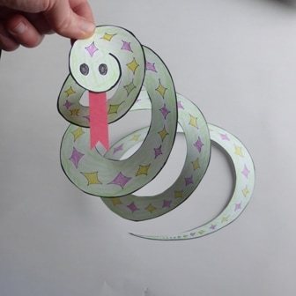
Spiral Snake
(Ages 5+, 5 mins)

Supplies Needed:
- Template
- Scissors
- Red Construction Paper
- Markers/Crayons

Instructions:
- This craft works for a variety of ages – encourage kids to color the template first, then cut along the lines and add a red tongue!

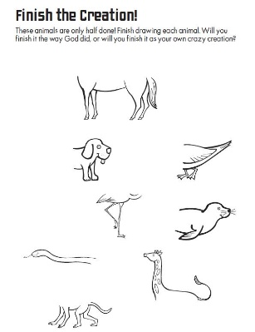
Adam and Eve Animal Creator
(Ages 3+, 5-10 mins)

Supplies Needed:
- Printed Handout
- Pen/Pencil/Crayons

Instructions:
- Similar to last week’s creation craft, but perhaps even funnier with the strange combinations of animals that kids might draw!

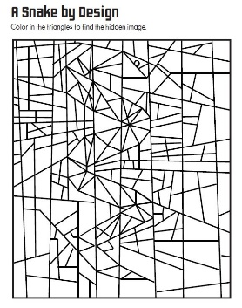
Adam and Eve Picture Puzzle
(Ages 6+, 5 mins)

Supplies Needed:
- Printed Handout
- Pen/Pencil/Crayons

Instructions:
- Although kids might be confused at first, encourage them to just color in any triangle that they see… and a snake will slowly start to emerge!
Biblical Background – Adam and Eve

As with many passages in Genesis, the actual biblical text of Adam and Eve can sometimes be hard to separate from the ways it has been interpreted over the years. One minor example of this: What fruit did Adam and Eve eat? Most people would say “apple” based on how this scene has been depicted over the years – but the text itself never actually states it was an apple. The same goes for more higher stakes interpretations: the serpent is never named or described as the devil, and the word “sin” never actually appears in the passage either.

This is not to say those interpretations are incorrect or wrong. Original Sin is one of the cornerstones of Reformed Theology and has deeply shaped our understanding of what it means to be Christian. The reason I bring it up is that I believe we do a disservice to the biblical text whenever we only make it about one thing. The creation of Adam and Eve – and their subsequent act of disobedience – can prompt many fruitful (pun intended) conversations:

- The close relationship between humans and the earth (the name Adam is Hebrew wordplay – adam = man, adamah = ground).
- What it means to be a partner to someone – and examples of partnership that we have in our lives today.
- Who Adam and Eve listened to… and who we listen to today.
- Even though God punished Adam and Eve, it should be noted that God made clothes for them right after and we believe God always forgives us. Why is forgiveness so important in our lives?

Those are just a few of the ways that the Adam and Eve passage has been read over the years – even if many Sunday School lessons do tend to focus on the sin aspect. For older students, this can also be an opportunity to talk about some of the anthropomorphism (assigning human characteristics to non-humans) that we see in this passage: talking snakes, fruit containing wisdom, and God literally walking in the garden in Genesis 2:8. As we covered last week, we believe that those who wrote the Bible were both inspired by God but also shaped by the thinking of their particular time, place, and culture – so we do not need to believe – for example – that snakes can talk in order to still take away important lessons from this passage for our lives.

Your ability to share this info with kids will vary depending on their age – this section is mainly written for teachers and parents to learn a bit more about the background to each week's passage!

