Red Sea September 18, 2022

Bible Verses: Exodus 14:5-22
Spark Story Bible: pages 84 to 89
--------------------------------------------------------------------------------------------------

Overall Lesson Takeaways

- God always watches over us and keeps promises.
The Biblical Background (last page) touches on this briefly as well, but God helping the Israelites is part of the covenant promise that God made with Abraham and Abraham’s descendants in the Book of Genesis (which we covered last year) – promises of new land and a new future with God. The Hebrew people were understandably scared as Pharaoh’s army was closing in on them – how could they not be!? – but one of the things we try to remind ourselves as we read the Bible is that God is always watching over us and wants to help and protect us. That was true for the Hebrew people in Moses’ time, and that is true for each one of us today. All of us will go through challenging times in our lives – along with times that are uncertain or frightening – but we do our best to remember that God is right there alongside us, showing us love and keeping that promise made to Abraham all those years ago.
- We give thanks to God for blessings in our lives.
Although our Bible passage only touches on it briefly, the entire 15th chapter of Exodus (which scholars believe is one of the oldest passages in the whole Bible) consists of Moses, Miriam, and the Hebrews singing and giving praise to God for this surprising turn of events – grateful for their salvation! We hopefully will never experience anything quite as intense or threatening as the Hebrew people did by the Red Sea, but all of us will have times in our lives when we are truly grateful for something that God has done for us, or for someone God has put in our lives. Cultivating a sense of gratitude is truly important, not only because it reminds us of the love that surrounds us – but that we are called to share love with other people too!
- We can have hope and excitement for the future God has for us.
We will continue to talk about the new land God was bringing the Hebrew people to next week, but at the end of today’s passage we can hear excitement from the people about what lies ahead. They were looking forward to a time when they didn’t have to follow orders from Pharaoh, but could instead try to start a country where everyone was treated with respect and kindness – and where everyone would have what they needed to live well. That dream didn’t perfectly come to pass back then (and it still has not come true today) but we continue to hope God uses us and our gifts to make the world a more loving and caring place – one where everyone is truly treated as a beloved child of God.

Checking In

Before the reading:
- Take the time to get to know the kids a little!
  - Names, favorite thing to do in the Fall, can use Conversation Cubes
- When was the last time you were really surprised about something? What made it so hard to believe?

Bible Lesson / Discussion

Reading the Bible:
- Today's reading is about a really surprising thing Moses and the Hebrew people experienced when they were trying to leave Egypt! Moses had told Pharaoh to let the people go, but Pharaoh didn’t listen…
- Read the text together, either in the Bible, or the Spark Story Bible.
  - Feel free to stop and ask questions during the reading, if helpful.
  - Afterwards, take time to explore what that passage might mean, and know there's no one correct way to read these passages!

Questions About the Passage
- How would you have felt if you were one of the Hebrew people? Do you think it would have been hard to trust God would help you?
- What do you think it would have looked and sounded life to walk through a sea? What would your face have looked like as you walked through?
- The people celebrated their surprising escape by singing and dancing – what is your favorite way to celebrate when something good happens?

Connections To Our Lives
- Moses had to be really brave in this passage – can you remember a time when you had to be brave? What helped give you courage?
- Making it out of Egypt meant the Hebrew people were one step closer to the new land God promised to them – and they were really grateful! What is something you are grateful for in your life? Is there anything you are looking forward to in the future?

Biblical/Church Connections
- There are still many places in the world where people are trying to escape violence, just like the Hebrews were running away from the Egyptians. Is there anything we can do to help bring peace into the world? What are ways that we as a church can help people impacted by wars and violence?
Alternate Preschool and K/1st Questions
Younger ages, particularly those in our preschool class, may have a hard time discussing the biblical text for very long (if at all). My hope is that these questions (and especially the activity) can help with engagement!

Opening Questions / Activity
- Continue taking some time to get to know the kids!
  - Share names, anything special they did this weekend?
- Warm Up Game – if you’re looking for a fun way to warm kids up, you can play a game of “Pharaoh Says” (basically Simon Says) – you begin as leader, but then kids can also take turns giving instructions after you finish. Once you’re done, transition into the Bible lesson for the day.

Bible Discussion/Questions
- When was the last time you were really surprised about something?
- Today's reading is about a really surprising thing that happened to Moses and the Hebrew people when they were trying to leave Egypt! Pharaoh wasn’t being nice to the Hebrew people and they wanted to get away from him, but he decided to chase them – they needed God’s help!
- Read the text together, either in the Bible, or the Spark Story Bible.
  - Feel free to stop and ask questions during the reading, if helpful.
  - Afterwards, take time to explore what that passage might mean, and know there's no one correct way to read these passages!

- Moses and the people had to be brave in this passage. What does it mean to be brave? Have you had to be really brave before? What helps you feel brave when you’re feeling scared?
- Everyone was surprised and amazed when they started walking through the sea… what would your face have looked like as you walked through?
- The people celebrated their surprising escape by singing and dancing – what is your favorite way to celebrate when something good happens?

People of Faith

In addition to reading our weekly Bible story, I'd love for our older grade school students to learn more about people whose lives were changed by their faith in Jesus. We'll lift up a new person each Sunday, trying to connect their story to our Bible passage as much as possible!

Desmond Tutu
Although he was one of the great human rights leaders of the 20th century, few probably would have believed that Desmond Tutu would become a leader at all. Tutu grew up poor in a small village in the northwest of South Africa and was very sick as a child. His family moved frequently and often lived apart from one another, as his father and mother travelled to find work wherever they could.

Tutu was baptized into the Methodist church as a baby, but his family would also attend Episcopal and Anglican parishes. When he was 16, Tutu was hospitalized from tuberculosis for 18 months – and during this time had numerous visits from an area priest that helped change his life. Although he initially began a career as a teacher, the South African government enacted a system of apartheid in schools in 1953 (separating black and white students), which led to Tutu leaving education to study as a priest.

Over the next few decades, Desmond Tutu would demonstrate an exceptional ability as both a student and teacher – serving in many different faculty positions at seminaries. He became a proponent of black theology, which focuses on liberating people of color from oppression – something that had continued to be a major issue in his home country of South Africa.

During the 1980s, Tutu would go on to lead the South African Council of Churches during an important period of time in the anti-apartheid movement, as many church and civil leaders worked to end segregation in South Africa – in 1984 he won the Nobel Peace Prize, and helped end apartheid in the 1990’s.

Tutu continues to be a strong advocate for justice around the globe today, both as a gay rights activist and in international politics – and his passion came from his faith in God. He is a deep believer that it is our Christian duty to fight against injustice – but he is also quoted as saying, “Without forgiveness, there’s no future”; always wanting to help bring about a better, more loving world.
Crafts / Activities

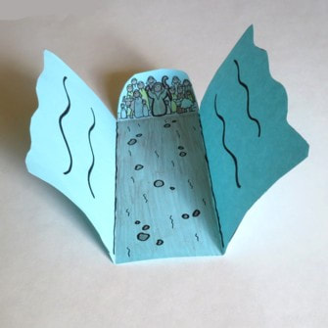
Red Sea Trifold
(Ages 3+, 5-10 mins)

Supplies Needed:
- Template
- Markers/Crayons
- Scissors
- Tape/glue

Instructions:
- Younger kids may need help with the cutting, but otherwise this is a pretty simple craft that helps recreate what it might have looked like!

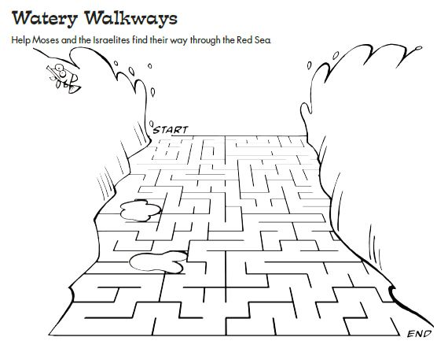
Red Sea Maze
(Ages 5+, 3-5 mins)

Supplies Needed:
- Printed Handout
- Pen/Pencil

Instructions:
- The somewhat 3-D perspective of this maze makes it a little unique, but most kids should be able to complete it after a few tries.

Red Sea Word Puzzle
(Ages 7+, 5 mins)

Supplies Needed:
- Printed Handout
- Pen/pencil

Instructions:
- This word puzzle is essentially akin to the game Boggle – have kids see how many words they can form by moving from square to square.
Biblical Background – Red Sea
Your ability to share most of this info with kids will vary wildly depending on their age – honestly, this section is mainly just written for you as teachers and parents to learn a bit more about the background to each week's passage!

While our time today is largely spent focused on the Israelites passing through the Red Sea by God’s help, it is important to remember that the groundwork for this exodus was being laid many chapters before! In Exodus 3, Moses experiences one of the more remarkable theophanies (appearances of God) in the entire Bible. While Moses is out tending to his father-in-law’s flock, he sees a bush which is somehow on fire without being consumed – and he soon learns not only the very name of God (YHWH – translated as “I am who I am”) but that God is calling him to lead the Hebrew people out of Egypt and into the Promised Land of Canaan – even if Moses doesn’t feel particularly qualified (see Exodus 4)

Over the next ten chapters, we see Moses try to convince Pharaoh to let the Hebrew people go – first by demonstrating God’s power, followed by a successive series of plagues designed to frighten and awe the Egyptians and Pharaoh. Pharaoh does reluctantly agree to release the Hebrews, only to abruptly reverse course through God hardening Pharaoh’s heart (which is itself a theologically challenging passage) and sending his army chasing after them.

Older kids may ask some variation of the question: “Did this really happen?”
– a question that gets asked a lot around every miracle story from the Bible. Miracles are, by definition, events that defy logic and reason – and “proving” them is not ultimately possible. There is no historical evidence of the Hebrew people passing through the Red Sea (nor would we expect there to be any) and there have been questions raised about how the Hebrew was translated in the first place (since the Hebrew phrase means “Reed Sea” rather than “Red Sea”). Instead, it often is helpful to focus on why the Bible talks about this miracle taking place rather than spending time on how or if it took place. Just as God’s promise to lead the people out of Egypt was a continuation of the covenant made with Abraham and Abraham’s descendants, so too this passage is a reminder that God is always with us – even in challenging times.

Your ability to share this info with kids will vary depending on their age – this section is mainly written for teachers and parents to learn a bit more about the background to each week's passage!

