Joseph 1 September 13, 2020

Bible Verses: Genesis 37
Spark Story Bible: pages 48 to 53
--------------------------------------------------------------------------------------------------

Overall Lesson Takeaways

  - Sometimes we fight with our siblings or friends – how can we repair our relationships with one another, even when we hurt each other?
I have often felt as though no one comes out of the early chapters of this narrative looking good. Jacob shows clear signs of favoritism towards Joseph, not only "loving [him] more than any of his other children" (ouch!) but making that readily apparent through his gift. Joseph apparently thinks it's a great idea to tell his underappreciated brothers that they will bow to him after continuing to wear this robe that serves as a symbol of his special status. Joseph's brothers allow their jealousy to reach a point where they consider murdering their brother before landing on tossing him in a pit. But while it's easy to judge all of these characters from afar, most (all?) of us live in complicated family systems ourselves. We allow resentments and slights to build up, or we allow our pride, ego, or favoritism to supersede our relationships. This wider Joseph narrative will see a great deal of growth from all involved – and it serves as a reminder for us to self-examine and grow as well. How might we be hurting someone else, whether friends or family? When should we say something about how we're feeling, rather than letting it bottle up?

  - God calls us to use our gifts humbly, helping others before ourselves.
We'll return to this question next week, but it is important to note that Joseph's early usage of his gift is one that benefits him. Now, he's not wrong – his brothers will later bow down to him unknowingly – but there is a distinct movement over the course of these 14 chapters from his ability to interpret benefitting him, then benefitting someone else (the cupbearer in prison, not so much the baker…), then benefitting the entirety of Egypt. This question of how we use what God has gifted us with is an important conversation that we should have with kids throughout the Joseph story.

  - God is always watching over us, even during terrible times.
Another important reflection point is how Joseph must have been feeling in his literal and metaphorical descent. We begin by Joseph dreaming of his brothers bowing to him, but in the chapters that follow he is tossed into a pit, sold into slavery, falsely accused of rape (we won't cover that part of the story in Sunday School), and thrown into a dungeon for two years. Nothing about his experience makes it seem as though God is watching over him or is helping him achieve his dream, and yet by Genesis 50 Joseph's life has undergone a remarkable transformation. It is hard for us to trust in God's promises to us sometimes, particularly when we find ourselves in the "pit" – but Joseph's experience can help remind us that God is always there for us, even if we may not recognize it.
Checking In

Before the reading:
- It's your first Sunday, so take a little time to get to know the kids!
  - Names, what is one of your favorite things you did this summer?
  - Younger kids: Show and Tell –
  - Older kids: Highs and Lows from their past week
- Who here has ever had a really crazy dream? Did you ever wonder what it meant? Joseph had the ability to understand dreams!

Bible Lesson / Discussion

Reading the Bible:
- Today's reading is about a family fight that gets a little out of hand!
You saw the video, but we’re going to read the Bible together…
- Read the text together, either in the Bible, or the Spark Story Bible.
  - You’ll need to screen share the passage for the day in Zoom.
  - Feel free to stop and ask questions during the reading, if helpful.
  - Afterwards, take time to explore what that passage might mean, and know there's no one correct way to read these passages!

Questions About the Passage
- How would you feel if one of your parents gave you a special gift? What if they gave a gift to another one of your family members, but not you??
- Joseph’s brothers were jealous of him and Joseph didn’t make it any better by boasting – how should we act if we have a special skill, or get a gift?
- Where do you think God was at work in this passage?

Connections To Our Lives
- Have you ever gotten into an argument or fight with a sibling or friend? What did you do to help fix it?
- What is harder: forgiving someone, or staying angry with them?
- How can you trust God, even during difficult times in your life?

Biblical/Church Connections
- This morning we learned about the ways in which the Social Service Center is helping to feed people now – and Joseph eventually uses his ability to interpret dreams to provide food during a famine. What are some ways that we can help those in deep need right now?

People of Faith

In addition to reading our weekly Bible story, I'd love for our older grade school students to learn more about people whose lives were changed by their faith in Jesus. We'll lift up a new person each Sunday, trying to connect their story to our Bible passage as much as possible!

Abbé Pierre (pronounced 'ah-bey')
Similar to the work we saw with the Social Service center this morning, Abbé Pierre's ministry was defined by helping those in deep need. Born in France in 1912, Abbé Pierre was a key part of the French resistance to the Nazis in World War II, helping to smuggle Jewish families to safety throughout the war despite being arrested twice.

After WWII, Pierre founded the Emmaus movement – an organization dedicated to addressing poverty and homelessness. Their motto was and is: "Serve those worse off than yourself before yourself. Serve the neediest first". During a particularly frigid winter in France, he shared the following over the radio:
My friends, come help ... A woman froze to death tonight at 3:00 AM, on the pavement of Sebastopol Boulevard, clutching the eviction notice which the day before had made her homeless... Each night, more than two thousand endure the cold, without food, without bread, more than one almost naked. To face this horror, emergency lodgings are not enough…
Tonight, in every town in France, in every quarter of Paris, we must hang out placards under a light in the dark, at the door of places where there are blankets, bunks, soup; where one may read, under the title 'Fraternal Aid Center', these simple words: 'If you suffer, whoever you are, enter, eat, sleep, recover hope, here you are loved'.
The forecast is for a month of harsh frosts. For as long as the winter lasts, for as long as the centers exist, faced with their brothers dying in poverty, all mankind must be of one will: the will to make this situation impossible. I beg of you, let us love one another enough to do it now. From so much pain, let a wonderful thing be given unto us: the shared spirit of France. Thank you! Everyone can help those who are homeless… thanks to you, no person, no child, will sleep on the asphalt or on the waterfronts of Paris tonight. Thank you.

After this address, it is believed that almost 500 million francs ($83 million dollars) were raised in order to help address people's basic needs. As Pierre once said: "It's not enough to attend church and pray every Sunday; you have to act. Anybody can identify a problem, but a true hero acts upon that problem".

Pierre's entire life was dedicated towards helping others – something he did because of his deep faith in Jesus, and belief that Jesus called him to help.
Crafts / Activities
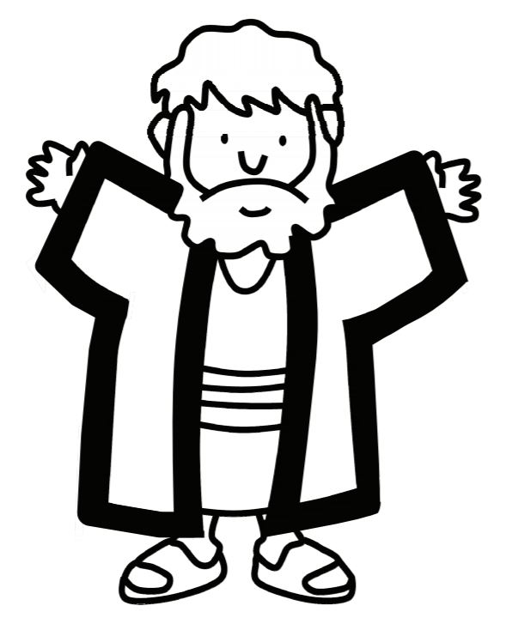

Joseph’s Coat of Many Colors
(Ages 3+, 5-10 mins)

Supplies Needed:
- Template
- Markers/Crayons
- OR Paint/Q-Tips
- Tape/glue

Instructions:
- This can be an easy coloring sheet for younger kids, or they can use Q-Tips and paint to make a dazzling coat through pointillism!

Joseph’s Coat (Color By Number)
(Ages 5+, 5 mins)

Supplies Needed:
- Template
- Markers/Crayons

Instructions:
- Very similar to the above coloring sheet, but there are instructions about what colors to use!

Colors in Joseph’s Coat Online Game
(1st through 5th Grade, 5 mins)
Supplies Needed:
- Website open on your computer
- Screen share with the kids

In order to play this game, you’ll need to open the Sporcle site and screen share the site with the kids. You have three minutes to guess the colors of Joseph’s coat according to the classic musical – have kids shout them out and type fast!
Biblical Background – Genesis 37-50

It may seem bizarre to begin our year at the end of Genesis, but in many ways Joseph is a perfect pivot point between what we studied last Fall and the theme of “leaders and prophets” that we’ll be exploring this Fall.

The family strife that we witness between Joseph and his brothers is certainly a common theme throughout Genesis – think Cain & Abel, Hagar & Sarah, or Jacob & Esau – but the overarching narrative helps transition us from Genesis’ focus on a particular family (Abram and his descendants) to God’s wider family in Exodus and beyond, as we begin to focus on the Hebrew people. God’s faithfulness and adherence to the covenant with Abram and his descendants is still at the core of much of the Old Testament – it should be noted that Joseph and his brothers are the names of the future 12 tribes of Israel – after all their father, Jacob, is Israel (see Genesis 32:22-32). However, the books of the Bible after Genesis deal more directly with the Hebrew people and the founding of Israel – and the leaders and prophets who try to help it align with God’s will.

Attentive readers may note that God does not appear in Genesis 37 – in fact, one of the fascinating aspects of the Joseph account is how little God is referenced throughout the course of these 14 chapters! After being a consistent and vocal presence throughout the vast majority of Genesis, God only speaks once (to Jacob in Genesis 46:1-4) – and that certainly transitions us into the rest of the Old Testament where God speaks more sparingly. By the end of the story, though, it is clear that Joseph sees God as having played a vital role throughout his journey (see the famous Genesis 50:20 verse) – something that I think has many lessons and implications for our faith journeys as well. Although we desire it, God rarely feels in constant communication with us during the course of our lives – our experiences of God's presence and calling often fall within transcendent moments. Joseph's experience, though, is a reminder that even when we aren't hearing from God directly, that does not mean that God has left us or isn't playing a role in our lives – and that’s something that we’ll return to again and again this semester.

Your ability to share this info with kids will vary depending on their age – this section is mainly written for teachers and parents to learn a bit more about the background to each week's passage!

