Creation September 12, 2021

Bible Verses: Genesis 1:1 to 2:4
Spark Story Bible: pages 2 to 7
--------------------------------------------------------------------------------------------------

Overall Lesson Takeaways

- God created everything there is.
Although there are certainly more complex lessons than this to take away from the Genesis 1 passage, we shouldn’t forget to share this vital takeaway too! It can be tempting at times to get bogged down in the historicity of this passage – fun fact: Christians have been arguing over whether this passage should be read literally since Origen in the 3rd century – but we shouldn’t ignore the sense of mystery, awe, and wonder that comes with reflecting on the act of creation or on God as Creator. Seeing all of creation as a gift from God – and recognizing that we have the image of God within us (Gen 1:26) – should ultimately change our relationship with creation.
- God sees goodness in creation – and so can we.
The biblical text not only talks about the act of creation, but makes an additional important proclamation: that when God saw what was created, "God saw that it was good". Believing in the essential goodness of creation may seem like a pretty basic thing, but it is important to try and expand that idea to people, places, or things that we may not care for. It's easy for us to write creation off as "fallen" due to the following chapters of Genesis, but I don't think that changes the fundamental view of God towards creation: goodness is a part of everything, even when we may not see it. How can it change our opinions of those people or things if we remember that God sees them as good? How can it change our opinion of ourselves if we remember that we have the image of God within us – and that we are called to live our lives from it?
- We have a responsibility to take care of what God created.
Although much of the focus often lands on what happened on each of the six days, we shouldn't miss a critical shift at the end of the chapter in verses 28-30: God gives human beings dominion over the animals and plants of the earth. Dominion literally means "control" or "domination", and many have used and abused this charge from God over the years. However, at a time when we are increasingly concerned about the damage that we have done to our planet, it is more than appropriate to read these verses in a different way: God has entrusted us with the responsibility of caring for our planet and all of creation. Have we done a good job of that? What might we need to change about the way that we live our lives to better care for creation? What might God say about the seemingly irreparable damage that we are doing to our planet?

Checking In

Before the reading:
- Check in with the kids – welcoming any newcomers warmly.
  - Younger kids: What was something fun you did this summer?
  - Older kids: Highs and Lows from their first few weeks of school
- This is our first time back at Sunday School in a looong time! What is it like being back? What did you miss about being here on Sundays?

Bible Lesson / Discussion

Reading the Bible:
- We are beginning a new Sunday School year today – and that means we are going all the way back to the first book of the Bible and the first page of the Bible. Can anyone tell me what that first book is called?
- Read the text together, either in the Bible, or the Spark Story Bible.
  - Feel free to stop and ask questions during the reading, if helpful.
  - Afterwards, take time to explore what that passage might mean, and know there's no one correct way to read these passages!

Questions About the Passage (see next page for PreK/K questions)
- The Bible says that God saw that all creation was good – what do you think that means? What do you see as being good in creation?
- It also says that we have the image of God in us… that’s a pretty big deal! How can we recognize that image of God in other people, or in ourselves?

Connections to Our Lives
- When was the last time that you spent a lot of time outside? What did you enjoy from being outdoors in creation?
- Later in this passage, God tells human beings that they are in charge of the animals/fish/wider creation. How well do you think people care for the environment today? What are things that you do in your family to care for God’s creation and creatures? What new things could you try?

Biblical/Church Connections
- Today is something called “Get Connected” Sunday at our church, which means people have a chance to learn about classes, ways to volunteer, or meet new people. What is something new that you’ve tried recently? What is something other than Sunday School you could do at church?
Alternate Preschool and K/1st Questions
Younger ages, particularly those in our preschool class, may have a hard time discussing the biblical text for very long (if at all). My hope is that these questions (and especially the activity) can help with engagement!

Opening Questions
- This is our first time back at Sunday School in a looong time! What is it like being back? What did you miss about being here on Sundays?
- Is there anything you’re really excited about this school year?

Fun Warm-Up Activity – Pick-A-Side
- Today we are going to be talking about God creating everything there is in the world – but before we do that, I thought it would be fun to play a little game to get to know each other better! Split the room into two sides and kids have to stand up and walk to the side that they like more…
- Your example to start: vanilla ice cream, or chocolate ice cream?
- Creation examples:
  - Day or Night? Being in the ocean or Being on a mountain?
  - Birds or Fish? Dogs or cats? Lions or elephants?
  - Encourage kids to come up with a few too!

Reading the Bible:
- We are beginning a new Sunday School year today – and that means we are going all the way back to the first book of the Bible and the first page of the Bible. Does anyone know what that first book is called?
- Read the text together, either in the Bible, or the Spark Story Bible.

Bible Discussion/Questions
- God made everything there is – me, you, our families, animals, our planet! What is something that you love about your family? What is something that you love about the world that God made?
- God sees that everything that was created is good. What does it mean to be good? How do you try to be good at home or at school?
- God also gave people a really important job: we’re supposed to take care of all of the animals and take care of our planet. What are ways that you take care of animals? What are ways that you take care of the planet? How do you think it makes God feel when we do those things?
People of Faith

In addition to reading our weekly Bible story, I'd love for our older grade school students to learn more about people whose lives were changed by their faith in Jesus. We'll lift up a new person each Sunday, trying to connect their story to our Bible passage as much as possible!

George Washington Carver
As we cover the wonder and beauty of creation today, it feels appropriate to honor the acclaimed inventor and environmentalist George Washington Carver who dedicated his entire life to conserving and creating from the earth.

Born into slavery in the early 1860s, Carver would later be raised by his former slaveholders after slavery was abolished in 1865. They taught him to read and write – eventually sending him off to an all-Black school. It was around this time that Carver decided to become Christian based on a conversation he had with another boy in town – “There isn’t much of a story to it”, he once wrote, “God just came into my heart one afternoon”. Nonetheless, Carver’s faith would continue to inspire his life, his research, and his interactions with others.

Carver proved to be an excellent student and successfully applied to college, only to be later denied on account of his racial identity. Carver created his own self-sufficient farm and worked odd jobs for the next five years before successfully applying to college at Iowa State, where he became the first Black student in 1891 and the first Black faculty member after graduating with a Masters of Science studying plant pathology and mycology.

Shortly thereafter, Carver was recruited to lead the Science Department at the Tuskegee Institute – a position he would hold for the next 47 years. During this time, Carver would pioneer a wide variety of practices and inventions ranging from rotating multiple crops through the same soil to famously creating 300 different products from the peanut plant. His research revolutionized crop planting throughout much of the United States, and he would go on to use his platform to promote interracial cooperation and environmentalism – meeting with three United States presidents and other world leaders. Through it all, his faith continued to guide his humble desire to help lift others up rather than chasing fame. He once remarked: “When you do the common things in life in an uncommon way, you will command the attention of the world”.
Crafts / Activities

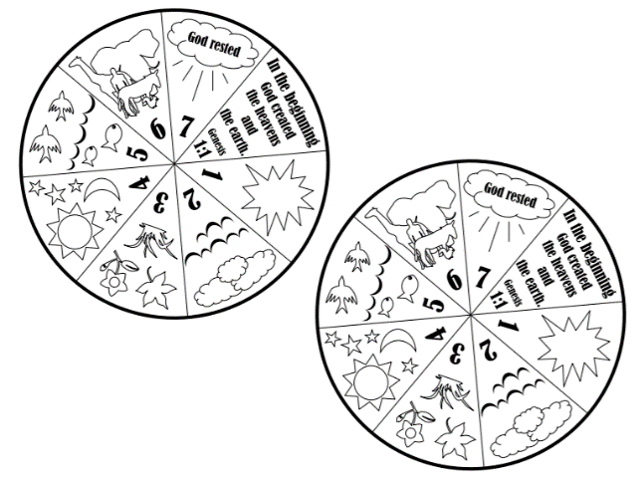
Creation Wheel
(Ages 5+, 10 mins)

Supplies Needed:
- Template
- Scissors
- Brad/Fastener
- Markers/Crayons

Instructions:
- This craft works for a variety of ages and can be used to reinforce or practice what happened during the seven days of creation in Genesis 1.

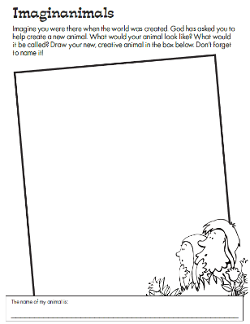
Creation Animal Design
(Ages 3+, 5-10 mins)

Supplies Needed:
- Printed Handout
- Pen/Pencil/Crayons

Instructions:
- Ask kids to put their thinking caps on and draw/create a brand new animal that they would have made during Creation!

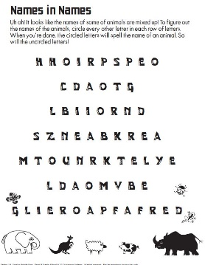
Creation Word Puzzle
(Ages 6+, 5 mins)

Supplies Needed:
- Printed Handout
- Pen/Pencil/Crayons

Instructions:
- This word puzzle is fairly straightforward but still a fun activity that you can do with your class if you need an additional craft.
Biblical Background – Creation

We’ll be spending a great deal of time in Genesis this semester, so it feels important to lift up a few background notes that will apply both to Genesis 1 as well as to the Book of Genesis as a whole:

When was Genesis written?
The answer to this question is both complex and layered. There is undoubtedly ancient oral tradition behind all the passages, but it may not have reached its final written form until as late as the 6th or 5th centuries BCE – and many theories abound about the various sources that were woven together to write it.

“Did creation really happen in six days?”
Dating back to Darwin’s theory of evolution (and more recently with the Big Bang theory), kids and adults alike have tended to read Genesis 1 and scientific theories as being in opposition to one another. However, while some denominations still insist on reading this passage literally (reading "day" as meaning "time period" or "era"), ours does not. “Genesis is not a scientific or historical textbook”, one biblical commentary notes, “it is a book of memories, marvels, and miracles”. Genesis 1 speaks of God's involvement in every aspect of creation and speaks of human beings' responsibility for helping to maintain that creation – those are some of the lessons that we can draw from this text.

The importance of our translations.
You may have wondered at some point why so many different translations of the Bible exist. Fourth uses the NRSV, others use the NIV, King James, or one of hundreds of others. Why so many, and why does it matter? Turns out, how we translate words makes a huge difference! Take Genesis 1:2, for example: it uses a Hebrew word, ruach, which has several different meanings – "wind", "breath", or "spirit" – depending on the context. One can see why breath and spirit would have been associated together in the ancient world. The problem comes when you need to translate this verse. Did a "wind from God" sweep over the face of the water? "A breath from God"? "God's Spirit"? They're all perfectly legitimate translations, but the theological difference between a "wind from God" and the presence of "God's Spirit" over the waters is massive!

Your ability to share this info with kids will vary depending on their age – this section is mainly written for teachers and parents to learn a bit more about the background to each week's passage!

