Baby Moses September 11, 2022

Bible Verses: Exodus 1:8-14, 2:1-10
Spark Story Bible: pages 66 to 71
--------------------------------------------------------------------------------------------------

Overall Lesson Takeaways

- God is always watching over us.
Although it’s probably best to not get too deep into the details – especially with younger kids! – the rescue of Moses in a time of great danger can serve as a reminder that God is with every single one of us in uncertain or scary times. Kids will likely be all over the map about times when they may have been afraid (going to a new school, storms, being away from parents, etc.) but the one constant you can share is that we can pray to God for help – and be reminded God is watching over each one of us to keep us safe! Sending Moses down the river would have been really scary for Moses’ mom and his sister Miriam, but they soon found Pharaoh’s daughter was able to take care of him and they knew and trusted God would be helping him too.
- God has put special people in our lives to help and care for us.
While trusting in God to watch over us is certainly an important part of this passage, we shouldn’t minimize the bravery of Moses’ mother, the fearless compassion of his sister Miriam, and the heart that Pharaoh’s daughter shows in rescuing him! One of the many ways God shows caring and compassion to each one of us is through the special people who are a part of our lives: parents, siblings, grandparents, relatives, friends, teachers, etc! All of us have a lot of loving relationships in our lives, and giving thanks for them can be an important aspect of this lesson as well. Moses would never have gone on to be a great leader without the love, care, and protection shown to him early in his life – and we too are the products of those who care for us.
- We are all learning and growing – and we can be leaders too!
The final aspect of this passage is that while Moses is a baby now, he’ll soon grow up to do great things for others – and that can be an opportunity to talk about the ways in which all of us are growing and gaining responsibility. Things like chores or homework might not seem like a lot of fun at the time (probably because they’re not!), but they are ways we are learning what it means to be responsible or gaining skills which can help us later in life. Moses isn’t ready to lead the people immediately, but through the help of those around him he soon learns what it means to lead – and he is always ready to lean on God’s help as well. For us, Moses can be an example of how we might be called to care for other people in our life – or think about ways we can use what we have for the benefit of others.

Checking In

Before the reading:
- It's your first Sunday, so take a little time to get to know the kids!
  - Names, where they go to school, favorite summer memories, etc.
- When was the last time you were around a baby? What are things that babies need help with? Is it easy or hard to care for a baby?

Bible Lesson / Discussion

Reading the Bible:
- Today's reading is about a baby who will grow up to be a great leader – not Jesus, but Moses! Babies need people help them and keep them safe – and in our Bible reading today, we'll learn about how Moses' family and God kept the baby Moses safe during a frightening time.
- Read the text together, either in the Bible, or the Spark Story Bible.
  - Feel free to stop and ask questions during the reading, if helpful.
  - Afterwards, take time to explore what that passage might mean, and know there's no one correct way to read these passages!

Questions About the Passage
- What would you have done if you were Moses' mother or sister? Do you think it was hard for them to trust that Moses would be OK? Why?
- Did Pharaoh's daughter do a brave thing by taking Moses in? Why do you think she chose to help Moses and his family out?
- How do you think God was at work in this passage?

Connections To Our Lives
- Have you ever had to make a difficult choice before? What are some of the things that you thought about before making that choice?
- How could trusting in God help you make tough choices?
- Moses' mother and sister helped keep him safe as a baby, and then he went on to save other people. How can we know when we need help from other people, or when we should help others? Both are important!

Biblical/Church Connections
- We are in a season of our church year called "Ordinary Time" – a time when we read the "Old Testament" (O.T.!). Sometimes, though, we believe that God wants us to do extraordinary things to help other people. What are ways we could be a help to friends, family, or even strangers?
Alternate Preschool and K/1st Questions
Younger ages, particularly those in our preschool class, may have a hard time discussing the biblical text for very long (if at all). My hope is that these questions (and especially the activity) can help with engagement!

Opening Questions / Activity
- It's your first Sunday, so take a little time to get to know the kids!
  - Names, favorite thing or something special they did this summer
- Warm Up Game – if you’re looking for a fun way to warm kids up and engage with them, you can play a game of “I Spy” – have one of the kids (or you) think of an object in the room and say what color it is. Kids take turns guessing what they think the object is. Once you’re done playing you can transition into the Bible lesson for the day.

Bible Discussion/Questions
- When was the last time you were around a baby? What are things that babies need help with? Is it easy or hard to care for a baby?
- Today's reading is about a baby who will grow up to be a great leader – not Jesus, but Moses! Babies need people help them and keep them safe – and in our Bible reading today, we'll learn about how Moses' family and God kept the baby Moses safe during a scary time.
- Read the text together, either in the Bible, or the Spark Story Bible.
  - Feel free to stop and ask questions during the reading, if helpful.
  - Afterwards, take time to explore what that passage might mean, and know there's no one correct way to read these passages!
- God is promising to help Moses and the Hebrew people – and we believe God is helping us all the time too. Who were some of the people who helped Baby Moses in this passage? Who are people who help you and love you every day?
- Have you ever been a helper, either at home or at school? Why is it important for us to help other people?

People of Faith

In addition to reading our weekly Bible story, I'd love for our older grade school students to learn more about people whose lives were changed by their faith in Jesus. We'll lift up a new person each Sunday, trying to connect their story to our Bible passage as much as possible!

Abbé Pierre (pronounced 'ah-bey')
Similar to the work we saw with the Social Service center this morning, Abbé Pierre's ministry was defined by helping those in deep need. Born in France in 1912, Abbé Pierre was a key part of the French resistance to the Nazis in World War II, helping to smuggle Jewish families to safety throughout the war despite being arrested twice.

After WWII, Pierre founded the Emmaus movement – an organization dedicated to addressing poverty and homelessness. Their motto was and is: "Serve those worse off than yourself before yourself. Serve the neediest first". During a particularly frigid winter in France, he shared the following over the radio:
My friends, come help ... A woman froze to death tonight at 3:00 AM, on the pavement of Sebastopol Boulevard, clutching the eviction notice which the day before had made her homeless... Each night, more than two thousand endure the cold, without food, without bread, more than one almost naked. To face this horror, emergency lodgings are not enough…
Tonight, in every town in France, in every quarter of Paris, we must hang out placards under a light in the dark, at the door of places where there are blankets, bunks, soup; where one may read, under the title 'Fraternal Aid Center', these simple words: 'If you suffer, whoever you are, enter, eat, sleep, recover hope, here you are loved'.
The forecast is for a month of harsh frosts. For as long as the winter lasts, for as long as the centers exist, faced with their brothers dying in poverty, all mankind must be of one will: the will to make this situation impossible. I beg of you, let us love one another enough to do it now. From so much pain, let a wonderful thing be given unto us: the shared spirit of France. Thank you! Everyone can help those who are homeless… thanks to you, no person, no child, will sleep on the asphalt or on the waterfronts of Paris tonight. Thank you.

After this address, it is believed that almost 500 million francs ($83 million dollars) were raised in order to help address people's basic needs. As Pierre once said: "It's not enough to attend church and pray every Sunday; you have to act. Anybody can identify a problem, but a true hero acts upon that problem".

Pierre's entire life was dedicated towards helping others – something he did because of his deep faith in Jesus, and belief that Jesus called him to help.
Crafts / Activities

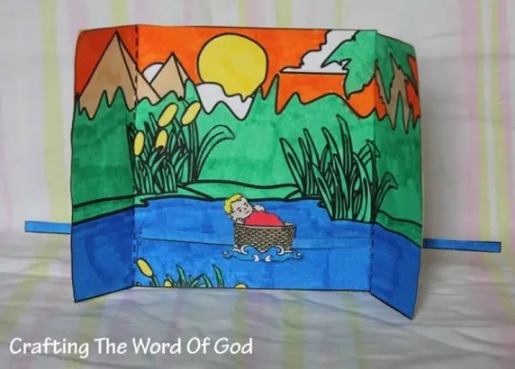
Baby Moses Floating River
(Ages 3+, 5-10 mins)

Supplies Needed:
- Template
- Markers/Crayons
- Scissors
- Tape/glue

Instructions:
- Younger kids will likely need help with this, but after assembling you can have Baby Moses “float” down the river using a sliding piece of paper.

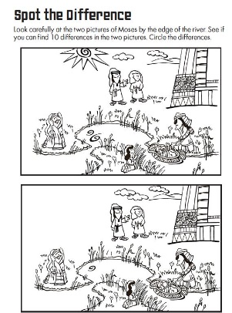
Baby Moses Spot the Difference
(Ages 3+, 3-5 mins)

Supplies Needed:
- Printed Handout
- Pen/Pencil

Instructions:
- Kids will need to identify ten differences between the upper and lower pictures on the page – this activity should work for most age groups

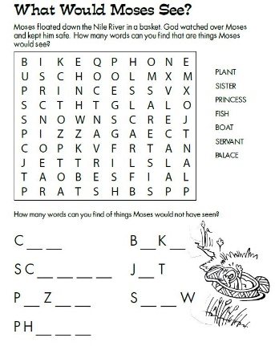
Baby Moses Word Search
(Ages 5+, 5-10 mins)

Supplies Needed:
- Printed Handout
- Pen/pencil

Instructions:
- This word search is not as complex as some, although the ‘fill-in the blank’ portion at the bottom might be tricky for the K/1st class.
Biblical Background – Baby Moses
Your ability to share most of this info with kids will vary wildly depending on their age – honestly, this section is mainly just written for you as teachers and parents to learn a bit more about the background to each week's passage!

There is clearly some time that elapses between Joseph's time in Egypt (Genesis 37-50) and the situation described in Exodus 1. The biblical text is vague about the timeframe, but studies of biblical genealogies suggest that in between Genesis and Exodus was a gap of somewhere around 215 to 430 years.

So, when does Exodus take place? It's impossible to know for sure, but most scholars place Exodus during the reign of Rameses II (1279 – 1213 BCE). The first reference to Israel comes from Rameses II's successor, Merneptah – and the timeline broadly fits within other Ancient Near East dates that are more certain.

Regardless, the Baby Moses account is the start of the era that will dominate the rest of the Pentateuch: God's people are being led out of Egypt towards a Promised Land, while receiving the Law and divine instruction along the way. Our curriculum will only spend time in the Book of Exodus, which primarily deals with Moses leading the people out of Egypt – however the second half of Exodus, as well as Leviticus, Numbers, and Deuteronomy, are largely written to establish what the laws, norms, and religious practices will be in this new land.

These first five books – also known as the Torah – are foundational for Judaism – but they continue to hold great value and resonance for us as Christians today, even if we may not observe particular practices (eating kosher, for example). God watching over Moses and the Hebrew people is a continuation of the covenant promises that we began learning about in Genesis – and people around the world, particularly those who have experienced oppression or who are experiencing it currently, have seen a great connection and affinity for the hope of a new day represented by Moses leading the people out of Egypt. To learn about Moses is to learn about hope, to listen for how God is asking us to live our lives, and to remember God will be with us every step of the way - something we'll continue exploring with the Crossing of the Red Sea next week!

Your ability to share this info with kids will vary depending on their age – this section is mainly written for teachers and parents to learn a bit more about the background to each week's passage!

