Joseph 1 October 31, 2021

Bible Verses: Genesis 37:1-28
Spark Story Bible: pages 48 to 53
--------------------------------------------------------------------------------------------------

Overall Lesson Takeaways

- The importance of fairness and humility.
I often feel that no one comes out of the early chapters of this story looking good. Jacob shows clear signs of favoritism towards Joseph, not only "loving [him] more than any of his other children" (ouch!) but making that readily apparent through his special gift. Joseph apparently thinks it's a great idea to tell his underappreciated brothers that they will bow to him – after tattling on them in 37:2, and continuing to wear this robe that serves as a symbol of his special status. Joseph's brothers allow their jealousy to reach a point where they actual consider murdering their brother (Cain/Abel call back?) before landing on tossing him in a pit and tricking their father about his "death". But while it's easy to judge all of these characters from afar, most of us live in complicated family systems ourselves. We allow resentments and slights to build up, or we allow our pride, ego, or favoritism to supersede our relationships. When should we say something about how we're feeling, rather than bottling it up?
- We should use our gifts to help others, not only ourselves.
We'll return to this question next week (since dreaming and the interpretation of dreams plays a large role in this story), but it is important to note that Joseph's early usage of his gift is one that benefits him. Now, he's not wrong – his brothers will later bow down to him unknowingly – but there is a distinct movement over the course of these 14 chapters from his ability to interpret benefitting him, then benefitting someone else (the cupbearer in prison, not so much the baker…), then benefitting the entirety of Egypt. This question of how we use what God has gifted us with is an important conversation that we should have with kids throughout the Joseph story.
- Keeping faith in God when we are in the “pit”.
Another important reflection point is how Joseph must have been feeling in his literal and metaphorical descent. We begin by Joseph dreaming of his brothers bowing to him, but in the chapters that follow he is tossed into a pit, sold into slavery, falsely accused of rape (we won't cover that part of the story in Sunday School), and thrown into a dungeon for two years. Nothing about his experience makes it seem as though God is watching over him or is helping him achieve his dream, and yet by Genesis 50 Joseph's life has undergone a remarkable transformation. It is hard for us to trust in God's promises to us sometimes, particularly when we find ourselves in the "pit" – but Joseph's experience can help remind us that God is always there for us, even if we may not recognize it.
Checking In

Before the reading:
- Check in with the kids – welcoming any newcomers warmly.
  - Younger kids: Happy Halloween! Trick-or-treating today?
  - Older kids: Share highs and lows from the past week
- What is one of your favorite gifts that you have ever received? What made it so special to you?

Bible Lesson / Discussion

Reading the Bible:
- After learning about Jacob and his twin brother Esau, we’re going to be learning about Jacob’s twelve sons over the next three weeks – including his favorite son, Joseph, who received a gift from his father…
- Read the text together, either in the Bible, or the Spark Story Bible.
  - Feel free to stop and ask questions during the reading, if helpful.
  - Afterwards, take time to explore what that passage might mean, and know there's no one correct way to read these passages!

Questions About the Passage (see next page for PreK/K questions)
- How would you have felt if you were one of Joseph’s brothers? What would have made you angrier: the special coat, or the dreams?
- There is a lot about this passage that is unfair: Jacob only gives a coat to Joseph, Joseph is bragging and showing off, and his brothers hurt and sell him away. What do you think should have happened instead?

Connections to Our Lives
- Joseph had an amazing ability to interpret dreams… what is a special ability you’d like to have? How could you use that ability to help others?
- Joseph’s dreams say that he’ll one day rule over his brothers, but right now he was sold to work in Egypt! Do you think he still believed in his dreams, even during those awful and hard moments he faced? How?

Biblical/Church Connections
- Today is Reformation Sunday, which we celebrate as an important time that changed the church 500 years – and helped create the Presbyterian Church. What are some changes you’d like to see at our church today?

Alternate Preschool and K/1st Questions
Younger ages, particularly those in our preschool class, may have a hard time discussing the biblical text for very long (if at all). My hope is that these questions (and especially the activity) can help with engagement!

Opening Questions
- What is one of your favorite gifts that you have ever received? What made it so special to you?

Fun Warm-Up Activity – Colors of the Rainbow
- In our story today, a boy named Joseph gets a special gift from his dad: a coat with lots and lots of colors! There wasn’t a lot of colorful clothing many years ago – but today we’re surrounded by color!
- Encourage the kids to do a colors scavenger hunt (either solo or as teams) and collect 9 different objects from around the room that have various colors: red, orange, yellow, green, blue, purple, brown, white, black!
- Have the kids show off their objects!

Reading the Bible:
- After learning about Jacob and his twin brother Esau, we’re going to be learning about Jacob’s twelve sons over the next three weeks – but the gift that Joseph got made his brothers feel pretty jealous…
- Read the text together, either in the Bible, or the Spark Story Bible.

Bible Discussion/Questions
- Joseph’s brothers do a really mean and bad thing to him – but they were jealous because he got a special gift and they didn’t. Have you ever been jealous before? How did it feel to be jealous? What should they have done instead of being mean to Joseph?
- Joseph also had an special ability to understand dreams… have you ever had a funny or strange dream?
- What is a special ability you’d like to have? How could you use that ability to help others?

People of Faith

In addition to reading our weekly Bible story, I'd love for our older grade school students to learn more about people whose lives were changed by their faith in Jesus. We'll lift up a new person each Sunday, trying to connect their story to our Bible passage as much as possible!

Katie Cannon
Today is known as Reformation Sunday in many denominations – but rather than focus on the events of 500 years ago, we can also pay tribute to the ways that the early reformers’ spirit is still at work for the “church Reformed and always reforming” – thanks to the work of people like Rev. Katie Cannon.

Cannon was born in Kannapolis, North Carolina on June 3, 1950. Her family was heavily involved in their local Presbyterian church, with both her mother and father serving as elders at the church, but the vast majority of her community was still racially segregated – she and her siblings were not allowed at the local pool, library, or YMCA.

Even at a young age, Cannon noticed a disconnect between what she learning at church and how the wider world was operating, once reflecting, “By 4 or 5, I was wondering: ‘What did we do as black people that was so bad? A good God would not do this.’” Determined to create change, Cannon began to pursue several higher education degrees – included a Masters of Divinity degree that paved the way for her to be ordained. In 1974, she became the first African-American woman to be ordained in the Presbyterian church – going on to serve a congregation in New York.

During her time in New York, though, she also began to pursue a doctorate degree at Union Seminary in the field of philosophy – calling attention to the ways that theological and ethical studies were dominated by white and male voices. Cannon would go on to be a pioneer in Black and womanist theology, seeking to highlight women’s voices – and specifically Black women’s voices – in how scripture is understood and contextualized. In 2001, she joined the faculty of Union Seminary and became one of the pre-eminent voices in biblical and theological study – publishing several books and receiving several awards honoring her excellence in teaching before her tragic passing in 2018.

Crafts / Activities

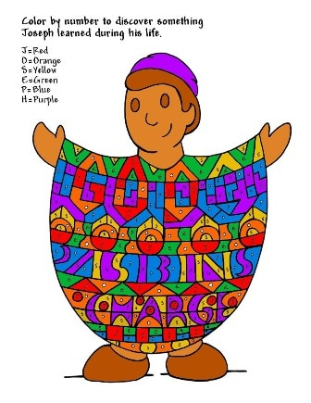
Joseph 1 Color-By-Number
(Ages 5+, 5 mins)

Supplies Needed:
- Printed sheet
- Markers/Crayons

Instructions:
- This color-by-number is fairly detailed so it may take kids awhile to complete! Kids are welcome to use the colors suggested in the upper left, or they are always more than welcome to create their own pattern!

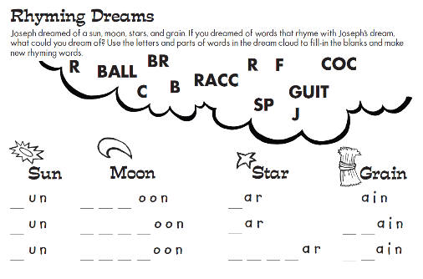
Joseph 1 Word Puzzle
(Ages 5+, 5 mins)

Supplies Needed:
- Printed Handout
- Pen/Pencil/Crayons

Instructions:
- This word puzzle can be tricky – K/1st classes may need help sounding this out – but it is a good reminder of images from Joseph’s dream.

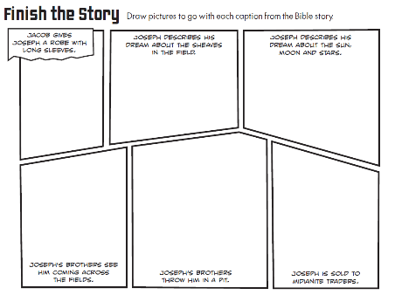
Joseph 1 Comic Book
(Ages 5+, 5-10 mins)

Supplies Needed:
- Printed Handout
- Pen/Pencil/Crayons

Instructions:
- Using a comic book strip format, kids are invited to sketch out major scenes from the first chapter of this Joseph story – this can be a helpful way to review the biblical text!

Biblical Background – Joseph 1

We’ve been in the Book of Genesis this entire semester so far – and over the next three weeks we’re closing with the beloved story of Joseph. Joseph's trials and travels serve as an important narrative transition from Abraham's family to Moses and the Exodus out of Egypt, but all along the way we’ll hear a powerful story of betrayal, talent, and redemption that still resonates for us today.

Joseph's story became relatively well-known after the musical Joseph and the Amazing Technicolor Dreamcoat hit it big – but you may be disappointed to learn that the coat is a complete after-thought in the biblical text. In fact, the NRSV (the primary translation that we use) uses a profoundly lame description for Jacob’s gift to Joseph: "a long robe with sleeves". The Hebrew word for it is otherwise unattested aside 2 Samuel 13:18, when it is used to describe clothing worn by the virgin daughters of the king, but the Septuagint (an important ancient Greek translation) once translated the word as "a coat of many colors", which is how we end up with the Osmonds' far superior version!

Rather than focus on technicolor dreamcoats, though, the Bible is far more interested in the familial drama – which we’ve noted time and again is a consistent theme in the Book of Genesis. There are echoes of previous passages from Genesis running throughout this text: Cain and Abel, a continuation of Abraham’s covenant, divine visions, and Jacob and Esau to name a few.

One of the fascinating differences, though, is how little God is referenced throughout the course of these 14 chapters after being a consistent and vocal presence throughout the vast majority of Genesis – in fact, God only speaks once! By the end of the story, though, it is clear that Joseph sees God as having a vital role throughout his journey (see Genesis 50:20) – something that I think has many lessons and implications for our faith journeys as well. Although we desire it, God rarely feels in constant communication with us during the course of our lives – our experiences of God's presence and calling often fall within transcendent moments. Joseph's experience, though, is a reminder that even when we aren't hearing from God directly, that does not mean that God has left us or isn't playing a role in our lives.

Your ability to share this info with kids will vary depending on their age – this section is mainly written for teachers and parents to learn a bit more about the background to each week's passage!

