Solomon October 30, 2022

Bible Verses: 1 Kings 6:1-13
Spark Story Bible: pages 136 to 139
--------------------------------------------------------------------------------------------------

Overall Lesson Takeaways

- We can worship God anywhere, but it’s important to have special places.
Throughout history, people have worshipped God in many, many different places. There are buildings like temples, churches, and mosques. There are informal gathering spaces like people’s homes or coffee shops. There are people who love to worship outside – and we have now seen a huge increase in people worshipping online. Worship and learning about God doesn’t need to take place in a building… but being in this time where we are doing church over Zoom rather than in-person has made many of us realize that physically gathering together really is important! Our buildings don’t define who we are as churches, but they are a really helpful way to help us get into a mental space of worshipping God – or even just thinking a little differently – and they’re also helpful as a place to bring all of us together.
- Coming to church helps us learn about God.
My guess is that kids throughout the ages have complained about having to go to temples, churches, synagogues, and mosques… particularly having to wake up early! But the reason that we head to these physical locations is that it gives us a chance to learn about God by reading in our Bibles, by talking about the Bible passages together, and by having a chance to worship God (whether in Children’s Chapel, our Sanctuary worship, or some other way). As Presbyterians, we have long maintained that we are able to learn best about God when we are listening and talking to other people, rather than just thinking we have all the right answers – otherwise, we might start to mistake what we want to be the same thing as what God wants! Having a chance to hear everyone’s questions, answers, perspectives, and ideas helps us grow – and we think that God is working through all of that sharing!
- Ultimately, though, church is more about the people than the building.
Today’s lesson is obviously focused on the Temple that Solomon built, and we’ll also discuss our physical location too. But while we enjoy our space, it’s important to remind ourselves that a church building can’t be Church unless there’s people inside. I’m guessing not many of us have been to Fourth during the pandemic, but I can attest that it is really bizarre to be at Fourth’s building right now without people on a Sunday. Having the opportunity to learn, worship, and grow together is the true thing that makes us a church family – not just our building!

Checking In

Before the reading:
- Take the time to get to know the kids a little!
  - Names, Conversation Cubes for warm-up, favorite candy?
- Have you ever built something, either by yourself or with a parent? How long did it take to plan? How long did it take to build?

Bible Lesson / Discussion

Reading the Bible:
- After learning about David, today we’re learning about David’s son Solomon, and the important place called the Temple that he built as king.
- Read the text together, either in the Bible, or the Spark Story Bible.
  - Feel free to stop and ask questions during the reading, if helpful.
  - Afterwards, take time to explore what that passage might mean, and know there's no one correct way to read these passages!

Questions About the Passage (see next page for PreK/K questions)
- How many years do you think it took Solomon and the workers to complete the Temple? (7 years, although 20 years w/other buildings) Why do you think it took so long?
- What would you have added or wanted as part of the Temple?

Connections to Our Lives
- What are some of your favorite things about going to church? Are there things that you don’t like?
- Do you think that the way a church looks is important? What are the most important parts of a church building?
- What would change about church (or Sunday School) if we met in people’s homes rather than the regular church building?

Biblical/Church Connections
- Today is “Reformation Sunday”, a day when we remember the important work that Luther, Zwingli, Calvin, and others did to help the church try to follow God more closely. What are things you might want to change about Fourth Church, or maybe even the worldwide church?

Alternate Preschool and K/1st Questions
Younger ages, particularly those in our preschool class, may have a hard time discussing the biblical text for very long (if at all). My hope is that these questions (and especially the activity) can help with engagement!

Opening Questions / Activity
- Take some time to welcome / get to know the kids!
  - Share names, what are you dressing up as for Halloween?
Warm Up Game – Line It Up
- Our Bible story today was about Solomon building a Temple for people to worship God in… but it took him 7 years to finish! He needed a lot of patience to see his vision come to life… and a lot of organization! We’re going to play a game that’s all about organizing called “Line It Up”
- Have kids line up in order according to the following:
  - Line up tallest to shortest
  - Line up by first letter in your first name, A to Z
  - Line up by first letter in your last name, A to Z
  - Line up by birthday, from January to December
  - Line up by shoe size, biggest to smallest
- This can go on as long as kids are having fun, but eventually you can move on to questions about the Bible passage.

Bible Discussion/Questions
- Our Bible story today is about David’s son Solomon building a special temple where people could worship God. What was the last thing that you built? How did you feel when you completed it?
- Read the text together, either in the Bible, or the Spark Story Bible.
  - Feel free to stop and ask questions during the reading, if helpful.
  - Afterwards, take time to explore what that passage might mean, and know there's no one correct way to read these passages!

- Solomon needed to have a lot of patience, but it was worth it – the Temple that he built stood for almost 400 years so people could worship in it! How old do you think that Fourth Church is? (108 years for building)
- Our church members haven’t always gone to church where we do now though… what do you like about where we go to church usually? Is there anything that you would change or add?

People of Faith

In addition to reading our weekly Bible story, I'd love for our older grade school students to learn more about people whose lives were changed by their faith in Jesus. We'll lift up a new person each Sunday, trying to connect their story to our Bible passage as much as possible!

Millard and Linda Fuller
While Solomon is best known for building the Temple, Millard and Linda Fuller are best known as home builders – particularly for the organization that they begin called Habitat for Humanity.

With degrees in both law and economics, Millard Fuller was a self-made millionaire before he turned 30 – but he had also long been concerned with the welfare of others through his Christian faith and involvement with the Disciples of Christ denomination. When they were 33, the Fullers decided to give away all of their money and live in a Christian farm community in Georgia that focused on building homes for people without charging interest or making a profit. While building their first house, Fuller was asked why he was building homes for poor people since there wasn’t any profit in it. “We’re not doing it to make money” he said. “We’re doing it because we’ve been reading the Bible”.

After spending time as missionaries in Zaire, the Fullers eventually returned to the United States and began the Habitat for Humanity project in 1976. Homes would be built using entirely volunteer labor, including from those who would eventually live in the home, but would still require homeowners to pay for all of the materials used in construction. The Fullers maintained that this was not simply a hand-out, but a hand up – making homeownership obtainable for people who may not have otherwise been able to afford a traditional mortgage.

Habitat for Humanity initially was at work in 14 different states, but now has affiliates in all 50 states as well as over 70 different countries. The program is believed to be responsible for building over 29 million homes – and it continues to operate both locally and globally today. Fuller once said: “I see life as both a gift and a responsibility. My responsibility is to use what God has given me to help people in need” – and that’s exactly what Habitat still does today.

Crafts / Activities

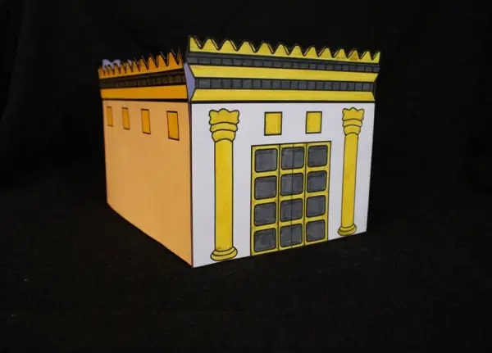
3D Temple
(Ages 5+, 5-10 mins)

Supplies Needed:
- Craft Template
- Scissors
- Glue/Tape
- Crayons/Markers

Instructions:
- Have kids color in all four walls before starting to assemble the Temple. Once finished, have them cut out all four walls and fold down the sides on the first page’s walls. Attach all four walls together, forming a square that can be reinforced to become a replica of Solomon’s Temple!

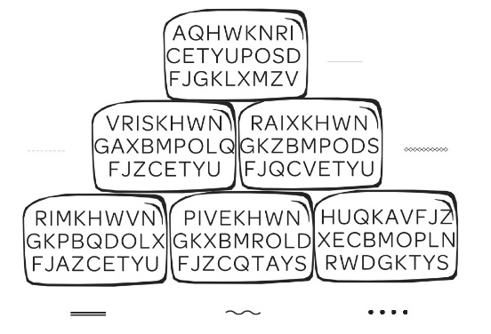
Solomon Word Puzzle
(Ages 5+, 5 mins)

Supplies Needed:
- Printed Handout
- Pen/Pencil/Crayons

Instructions:
- It’s actually deceptively tricky, but this is a good word puzzle that involves trying to identify missing letters to solve a six letter word

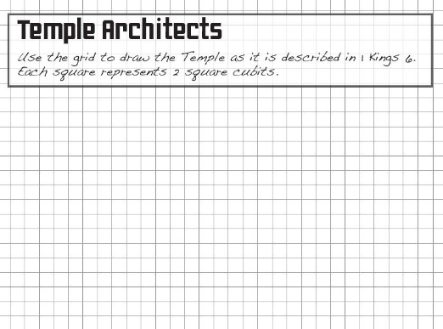
Solomon Temple Designer
(Ages 5+, 5 mins)

Supplies Needed:
- Printed Handout
- Pen/Pencil/Crayons

Instructions:
- This craft asks kids to draw a Temple according to the dimensions given in the Bible, but I think it’s fine for them to imagine their own version!
Biblical Background – Solomon

Although David is frequently lifted up as a sort of idealized leader in the biblical text, Solomon’s reign and the construction of the Temple could certainly be characterized as the high water mark for ancient Israel before in-fighting and civil war began to tear the country apart. Ruling for a nearly 40 year span during the middle portion of the 10th century BCE, Solomon’s tenure was defined by wealth, success, and wisdom – but the construction of the First Temple remains his greatest achievement, in no small part because of what it represented to the Israelite people.

The Temple was a permanent replacement for the Tabernacle, which (for lack of a better term) was the sacred, portable tent where God’s presence was believed to dwell. The Tabernacle primarly appears in the Exodus narrative and was a symbol of the nomadic and unsettled nature of Israel’s early years. David’s establishment of Jerusalem as the national capital and Solomon’s establishment of the Temple in Jerusalem was, for all intents and purposes, a symbol that Israel had finally arrived as a permanent country, rather than group of nomads.

The temple would soon become the center of Israel’s religious life, even after the country fractured into northern and southern kingdoms (Israel and Judah, respectively) shortly after Solomon’s death. This rapid devolving under Solomon’s son Rehoboam certainly was a detriment to Solomon’s legacy, and the rest of 1 and 2 Kings records the eventual downfall of the Northern Kingdom to the Assyrians in 722 BCE and the downfall of the Southern Kingdom to the Babylonians in 586 BCE. Solomon’s Temple (aka, the First Temple) was destroyed as part of the Babylonian invasion in 586 BCE – which, combined with the Exile, marked rock bottom for Israel over the next several centuries.

As for Solomon’s wider legacy, several biblical books were once believed to have been written entirely by him – Proverbs, Ecclesiastes, and Song of Solomon – although most modern scholars reject that idea. It remains possible that later writers added or expanded upon Solomon’s writings, but their attribution to Solomon almost certainly had to do with his close association with wisdom (1 Kings 3) in the ancient world.

Your ability to share this info with kids will vary depending on their age – this section is mainly written for teachers and parents to learn a bit more about the background to each week's passage!

