Deborah October 2, 2022

Bible Verses: Judges 5:1-12
Spark Story Bible: pages 106 to 109
--------------------------------------------------------------------------------------------------

Overall Lesson Takeaways

- Being a leader sometimes means making hard decisions or choices.
Even though biblical “Judges” weren’t exactly judges in the way that we’d think about today, Deborah would often have to use good judgment as the leader of Israel. She had to help people solve disputes and arguments, she had to share messages from God whether they were good or bad, and she had to care for all of people of Israel – even if that meant making tough decisions like sending people into battle in order to rescue prisoners. If we are leaders in our friend group or our classroom, sometimes that might mean that we need to make tough decisions that might be unpopular. But we can use Deborah as an example of someone who always tried to do what she thought was right – and she listened to God for ways to help others, even before she would help herself.
- Sometimes we are called to risk things for the sake of others.
The books of Joshua and Judges are sometimes not terribly conducive to children; they’re filled with violence (in no small part because violence was a constant threat in the ancient world) and the situations that people find themselves in feel different then our world today. Nonetheless, an important and sometimes overlooked part of this passage is that Deborah is taking a huge risk by sending a big part of the Israelite army to rescue those who had been captured. The risks that we would take today might look a whole lot different, but the spirit behind it remains the same: we are sacrificing something for the sake of someone else. Sacrifice can take a lot of different forms for kids – time, attention, allowance money – but you can talk about ways that we all can give those things for the sake of others, even though we may prefer to keep them for ourselves.
- We can trust in God, even during frightening times.
This is admittedly a theme that we are returning to again and again – as mentioned above, the ancient world was a dangerous place! – but it is an important message for kids to continue hearing in these frightening and uncertain times today. Deborah and Barak knew that the battle would be fierce, and I’m sure that Deborah may have had some doubts along the way, but God was able to help them win – and, most importantly, bring about 40 years of peace. There are already times in the midst of frightening situations where it may feel like God has abandoned us, but Deborah reminds us that we can trust in God to watch over us even during the difficult or frightening times in our lives.
Checking In

Before the reading:
- Take the time to get to know the kids a little!
  - Names, Conversation Cubes for warm-up, Highs and Lows
- What does it mean to judge something? Is it a good or a bad thing? How could good judgment be important to a leader?

Bible Lesson / Discussion

Reading the Bible:
- After Moses led the people to a new land, they were led by leaders called “Judges” – and a woman named Deborah was one of these Judges.
- Read the text together, either in the Bible, or the Spark Story Bible.
  - Feel free to stop and ask questions during the reading, if helpful.
  - Afterwards, take time to explore what that passage might mean, and know there's no one correct way to read these passages!

Questions About the Passage
- What do you think makes someone a good leader? Why do you think that God chose Deborah to lead the Israelite people?
- Deborah served as a judge, or leader, in Israel – but that also meant that people came to her with problems and she had to give them advice. Who do you know who gives good advice? What makes it so helpful?

Connections to Our Lives
- Deborah had to send soldiers into battle to help rescue some prisoners. What is one of the hardest choices that you’ve ever had to make? What helped you make your decision?
- The Bible passage talks about Deborah being very wise and helping people out with arguments. Have you ever had an argument with a friend or family member? What helped you have a better discussion with them?

Biblical/Church Connections
- Today is World Communion Sunday – a day when churches all over the world take communion on the same day to remind ourselves we are part of a worldwide church family. What else is special about communion? How can we be family with people who don’t live near us?

Alternate Preschool and K/1st Questions
Younger ages, particularly those in our preschool class, may have a hard time discussing the biblical text for very long (if at all). My hope is that these questions (and especially the activity) can help with engagement!

Opening Questions / Activity
- Take some time to welcome / get to know the kids!
  - Share names, what they might want to be for Halloween
Warm Up Game – Identify the Sound
- In our Bible passage today, we’re learning about a woman named Lydia, who was a “Judge”, or leader. Being a judge meant you had to listen closely – so it might be fun to play a game to test our listening skills!
- Have kids close their eyes and select several things that might make a sound – see if kids can identify them from the sounds being made:
  - Crumbling a piece of paper
  - Clap your hands
  - Snap your fingers
  - Use scissors to cut paper
  - Loudly draw on a piece of paper
  - Tap the wall / knock on a door
- Play as long as kids are having fun, then transition to the Bible questions.

Bible Discussion/Questions
- Have you ever had to make a hard decision or a hard choice? What was the hard choice that you had to make?
- Today's reading is about a leader named Deborah, who had to make hard choices about what to do with God’s help.
- Read the text together, either in the Bible, or the Spark Story Bible.
  - Feel free to stop and ask questions during the reading, if helpful.
  - Afterwards, take time to explore what that passage might mean, and know there's no one correct way to read these passages!

- It can be hard to know what choices to make, but last week we learned about two important rules: loving God and loving others. How could those help us sometimes when we have a tough decision to make?
- What are some things you need help with sometimes? You can ask a parent or a teacher – but sometimes you can pray for help from God too!
People of Faith

In addition to reading our weekly Bible story, I'd love for our older grade school students to learn more about people whose lives were changed by their faith in Jesus. We'll lift up a new person each Sunday, trying to connect their story to our Bible passage as much as possible!

C.S. Lewis
Although he was perhaps one of the best-known Christian authors of the 20th century, C.S. Lewis (short for Clive Staples Lewis) was not terribly fond of religion or going to church growing up! Bored by church and frustrated with the many problems in the world, Lewis was far more enamored with mythology from around the world – eventually deciding to become an atheist at age 15.

Lewis would remain an atheist for the next 15 years of his life, but a series of conversations with J.R.R. Tolkien (better known as the author of the Lord of the Rings trilogy) eventually helped convince him of God’s existence. Lewis would go on to join the Anglican church at the age of 33, and his experience with God and the church would inform his work as an author.

Lewis wrote over 30 books over the course of his life, many of which dealt with Christian “apologetics” – a term meaning arguments advocating for Christianity. His work, though, often went into other territory as well. From 1950 to 1956, Lewis wrote a series of children’s books called The Chronicles of Narnia, a fantasy series that certainly drew from Lewis’ interest in mythology, but also worked as an allegory for Christianity. Lewis also wrote an incredibly personal book about grieving, pain, and loss entitled A Grief Observed, just months after his wife passed away.

C.S. Lewis was a mixture of head and heart, with a willingness to address big issues directly, but also a willingness to be personal – and that is part of what made him so beloved as an author. His books have sold millions of copies over the years in part because of how true some of his writings feel:

- “To love is to be vulnerable. If you love, you’re going to get hurt. But it’s still worth it.”
- “True humility is not thinking less of yourself. It is thinking of yourself less.”
- “I believe in Christianity as I believe that the sun has risen: not only because I see it, but because by it I see everything else.”

Crafts / Activities

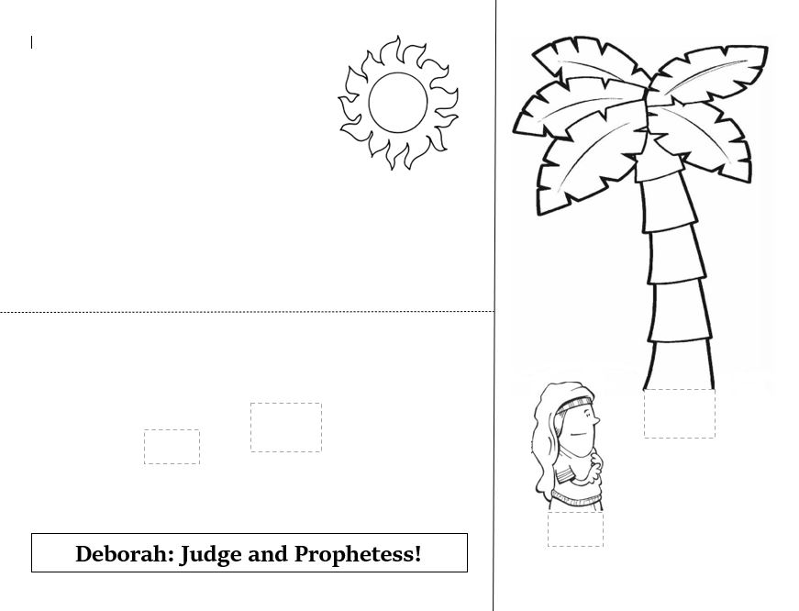
Deborah 3-D Scene
(Ages 5+, 10 mins)

Supplies Needed:
- 3-D Scene Template
- Scissors
- Glue/Tape
- Crayons/Markers

Instructions:
- Cut the sheet of paper in half on the solid line, then cut out Deborah and the palm tree. Fold the remaining paper on the dotted line to create a backdrop, then attach Deborah and the tree to both halves of the paper.

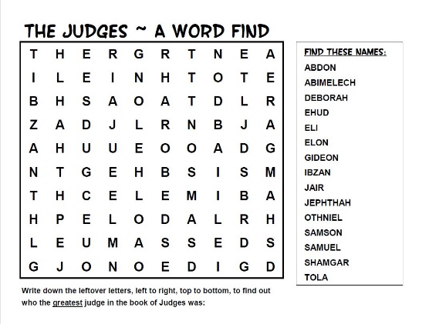
Judges Word Search
(Ages 5+, 5 mins)

Supplies Needed:
- Printed Handout
- Pen/Pencil

Instructions:
- You’ll need families to print out the word search ahead of time, but this is a great activity for those in grade school.

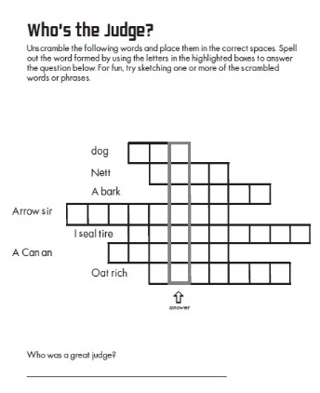
Deborah Word Scramble
(Ages 7+, 5 mins)

Supplies Needed:
- Printed Handout
- Pen/pencil

Instructions:
- Although it might be a little tricky for younger kids, this word scramble will eventually reveal a secret code word from the answers: Deborah!
Biblical Background – Joshua/Judges

Deborah’s story comes from a period of Israel’s history that is often not covered: the roughly 150-200 years between Moses (perhaps 13th century B.C.E.) and the “United Monarchy” of Saul, David, and Solomon (began mid-11th century B.C.E.). The books of Joshua and Judges are our best window into the time period, although readers for centuries have noted that they are fraught with historical and theological challenges. Before diving into those challenges, though, it’s important to describe what those 150-200 years were like.

The Book of Joshua primarily describes the Hebrew people’s invasion and conquering of the area now known as Israel, perhaps best known from the fall of Jericho. In Judges, the book that Deborah comes from, we see the de facto government that emerged in this newly created land – a system of “judges”, or temporary leaders. Despite what the name connotes to us today, these were leaders first and foremost – perhaps similar to a tribal chief. These leaders tried to help lead Israel through it’s chaotic early days – and the biblical text often doesn’t try to hide the fact that things weren’t going well.

The Book of Judges frequently says “In those days there was no king in Israel” – leading many to assume that the book was actually written either during or, more than likely, after the “United Monarchy” time period. One well known exception to this is the Song of Deborah in Judges 5 – perhaps one of the oldest oral traditions in the Bible (typically dated in the 12th century B.C.E.). But, overall, the wider period of Judges is depicted as a failure that necessitates the introduction of the monarchy – first in Saul, then in the better known David.

I referenced historical and theological challenges at the start, so it’s worth a brief note on both. To date, scholars have not found archeological evidence of the widespread battles that Joshua and Judges describe – instead, the evidence seems to show peaceful assimilation. In light of that, the embrace of conquest that Joshua/Judges present is all the more troubling – that God would condone, and even aid, in the killing of people groups like the Canaanites. We often note the Bible was written by human hands – my belief is that the wars of Joshua and Judges are an example of a human propensity for violence, rather than God’s.

Your ability to share this info with kids will vary depending on their age – this section is mainly written for teachers and parents to learn a bit more about the background to each week's passage!

