David October 25, 2020

Bible Verses: Samuel 16:1-13
Spark Story Bible: pages 126 to 129
--------------------------------------------------------------------------------------------------

Overall Lesson Takeaways

- God looks at who we are, rather than what we look like.
At the center of this story is a challenge to all of us: to try not to see people through our usual lenses and to try and look at them through God’s eyes. Easier said than done, obviously, but the central message of this story - “the Lord does not see as mortals see; they look on outward appearance, but the Lord looks on the heart” – is convicting. We are all prone to snap judgments about people based on how they dress or look, but this story reminds us that what truly matters is a person’s heart. It is worth spending time with the kids reflecting on the ways that others make judgments about them based on their age (and unpacking how hurtful that feels) before moving on to ask how we might make judgments about others that also might not be accurate or fair. How can we keep from judging others? How can we try to see what's in someone's heart rather than judging them based on their outward appearance.
- God calls people of all ages into ministry.
Last week we learned about God calling Samuel at a young age – and this week we see the same thing for David! We all know about David beating the odds against Goliath, but his initial call to be king would have been equally shocking. David was the youngest of Jesse’s sons, meaning he wasn’t in line for anything, much less the throne – in fact, when Samuel calls the family together, they leave David out in the fields because of course Samuel wouldn’t want him! But, to the surprise of everyone, Samuel ends up passing on all of the older sons and anoints David as king. The Bible is filled with this motif – think back to Genesis: Jacob instead of Esau, or Joseph instead of his brothers! To me, this story is a reminder of that God works through all of us, even (or perhaps especially) through people who others don't expect much from. It's a reminder that we should never write people off… particularly in light of the next point.
- We’ll never have all the answers, so we stay open to learning.
The final piece of this story that I’ve always found interesting is remembering that although David was chosen by God to be king, he wasn’t even considered as a candidate in the first place! It’s a reminder that, unlike Samuel and Jesse in this story, we are called to be self-reflective whenever we find ourselves making decisions, particularly big ones. Do we have any blind spots? Who or what might we be missing? Sometimes those things are unknowable, but whenever we try to get past our initial assumptions or stereotypes about who should be involved, I think we come a bit closer to “seeing as God sees”.
Checking In

Before the reading:
- Check in with the kids – welcoming any newcomers warmly.
  - Names; plans for Halloween this week (and about costumes)
  - Younger kids: Show and Tell with costumes?
  - Older kids: Highs and Lows from their past week
- Have you ever been the youngest in a group before, whether in your family or with friends? Is it hard being younger than others?

Bible Lesson / Discussion

Reading the Bible:
- David was the youngest of eight, which meant that he would always be considered last in his family – but God had big plans for David!
- Read the text together, either in the Bible, or the Spark Story Bible.
  - You’ll need to screen share the passage for the day in Zoom.
  - Feel free to stop and ask questions during the reading, if helpful.
  - Afterwards, take time to explore what that passage might mean, and know there's no one correct way to read these passages!

Questions About the Passage (see next page for PreK/K questions)
- Samuel was sent by God to look for the next king – what do you think a king would look like?
- Do you think his brothers were surprised that David was chosen to be king? How did they see David?
- The Bible says God looked at David’s heart rather than how old he was, or how he looked. What do you think that means?

Connections to Our Lives
- Have you ever met someone who was much different than you thought they would be?
- How can we try to look at other people’s hearts, rather than how they look, how they dress, or how old they are?

Biblical/Church Connections
- Today is “Reformation Sunday”, a day when we remember the important work that Luther, Zwingli, Calvin, and others did to help the church try to follow God more closely. What are things you might want to change about Fourth Church, or maybe even the worldwide church?

Alternate Preschool and K/1st Questions
Younger ages, particularly those in our preschool class, may have a hard time discussing the biblical text for very long (if at all). My hope is that these questions (and especially the activity) can help with engagement!

Opening Questions
- What are some things that can help people see better? (Glasses, magnifying glass, telescope, binoculars, etc.)
- Can you tell if someone is nice or not just from looking at them? Why can’t we see that with our eyes?

Fun Activity
- Our Bible story today had to do with noticing and seeing things – so I thought it might be fun to play “I Spy”
- (Explain that you’ll start by picking something that’s on someone’s screen, then saying “I Spy something… list a color”. Kids then take turns, or chaotically shouting, guesses. Whoever gets it right goes next!)
- Examples:
  - I spy something… green! (Plant in background)
  - I spy something… orange! (Goldfish in a fish tank)
- This can go on as long as kids are having fun, but eventually you can move on to questions about the Bible passage.

Bible Discussion/Questions
- In our Bible reading today, Samuel was asked to pick a new king – but he didn’t know who God wanted him to pick at first. What do you think a king would look like?
- The answer was surprising – it was David, who was the youngest person in his family and who was just a kid! But even though he was young, David cared about other people and wanted to listen to God – and that was more important than how he looked or how old he was. Do you think you could be a good king? How would you try to help people?

People of Faith

In addition to reading our weekly Bible story, I'd love for our older grade school students to learn more about people whose lives were changed by their faith in Jesus. We'll lift up a new person each Sunday, trying to connect their story to our Bible passage as much as possible!

John Calvin
Today is Reformation Sunday, so it’s only appropriate to learn more about one of the key figures in the Reformation (and the Presbyterian denomination)!

Although he would become best known for his work in Switzerland, John Calvin was born in France in 1509. His father was well-off and well-connected, and he initially wanted John and his two brothers to all become priests. Calvin was an excellent student and, by his father’s orders, spent time studying law as well.

When he was in his early 20’s, though, Calvin’s study of the New Testament led him to break from Catholic teachings at the time and to resign his position. After being forced to flee France due to increasing unrest between the Catholic Church and “reformers”, Calvin eventually landed in Geneva, Switzerland and became pastor of St. Pierre Cathedral. He preached over 2,000 sermons at this church, sometimes as many as 5 per week, and his sermons lasted around an hour… imagine if our church was like that!

In addition to being pastor, John Calvin was a prolific writer – best known for the Institutes of the Christian Religion, which was an epic work focusing on theology and doctrine ranging from how communion was understood, to arguments against Catholic church practices and hierarchy. Calvin denied that the Pope could be head of the church, as well as the idea that bread/wine were changed into Jesus’ body and blood – a view which got him into a great deal of trouble and led to disagreements with other reformers like Luther.

Calvin’s theology would later be taken up by the Scottish Reformer, John Knox, who would combine that theology with a “presbyterian” system of government (being governed by elected elders, rather than bishops) to establish the roots of what we know as the Presbyterian Church.

Crafts / Activities

The Lord Is My Shepherd
(Ages 5+, 5-10 mins)

Supplies Needed:
- Craft Template
- Scissors
- Glue/Tape
- Crayons/Markers

Instructions:
- Have the kids color the pieces first before cutting them out. Once cut, fold the legs down at the dotted lines – using the tabs on front and back to secure them. You can then cut out the head and the tail, taping/gluing them on top of the body (or threading them underneath).

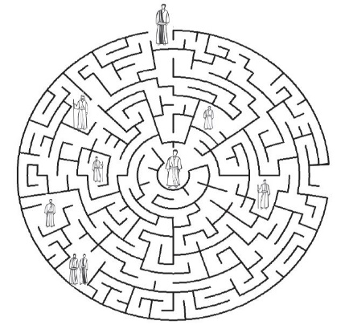
David Maze
(Ages 5+, 3 mins)

Supplies Needed:
- Printed Handout
- Pen/Pencil

Instructions:
- This maze is actually pretty tough! Could be a fun challenge for any grade schooler to complete – or you can screen share and do it as a class!

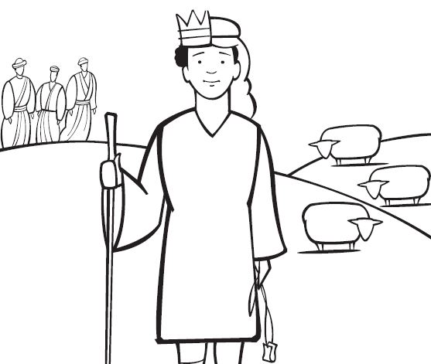
David: Shepherd and King
(Ages 5+, 5 mins)

Supplies Needed:
- Printed Handout
- Crayons/markers

Instructions:
- Paying homage to David’s humble beginnings, kids will imagine what David looked like as both a shepherd and a king, split down the center!
Biblical Background – David

We covered some of this last week, but the books of 1 and 2 Samuel cover the time period after the Judges ruled Israel – roughly from the middle of the 11th century BCE to the middle of the 10th century BCE – and many scholars believe that Samuel is part of a wider arc known as the Deuteronomistic History. Precise dating of David’s reign remains something of a mystery, but scholars believe his 40 year reign took place somewhere in the neighborhood of 1,000 BCE (a nice round number that kids can remember!) and was a time period in which Israel was transforming from being largely tribal to one ruled by a king.

This time is often referred to as the “United Monarchy”, a sort of golden era in which the more powerful northern kingdom of Israel and the smaller southern kingdom of Judah were united under Saul, David, and Solomon. The biblical text records this time period as one of explosive growth, as Israel (meaning Israel and Judah) managed to expand well beyond its limited borders into the territory of rivals like the Philistines, the Amalakites, and others. The successes of David and Solomon’s reign, though, quickly fell apart by the end of the 10th century, as in-fighting and tensions between the northern and southern kingdoms quickly turned ugly. David was a key figure in establishing the southern city of Jerusalem as the capital of the united monarchy rather than the much larger northern city of Samaria – and archeological evidence shows that Jerusalem may not have been very large at all. Nonetheless, Jerusalem would obviously go on to be a crucial location – particualrly after the Assyrians destroyed the northern kingdom in 722 BCE.

As for David, he was many things over the course of his life: a shepherd, a musician, a warrior, and an unlikely king. Most importantly for the author of 1 and 2 Samuel, though, was that David served as a sort of archetype for how a king should lead. This is not to say that David was perfect; the biblical text makes it clear that he very much was not. His leadership, though, was defined by his willingness to listen to God and being able to recognize and confess when he had done wrong. David always remained open to learning and growing, and that’s a lesson that all of us can take away for our lives today – whether we’re in a leadership role or not.

Your ability to share this info with kids will vary depending on their age – this section is mainly written for teachers and parents to learn a bit more about the background to each week's passage!

