Jacob Wrestles October 24, 2021

Bible Verses: Genesis 32:24-33:11
Spark Story Bible: pages 46 to 47
--------------------------------------------------------------------------------------------------

Overall Lesson Takeaways

- Wrestling with God… and ourselves!
Scholars have long been puzzled with this passage: Jacob is travelling with his family overnight when suddenly a man starts wrestling with him by the banks of a river with absolutely no warning or reason! There have been many over the years who have read this passage through the lens of a dream or metaphor – particularly given the vision of Jacob’s ladder earlier. But when Jacob calls the place "Peniel" (literally, "face of God"), it becomes clear this was an encounter with some sort of divine figure – whether God, or an angel acting on behalf of God. Regardless, while Jacob's wrestling with this divine figure doesn't make much sense on a physical level, it makes perfect sense on a metaphorical and spiritual level. Since his birth, Jacob had been a fighter – struggling and scraping as the youngest – but that fighting also had costs. He lost his homeland, his relationship with his brother, and now found himself on the run. This confrontation can easily be read as Jacob wrestling with a sense of guilt at how he hurt his brother -- and it reminds us of times when we hold that type of guilt and regret.
- The importance of forgiveness and reconciliation.
Read through the lens above – that this is Jacob wrestling with guilt – it's no accident that immediately after Jacob has a face-to-face encounter with this divine figure, he has a face-to-face encounter with Esau, the brother who he wronged. Rather than continue to fight, though, Jacob acknowledges his wrongdoing – bowing to his brother seven times as a direct apology for the blessing that their father Isaac had given Jacob in Genesis 27:29. This contrite spirit, and subsequent reconciliation and familial reunion, is a beautiful example of how powerful confession and forgiveness are, even when the hurt runs deep. If we read Jacob's wrestling as a sort of internal struggle, this moment of reunion between brothers helps bring a sense of peace and calm.
- Acknowledging that we will all continue to make mistakes.
It would be wonderful if we learned perfectly from our mistakes, but unfortunately that’s not always the case. Jacob will go on to partially instigate family drama again in our passage next week – showing favoritism to Joseph, one of his younger sons, who soon finds himself tossed into a pit by his brothers (ultimately leading again to a powerful account of reconciliation and forgiveness). It is disappointing to see Jacob botch this second attempt at equitably distributing his blessing – but it does remind us that, despite our best intentions, all of us will continue to make mistakes.
Checking In

Before the reading:
- Check in with the kids – welcoming any newcomers warmly.
  - Younger kids: Have you painted/carved a pumpkin yet??
  - Older kids: Share highs and lows from the past week
- Jacob in our Bible passage today had been away from his family for a long time… what’s the longest you’ve ever been away?

Bible Lesson / Discussion

Reading the Bible:
- Last week we learned about Jacob and Esau, two twin brothers who did not get along – Jacob tricked his brother and father into making him the leader of the family but then ran away because he was scared…
- Read the text together, either in the Bible, or the Spark Story Bible.
  - Feel free to stop and ask questions during the reading, if helpful.
  - Afterwards, take time to explore what that passage might mean, and know there's no one correct way to read these passages!

Questions About the Passage (see next page for PreK/K questions)
- What do you think it would be like to wrestle God or an angel? Would you do it, or do you think Jacob was kind of crazy to do it!?
- In the Bible, it talks about Jacob meeting his brother Esau after this night of wrestling, with Jacob apologizing and Esau forgiving him. How does it feel to be forgiven? Why is it important to forgive people?

Connections to Our Lives
- Have you ever done something that you really regretted later? Sometimes people talk about guilt as “wrestling with ourselves” – do you think Jacob was wrestling with himself too after tricking his father and brother?
- Esau was kind to his brother, even though Jacob had really hurt him. Is there anything that helps you forgive someone if they’ve hurt you?

Biblical/Church Connections
- Today is “United Nations Day” around the world, which reminds us we are all part of the same family no matter where we live – something that we believe as Christians too! How can we better live that truth out?

Alternate Preschool and K/1st Questions
Younger ages, particularly those in our preschool class, may have a hard time discussing the biblical text for very long (if at all). My hope is that these questions (and especially the activity) can help with engagement!

Opening Questions
- Have you ever gotten into a fight or argument with someone you care about? How did you feel? How did you try to make it better later?

Fun Warm-Up Activity – Pick-A-Side
- We are learning about two twin brothers named Jacob and Esau who got into a big argument – but we’re going to have a chance to disagree with each other in a fun way by playing “Pick a Side!”
- One side of the room will be for one answer, one side for the other – kids should stand up and walk to the side they choose.
- All of these are examples for Fall:
  - Would you rather: jump in leaves or play in the snow?
  - Would you rather: go trick-or-treating or watch Halloween movies?
  - Would you rather: go in a corn maze or bob for apples?
  - Would you rather: have a pumpkin hat, or pumpkins for shoes??

Reading the Bible:
- Last week we learned about Abraham and Sarah’s grandkids Jacob and Esau who had a big fight and Jacob ran away. Today, we’re going to learn about a strange experience he had before he apologized to his brother.
- Read the text together, either in the Bible, or the Spark Story Bible.

Bible Discussion/Questions
- Jacob wrestles with God, but some people think that Jacob was also wrestling with how guilty or bad he felt about tricking his brother. Have you ever done something you felt bad about later? What did you do to try to make it better?
- In the Bible, it talks about Jacob meeting his brother Esau after this night of wrestling, with Jacob apologizing and Esau forgiving him. How does it feel to be forgiven? Why is it important to forgive people?

People of Faith

In addition to reading our weekly Bible story, I'd love for our older grade school students to learn more about people whose lives were changed by their faith in Jesus. We'll lift up a new person each Sunday, trying to connect their story to our Bible passage as much as possible!

Kim Dae-jung
On a day when we are reflecting on reconciliation and forgiveness, one of the great modern examples of that type of difficult work is former South Korean President Kim Dae-jung and his efforts to reconcile with North Korea and Japan.

Dae-jung was born on a small Korean island named Hauido in 1925 and was the second of seven children. He grew up during a particularly tumultuous time for Korea: Korea was occupied by Japanese rule until 1945, divided into North and South Korea by the U.S. and the U.S.S.R. following WWII, followed shortly by the outbreak of the Korean War in 1950.

Following the conclusion of the Korean War, Dae-jung began to be heavily involved in politics and soon became known as a fantastic public speaker. Shortly after being elected for the Korean national legislature, though, a military coup soon overthrew South Korea’s government. Dae-jung would become a prominent critic of the new regime and experienced several attempts on his life. He would later reflect that his faith in God and his membership in the Catholic church helped him through these difficult times – “I have lived, and continue to live, in the belief that God is always with me. I know this from experience.”

Over the next several decades, Dae-jung would live in exile, be sentenced to house arrest, survive assassination attempts, and be sentenced to death. Amazingly, he kept surviving and staying engaged in politics – eventually winning the presidency 26 years after he had first ran!

As President, he won the Nobel Peace Prize for beginning talks between North and South Korea, pardoned the leaders who once condemned him to death, and symbolically co-hosted the 2002 World Cup with Japan. Despite suffering countless dangers from those who opposed him, Kim Dae-jung was able to foster forgiveness and reconciliation all throughout his tenure, earning comparisons to Nelson Mandela as one of the great peacemakers of our time!
Crafts / Activities

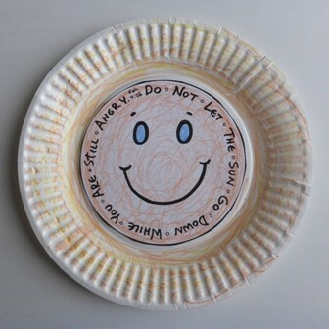
Jacob Wrestles Sun Craft
(Ages 3+, 5 mins)

Supplies Needed:
- Printed sheet
- Scissors
- Paper plate
- Markers/Crayons

Instructions:
- This craft serves as a reminder of Esau’s forgiveness of Jacob, using words of wisdom from Ephesians 4; simply cut out and glue/tape onto a plate!

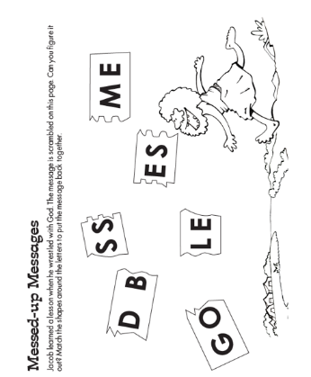
Jacob Wrestles Word Puzzle
(Ages 3+, 2-3 mins)

Supplies Needed:
- Printed Handout
- Pen/Pencil/Crayons

Instructions:
- This word puzzle is very simple – probably best for the 5-7 year old age range – but it can also function as a coloring page for younger students.

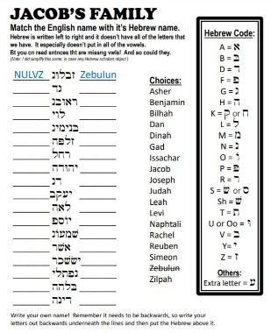
Jacob and Esau Hebrew Translator
(Ages 7+, 10 mins)

Supplies Needed:
- Printed Handout
- Pen/Pencil/Crayons

Instructions:
- This is a repeat from last week, but can serve as an intro to learning about Jacob’s family – as well as a little bit more about the Hebrew language (especially reading left to right!)

Biblical Background – Jacob Wrestles

We began learning about Jacob last week, but it’s worth looking back at what happened: Jacob and Esau were Abraham's twin grandchildren who were quarreling from birth. Jacob would go on to trick Esau, his (technically) older brother into giving him his birthright and Jacob would later trick his father into blessing him rather than Esau. But after last week's story of betrayal, today we focus on their reconciliation and forgiveness – preceded by this fascinating story of Jacob wrestling with a divine figure who may or may not be God.

The name Jacob (ya'aqov) comes from the Hebrew word for "heel" ('aqev), calling back to Jacob grabbing onto Esau's heel as they exited the womb in Genesis 25:26. This grasping/fighting spirit appears again as Jacob wrestles with this divine figure by the Jabbok River. A three-way wordplay occurs in that passage: Jacob (ya'aqov) wrestles (ye'abeq) at the Jabbok (yabboq), making clear that wrestling is a key piece of Jacob’s identity.

After this struggle, though, this divine figure (God or an angel) gives Jacob a new name: Israel. Israel is, of course, better known as a country name rather than a personal name, but the Hebrew helps shed light on why the name fits for both. The word is a combination of the Hebrew verb śarar (to rule, contend) and the Hebrew word elohim (God, gods) – but, interestingly, there's some level of disagreement about who the subject is in this combination. Is it Jacob, who has "contended" with God (the traditional understanding)? Is it God, who "rules", as the modern Jewish Study Bible suggests? Both are possible – and both understandings fit for the struggle that Israel (the country) experienced, as well as the pervading understanding that God was still in control even in the midst of those struggles.

Looking ahead in the biblical text, we will continue to see echoes from these Jacob and Esau passages: Jacob’s son Joseph will live out another example of familial betrayal, guilt, and forgiveness. David’s call as king echoes the selection of someone other than the firstborn to lead. Esau’s running to embrace one who wronged him has echoes of the father running to embrace the prodigal son. Although not as commonly known, these two passages are foundational!

Your ability to share this info with kids will vary depending on their age – this section is mainly written for teachers and parents to learn a bit more about the background to each week's passage!

