Samuel October 18, 2020

Bible Verses: Samuel 3:1-11
Spark Story Bible: pages 122 to 125
--------------------------------------------------------------------------------------------------

Overall Lesson Takeaways

- Listening is a tough but important skill for us to learn.
Every time that I read about Samuel’s call, I am reminded about how hard it is to listen – but also how incredibly important it is! Samuel hears a voice speaking to him three different times, but is never able to fully understand what’s going on until the prophet Eli helps him understand that it is actually God speaking to him. Likewise, research has shown that people typically need to hear something many times in order for it to “stick” – studies have shown that it takes most people between 6 and 20 times of hearing something to truly sink in. That’s a lot – and it’s not always a luxury that we have! Instead – particularly during our frequently all too busy lives – perhaps one of the things that God wants for us is to truly listen to our family, our friends, and to God as well. Being able to hear someone helps us to understand them better – and that’s a gift for both us and them.
- God calls people of all ages into ministry.
- When we imagine people from the Bible, we tend to envision old men with grey beards… but stories like Samuel, Jeremiah, or next week’s story of David being chosen to be king are a reminder that God can use all of us to do wonderful things, no matter what our age. Kids don’t need to wait to be disciples or to do ministry – they already are disciples and they already are doing ministry! As you reflect on this passage together, it may be worth drawing out examples of places and ways that kids are already making a big difference – before asking them about other ways that they can think of to serve God and others.
- How do we figure out when God wants us to do something?
Speaking of: how do we know when God is calling us to do something? The story of Samuel is certainly written to be amusing, but I think that all of us could empathize with Samuel’s confusion about who was calling him! The biblical text (though not the Spark Bible) notes that “the word of the Lord was rare in those days; visions were not widespread” – a comment that we would probably make about our own context today. How, then, can we know what God’s call is? We, as Presbyterians, have long believed in the power of groups to discern God’s call and will in our world – it’s why our church is structured like it is, rather than relying on singular authority. That’s not to say that individuals can’t have insight or receive calls – the Bible is filled with stories like that! Instead, we count on our communities to discern whether God has called individuals or churches to a particular type of ministry.
Checking In

Before the reading:
- Check in with the kids – welcoming any newcomers warmly.
  - Names; do you like pumpkin flavored things (candy, pie, etc.)?
  - Younger kids: What’s your favorite thing to do in Fall?
  - Older kids: Highs and Lows from their past week
- Has it been easier or harder for you to listen at school with it all being online? What makes it easier or harder?

Bible Lesson / Discussion

Reading the Bible:
- Samuel was asked by God to be a prophet when he was just a kid – but at first Samuel didn’t even know that God was talking to him!
- Read the text together, either in the Bible, or the Spark Story Bible.
  - You’ll need to screen share the passage for the day in Zoom.
  - Feel free to stop and ask questions during the reading, if helpful.
  - Afterwards, take time to explore what that passage might mean, and know there's no one correct way to read these passages!

Questions About the Passage
- Samuel became a prophet when he was just a child – and that meant that he shared messages from God to adults. Is that something that you could do? Do you think adults listen well enough to kids?
- Both Samuel and Eli were confused to learn that God was talking – how might you have reacted if you were them?

Connections to Our Lives
- What do you think makes someone a good listener? Are there things that we can practice or try when we are in a conversation with someone else?
- Do you think it’s easier or harder to listen to other people these days?
- Do you think it’s easier or harder to listen for God these days?

Biblical/Church Connections
- Our Kindergarteners received Bibles at Children’s Chapel this morning – why do you think it’s important to be able to read the Bible on our own, and not just at Sunday School?

Alternate Preschool and K/1st Questions
Younger ages, particularly those in our preschool class, may have a hard time discussing the biblical text for very long (if at all). My hope is that these questions (and especially the activity) can help with engagement!

Opening Questions
- Has anyone ever said something to you and you couldn’t figure out what they were saying? How did you feel trying to understand them?
- What makes it hard to listen? What can help you listen?

Fun Activity
- Our Bible story today had a lot to do with listening – Samuel couldn’t figure out that God was talking to him until Eli let him know. We’re going to play a fun game called “Story Chain” that means you’ll need to listen to what other people are saying as we build a story together!
- (Explain that you’ll start telling a story, but you’re going to stop during one of your sentences and then pick a volunteer raising his/her hand to continue the story! You’ll go through several volunteers as you keep adding on layers of the story – and have kids help you keep track of it all!
- Examples:
  - “There once was a Kindergartener named _______, and she loved to read! She read in the morning, in the afternoon, and in the evening. She would read all types of books, but her favorite book to read was….” (call on a volunteer to continue by making up a book and then have kids continue to develop the story).
- This can go on as long as kids are having fun, but eventually you can move on to questions about the Bible passage.

Bible Discussion/Questions
- Listening and remembering can be hard things sometimes – and in our Bible reading today, Samuel had a hard time listening to God. He thought that Eli was talking to him, and he kept waking Eli up!
- Eli helped Samuel understand that God was talking to him, and he helped Samuel learn about God. Who helps you learn about God?
- God asked Samuel to be a prophet, which meant that Samuel would share messages from God to other people. Do you think you could be a prophet? Practice by telling someone else that God loves them!

People of Faith

In addition to reading our weekly Bible story, I'd love for our older grade school students to learn more about people whose lives were changed by their faith in Jesus. We'll lift up a new person each Sunday, trying to connect their story to our Bible passage as much as possible!

Cindy Wang Brandt
Although we tend to think about God being at work in big, life-changing moments or events, Cindy Wang Brandt is a great example of someone whose faith has helped shape her and thousands of others in quiet, but powerful ways.

Born in Taiwan to a family that wasn’t religious, Brandt began attending a grade school for Christian missionaries as a child and eventually decided to become a Christian herself. After attending Wheaton College (also a Christian school) and seminary, she became a missionary in China in order to spread her faith.

Over time, though – particularly after she had her two kids – she began to question some of the teachings of the evangelical denomination that she was a part of, particularly around original sin and their stance against gay marriage and those who were LGBTQ. To her, these positions seemed harmful and they did more to tear families apart rather than helping them love one another.

Cindy’s brother is transgender, and she knew that he was not being sinful like her church claimed – he was being exactly who God created him to be. One year, both her and her mother decided to attend a pride parade in Taiwan during Pride Month (June) – even though that was against the rules of the Christian school where she worked. A few days later, Cindy was called into her bosses’ office and was told that she could not say or post anything on Facebook that would be supportive of her brother or LGBTQ rights. Hurt that the school would tell her that she couldn’t support her brother, she decided to quit her job.

Although she had long been a writer, Cindy began publishing and writing more frequently on her blog, primarily around the importance of teaching kids how to practice justice, mercy, and kindness – not indoctrinating them with faith in the same way that she had been. As she likes to say: “Rules matter less to me than human lives”. Cindy now helps parents as a public speaker, an author, and a podcaster – and her first book came out in 2019.
Crafts / Activities

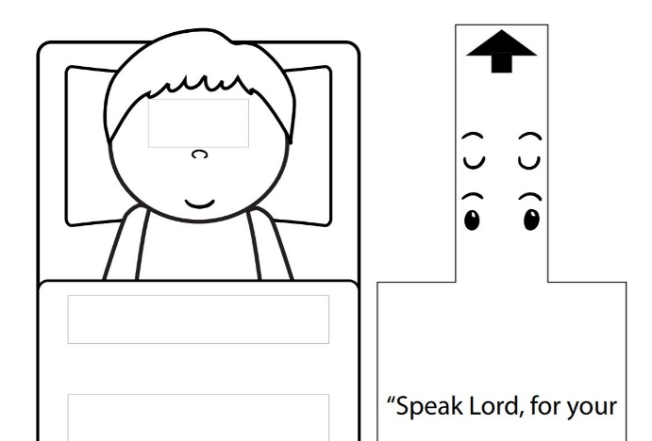
Samuel Listens Craft
(Ages 5+, 10 mins)

Supplies Needed:
- Craft Template
- Scissors
- Glue/Tape
- Crayons/Markers

Instructions:
- There are instructions included on the template, but have the kids color the picture and then cut out Samuel and the piece with the verse on it. After cutting out Samuel, have kids carefully cut on the boxes on Samuel’s eyes and bed and then thread the other piece through.

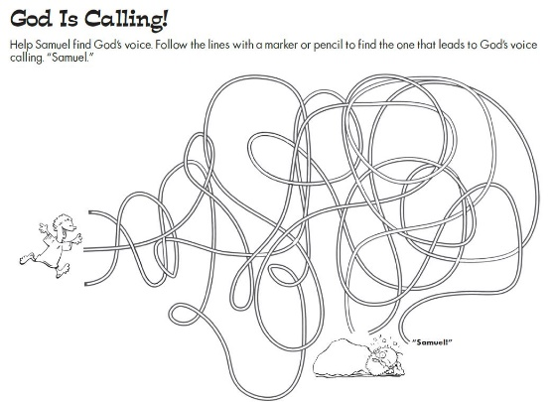
Samuel Maze
(Ages 5+, 3 mins)

Supplies Needed:
- Printed Handout
- Pen/Pencil

Instructions:
- This may not be super complex, but my guess is that many kids will at least have fun trying to figure out which of the three paths work.

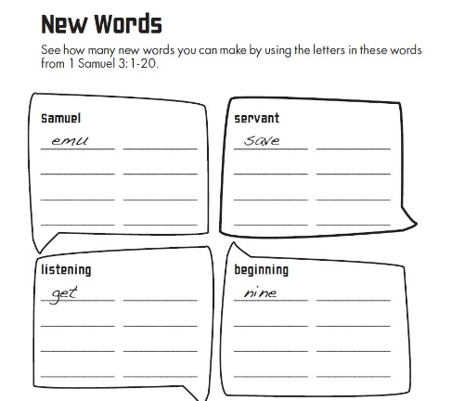
Samuel Word Puzzle
(2nd thru 5th Grade, 5-10 mins)

Supplies Needed:
- Printed Handout
- Pen/pencil

Instructions:
- You’ll need families to print out the handout ahead of time; encourage kids to create new words out of the words listed – could make a fun game!
Biblical Background – Samuel

Although the books of 1 and 2 Samuel (originally just one long book) cover the time period after the Judges ruled Israel – roughly from the middle of the 11th century BCE to the middle of the 10th century BCE – many scholars believe that Samuel is part of a wider biblical arc known as the Deuteronomistic History. Beginning with the books of Joshua and Judges (perhaps 13th century BCE) and going all the way until the end of 2nd Kings (mid-6th century BCE), we see the ways in which Israel transformed from being largely tribal, to the “golden age” of the united monarchy under Saul, David, and Solomon, to the slow devolution of being conquered and exiled by their stronger northern neighbors.

Because there is such a close focus on Israel’s leaders in this time period, as well as the ways in which they either listened to or disobeyed God, we may expect the book to be named after David or Solomon – two well-renowned leaders from Israel’s history. However, I think that it’s very telling that the book is named after a prophet rather than a king – whoever wrote or compiled this history clearly held the role of prophets in an even higher regard than they did kings.

We tend to think of prophets as people who could tell the future, but the role that they were understood to play in ancient Israel was delivering unedited messages from God, whether those messsages were hard to hear or not. 1 and 2 Samuel frequently show Samuel or Nathan standing up to kings and calling them out, and later books will even have prophets arguing with groups of sycophantic, “yes-men” prophets who kings have surrounded themselves with. The role of the prophetic word, and the idea that even those with great earthly power are subordinate to God, are central themes of this wider history.

Although he is often left out when we remember the great prophets of Israel (Elijah, Isaiah, Jeremiah, and others), Samuel certainly deserves to be among their number. The biblical text covers his life from birth to death – hearing about someone as a child is certainly a rarity for most biblical figures! – and he helps to usher in two massive transitions within Israel: the switch to the monarchy, and navigating a not-so-peaceful transition of power between Saul and David. For that (and more), he is an important person to learn about.

Your ability to share this info with kids will vary depending on their age – this section is mainly written for teachers and parents to learn a bit more about the background to each week's passage!

