Jacob and Esau October 17, 2021

Bible Verses: Genesis 27:1-19
Spark Story Bible: pages 42 to 45
--------------------------------------------------------------------------------------------------

Overall Lesson Takeaways

- Sometimes we fight and argue with our family.
One of the easiest entry points of connecting this story to kids is spending a little time talking about how sometimes we fight with our siblings (or friends, for those who are only children), but at the end of the day we still love them very much. Despite being twins, Jacob and Esau were very different people: Esau is described as a "skillful hunter", a "man of the field", and is almost comically hairy (see Genesis 27), while Jacob is described as a "quiet man", a trickster, and is smooth skinned. The biblical text makes it clear that they are character foils to one another – opposite in almost every way. While not all siblings are that diametrically opposed, I'm sure that all of us have experienced situations where we can't believe two people come from the same family! But even though we may see the world differently than our brother, sister, or friend, that doesn't mean that we should love them any less.
- God often chooses/calls the unexpected person.
Jacob receiving the family birthright and blessing is just the first of many times throughout the Bible in which God subverts cultural expectations: Joseph would have his brothers bow to him as second-youngest, David would be named king despite being the youngest, and Jeremiah was called to be a prophet as a boy, to name a few. Having an "underdog" emerge victorious in all of these accounts was an important aspect of how Israel (Jacob's later name, given to him in next week's lesson) understood itself. In a similar vein, children often hear about things that they can't do or that they aren't ready for – but the biblical text reminds us again and again that we should expect God to do the unexpected… including working through and with children to do great things.
- Sometimes we do things we later regret.
Teaching this story to children is admittedly complicated, because Jacob's deceit and trickery are ultimately rewarded (though Jacob does flee at his brother's rage). It's important to keep the wider context of Jacob and Esau's relationship in mind, though: next week, we'll see Jacob express deep regret at the hurt that he had caused his brother. To me, our lesson this week and next week is a reminder that all of us will hurt others in our life from time to time, whether intentionally or unintentionally, but when we do it is always crucial that we apologize and ask forgiveness.

Checking In

Before the reading:
- Check in with the kids – welcoming any newcomers warmly.
  - Younger kids: What is something that you love to do every day?
  - Older kids: Share highs and lows from the past week
- What is something special or meaningful to you that you would never sell for any price? What makes it so special?

Bible Lesson / Discussion

Reading the Bible:
- We have been learning about Abraham and Sarah and God’s promise that they would have a family – today, we’re meeting their grandkids, Jacob and Esau… but they are twins who really don’t get along…
- Read the text together, either in the Bible, or the Spark Story Bible.
  - Feel free to stop and ask questions during the reading, if helpful.
  - Afterwards, take time to explore what that passage might mean, and know there's no one correct way to read these passages!

Questions About the Passage (see next page for PreK/K questions)
- How would you have felt if you were Esau and your brother tricked you and took something important to you? How long would it take you to forgive him – and what would he need to do for you to forgive him?
- Is it fair that the oldest child would always become the family leader many years ago? Was it OK that Jacob tricked his brother and father so he could be a leader, or do you think that he was wrong to do that?

Connections to Our Lives
- Have you ever been in a big argument with a brother, sister, or friend? How long were you mad at each other? What helped you forgive them?
- Jacob was younger, smaller, and quieter than his brother – but he became the leader and his family was one of the most important families in the Bible. What do you think makes someone a good leader?

Biblical/Church Connections
- Yesterday was “World Food Day” to raise awareness and help millions of people around the world who suffer from hunger. How does being hungry affect you? What can we do to help others get nourishing food?
Alternate Preschool and K/1st Questions
Younger ages, particularly those in our preschool class, may have a hard time discussing the biblical text for very long (if at all). My hope is that these questions (and especially the activity) can help with engagement!

Opening Questions
- Today’s story is about two brothers – one who likes to be outside, and one who likes to be inside. What’s something that you really like doing outside? What’s something that you really like doing inside?

Fun Warm-Up Activity – Playing “Simon Says”
- These two brothers both wanted to be the next leader in their family. It can be fun to be the leader, so we’re going to play the game where all of us get to take turns being a leader: “_______ Says”
- Anyone who wants to play can take a turn sharing three instructions, using their name in place of “Simon” if they want. Remember that if they give an instruction without saying “Simon Says”, no one should do it!

Reading the Bible:
- We have been learning about Abraham and Sarah and God’s promise that they would have a family – today, we’re meeting their grandkids, Jacob and Esau… but they are twins who really don’t get along…
- Read the text together, either in the Bible, or the Spark Story Bible.

Bible Discussion/Questions
- Jacob and Esau were always fighting with each other. Do you ever get really mad at your brother, or sister, or friends? What helps you forgive each other?
- Jacob tricked his father, Isaac, into making him the new leader of the family instead of his brother Esau. Has anyone ever played a trick on you? How did it feel?
- Jacob ended up feeling bad that he tricked his brother and took something so special from him. What is something that is really special or important to you?

People of Faith

In addition to reading our weekly Bible story, I'd love for our older grade school students to learn more about people whose lives were changed by their faith in Jesus. We'll lift up a new person each Sunday, trying to connect their story to our Bible passage as much as possible!

Johann Sebastian Bach
The theme of the youngest child becoming the greatest in a family has been seen many times throughout history – and one remarkable example is the life of one of the greatest composers in history: Johann Sebastian Bach.

Bach was born in Germany in 1685 and was the youngest of eight children. His father served as the music director in the town where he grew up and all of his uncles and older brothers became accomplished musicians in their own right. When he was 10, though, Bach’s father and mother passed away within months of each other – which left him an orphan and he was forced to move in with one of his older brothers who was serving as a church organist.

His brother taught Bach a great deal about music – and Bach furthered his learning by secretly studying his brother’s compositions. By the time he was 15, Bach became enrolled in a prestigious music school and was able to graduate in a few years – looking for employment as an organist at the age of 17. As word of his ability began to spread, Bach was able to steadily advance his career – but he also soon became known as being very difficult to work with. He had arguments with students and his employers, being dismissed from several positions and even arrested for how he responded to one dismissal.

Despite this, his talent in composing and performing organ music continued to gain him renown in the music world – eventually landing him a position at St. Thomas Church in Leipzig, where he continued to compile and compose many of the works that he is best known for today. Bach was said to have a deeply devout relationship with God and taught Luther’s Short Catechism for years – something that heavily influenced the music that he composed. After he passed away from complications from surgery, fellow composers continued to develop his works – and he gained such renown that, in a recent poll of musicians, Bach was named as the greatest composer who ever lived… yet one more example of the youngest child unexpectedly becoming the greatest!
Crafts / Activities

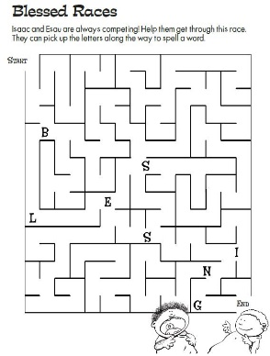
Jacob and Esau Maze (Easy)
(Ages 5+, 2-3 mins)

Supplies Needed:
- Printed handout
- Markers/Crayons

Instructions:
- This maze is easier than most since your path spells out “blessing” along the way! This can be a chance to talk again about what blessing means.

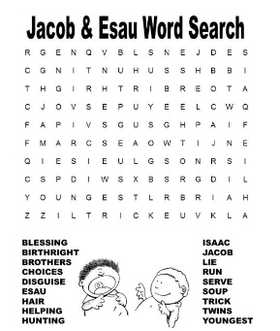
Jacob and Esau Word Search
(Ages 7+, 5-10 mins)

Supplies Needed:
- Printed Handout
- Pen/Pencil/Crayons

Instructions:
- This word search could potentially be a stretch for a K/1st class, but older kids will enjoy a chance to look for key words from our passage today.

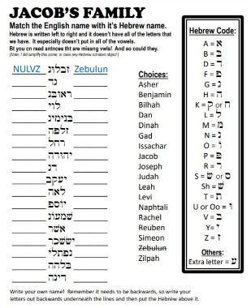
Jacob and Esau Hebrew Translator
(Ages 7+, 10 mins)

Supplies Needed:
- Printed Handout
- Pen/Pencil/Crayons

Instructions:
- Ever been curious about learning Hebrew?? This letter decoding puzzle will help kids learn about Jacob’s family (his blessing) and a little bit more about the Hebrew language (especially reading left to right!)

Biblical Background – Jacob and Esau

After spending time with Abraham the past two weeks, we skip a generation (sorry, Isaac!) and meet Abraham's grandchildren: Jacob and Esau. Even from the early moments, these boys were quarreling – Genesis 25:22 states that they struggled with one another in the womb – and after they were born things weren't much different! This Jacob and Esau account is, at its core, a story of betrayal and forgiveness – one we will see replicated later in Genesis with Jacob’s son Joseph – but it has also held meaning for how Israel saw itself and its relationships with its larger, stronger neighbors. We will spend time with the meaning of the name “Israel” next week, since that is the name bestowed upon Jacob after wrestling with God in next Sunday’s passage – but both Jacob and Esau’s names still hold important meanings for how this text has been interpreted and understood over the years.

The name Esau means "hairy" or "rough" in Hebrew… not exactly the most complementary name, but I suppose is an accurate one! Most interesting, however, is the connection drawn between descriptions of Esau's appearance: red (admoni) and hairy (se'ar) – with Edom and Seir, regions directly to the south of Israel. Edomites were traditionally believed to be ancestors of Esau – and, unfortunately, were treated by the Israelites with disdain… apparently the brothers reuniting and forgiving in Genesis 33 didn't translate into a settling of disputes between Israel and their southern neighbors.

The name Jacob (ya'aqov) comes from the Hebrew word for "heel" ('aqev), calling back to Jacob grabbing onto Esau's heel as they exited the womb in Genesis 25:26. This grasping/fighting spirit would define his entire life, from usurping his older brother’s birthright through trickery, to wrestling with a divine figure by the Jabbok River next week. Because of that, it is thought that Israel saw Jacob’s life as a symbol for how they were able to survive (and even occasionally thrive) despite spending countless generations in the shadow of the Egyptians, the Babylonians, the Assyrians, the Persians, and the Romans. Israel was often the “little brother” to those empires – yet, seemingly against all odds, they were able to outlast them all thanks to their cleverness and tenacity, as well as the blessing that they had received from God.

Your ability to share this info with kids will vary depending on their age – this section is mainly written for teachers and parents to learn a bit more about the background to each week's passage!

