Joseph 2 November 7, 2021

Bible Verses: Genesis 41:25-40
Spark Story Bible: pages 54 to 59
--------------------------------------------------------------------------------------------------

Overall Lesson Takeaways

- Once again, it’s important how we use our gifts.
I mentioned this last week, but there is a distinct shift in how Joseph is using his gift of interpreting dreams in our lesson today. Last week, he was bragging about how his brothers would bow down to him. This week, he's helping to save thousands of people by prudently saving grain during a surplus. All of us have particular gifts that we can use in a variety of ways, but we believe that God asks us to use those gifts for the benefit of not just ourselves, but others too. This week can be another chance to discuss and explore kids' gifts with the encouragement to think about how those gifts could be used for others.
- All of us will have times when we’re full or empty.
Our discussion last week touched on trusting God during periods of time when we too are in a "pit" (metaphorically, not literally like Joseph) – likewise, Pharaoh's dream and Joseph's interpretation can be an entry point to talking about what we do during periods of abundance and periods of scarcity in our lives. Joseph's prudent decision to save grain for the lean times bears a lot of similarity to how we "save for a rainy day". You could try to do a few thought experiments with older kids about how they might distribute a hypothetical allowance… if they suddenly received $100, but it would be the only allowance they would receive for the next three months, how would they spend it? All at once? Distribute it evenly? Save in case you need it later?
- Thinking about how famine affects our world today.
The other underlying issue in our story today – one that is thankfully staved off by Joseph's wisdom in Egypt, but still affects Joseph's brothers in Israel – is the very real issue of famine. None of us have probably been in a situation where there is a famine, but it is still a very real and scary thing in our world today. Ongoing famines in Yemen and South Sudan have left millions without consistent access to food the past several years, and our changing climate is a threat to global food security in nations around the world. Joseph using his gifts to prevent a widespread crisis is a reminder that we too are called to do what we can to advocate, donate, and provide for those in need in our world as well. We may not have the ability to create a decade-long food plan like Joseph, but we can still use what we've been given to make a difference in others' lives.

Checking In

Before the reading:
- Check in with the kids – welcoming any newcomers warmly.
  - Younger kids: What do you love about your family?
  - Older kids: Share highs and lows from the past week
- Who is someone who has been an important role model for you in your life? (Teacher, parent, grandparent, etc.)

Bible Lesson / Discussion

Reading the Bible:
- This is our second week learning about Joseph, who had a special ability to understand dreams and who received a special gift from his father… but that made his brothers jealous and they sold him to slavery in Egypt.
- Read the text together, either in the Bible, or the Spark Story Bible.
  - Feel free to stop and ask questions during the reading, if helpful.
  - Afterwards, take time to explore what that passage might mean, and know there's no one correct way to read these passages!

Questions About the Passage (see next page for PreK/K questions)
- Joseph was in jail for over two years – and it wasn’t his fault. How do you think he felt? Do you think he trusted God was still with him?
- Joseph goes from being in prison to being second-in-command! What might you have done to help Egypt through the coming famine?

Connections to Our Lives
- Pharaoh’s dream meant that there would be good times and bad times ahead for Egypt. Have you ever had a time in your life that was really hard? What helped you when you were feeling discouraged?
- Egypt was about to experience a famine, which means a widespread shortage of food. Do things like that still happen in our world today? What do you think God might want us to do to help?

Biblical/Church Connections
- Today is All Saints’ Sunday, where we give thanks for people who have been good examples of what it means to be a Christian. Who in history has been a good example? What about in your life today?

Alternate Preschool and K/1st Questions
Younger ages, particularly those in our preschool class, may have a hard time discussing the biblical text for very long (if at all). My hope is that these questions (and especially the activity) can help with engagement!

Opening Questions
- Today is a special day at church when we say thank you to people who have helped us grow up? Who is someone who is really special to you? (Teacher, parent, grandparent, etc.) What do you love about them?

Fun Warm-Up Activity – I Spy!
- In our Bible passage today, Joseph was in jail for a long time because someone thought he did something bad, even though he didn’t – and that meant he had to do a lot of waiting… what do you do when you’re bored?
- Sometimes when we’re trying to pass the time waiting, we play a game called “I Spy”. Someone will pick something around the room that they see and they’ll say what color it is – like “I spy something… green” – and then we take turns guessing what it is!
- Everyone in the class can take a turn picking something if they want – and you can encourage kids to play this game next time they’re having a hard time waiting for something (car trip, etc.)

Reading the Bible:
- This is our second week learning about Joseph, who had a special ability to understand dreams and who received a special gift from his father… but that made his brothers really jealous – and they sent him to Egypt.
- Read the text together, either in the Bible, or the Spark Story Bible.

Bible Discussion/Questions
- Joseph was in jail for over two years – and it wasn’t his fault. How do you think he felt? Do you think he trusted God was still with him?
- Joseph’s special ability to understand dreams helped people make sure they saved enough food. Have you ever been really hungry before? How did you feel when you finally got a chance to eat?
- Some people in our city and in our world don’t always have enough to eat. What are things we could do to help them?

People of Faith

In addition to reading our weekly Bible story, I'd love for our older grade school students to learn more about people whose lives were changed by their faith in Jesus. We'll lift up a new person each Sunday, trying to connect their story to our Bible passage as much as possible!

William Wilberforce
Joseph’s unlikely rise to power – and using his position for good – is reminiscent of many great world leaders throughout history, such as William Wilberforce, an English politician who became a leading voice for abolishing slavery.

Born into a wealthy family in 1759, Wilberforce was very sickly as a child – and his world was turned upside down after his father passed away when he was 9 years old. He was sent to live with his aunt and uncle following his father’s death and became heavily influenced by their evangelical Christian faith.

By the time he was 17, Wilberforce’s father, grandfather, and uncle had all passed away – leaving him with a great deal of money that he used to gamble and drink all throughout college. Despite his lack of interest in his studies, though, he did take an interest in politics and successfully ran for Parliament at the age of 21 by self-financing his entire campaign.

When he was 25, though, he rediscovered his aunt and uncle’s evangelical Christian faith – and he began to use his political position to help others rather than only seeking self-benefit. After hearing testimonies from clergy who had witnessed the horrors of the slave trade, Wilberforce became involved in the abolitionist movement – writing in 1787 at the age of 27, “God Almighty has set before me two great objects: the suppression of the slave trade, and the reformation of moral values”.

Over the next two decades, Wilberforce worked with allies to propose bills to Parliament that would end the slave trade – gradually moving from a 163 to 88 loss in 1791, to a resounding 283 to 16 win in 1807. Having officially abolished the slave trade, Wilberforce and allies turned towards abolishing slavery altogether – eventually leading to the passage of England’s Slavery Abolition Act in 1833, just three days before Wilberforce passed away.

Crafts / Activities

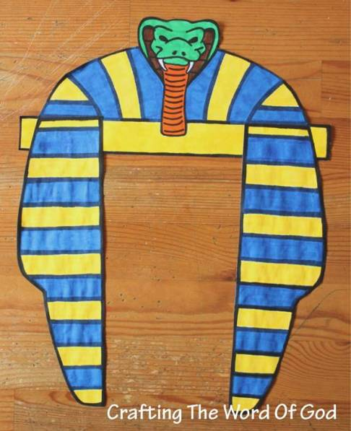
Joseph 2 Pharaoh’s Headdress
(Ages 3+, 5 mins)

Supplies Needed:
- Printed Handout
- Scissors/Tape
- Markers/Crayons

Instructions:
- This headdress is the first of two options so kids can look like Egyptian royalty – simply cut out, decorate, and then tape around kids’ heads!

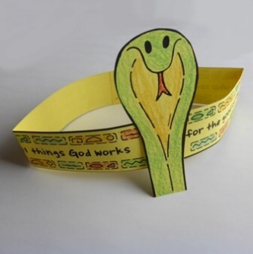
Joseph 2 Snake Headband
(Ages 3+, 5 mins)

Supplies Needed:
- Printed Handout
- Scissors/Tape
- Markers/Crayons

Instructions:
- This headband gives kids a second option if they want to look like Egyptian royalty – cut out, decorate, and then tape around kids’ heads.

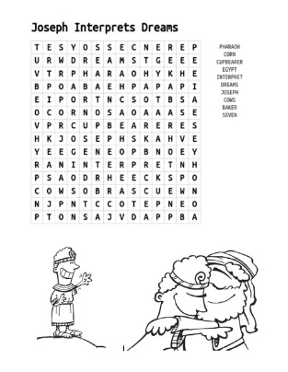
Joseph 2 Word Search
(Ages 7+, 5 mins)

Supplies Needed:
- Printed Handout
- Pen/Pencil/Crayons

Instructions:
- This self-created word search can be used to review and highlight aspects of this middle portion of Joseph’s story

Biblical Background – Joseph 2

After being introduced to Joseph and his family last week, this Sunday we find ourselves dealing with the aftermath of his brothers’ decision to toss him into a pit and sell him into slavery. Joseph eventually becomes a servant for Potiphar, the Egyptian captain of the guard – but after being falsely accused of making advances on Potiphar's wife, Joseph is tossed in jail. During his time in prison, he interprets the dreams of the Pharaoh's cupbearer and baker – with a positive outcome for the cupbearer and a… less than positive outcome for the baker.
After Pharaoh has a few strange dreams, though, the cupbearer remembers that there was some guy in prison who can interpret dreams (a full two years after Joseph helped him out -- thanks a lot, cupbearer)! Amazingly, Joseph is able to parlay this assistance into becoming second-in-command in the entire country – setting the stage for next week’s dramatic reunion with his family.

As noted last week, the story of Joseph is an important connector between Genesis and Exodus – describing how Abraham’s descendants in the land of Canaan ended up in Egypt – but it also helps us contextualize the Bible through the well-preserved history of the Egyptian empire! It would be much easier if Pharaoh were specifically named in Genesis – but, alas, scholars have had to use some contextual clues to figure a timeline out… starting with Moses’ era.

Most scholars believe that Rameses II (1279–1213 BCE) was the Pharaoh during Moses' time – in part because the timing fits with later biblical dates, and in part because the first reference to "Israel" is found during the time of Rameses II's successor Merneptah. Unfortunately, though, the Bible doesn't give a clear sense of time in between Genesis and Exodus – Exodus 1:6 suggests it was in a generation, but presumably there had to be a significant amount time to go from Joseph and his eleven brothers to the vast multitude of Hebrew slaves in Egypt. Thutmose IV (1400-1390 BCE) is famous for an inscription describing a vivid dream he had about his divinity, but his shorter reign doesn't fit the minimum of 14 years that elapse during Joseph's tenure. Instead, looking at biblical genealogies seem to suggest somewhere between 215 and 450 years elapsed between Genesis and Exodus – meaning that Joseph likely would have been somewhere between 1729 and 1504 BCE.

Your ability to share this info with kids will vary depending on their age – this section is mainly written for teachers and parents to learn a bit more about the background to each week's passage!

