Angels Visit November 28, 2021

Bible Verses: Luke 1:26-38
Spark Story Bible: pages 196 to 201
--------------------------------------------------------------------------------------------------

Overall Lesson Takeaways

- The angel helped Mary prepare for Jesus’ birth.
Although it might seem strange to talk about preparing ourselves for Jesus’ birth during Advent, that is exactly what we believe that this season is for. All of us do a variety of things to get ready for Christmas: decorating houses, buying gifts, and baking cookies. But the angel Gabriel’s visit reminds us that this season isn’t just about getting our outside ready (house prep) – it’s about getting our inside (our hearts/minds) ready for Jesus’ birth as well. Being open to things like hope, joy, and love are easier for kids, I think, but it is still important to be reminded of what the baby Jesus means through reading the Bible, praying, and being able to share with others in need. Jesus came into the world to help us know that we are loved, and that we should show love to others – that is the heart of this season!
- Preparation is the difference between “active” and “passive” waiting.
This second point is one that will work much better for older grades, but it is still an important message to share in a season that feels built on waiting… and waiting. 25+ days feels like an eternity for kids, and there’s a temptation to just wait out the count down until Christmas. Advent, though, can be a chance to practice “active waiting” – of trying to put the messages of hope, joy, and love found at Christmas into practice throughout the month! Encourage kids to think of small ways they can show love to others – either once a week, or maybe even once a day if they’re inspired: write letters, give surprise gifts, share a toy with someone in need, or call someone and tell them you love them. Practice makes perfect – and so we can be practicing the true meaning of Christmas all month, rather than just waiting for presents on Christmas.
- There’s a lot of importance to Jesus’ name and titles!
We’ll touch on the importance of the name Emmanuel (God with Us) in Children’s Chapel, but the angel Gabriel also shares that the child that Mary will give birth to will be called: Son of God, Son of the Most High, he will reign over the House of Jacob, and he will be called Jesus. The first two are somewhat self-explanatory but are obviously important. The “House of Jacob” refers to the combined kingdoms of Israel and Judah (see past Bible Backgrounds for more) – and was a promise that God’s kingdom would indeed reign. Finally, Jesus was a Greek variant of the name Joshua, which was a Hebrew word meaning “Yahweh saves” – both drawing from the name of God given to Moses in Exodus, as well as a Hebrew word meaning “to rescue” or “to deliver”.
Checking In

Before the reading:
- Check in with the kids – welcoming any newcomers warmly.
  - Younger kids: What is one of your favorite Christmas ornaments?
  - Older kids: Highs and Lows from their past week
- What are things that you do every year to prepare for Christmas? What are some of your favorite decorations or traditions?

Bible Lesson / Discussion

Reading the Bible:
- Today, we’re reading about a visit that Mary had from the angel Gabriel, who had some shocking news that would change her entire life!
- Read the text together, either in the Bible, or the Spark Story Bible.
  - You’ll need to screen share the passage for the day in Zoom.
  - Feel free to stop and ask questions during the reading, if helpful.
  - Afterwards, take time to explore what that passage might mean, and know there's no one correct way to read these passages!

Questions About the Passage (see next page for PreK/K questions)
- Gabriel starts by telling Mary, “Do not be afraid!” How do you think that you would react if you were visited by an angel?
- Gabriel was helping prepare Mary for being Jesus’ mother – do you think it would have been hard being Jesus’ mom and dad?
- “Angel” comes from the Greek word angelos, meaning messenger. If God sent an angel to bring you a message today, what might it be about?

Connections to Our Lives
- We spend a lot of time with different traditions around Advent and Christmas, especially around getting outside decorations together. What are ways that we help get our hearts/minds (inside) ready for Christmas?
- The baby Jesus showed us how much God loves us – what are small ways that we can show love to other people during this Advent season?

Biblical/Church Connections
- The candle for the first Sunday of Advent is the candle of “Hope” – something that is important for all of us, no matter what age we are. What hopes do you have, whether for yourself, your family, or the world?

Alternate Preschool and K/1st Questions
Younger ages, particularly those in our preschool class, may have a hard time discussing the biblical text for very long (if at all). My hope is that these questions (and especially the activity) can help with engagement!

Opening Questions
- What has your family been doing to get ready for Christmas?
- What are some of your favorite decorations?
- What are some of your favorite Christmas songs?

Fun Warm-Up Activity – Red Light, Green Light
- We’re going to play a game that will require you to be excellent listeners – that is an important part of our Bible passage today, so we’re going to practice being good listeners.
- Explain the rules of Red Light/Green Light – you can either have kids walking from one side of the room to the other, or it can be more of a freeze dance style where kids are running/dancing/jumping in place.
- Make sure that when you say “Red Light” you turn quickly to try to catch movement (although obviously be forgiving!) and you can also have kids participate as the leader too.

Reading the Bible:
- Today is the first Sunday of Advent, the season when we are waiting for Jesus to arrive on Christmas Eve and Christmas Day. And in our Bible passage, we’ll hear about the angel Gabriel giving Mary a really important message – and that means we’ll need to listen closely!
- Read the text together, either in the Bible, or the Spark Story Bible.

Bible Discussion/Questions
- The angel surprised Mary with the news that she was going to have a baby… pretend that you are both surprised and excited – what would your face look like??
- What do you think Mary had to do to get ready for baby Jesus? What are things that babies need?
- Even though he’s little, the baby Jesus reminds us that God’s love for us is really big! How do you show people that you love them?

People of Faith

In addition to reading our weekly Bible story, I'd love for our older grade school students to learn more about people whose lives were changed by their faith in Jesus. We'll lift up a new person each Sunday, trying to connect their story to our Bible passage as much as possible!

Fanny Crosby
The Advent season is a time when music is so incredibly central to everything that we do as church – and so it makes sense to spend a little time learning about one of the most amazing hymn writers in history: Fanny Crosby.

Born in New York in 1820, Crosby suffered a severe illness as an infant which ultimately made her completely blind by the age of 3. Crosby’s mother and grandmother were very devout Christians and she spent a great deal of time memorizing passages from the Bible at home. What she really discovered a joy for, though, was church music – and she soon began to play a wide variety of instruments ranging from the piano, organ, harp, and guitar.

Crosby would later attribute being blind to enhancing her deep love of music: “It seemed intended by the blessed providence of God that I should be blind all my life, and I thank God for the dispensation. If perfect earthly sight were offered me tomorrow I would not accept it.” After graduating from college, she began to lobby and argue for education services for the blind – eventually becoming the first woman to ever speak in the United States Congress.

During this time, though, she also discovered a deep passion and talent for writing poems, songs, and hymns – and she soon began to publish these works in a variety of different contexts. She was only paid $1 or $2 per hymn – but rather than financial gain, she set a goal of having 1 million people become Christians through hearing her hymns. By the end of her career, she had written over 8,000 hymns – sometimes writing as many as 6 or 7 in a day.

Although her style of hymn writing has largely gone out of fashion today, she nonetheless has been described as “the most prolific of all nineteenth-century American sacred song writers” and someone who changed church hymnody through her tireless writing and deep faith in God!

Crafts / Activities

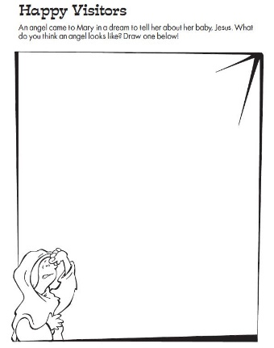
Angel Drawing
(Ages 5+, 3-5 mins)

Supplies Needed:
- Printed Handout
- Pen/Pencil/Crayons

Instructions:
- Although we often think of angels dressed in white, no one really knows what angels look like! Ask the kids to use their imagination and draw what they think the angel Gabriel looked like, and share it when finished!

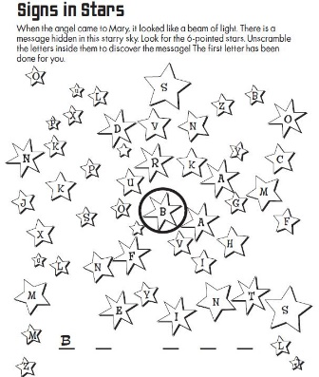
Angel Word Puzzle/Scramble
(Ages 5+, 5 mins)

Supplies Needed:
- Printed Handout
- Pen/Pencil/Crayons

Instructions:
- This is essentially two puzzles in one – first, identifying 11 six-pointed stars, followed by unscrambling those 11 letters into a short message.

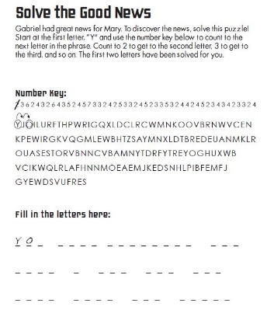
Angel Word Puzzle (Hard)
(Ages 7+, 10 mins)

Supplies Needed:
- Printed Handout
- Pen/Pencil/Crayons

Instructions:
- This word puzzle will take a bit of time to complete, but older kids should be adept at cracking the code. Kids need to carefully keep track of the number of letters they should skip, filling in the phase at the bottom.
Biblical Background – Angels Visit

On this first Sunday in Advent, we finally make our way into the New Testament – turning to the first chapter of Luke, and the angel’s visit to Mary!
There is obviously a lot that happened in between the Book of Ruth and the Gospels, so I’ll sum up below:

- 1000 BCE – Ruth’s great-grandson David becomes king, starting a brief “golden era” for Israel.
- 930 BCE – The United Kingdom of Israel splits into North (Israel) and South (Judah)
- 722 BCE – The ascendant kingdom of Assyria conquers the Northern Kingdom of Israel; Judah survives due to making a treaty with Assyria behind Israel's back.
- 722-586 – Judah continues to get harsh critiques from the prophets, briefly flourishes when the Assyrian empire collapses, but then is threatened by the Babylonians.
- 586 – The Babylonians conquer Judah, taking thousands into exile and destroying the Temple.
- 586-539 – The religious and political leaders of Judah are in exile, leaving the land decimated and the future of the Hebrew people uncertain (at best).
- 539-333 – The sudden rise of the Persian Empire under Cyrus the Great leads to the defeat of the Babylonians. Unlike the Babylonians, Cyrus has a radically different approach to ruling – allowing conquered countries to rebuild and keep their own religious traditions.
- 333-323 – Alexander the Great has one of the great military campaigns in history, conquering a massive area. Unfortunately, conquering and ruling are different skill sets… Alexander's death with no succession plan leads to widespread civil war between his generals.
- 322-164 - One of those generals, Ptolemy, and his successors take over the area of Judah, followed by the Seleucids, also one of Alexander's former generals.
- 166-164 – A rebellion breaks out against the widely hated Seleucid ruler Antiochus IV
- 164-63 – The Maccabean revolt leads to the establishment of the first self-ruling Hebrew government since 586 – known as the Hasmonean Dynasty.
- 63-40 – Rome begins to flex their muscles across the Mediterranean, conquering Judah (renaming it Judea) and bringing an end to the Hasmonean Dynasty… and leading to growing hopes about a future leader/Messiah who can usher in a new era .
- 40-4 BCE – Herod the Great is appointed King of the Judea by the Roman Senate
- 4 BCE – Jesus is believed to have been born in this year.

It is also important to note that it is angels, rather than prophets, who begin to take on the role of being God’s messengers in the New Testament. Angels do appear in the Old Testament (most famously in Isaiah’s vision of God in Isaiah 6) but their appearance was not commonplace. By contrast, angels appear both around Jesus’ birth and death as a reminder that God is beginning to speak to the people in a new, direct way. In Emmanuel (“God with Us”) we will be able to hear God more clearly – and that will be cause for rejoicing at Christmas!

Your ability to share this info with kids will vary depending on their age – this section is mainly written for teachers and parents to learn a bit more about the background to each week's passage!

