Isaiah and Micah November 27, 2022

Bible Verses: Isaiah 7:13-17, Isaiah 9:6-7, Micah 5:2-5a
Spark Story Bible: pages 168 to 171, 194 to 195
--------------------------------------------------------------------------------------------------

Overall Lesson Takeaways

- Advent is a season of waiting and hope.
Today marks the start of the season of Advent – a beautiful and contemplative season that is beloved by most adults, but also a time that feels like an interminable wait for many kids as they count down the days until Christmas! Waiting and patience are certainly difficult skills to learn, particularly in a time when we’re so used to getting everything we want on-demand and immediately, but they are nonetheless an important part of the overall biblical story – particularly since things happen in God’s time rather than our own! Waiting, though, also serves an important purpose: it gives us something to look forward to – which in turn can give us hope. Today’s candle for the first Sunday of Advent is the candle of “hope” – and when we light that today, as well as read the hopeful words of prophets from many years ago, we remember that Jesus both is coming and has already come to make this world better for all people.
- How do we find hope, even in really difficult times?
Although this year has certainly been especially tough, both for kids and adults, all of us will encounter difficult times throughout our life – and sometimes those things can really weigh us down. It’s ok to feel sad or discouraged sometimes – we certainly don’t want anyone to pretend that things are perfect all the time! – but finding things to look forward to or hope for is really important for getting us through difficult times. Both Isaiah and Micah were no strangers to difficult times (see the Biblical Background section) but they still trusted that God was at work and had hope that God was planning a better future for them too.
- Jesus as Immanuel – “God with us”.
Although it might be a trickier point for younger kids to grasp, one of the truly special things about Isaiah’s prophecy is using the name “Immanuel” for Jesus – a name that in Hebrew means “God with us”. That God would choose to come into the world as a tiny baby, as one of us, is an amazing miracle in itself – but perhaps the most important piece is that it means, in Jesus, God has experienced what it is like to be human. God has experienced joy and laughter, sadness and pain, fear and anxiety, hope and uncertainty. Knowing that God has experienced all of those things and more can help us know that God understands how we feel and knows how to care for us. There is a lot about Christmas that brings us joy and happiness, but knowing that we are fully known and deeply loved is one of God’s greatest gifts to us!
Checking In

Before the reading:
- Take the time to get to know the kids a little!
  - Names, Conversation Cubes for warm-up, Highs and Lows
- Think about a time when you had to wait for something – what were you waiting for? What was the hardest part about waiting?

Bible Lesson / Discussion

Reading the Bible:
- Today, we’re reading about a pair of prophets who shared a message that God would one day send an important leader for the people – but they would have to wait a long time.
- Read the text together, either in the Bible, or the Spark Story Bible.
  - Feel free to stop and ask questions during the reading, if helpful.
  - Afterwards, take time to explore what that passage might mean, and know there's no one correct way to read these passages!

Questions About the Passage (see next page for PreK/K questions)
- Isaiah wrote that a child named Immanuel (God with us) would come to bring hope for the poor and peace for all. What are some things that Jesus did to help bring hope, help, and peace for all people?
- Micah also wrote that this leader would bring peace – what would peace look like in our world today? How would it help?

Connections to Our Lives
- Micah and Isaiah shared these messages during a really challenging time in Israel – and we’re in a really challenging time today. How can we find hope, even during times when things can sometimes seem hopeless?
- The start of Advent means that we’re counting down the days until Christmas – what traditions does your family during this time to help you get ready to celebrate on Christmas Eve and Christmas Day?

Biblical/Church Connections
- The candle for the first Sunday of Advent is the candle of “Hope” – something that is important for all of us, no matter what age we are. What hopes do you have, whether for yourself, your family, or the world?

Alternate Preschool and K/1st Questions
Younger ages, particularly those in our preschool class, may have a hard time discussing the biblical text for very long (if at all). My hope is that these questions (and especially the activity) can help with engagement!

Opening Questions / Activity
- Take some time to welcome / get to know the kids!
  - Share names, what does your family do to get ready for Christmas?
Warm Up Game – 20 Questions
- Today is the first Sunday of Advent, which is a season when we are waiting for Jesus to arrive on Christmas Eve and Christmas Day – but it can be really hard to wait sometimes. I thought it would be fun to practice our waiting skills with a game called 20 Questions
- (Explain that it may take a long time for them to figure out what you’re thinking of, but they can keep asking questions until they figure it out!
- Potential examples:
  - Baby Jesus
  - Mary and Joseph
  - Christmas Tree
- This can go on as long as kids are having fun, but eventually you can move on to questions about the Bible passage.

Bible Discussion/Questions
- Our Bible passages today are from two prophets who were waiting for a special leader that God was sending – someone who would be “God with us” and would help people and bring peace. We know now that they were talking about Jesus! Do you think it was hard for people to wait for Jesus?
- Read the text together, either in the Bible, or the Spark Story Bible.
  - Feel free to stop and ask questions during the reading, if helpful.
  - Afterwards, take time to explore what that passage might mean, and know there's no one correct way to read these passages!

- When was the last time you had to wait for something? How did it feel while you were waiting?
- Is there anything that helps you wait when you really want to do something?

People of Faith

In addition to reading our weekly Bible story, I'd love for our older grade school students to learn more about people whose lives were changed by their faith in Jesus. We'll lift up a new person each Sunday, trying to connect their story to our Bible passage as much as possible!

Gustavo Gutierrez
As we study the biblical prophets today, and the ways that they prophesied on behalf of all of God’s people, it’s important to remember that there are many who continue that work today – and Gustavo Gutierrez is one of those prophets.

Born in Peru in 1928, Gutierrez was extremely ill as a child – eventually being diagnosed with bone infections that left him either bed-ridden or forced to use a wheelchair from the time he was 12 to 18. During this period, Gutierrez learned the importance of hope and faith even during difficult times, and he eventually decided that he would become a priest.

After concluding his studies in Europe – and seeing the vast amount of wealth present there – Gutierrez returned back to Peru and was overwhelmed by the dire conditions that so many were experiencing. Almost half of the Peruvian population was suffering from extreme poverty, and Gutierrez stated that his desire was to restore “love thy neighbor” as the church’s central mission.

Gutierrez began developing what would become known as “liberation theology” – a focus on addressing the tangible needs of the poor, as well as seeking liberation for people oppressed socially or politically. Addressing poverty wasn’t just about giving people material things, he wrote, poverty “affects how people live, think, love, pray, believe and wait, spend free time, and fight for life”. Those experiencing poverty, he argued, are not being allowed to live in the fullness of their humanity – or what God intends for them – and so we are called as Christians to address that.

Gutierrez continues to be a controversial figure for many today – even almost having his ordination revoked because his embrace of Marxism/Communism – but his efforts throughout South America and beyond have shed light on the importance of not just reading and studying our faith – but actually living it out for the sake of others, particularly those experiencing dire poverty.
Crafts / Activities

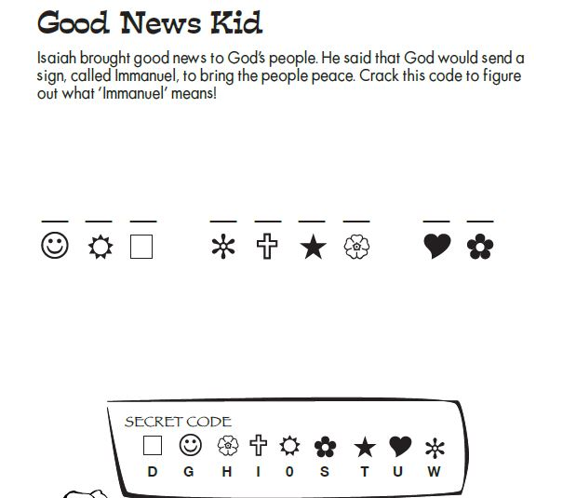
Prophets Word Puzzle
(Ages 5+, 3-5 mins)

Supplies Needed:
- Printed Handout
- Pen/Pencil/Crayons

Instructions:
- This is a tougher week in the craft department (not a lot out there for prophets!) but we do have plenty of word puzzles! Younger students may just enjoy the simple coloring sheet that you can find on the website.

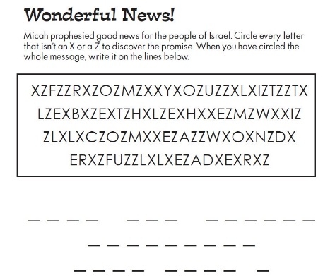
Prophets Word Puzzle
(Ages 5+, 5 mins)

Supplies Needed:
- Printed Handout
- Pen/Pencil/Crayons

Instructions:
- Slightly trickier than the puzzle above, but this should still be doable for most students (albeit a bit more time consuming!)

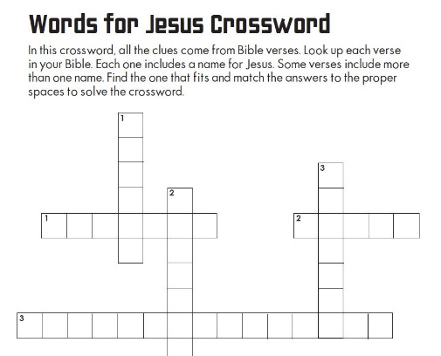
Prophets Crossword
(Ages 7+, 5-10 mins)

Supplies Needed:
- Printed Handout
- Pen/Pencil/Crayons

Instructions:
- Kids will have to get their Bibles out for this one! Each clue is a Bible verse containing a name from Jesus – kids will have to find the passage and right the name down in the corresponding spaces.
Biblical Background – Isaiah and Micah

The first Sunday in Advent often remembers important prophecy about Jesus – and we’ll take time this year to look at two different prophets: Isaiah and Micah.

Both Micah and Isaiah (the first 39 chapters, anyway) were active during a roughly similar timeframe – somewhere between 738 and 696 BCE. If you’ve been reading these biblical backgrounds the past several weeks, you’ll know that we made a quick jump from Solomon (970-931 BCE) to Jonah and Esther (post 539 BCE) – but there was a great deal of disaster, disappointment and destruction for Israel and Judah in those interceding years. Unfortunately, those three words accurately describe the overall context that Micah and Isaiah were prophesying in.

Years of civil war, inept leadership, and increasingly aggressive neighbors had left Israel and Judah quite vulnerable – and by the time that Isaiah (738 BCE) and Micah (736 BCE?) began their prophetic careers, both Israel and Judah were teetering on the brink. Within a few decades, the Neo-Assyrian empire would completely wipe out the northern kingdom of Israel and effectively subjugate the southern kingdom of Judah as well.

In their overall work, we see Isaiah and Micah both walk a fine line in their prophecies – issuing condemnation from God for the ways in which both leaders and the common people turned away from justice, kindness, and mercy, while also maintaining that God had not abandoned people entirely. That they were able to cultivate and prophecy hope in this time is truly remarkable – and perhaps no more so than in the passages that we’ll read today. Both Isaiah and Micah looked forward to a day when God would once more send a leader – a descendant of David – who could usher in a new era of peace.

Isaiah and Micah were obviously not around for Jesus’ birth, but the spirit of hope that they kindled – even in the midst of bleak circumstances – was something that continued to be passed down for generations to come. Our Advent season remembers this long wait, because even though it may have taken 700+ years, a new leader sent by God did indeed come!

Your ability to share this info with kids will vary depending on their age – this section is mainly written for teachers and parents to learn a bit more about the background to each week's passage!

