Daniel November 20, 2022

Bible Verses: Daniel 6:10-23
Spark Story Bible: pages 184 to 189
--------------------------------------------------------------------------------------------------

Overall Lesson Takeaways

- Trusting in God in frightening times.
Ultimately, the Book of Daniel is a book about hope – a book that proclaims that God is with us even in times when we may scarcely believe it. The story of Daniel in the lions’ den has long been an evocative story in Sunday School for prompting these questions – in part because kids understand the inherent danger that lions pose – but the true message of this story can and should be applied far more broadly than this particular context. Everyone knows what it is like to be in a situation that feels lost, hopeless, or is deeply frightening and this story reminds us that we believe we are never truly alone because God will always be with us. This is not an easy thing to believe – and part of our class time may be spent talking about that – but we believe that truth can give us hope.
- What do we do when our faith conflicts with laws?
Readers and interpreters over the years have used this story as an example of how we are called to obey God above government – even at risk to ourselves. This topic is far more suited to older students, as younger children have a much more rigid understanding of right and wrong, but older children may benefit from reflecting on what we should do when our calling as Christians to love God and our neighbor, and to follow Jesus might conflict with our local and national laws. This conflict of church and state has taken place throughout history, from the historical contexts of the Babylonian, Persian, and Roman empires to countries all over the world today.
- Looking forward to a new leader to guide us!
Although our passage today doesn’t get at this idea, the rest of the book of Daniel does – and we should also note this Sunday is known as “Reign of Christ Sunday”, the end of our church calendar year as well as a reminder that we believe God sent Jesus into this world to usher in an entirely new era. Over the coming seasons of our church year – from the anticipation of Advent to the surprising triumph of Easter – we will be learning more about how Jesus’ teachings can change the way we live our lives and how Jesus’ identity as Messiah forever changed our relationship with God. Jesus’ life, death, and resurrection does not mean we will be immune to suffering in our lives – that was not true for the disciples or the generations after them – but it does mean we can trust God’s love will always be with us, even in the midst of hardship, fear, or pain. For that, we are thankful and grateful!
Checking In

Before the reading:
- Take the time to get to know the kids a little!
  - Names, Conversation Cubes, are you traveling for Thanksgiving?
- Have you ever felt peer pressure about something? Is it hard to do the right thing if everyone else around you is doing something else?

Bible Lesson / Discussion

Reading the Bible:
- Today, we’re reading about a man named Daniel, who risked his life in order to follow God instead of an incorrect law.
- Read the text together, either in the Bible, or the Spark Story Bible.
  - Feel free to stop and ask questions during the reading, if helpful.
  - Afterwards, take time to explore what that passage might mean, and know there's no one correct way to read these passages!

Questions About the Passage (see next page for PreK/K questions)
- Daniel had to choose between disobeying the king and being thrown to lions or disobeying God. What would you have done if you were Daniel?
- In Daniel’s time, praying to God and not to the king was against the law. What would you do if something we do at church was against the law and could get you thrown in jail? How do you decide what is most important?

Connections to Our Lives
- Daniel had to be incredibly scared before he was thrown in the lions’ den -can you remember a time when you were really scared to do something? What was the outcome?
- Daniel prayed to God three times a day – when are times when you and your family pray? Are there other ways you can remind yourself God is with you, even in terrifying times?

Biblical/Church Connections
- Today is “Reign of Christ Sunday”, the last Sunday of our church year… essentially like New Years! What is something new you’d like to practice in this new church year? What is something our church could try practicing, even if it means making a big change?

Alternate Preschool and K/1st Questions
Younger ages, particularly those in our preschool class, may have a hard time discussing the biblical text for very long (if at all). My hope is that these questions (and especially the activity) can help with engagement!

Opening Questions / Activity
- Take some time to welcome / get to know the kids!
  - Share names, what are you doing for Thanksgiving this week?
Warm Up Game – Simon Says
- Our Bible story today is about a man named Daniel who was asked to obey the orders of a king – and we’re going to practice that through a fun game called Simon Says!
- Examples (but have kids take turns being the leader too):
  - Simon says… cover your eyes!
  - Simon says… jump up and down!
  - Simon says… stand on one foot!
  - Touch your nose!
  - Simon says… pat your head!
- This can go on as long as kids are having fun, but eventually you can move on to questions about the Bible passage.

Bible Discussion/Questions
- We’re going to read about a time when Daniel had to make a really hard choice about whether to follow God or a king – and it got him in trouble.
- Read the text together, either in the Bible, or the Spark Story Bible.
  - Feel free to stop and ask questions during the reading, if helpful.
  - Afterwards, take time to explore what that passage might mean, and know there's no one correct way to read these passages!

- Daniel had to be incredibly scared before he was thrown in the lions’ den -can you remember a time when you were really scared? How can we remember God loves us and wants us to be safe?
- Daniel prayed to God three times a day – when do you and your family pray? Meals? Bedtime? Others?
- Whenever you pray, remember that God is always with you and loves you very much!

People of Faith

In addition to reading our weekly Bible story, I'd love for our older grade school students to learn more about people whose lives were changed by their faith in Jesus. We'll lift up a new person each Sunday, trying to connect their story to our Bible passage as much as possible!

John Calvin
As we come to the close of our liturgical year and prepare to transition into a new one, it feels like a good opportunity to learn more about someone else who brought about changes (and the start of our Presbyterian denomination)!

Although he would become best known for his work in Switzerland, John Calvin was born in France in 1509. His father was well-off and well-connected, and he initially wanted John and his two brothers to all become priests. Calvin was an excellent student and, by his father’s orders, spent time studying law as well.

When he was in his early 20’s, though, Calvin’s study of the New Testament led him to break from Catholic teachings at the time and to resign his position. After being forced to flee France due to increasing unrest between the Catholic Church and “reformers”, Calvin eventually landed in Geneva, Switzerland and became pastor of St. Pierre Cathedral. He preached over 2,000 sermons at this church, sometimes as many as 5 per week, and his sermons lasted around an hour… imagine if our church was like that!

In addition to being pastor, John Calvin was a prolific writer – best known for the Institutes of the Christian Religion, which was an epic work focusing on theology and doctrine ranging from how communion was understood, to arguments against Catholic church practices and hierarchy. Calvin denied that the Pope could be head of the church, as well as the idea that bread/wine were changed into Jesus’ body and blood – a view which got him into a great deal of trouble and led to disagreements with other reformers like Luther.

Calvin’s theology would later be taken up by the Scottish Reformer, John Knox, who would combine that theology with a “presbyterian” system of government (being governed by elected elders, rather than bishops) to establish the roots of what we know as the Presbyterian Church.
Crafts / Activities

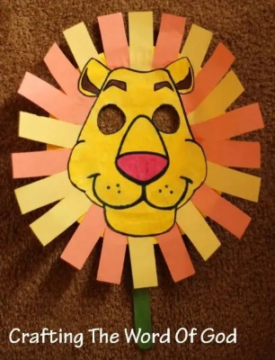
Daniel Lion Mask
(Ages 3+, 10 mins)

Supplies Needed:
- Craft Template
- Scissors
- Glue/Tape/Popsicle Sticks
- Crayons/Markers

Instructions:
- Have kids color the mask template before cutting it out – and use strips of orange and yellow construction paper for the mane, if needed. This craft might require teacher help for assembly, but the final product is fun!

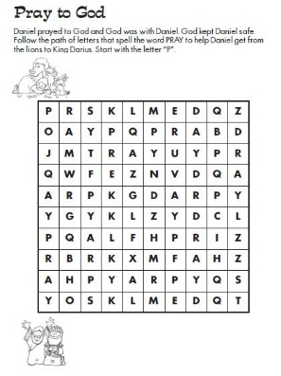
Daniel Word Maze
(Ages 5+, 2-3 mins)

Supplies Needed:
- Printed Handout
- Pen/Pencil/Crayons

Instructions:
- This maze is a little confusing at first – kids need to follow the letters for “Pray” over and over. Keep following P-R-A-Y-P-R-A-Y… until you win!

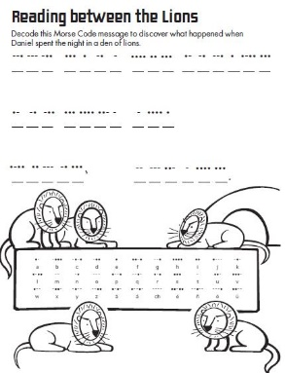
Daniel Morse Code
(Ages 5+, 3-5 mins)

Supplies Needed:
- Printed Handout
- Pen/Pencil/Crayons

Instructions:
- Using the morse code translator on the bottom, have kids decode a message that shares what happened in today’s passage.
Biblical Background – Daniel

Today’s lesson on Daniel wraps up the series of “post-exilic” books we’ve been covering these few weeks, along with Jonah and Esther. The Jewish people began to return home from the Babylonian Exile around 539 BCE – but over the next several centuries Judah would continue to be occupied and ruled by foreign governments first by the Persians, then the Greeks, and eventually the Romans.

The Book of Daniel is somewhat confusing at first glance, if in no small part because the book seems to be two different books mashed into one. The first half of the book (Daniel 1-6) is a collection of stories set during the reigns of well-known rulers such as Nebuchadnezzar (Babylon, 605-562 BCE) and Darius (Persia, 522-486 BCE) and deal with issues of how one can still adhere to worshiping God while directly under foreign rule. The second half of the book (Daniel 7-12) is a series of prophetic visions which Daniel has relating to Israel’s future and its relationship with foreign governments – and Daniel 11 also seemingly describes historical events which occurred in 164 BCE in clear detail, which would make it the latest book written in the entire Old Testament!

Daniel’s experience with the lions – along with the famous story of Shadrach, Meshach, and Abednego being tossed into an oven but not burned – would become sources of inspiration for those experiencing oppression at the hands of larger, more powerful governments. If Daniel was indeed written around 164 BCE and the Maccabean (Jewish) Revolt against the hated Greek ruler Antiochus the IV, these passages would have served to strengthen trust in God in difficult times – much as they would later to Christians experiencing oppression at the hands of the Romans (including, in a bizarre coincidence(?), rare instances where Christians were fed to lions).

Even in the midst of that oppression, though, Daniel’s visions in the second half of the book lay out a case for hope – including a coming day when a messianic “Son of Man” figure would eventually come to usher in a new era for all of creation – and to this figure “was given dominion and glory and kingship, that all peoples, nations, and languages should serve him. His dominion is an everlasting dominion that shall not pass away” (Daniel 7:14).

Your ability to share this info with kids will vary depending on their age – this section is mainly written for teachers and parents to learn a bit more about the background to each week's passage!

