Jonah November 15, 2020

Bible Verses: Jonah 1 & 2 (selected verses)
Spark Story Bible: pages 190 to 193
--------------------------------------------------------------------------------------------------

Overall Lesson Takeaways

- What do we do when God asks us to do something we don’t want to do?
Although chapters 3 and 4 of Jonah get into some deeper theological questions (see below), one of the reasons that people have long loved Jonah is that we can all relate to him running away from something that someone asked him to do! All of us, whether at school, at home, or perhaps even at church, have been asked to do things that we’d rather not: share something that we have with others, save or donate part of our allowance rather than spend it, volunteer when we’d rather watch TV, etc. etc. But we all know that sometimes we need to do things that we don’t want to – whether it’s homework or whether its helping other people – because ultimately that’s what’s for the best, both for us and for others.
- If God loves and forgives everyone, does that mean we should too?
Over the course of the story, we come to learn that Jonah thinks that the Ninevites are bad people – and so he runs away because he doesn’t want God to forgive them! While this may seem a little ridiculous at first, especially since we celebrate God being loving and forgiving often at church, it’s not hard to think of examples of people in our lives or beyond who are just plain mean. Do you think God loves and forgives them? What about people who are really, really bad – does God forgive them too? What seems like an easy question to answer at first (of course God should forgive everyone!) becomes much harder when you start putting that forgiveness into practice. Does that mean that all of us are called to love and forgive other people, even when they hurt us? I think the answer is “Yes, as best we can” – but that can be a hard thing! I’ve always loved how my pastor growing up put it: “You don’t need to like everyone, but you do need to show love to everyone” – showing love to others is something that you can do no matter what.
- God can help transform people’s lives, even if they seem bad.
One of the fun pieces of Hebrew wordplay in this story comes from Jonah’s single line of prophecy to the people of Nineveh: “Forty days more, and Nineveh will be overthrown”. The word for ‘overthrown’ in Hebrew (ha-phak) can mean destroyed – it’s the same word used for Sodom and Gomorrah’s destruction – but it also can mean transformed. Jonah wanted Nineveh to be destroyed and punished, but God instead chose to transform the people’s lives by having them repent and giving them a second chance. This can be an opportunity to think about ways that we can give people second chances in our lives – especially if we’d like others to do the same for us.
Checking In

Before the reading:
- Check in with the kids – welcoming any newcomers warmly.
  - Younger kids: Something you do with your family every Fall
  - Older kids: Highs and Lows from their past week
- Is there a chore at home, or an activity at school, that you really don’t like doing? Have you ever totally avoided doing it??

Bible Lesson / Discussion

Reading the Bible:
- Today, we’re reading about the prophet Jonah, who was asked by God to deliver a message to the people of Nineveh, but he ran the other way!
- Read the text together, either in the Bible, or the Spark Story Bible.
  - You’ll need to screen share the passage for the day in Zoom.
  - Feel free to stop and ask questions during the reading, if helpful.
  - Afterwards, take time to explore what that passage might mean, and know there's no one correct way to read these passages!

Questions About the Passage (see next page for PreK/K questions)
- Jonah really didn’t like the people of Nineveh – but God asked him to help them. What would you have done if you were Jonah? Would you have listened to God, or would you have run away like him?
- Should we be nice to people, even if they’re mean to us? What makes that idea so hard to follow sometimes?
- The people of Nineveh eventually decided to change the way they were acting – have you ever changed your mind about something? What helped you change your mind?

Connections to Our Lives
- Why is it important to do things like chores or homework, even if we really don’t want to do them?
- What lessons from church or from reading the Bible do you think are really hard to follow? Why might God want us to do those things, even if they’re really hard to do?

Biblical/Church Connections
- Do you think being a prophet would be a hard job? What would make someone a good (or a bad) prophet?
Alternate Preschool and K/1st Questions
Younger ages, particularly those in our preschool class, may have a hard time discussing the biblical text for very long (if at all). My hope is that these questions (and especially the activity) can help with engagement!

Opening Questions
- Do you have any chores that you do for your family? What chores do you like doing… and what do you not like doing?
- If you didn’t do your chores, how would your family feel? Why is it important that we help our family, our teachers, or our friends?

Fun Activity
- Our Bible story today was about God asking Jonah to deliver a message, but Jonah didn’t want to – he did the opposite of what God wanted and ran the other way. I thought it would be fun to pretend to play a game where we pretended to be Jonah – but instead of listening, you’ll do the opposite of what I say
- (You are essentially playing Simon Says, just with the twist of everyone doing the opposite. It will get a little confusing, but that’s part of the fun)
  - Simon says… don’t cover your eyes!
  - Simon says… don’t jump up and down!
  - Simon says… jump up and down!
  - Touch your nose! (I don’t know if kids should do this or not… it’s too confusing with the double negative - just have fun!)
  - Simon says… don’t laugh out loud!
  - Simon says… let’s keep playing this game.

Bible Discussion/Questions
- Was it hard playing the game to do the opposite of what you were asked to do? Why do you think Jonah didn’t want to do what God asked?
- God wanted to tell the people of Nineveh that he loved and forgave them, even when they weren’t doing what was right. Do you think God forgave Jonah for running away? How does it feel to be forgiven? Do you think it helped everyone get along better?

People of Faith

In addition to reading our weekly Bible story, I'd love for our older grade school students to learn more about people whose lives were changed by their faith in Jesus. We'll lift up a new person each Sunday, trying to connect their story to our Bible passage as much as possible!

Mother Teresa
Before she became one of the best-known humanitarians of the 20th century, Mother Teresa was simply known as Agnes, the “little flower” who was the youngest child of 3 and who helped at her parents’ family-run grocery store. Agnes was fascinated by stories of church missionaries who travelled around the world to help others, and she decided to leave her family at the age of 18 – travelling to Ireland to learn English, followed by a move to Darjeeling, India – the country that would become her home for the rest of her life.

Agnes would start out as a teacher in India, and she also became a nun two years after her arrival – choosing the name “Teresa” as an homage to Therese de Lisieux, the patron saint of missionaries. Although she continued teaching for the next two decades, Teresa also had an increasing sense that God was calling her to do work among the poor – as she put it, “it was her call within a call”. In 1949, she left her convent and began living in the slums of Calcutta trying to focus on helping the poorest of the poor.

Although she was unsuccessful in her first year, Teresa eventually was able to start the organization that would become the Missionaries of Charity – focused on helping house people who were sick and dying, but had nowhere else to go. This would eventually expand to orphans and homeless youth, and by the time her career was over, the Missionaries of Charity had opened over 500 centers across the world, still dedicated to serving the poorest of the poor.

Although she was short in height (only standing 5’0”, if that), her passion and commitment helped serve thousands over the years – eventually winning her the Nobel Peace Prize in 1979. She remained committed to her order’s charitable work for the rest of her life, and she still is remembered as someone who wanted to make a difference in the lives of others – particularly those whom society had forgotten or pushed aside.

Crafts / Activities

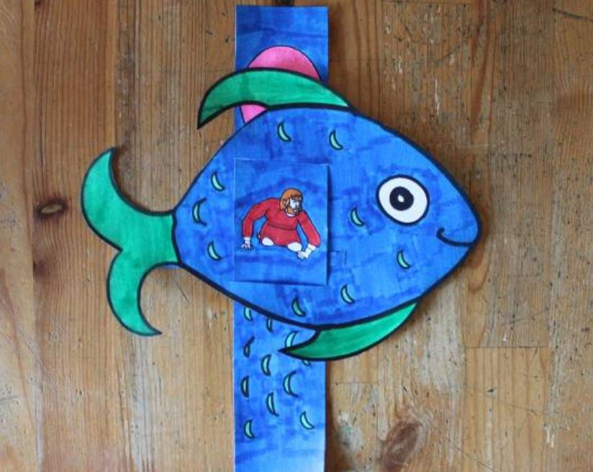
Jonah & Big Fish Craft
(Ages 5+, 5-10 mins)

Supplies Needed:
- Craft Template
- Scissors
- Glue/Tape
- Crayons/Markers

Instructions:
- Have kids color the pieces of the template before cutting them out. You’ll need to cut along the dotted lines on the fish and thread the long strip of paper through – once you’re finished, you can have Jonah enter into the fish’s belly… and you can have the fish spit Jonah out for good measure!

Jonah Word Puzzle
(Ages 5+, 5 mins)

Supplies Needed:
- Printed Handout
- Pen/Pencil/Crayons

Instructions:
- Kids will need to find and match the letter/number combos that appear around the picture of the whale – not hard, but may take a little time.

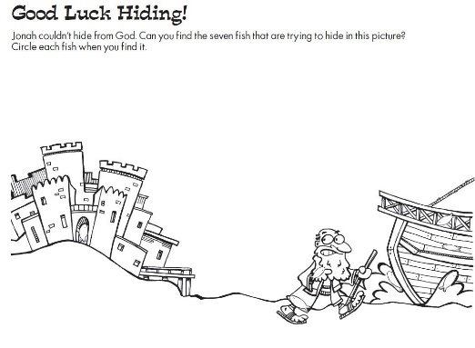
Jonah Fish Finder Puzzle
(Ages 3+, 2-3 mins)

Supplies Needed:
- Printed Handout
- Pen/Pencil/Crayons

Instructions:
- There are seven fish hidden in this drawing of Jonah running away from Nineveh – find them all, whether via printout or screen sharing with kids!
Biblical Background – Jonah

If you’ve ever read the biblical text of Jonah (not the children’s story version that stops after the whale), you know that the book is quite different from the other prophetic texts that it appears with. While most prophetic texts are focused on the words that a prophet said, Jonah only utters one verse of prophecy in the entire story! The book is far more interested in Jonah’s actions and attitude – both of which can be best described as petulant.

Further adding to the mystery is that it is unclear when Jonah was written. There was a prophet named Jonah ben Amittai in the 8th century BCE (2 Kings 14:25) but the book does not claim to be written by him. The language used spans several centuries, ranging from antiquated Hebrew terms to Persian loanwords that wouldn’t appear in Hebrew until after the exile (539 BCE). Almost all scholars place the book as being written sometime after 539 BCE, although it should be noted that Nineveh/Assyria had been completely destroyed by that point in history – which only adds another layer of complication to how we are to understand the central message of the book!

Setting the intriguing question of when the book was written aside, though, the most important piece of history to understand while interpreting Jonah is to understand what the Ninevites represented – particularly in Israel. Nineveh became the capital city of the Neo-Assyrian Empire around 700 BCE – shortly after the Neo-Assyrian Empire destroyed the Northern Kingdom of Israel and forced the Southern Kingdom of Judah to become a vassal state. The Assyrians were militarily dominant (first to use iron) and notably cruel to conquered territories, so the people of Nineveh would have been seen as being truly terrible – profiting off others’ misery to create the greatest city of its day.

This view of Ninevites as being almost irredemably bad people is likely what is at play with Jonah’s reluctance to prophesy to them, as well as his anger when God decides to not punish them. How could God pardon the very people who had destroyed the northern kingdom of Israel, who carried off thousands upon thousands into slavery? We love that God is gracious and merciful… until God forgives those we think don’t deserve it. That’s what this book is wrestling with.

Your ability to share this info with kids will vary depending on their age – this section is mainly written for teachers and parents to learn a bit more about the background to each week's passage!

