Joseph 3 November 14, 2021

Bible Verses: Genesis 45:1-15, 50:15-21
Spark Story Bible: pages 60 to 65
--------------------------------------------------------------------------------------------------

Overall Lesson Takeaways

- God’s love and forgiveness are bigger than our mistakes.
"Even though you intended to do harm to me, God intended it for good". This famous line from Genesis 50 is a wonderful summary of Joseph's long and winding journey – but it can also open us to some important discussions about how we experience God in our lives today. Issues like the problem of evil, or how God intervenes in our lives, are questions that people of faith have wrestled with for several millennia – and this verse seems to suggest that even when we can't see God at work, God is still there working for good. We believe that we as human beings are afforded free will – a gift from God – but that sometimes our choices, or others' choices, end up doing harm. This text presents us (both kids and adults!) with an opportunity to reflect on times in our lives when a mistake that we made ended up being a good thing. How might God have been a part of that? How can we see mistakes as an opportunity to grow and learn?
- The importance of forgiveness and reconciliation.
Given the above statement – that sometimes our choices, or others' choices, end up doing harm – it is imperative at times that we find ways to forgive and reconcile with others when they hurt us. This process is not easy – and there are debates on whether or not forgiveness and reconciliation is even possible without some sort of contrition or changed behavior on the part of the one perpetrated the hurt – but the biblical text over and over emphasizes that forgiveness is vital as a way to break cycles of violence and hurt. You may ask kids to reflect on what Joseph could have done to his brothers in his position of authority. What's the difference between what is fair versus what is right? It would have been fair for him to punish them… but would it have been right?
- Once again, thinking about how famine affects our world today.
We covered this already last week, but Joseph’s family comes to Egypt because of a widespread famine across the Ancient Near East – and famine remains a very real and scary thing in our world today. Ongoing famines in Yemen and South Sudan have left millions without consistent access to food the past several years, and our changing climate is a threat to global food security in nations around the world. Joseph using his gifts to prevent a widespread crisis is a reminder that we too are called to do what we can to advocate, donate, and provide for those in need in our world as well. We may not have the ability to create a decade-long food plan like Joseph, but we can still use what we've been given to make a difference in others' lives.

Checking In

Before the reading:
- Check in with the kids – welcoming any newcomers warmly.
  - Younger kids: What is one of your favorite things to eat?
  - Older kids: Share highs and lows from the past week
- Have you ever travelled to a different country? What was that experience like for you?

Bible Lesson / Discussion

Reading the Bible:
- This is our last week learning about Joseph, who was now an important leader within Egypt – only to be visited by his brothers who had once thrown him into a pit… and they are in desparate need of food!
- Read the text together, either in the Bible, or the Spark Story Bible.
  - Feel free to stop and ask questions during the reading, if helpful.
  - Afterwards, take time to explore what that passage might mean, and know there's no one correct way to read these passages!

Questions About the Passage (see next page for PreK/K questions)
- Joseph’s brothers didn’t recognize him at first… would you have had a hard time keeping it a secret? How would you have treated them?
- Joseph ends up forgiving his brothers and giving them the food they need. Is forgiving people easy or hard? How can forgiving someone help us?

Connections to Our Lives
- The Bible talks about how even though Joseph’s brothers tried to hurt him, God still used that for good. Can you think of a time when you really didn’t want to do something, but it ended up being a good thing?
- Joseph’s brothers come to Egypt because they are in the middle of a famine. What does hunger look like in our world today? How is it similar and how is it different than what it might have been like many years ago?

Biblical/Church Connections
- Today is Hunger and Homelessness Sunday, where we remember that almost 1 out of every 6 kids don’t have enough food and over a half million people experience homelessness every year. What can we do as individuals – and as a church – to help those experiencing these things?
Alternate Preschool and K/1st Questions
Younger ages, particularly those in our preschool class, may have a hard time discussing the biblical text for very long (if at all). My hope is that these questions (and especially the activity) can help with engagement!

Opening Questions
- Have you ever travelled somewhere far away on a trip or vacation? What was it like to be far away from home?

Fun Warm-Up Activity – Simon Says
- In our Bible passage today, Joseph was living far away from home and his brothers come to visit him because they need food – but they found out that he was an important leader and they had to do what he said!
- Has anyone ever played Simon Says? We are going to take turns having everyone in the room be a leader – and you get to tell us what to do by saying “(your name) says… ________”
- Ideas include cover your eyes or ears, jump on one foot, turn around, jumping jacks, etc. – but if the person doesn’t say “______ says” before then you’re not supposed to do it!

Reading the Bible:
- This is our last week learning about Joseph – he finally is seeing his brothers again after they had been mean to him… what would he do!?
- Read the text together, either in the Bible, or the Spark Story Bible.

Bible Discussion/Questions
- Joseph’s brothers didn’t know it was him at first… would you have kept it a secret? Or would you have told them?
- His brothers really were hungry and needed food – but the last time they were together, they had been really mean to him. Do you think Joseph did the right thing by helping them?
- What does it mean to forgive someone? How does saying you’re sorry and giving someone a hug make you both feel?

People of Faith

In addition to reading our weekly Bible story, I'd love for our older grade school students to learn more about people whose lives were changed by their faith in Jesus. We'll lift up a new person each Sunday, trying to connect their story to our Bible passage as much as possible!

Chiune Sugihara
Joseph was able to use his political position within the Egyptian government to help not only his family, but thousands of others – and that same spirit can be seen in the Japanese diplomat Chiune (chee-oo-nay) Sugihara in World War II.

Born in rural Japan in 1900, Sugihara was an excellent student and quickly progressed through school – eventually winning a scholarship to study the Russian language in China, where he would marry a Russian woman and formally convert to the Russian Orthodox Christian Church. His fluency in Russian eventually landed him a job as a diplomat in Lithuania in the Fall of 1939, right as Germany invaded Lithuania’s western neighbor Poland to begin World War II.

As the war continued to intensify, Lithuania was caught between Germany on one side and the Soviet Union on the other – so Lithuanian-Jewish residents began making appeals to diplomats from foreign governments in order to obtain paperwork for safe passage from the country. Unfortunately, virtually every government was closing their borders at this time – including Japan, which instructed Sugihara not to issue any travel visas to Lithuanian citizens – but as he would later reflect: “I made up my mind not to wait. I knew somebody would surely complain about me in the future. But, I myself thought this would be the right thing to do. There is nothing wrong in saving many people's lives.”

In July and August 1940, he began to issue 10-day travel visas to anyone who asked – essentially providing a way for Lithuanian-Jews to escape through Japan. All told, he is believed to have written over 2,000 visas – which led to somewhere between 4,500 to 6,000 people escaping. Sugihara was evacuated in September 1940 and eventually lost his job shortly after WWII because of these visas – but he was recognized by both Israel and Japan after he passed away for his tremendous bravery and selflessness in saving so many lives.

Crafts / Activities

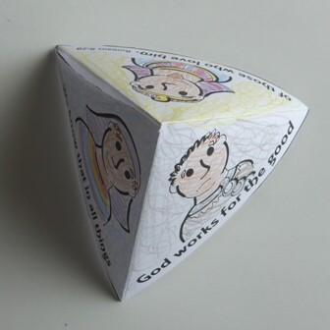
Joseph 3 Paper Pyramid
(Ages 3+, 3-5 mins)

Supplies Needed:
- Printed Handout
- Scissors/Tape
- Markers/Crayons

Instructions:
- Have kids color the three sides of the pyramid, cut it out as one large piece, and then fold and tape the pyramid together.

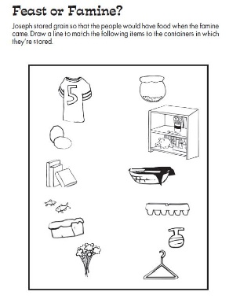
Joseph 3 Picture Puzzle
(Ages 3+, 3 mins)

Supplies Needed:
- Printed Handout
- Markers/Crayons

Instructions:
- This is a very easy puzzle skewed towards younger ages; simply have the kids match objects in the left side with where they are usually stored.

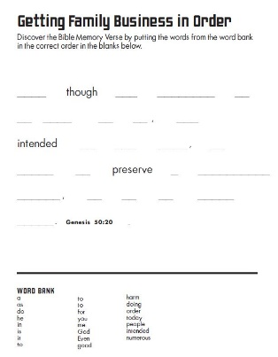
Joseph 3 Word Puzzle
(Ages 7+, 5 mins)

Supplies Needed:
- Printed Handout
- Pen/Pencil/Crayons

Instructions:
- This isn’t as much a puzzle as it is a reconstruction of the famous verse summarizing Joseph’s journey and his deep faith in God’s goodness.

Biblical Background – Joseph 3

Our lesson this Sunday marks a long-awaited reunion: Joseph and his brothers finally meet one another years after they had tossed Joseph into a pit and sold him into slavery. Similar to Jacob and Esau, though, Joseph and his brothers have grown quite a bit since they last encountered one another – Joseph's concern for his family's well-being (after an initially cold reception in Genesis 42) and his brothers' full apology to Joseph culminates in the beautiful conclusion of Genesis 50. As they mourn their father's death together (more on that below), these former adversaries share tears and forgiveness, accompanied by the famous words of Genesis 50:20 "Even though you intended to do harm to me, God intended it for good… as God is doing today".

The book of Genesis concludes shortly thereafter with the death of Joseph – although it is noteworthy that Joseph's death isn't quite given the same level of importance that Jacob's death does. Jacob's final words are the entirety of Genesis 49, with 14 verses centered on mourning his death in Genesis 50. In contrast, Joseph – the central figure of the last 14 chapters – only gets a whopping 3 verses for his final words and death (Genesis 50:24-26)! The death of Jacob – and later Moses – marks a new stage of fulfillment in the ongoing promise that God gave to Abram and his descendants back in Genesis 12: the era of the "Patriarchs", of God's promises being wrapped up in an intimate family drama, is coming to an end. Instead, we see God’s promises beginning to expand wider.

The fortunes of Joseph and his brothers’ descendants obviously take a turn for the worse in the start of Exodus – which eventually leads to God raising a new leader in Moses to help the people return to the land that was once promised to Abraham – but we’ll spend more time with Moses and other leaders next Fall (after all, we only have two more weeks until Advent begins)! Instead, we will briefly turn towards Ruth, as we begin to see God's promises expanding towards all people before those promises are made fully manifest in Jesus’ arrival. It is bittersweet to say goodbye to Genesis – and the many flawed, but faithful people we have met along the way – but that theme of covenant running throughout Genesis will continue to be vital as we prepare ourselves for Jesus’ ministry.

Your ability to share this info with kids will vary depending on their age – this section is mainly written for teachers and parents to learn a bit more about the background to each week's passage!

