Esther November 13, 2022

Bible Verses: Esther 8:1-8
Spark Story Bible: pages 152 to 157
--------------------------------------------------------------------------------------------------

Overall Lesson Takeaways

- Sometimes small things that we do can make a big difference.
Although Esther’s position as queen obviously helped quite a bit, there’s still a lesson in here about how the decisions that we make about how to treat people, or when to help, can have a much bigger impact than we might even realize at the time. When Esther asked the king to help the Jewish people, she did it because it was the right thing to do – but it helped hundreds and maybe even thousands of people. Our decisions may not make that big of an impact, but the choices that we make about helping others, buying food and clothes that help workers get fair wages, or donating toys/clothes to other kids in need can make a huge difference in people’s lives – even if we might not get a chance to see it first-hand.
- Who do we put our faith in: people or God?
One of the central disagreements within the Book of Esther comes when Mordecai, Esther’s surrogate father, refuses to bow down to Haman and the Persian government – for Haman’s faith allowed him to bow down to God alone. This is a tricky lesson for kids to engage with, because ultimately it is challenging us to think about how we weigh different authority figures in our lives against one another, but it is an important reminder that sometimes following God will involve making some difficult choices. As with the story of Jonah last week, following God can call us into places we may not want to go, or give up things we may not want to give up, but making those choices are a big part of what it means to be a disciple of Jesus.
- Trusting that God is with us, even when we don’t sense God’s presence.
Esther is one of the more unique books in the Old Testament in that God is never explicitly named as acting or speaking in this story. Nonetheless, the Book of Esther provides a powerful witness of faith in action today, particularly in a time period when most of us would not describe God as speaking directly to us or physically changing/manifesting the world on our behalf. Esther and others are seen as doing God’s will and that God is working through them, and in doing so they become an example of how to act in faith – to serve and care for other people because we know that that is what God would want us to do. We sometimes refer to our role as Christians as being God’s hands at work in this world, and Esther certainly seems to encourage each of us to work hard for what we believe in and to serve God using whatever ability or influence we may have.
Checking In

Before the reading:
- Take the time to get to know the kids a little!
  - Names, Conversation Cubes, favorite Thanksgiving food?
- If someone made you the king or queen of a country, what is one of the first things that you would decree or do?

Bible Lesson / Discussion

Reading the Bible:
- Today, we’re reading about Queen Esther, who helped save a lot of people because she cared about them and helped convince the king to save them.
- Read the text together, either in the Bible, or the Spark Story Bible.
  - Feel free to stop and ask questions during the reading, if helpful.
  - Afterwards, take time to explore what that passage might mean, and know there's no one correct way to read these passages!

Questions About the Passage (see next page for PreK/K questions)
- Esther didn’t know how the king would react when she asked for his help – how would you have convinced him that he should help these people?
- Esther is still remembered each year during the Jewish festival of Purim (purr-REEM) – what are some of your favorite celebrations each year?

Connections to Our Lives
- Some problems are too big for us to solve alone, but we also believe God uses ordinary people to do extraordinary things, just like Esther. What is a big problem in our world today? What can you do to help solve it?
- Think about the last time that you did something nice for someone else – whether by donating something, or through a kind action. How did it feel to help? How does it feel to receive someone else’s help? Giving to others, and receiving from others, can help make us closer!

Biblical/Church Connections
- Being a Christian isn’t dangerous in the United States, but it can be in many other parts of the world. Do you think you would still go to church if being a Christian meant you could be arrested? What might be different about how you practice being a Christian in those countries?

Alternate Preschool and K/1st Questions
Younger ages, particularly those in our preschool class, may have a hard time discussing the biblical text for very long (if at all). My hope is that these questions (and especially the activity) can help with engagement!

Opening Questions / Activity
- Take some time to welcome / get to know the kids!
  - Share names, what is your favorite food to eat for Thanksgiving?
Warm Up Game – I Spy!
- Our Bible story today is about a queen who helped a lot of people – she did a really good job paying attention to what others needed. To help us practice paying attention, I was hoping that we could play some “I Spy”!
- Examples:
  - I spy something… green! (Plant in background)
  - I spy something… orange! (Goldfish in a fish tank)
- This can go on as long as kids are having fun, but eventually you can move on to questions about the Bible passage.

Bible Discussion/Questions
- (Today’s lesson is a really tough one for the PreK age group – focusing on giving/kindness, like how Esther helped others, may be best!)
- Our Bible story today is about a Queen named Esther many years ago who saw people who were in trouble – and she decided she would help them!
- Read the text together, either in the Bible, or the Spark Story Bible.
  - Feel free to stop and ask questions during the reading, if helpful.
  - Afterwards, take time to explore what that passage might mean, and know there's no one correct way to read these passages!

- When was the last time that you did something nice for someone else? How did it feel to help? How does it feel when someone helps us?
- How can you tell when someone needs help? Giving to others, and receiving from others, can help make us closer!
- Esther was a really big help in other people’s lives – think about someone that you can help today, and what you could do for them. Share your ideas together and make a promise to help them!

People of Faith

In addition to reading our weekly Bible story, I'd love for our older grade school students to learn more about people whose lives were changed by their faith in Jesus. We'll lift up a new person each Sunday, trying to connect their story to our Bible passage as much as possible!

Fred Rogers
Although he might not be as well known to kids today, Mister Rogers was an incredible advocate and teacher for several generations of kids – all through a television show featuring puppets and a land of make-believe.

Born as an only child in 1928, Fred Rogers had a very lonely childhood. His father was president of a major brick company in Pennsylvania, and his mother did a great deal of hospital volunteer work, which often meant that Rogers was alone as a child. He was overweight and extremely shy, often being bullied in school and spending a great deal of time alone in his room. It was during this time that he developed a very active imagination – possibly laying the groundwork for what his future show would be.

Rogers earned a college degree in music, followed by becoming a Presbyterian minister at the age of 35. During this time he began experimenting with children’s TV shows – discovering that he had a real gift for talking to and connecting with kids. It was during this time that he introduced puppets like Daniel the Striped Tiger, King Friday, and Sara Saturday – characters that would eventually become features on his hit show Mister Rogers’ Neighborhood that ran from 1968 to 2001 with 895 total episodes.

Mister Rogers’ Neighborhood, as well as the more recent Daniel Tiger cartoon it inspired, focused on the very real issues of being a kid. Rogers always tried to talk directly to the kids and to help them focus on processing emotions like anger, fear, and sadness. He saw his work with children as an essential part of his faith, preferring not to talk about Christianity directly, but leaning on the lessons of humility, kindness, charity, and patience that came from his daily Bible study each morning. Fred Rogers truly cared about people, both kids and adults, and that came through in everything he did – whether answering every single fan letter he received, or reminding all of us that every person deserved to be heard, known, and loved.
Crafts / Activities

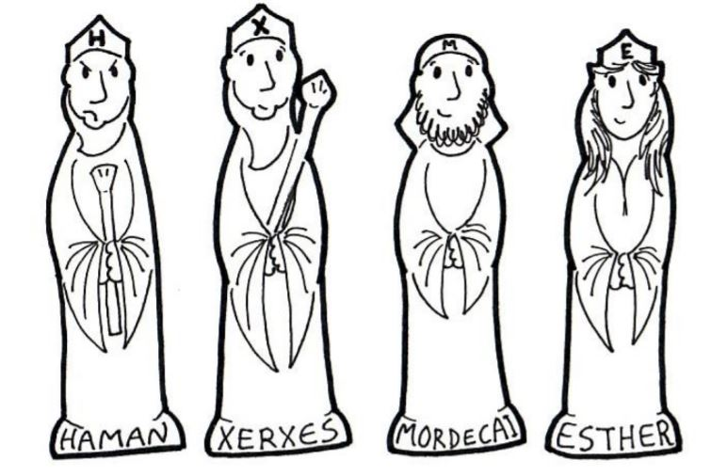
Esther Stick Puppets
(Ages 3+, 5-10 mins)

Supplies Needed:
- Craft Template
- Scissors
- Glue/Tape/Popsicle Sticks
- Crayons/Markers

Instructions:
- Have kids color the people on the template before cutting them out. After cutting them out, kids will just need to attach them onto popsicle sticks using tape or glue – it’s a pretty easy craft!

Esther T-Shirt Design
(Ages 5+, 5 mins)

Supplies Needed:
- Printed Handout
- Pen/Pencil/Crayons

Instructions:
- It’s a little abstract, but in honor of Esther raising awareness of people in great need this craft asks kids to imagine a design raising awareness for a cause of their choice (

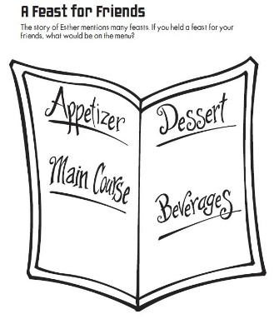
Esther Food Menu
(Ages 5+, 2-3 mins)

Supplies Needed:
- Printed Handout
- Pen/Pencil/Crayons

Instructions:
- There was a big feast after Esther saved everyone – so this can be a way to learn what kids would choose to have at a big feast/party for them!
Biblical Background – Esther

These past couple of weeks of Sunday School (Jonah, Esther) are moving us at warp speed through over 900 years of history (Solomon to Jesus) – so we’ll start with a very quick recap of what happened after Solomon’s reign. After Solomon died in 931 BCE, the country fractured into civil war between the Northern Kingdom of Israel and Southern Kingdom of Judah. Israel was destroyed in 722 BCE by the Neo-Assyrian Empire (see Jonah last week) and Judah (along with Solomon’s temple) was destroyed by the Neo-Babylonian Empire in 586 BCE. Things looked incredibly grim for the Jewish people’s survival, but the sudden emergence of the Persian Empire under Cyrus the Great (and the Persians’ ruling by heavy taxation rather than destruction) meant that Jersualem and Judah began to re-populate around 539 BCE. The scattering of the Jewish people that occurred from conquering and deportation under the Ne0-Babylonian empire, though, continued – eventually becoming known as the Jewish diaspora (a word meaning a people group scattering across many lands).

The Book of Esther is likely one of the latest books written in the Old Testament, clearly reflecting the context of the Persian Jewish diaspora even after people were allowed to return home to Jerusalem/Judah. The ruler called Ahasuerus in Esther is likely another name for Xerxes or Artaxerxes, both of whom ruled during the mid 5th century BCE, so that represents the earliest possible date that it could have been written. Most scholars, though, believe the book was written during the 4th century BCE.

The Book of Esther, on the whole, is a frightening window into the sentiment of anti-Semitism that will tragically continue well beyond the context of this story – but the book ends with the institution of Purim – an important holiday in the Jewish calendar celebrating that God, via Esther, saved the Hebrew people from death (much in the same way that Passover celebrates God saving the Hebrews in Exodus). Purim celebrations involve reading the Book of Esther, a celebratory meal, and charity/giving practices to both friends and strangers. For the context of Sunday School, Esther is a story of celebrating God’s faithfulness – particularly during a historical time when the Jewish people were scattered and facing an uncertain future.

Your ability to share this info with kids will vary depending on their age – this section is mainly written for teachers and parents to learn a bit more about the background to each week's passage!

