Paul’s Letters May 9, 2021

Bible Verses: 1 Corinthians 13
Spark Story Bible: pages 540 to 541, 546 to 549
--------------------------------------------------------------------------------------------------

Overall Lesson Takeaways

- The words that we use matter.
While there is certainly plenty to talk about reading any of Paul’s letters, on a macro level this can be an opportunity for kids (and adults!) to reflect on how the words we use every day have an impact on others. Paul wrote these letters to encourage, teach, and inspire early Christians (and occasionally scold them) – and countless people over the centuries have been helped and inspired by those words. We obviously do not have the same wide reach in our lives, but what we say – positive or negative – still has a huge impact on those around us. We can offer compliments or praise. We can tease or talk behind people’s backs. We can encourage people when they’re feeling down, or we can make them feel worse. The way that we speak to others (or post/text/etc.) is incredibly important – and we believe that we have a responsibility to use our words to build others up rather than try to tear them down.
- True love is more than just a special feeling.
You’ve almost certainly heard Paul’s famous words in 1 Corinthians 13 at weddings each summer – but part of what makes that passage so beloved is that it helps us expand our definition of what love really is. Many of us hear “love” and we think of either warm, fuzzy feelings or romance – but Paul is instead writing about a type of love called agape (uh-gaa-pay). The easiest translation of that Greek word for love is a love that is self-giving: patient, kind, not envious, boastful or rude. Another way to put it – particularly on Mother’s Day – is that it is like a parent’s love for their child… even when that child makes mistakes, the parent still loves them no matter what. That is the type of love that we believe that we have been called to as Christians – a deep, self-giving love that calls us to live for something bigger than just ourselves.
- Thinking about how we can communicate love today.
I know that kids probably still get letters on very rare occasions today, but Paul’s primary mode of communication is pretty outdated! Instead, it is worth spending time talking about how we most often communicate today – both kids and adults – and the lessons that we can take away from Paul about how we are called to share and support one another through that communication. Whether its texting a family member or friend to tell them you love them, posting something on social media, or recording a video that is nothing more than a smile and telling them you love them – we all have the ability to use our voices (literal and figurative) to share God’s love with others in our lives.
Checking In

Before the reading:
- Check in with the kids – welcoming any newcomers warmly.
  - Younger kids: How are you celebrating Mother’s Day today?
  - Older kids: Highs and Lows from the past week
- We’re learning about a few of the letters that Paul wrote today – when was the last time that you wrote a handwritten letter?

Bible Lesson / Discussion

Reading the Bible:
- This is our final Sunday learning about Paul – we’ve been talking about his preaching, but Paul was probably best known for his writing!
- Read the text together, either in the Bible, or the Spark Story Bible.
  - You’ll need to screen share the passage for the day in Zoom.
  - Feel free to stop and ask questions during the reading, if helpful.
  - Afterwards, take time to explore what that passage might mean, and know there's no one correct way to read these passages!

Questions About the Passage (see next page for PreK/K questions)
- Paul was trying to teach these early communities what it meant to be a Christian and how to be a church. What do you think would be important to tell people about what it means to be a Christian, or to be church?
- Paul wrote a lot about love in his letters – saying love was patient, kind, and not selfish. Do you agree? How would you describe what love is?

Connections to Our Lives
- How do you feel when someone compliments you? What if they are mean to you? Why are the words we use with one another so important?
- It is easier to communicate with people than it was back in Paul’s time, but sometimes we forget to take advantage of it! What are ways – big or small – that you like to tell your family and friends that you love them?

Biblical/Church Connections
- We are still in the season of Eastertide – but it is also Mother’s Day! How has your mom (or grandma, aunt, etc.) been an important example of what it means to love? What are things that she does each day to show you how much she cares about you?
Alternate Preschool and K/1st Questions
Younger ages, particularly those in our preschool class, may have a hard time discussing the biblical text for very long (if at all). My hope is that these questions (and especially the activity) can help with engagement!

Opening Questions
- Before we get into our lesson, we should celebrate Mother’s Day today! Did anyone do anything special for their mom this morning? What is something that you really love about your mom?
- Our lesson today is about love too – and a special letter that Paul wrote that was helping teach people what it means to love others. Who has taught you what love means? How do they tell/show you they love you?

Fun Activity
- Our Bible passage today comes from Paul teaching important messages for early Christians to follow, so I thought it would be fun to play a game where we have to follow messages too: Paul Says!
- (Explain the rules to Simon Says, where you’ll give commands (or invite kids to take turns giving commands) and kids need to follow them… unless you didn’t start with “Paul says”:
  - Paul says: Clap your hands
  - Paul says: Jump up and down
  - Stop jumping. (Paul didn’t say!)
  - Paul says: Flap your arms like a bird
  - Paul says: Touch your ears
  - Paul says: Make a silly face
  - Etc. Etc.
- Play as long as kids are having fun, then transition to the Bible questions.

Bible Discussion/Questions
- Paul wrote a lot of letters that helped people – how can we use our words to help others?
- If you were going to write a letter to someone, who would it be? What would you write about? If you have time after church, you could ask a parent to help you write that letter!

People of Faith

In addition to reading our weekly Bible story, I'd love for our older grade school students to learn more about people whose lives were changed by their faith in Jesus. We'll lift up a new person each Sunday, trying to connect their story to our Bible passage as much as possible!

Kate Christensen-Martin
As we celebrate and acknowledge all of the mothers and mother figures in our lives today, we’ll also take a moment to learn about a current pastor who has seen mothering as an important example of what it means to be Christian.

Christensen-Martin grew up in Oregon, but her mother was unfortunately diagnosed with brain cancer when she was 12. After caring for her mother for years, Christensen-Martin took off her senior year of high school to help provide hospice care – and her mom passing away had a significant impact on her life.

She also faced additional challenges when she married a young pastor and soon found herself in the uncomfortable role of “pastor’s wife” – she was silenced at church but expected to do a great deal. She began to learn more about the church’s history of marginalizing women, even though many of Jesus’ early disciples and followers were women – and she began to believe that God was calling her into ministry.

Eventually, she and her husband decided to leave the church and begin their own church out of their home – all while trying to care for their four boys. It was a risk – but it was also worth it to create a community where they could affirm that everyone was important and valued for who they are. As co-pastors, Christensen-Martin and her husband began to teach others about the long history of God’s Spirit being talked about using feminine language – and the importance of thinking about God in terms of being Mother and not just Father.

“Jesus called God ‘Father’ because people had been taught that God was far away and distant”, she once explained, “but Jesus wanted people to know that God is near, as near as a parent – a mother or father – tenderly holding their child close.” As we remember and celebrate Mother’s Day today, Christensen-Martin reminds us that all of us are called to demonstrate a mother’s love towards one another – “Go be a mother”, she often says.
Crafts / Activities

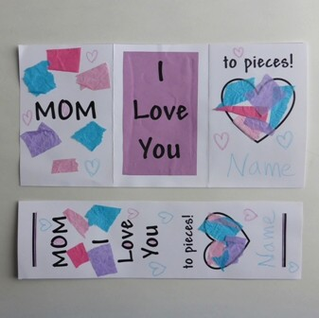
Mother’s Day Card and Bookmark
(Ages 3+, 5 mins)

Supplies Needed:
- Printed Handout
- Scissors
- Crayons/Markers/Colored Pencils
- Stickers or Tissue Paper/Glue

Instructions:
- This craft would make the most sense with ripped up tissue paper pieces, but stickers could also suffice – either way, a huge thanks to all moms!

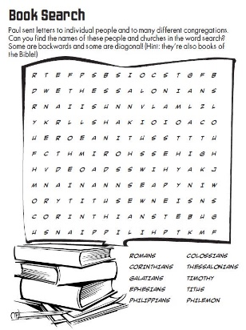
Paul’s Letters Word Search
(Ages 6+, 5 mins)

Supplies Needed:
- Printed Handout
- Pen/Pencil/Marker

Instructions:
- This word search is moderately difficult, but should be fun for most ages – it’s based on Paul’s letters, so is a perfect reinforcement of the lesson.

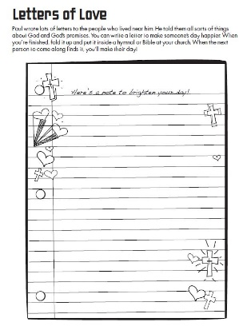
Paul’s Letters Write a Letter
(Ages 6+, 5 mins)

Supplies Needed:
- Printed Handout
- Pen/Pencil/Marker

Instructions:
- You don’t really need a special handout for this, but learning about Paul’s letters is a great opportunity to write some letters of our own. Write an encouraging note to someone you care about – or even a stranger!
Biblical Background – Paul’s Letters

This will be our last Sunday on Paul’s ministry, so it’s worth taking a step back to acknowledge the massive impact that he had on the development and growth of the early church during its formative years – something made all the more remarkable given that Paul never actually met Jesus in person! Here are three of Paul’s most lasting contributions to Christianity:

Mission to the Gentiles
As referenced in the Saul Becomes Paul lesson, Paul wasn’t the first to share Christianity across the Roman empire… but he likely was the most travelled and successful in doing so! Paul travelled an estimated 10,000 miles throughout his missionary journeys and helped to begin and nurture early Christian communities in a time when learning about Jesus would have been nearly impossible to those living across the Roman empire. Paul also was a strong proponent for this “mission to the Gentiles” among the earliest church leaders – the Council of Jerusalem in 49 CE (Acts 15) helped to lay the groundwork for what the church would become over the next several centuries.

Church Growth
It’s almost impossible to determine accurate numbers of how many Christians there would have been in the first few centuries, but the explosion of growth that we see during the 3rd century was only possible because of the work that Paul (and others) did to sow seeds in cities across the Roman empire – starting house churches and equipping leaders in those communities. If we take Acts 1 as a rough starting place, the church had around 120 people when it officially began, 1,000 by the end of Paul’s ministry, and 7,500 by the end of the century.

Earliest Christian Writings
Although the Gospels record the life and ministry of Jesus, every scholar acknowledges that the Gospels were written and compiled several decades later. Paul’s letters, in contrast, are a primary, first-person window into the early days of the church – and over the next several centuries they would continue to circulate and instruct early Christian communities, even before the creation of the New Testament canon in 325 CE.

Your ability to share this info with kids will vary depending on their age – this section is mainly written for teachers and parents to learn a bit more about the background to each week's passage!

