Road to Emmaus May 1, 2022

Bible Verses: Luke 24:13-35
Spark Story Bible: pages 488 to 491
--------------------------------------------------------------------------------------------------

Overall Lesson Takeaways

- Communion helps us recognize Jesus’ presence in our lives.
Although perhaps one of the best-known post-resurrection stories in the New Testament, the “Road to Emmaus” passage can still be confusing for kids: Why didn’t these disciples recognize Jesus when he was walking with them?! Why didn’t they put 2+2 together about what he had previously said about being raised from the dead after three days? Knowing what we know, it does seem hard to believe – but imagine how hard it would have been for them! They did not expect Jesus to be among them – in the same way that we would not expect Jesus to be among us today. But one of the gifts we have been given is the Sacrament of Communion – an opportunity to remember not only Jesus’ final night with the disciples, but also a reminder that Jesus continues to be with us in our lives and a reminder that God’s love for us will never let us go. Whenever we share in communion as a church we too “recognize” those things, along with recognizing that we are part of a much wider body of Christ: the church.
- Are there people today we don’t “recognize”?
As stated in the above paragraph, kids often express confusion about why the disciples couldn’t recognize Jesus – but one of the things this passage always reminds me is there are many people in my life that I do not recognize, both on a literal and metaphorical level. We all encounter people who are strangers to us – or people we think we know but actually don’t – and that runs counter to understanding ourselves as part of a much wider body of Christ. In Matthew 25, Jesus talks about “whatever you have done for the least of these, you have done for me” – and I sometimes think about how we are called to stay curious and compassionate about all our neighbors, recognizing and seeing them for who they are because that’s what Jesus would want.
- The power of sharing a meal with someone.
This is perhaps an overly simplistic reading of this passage, but I do think that there is a lot of truth to the fact that the disciples don’t see Jesus until they stop and share a meal / break bread with him. All of us lead busy lives and our attention always seems to be on at least a few things at once, in no small part from our phones/devices! Whether its social media, mindless web scrolling, games, or watching videos – I spend more time staring at my phone and less time getting to know others than ever before. The disciples, too, were on the move but when they stopped with Jesus – when they sat and ate together – they were brought that much closer together.
Checking In

Before the reading:
- Check in with the kids – welcoming any newcomers warmly.
  - Younger kids: What is one of your favorite things to do in summer?
  - Older kids: Highs and Lows from the past week
- Who is someone who you know really, really well? How far away do you think they could be, but you’d still be able to recognize them?

Bible Lesson / Discussion

Reading the Bible:
- In our passage today, Jesus appears to two disciples after Easter… but they don’t know who he is at first!
- Read the text together, either in the Bible, or the Spark Story Bible.
  - Feel free to stop and ask questions during the reading, if helpful.
  - Afterwards, take time to explore what that passage might mean, and know there's no one correct way to read these passages!

Questions About the Passage (see next page for PreK/K questions)
- Why do you think that the disciples couldn’t recognize Jesus at first? How might Jesus breaking bread with them have helped to remind them?
- Imagine you were walking with Jesus on an almost seven-mile journey – what would you most want to ask him?

Connections to Our Lives
- The disciples didn’t recognize Jesus at first – have you ever experienced someone not recognizing you or looking past you? How did it feel? Have you ever done that to someone else?
- Have you ever taken Communion here at church before? What do you usually think about when you eat the bread and drink the juice? How can Communion help us better know who Jesus is?

Biblical/Church Connections
- Our Kindergarteners received Bibles from the church today – do you remember receiving a Bible when you were that age? How did it feel to be able to read the Bible yourself? What are some of your favorite parts of the Bible to read?

Alternate Preschool and K/1st Questions
Younger ages, particularly those in our preschool class, may have a hard time discussing the biblical text for very long (if at all). My hope is that these questions (and especially the activity) can help with engagement!

Opening Questions
- It is the start of May today – and that means summer is right around the corner! What is one of your favorite things to do in the warmer weather?
- We are going to read a Bible passage where two disciples are taking a really long walk to a village called Emmaus – almost 7 miles away! What is the longest walk you’ve ever taken? Who did you take it with?

Fun Activity
- On their walk to Emmaus, Jesus appears to those two disciples… but they don’t know who he is at first! Sometimes it can be hard to recognize things or people, so I thought it might be fun to play a game and practice!
- Use the “Spot the Difference” handout
  - There are two pictures – an original on top, and a second picture with things that are erased or missing!
  - See if kids can spot all of the differences – there should be 5 in the first picture and 4 in the second (unless I miscounted…)
- Play as long as kids are having fun, then transition to the Bible questions.

Bible Discussion/Questions
- The disciples didn’t know it was Jesus at first, but they finally figure out when they share bread together. Who do you usually eat lunch or dinner with? What do you like to talk about during the meal?
- This passage reminds a lot of people of a special meal we share at church called Communion. We share bread and grape juice to remember Jesus’ last night with the disciples – but also Jesus telling us he’ll always be with us and love us. What are things you share with others to tell them you love them?

People of Faith

In addition to reading our weekly Bible story, I'd love for our older grade school students to learn more about people whose lives were changed by their faith in Jesus. We'll lift up a new person each Sunday, trying to connect their story to our Bible passage as much as possible!

Ding Limei
As we remember the spread of the early church and the challenges those earliest disciples often faced, one modern example is the witness of Ding Limei – a Christian evangelist who travelled across China spreading the gospel.

Born in 1871 in the Chinese province of Shandong, Limei grew up in a Christian household – something that was extremely rare in China at the time. Although little is known about his early life, he was sent at the age of 13 to study at a Presbyterian school – eventually graduating and serving as a teacher for several years before he decided to study theology and become a pastor at the age of 26.

Two years later, in 1898, Limei was officially ordained and he returned home to his native Shandong province, travelling and preaching the gospel. The start of his ministry, though, unfortunately coincided with a massive anti-foreigner, anti-Christian movement in China called the “Boxer Rebellion” (1899-1901). Limei would be arrested and beaten five separate times due to sharing his Christian faith – along with being jailed for 40 days.

At the conclusion of the Boxer Rebellion, Limei emerged with an even greater desire to preach about Jesus. He committed to visit every province in China (18 then, 34 now) as an itinerant preacher, and his preaching soon began to attract hundreds and perhaps even thousands of people to the Christian faith. It is said that he convinced almost 300 people to become pastors themselves, and after almost two decades he was able to visit all 18 provinces in a country slightly larger than the United States!

Eventually, Limei shifted back into his original passion of teaching – working at a newly created seminary in Shandong. Colleagues would later note that he kept a prayer journal of almost 5,000 people whom he prayed for by name each day – an amazing example of the faith and caring which inspired him all throughout his life and ministry.
Crafts / Activities

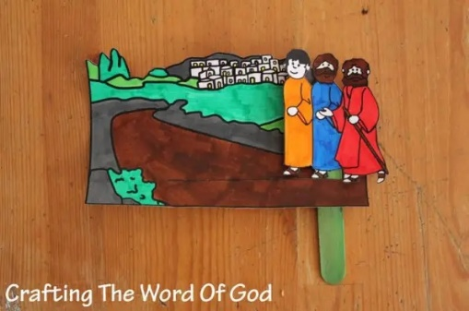
Road to Emmaus Travel Craft
(Ages 3+, 5 mins)

Supplies Needed:
- Printed Handout
- Popsicle Stick
- Scissors/Tape
- Crayons/Markers/Colored Pencils

Instructions:
- Most of the time on this craft will be spent coloring, but what makes this craft really neat is cutting a line through the black line on the road, sliding a popsicle stick through, and attaching the three men so they can “walk”

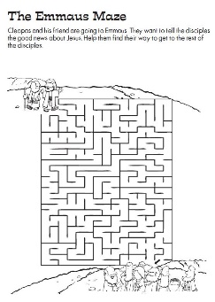
Road to Emmaus Maze
(Ages 5+, 2-4 mins)

Supplies Needed:
- Printed Handout
- Pen/Pencil/Marker

Instructions:
- This maze might be a little complicated for younger ages, but should be a good challenge for multiple ages/grade levels

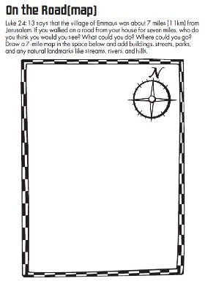
Road to Emmaus Map
(Ages 7+, 5 mins)

Supplies Needed:
- Printed Handout
- Pen/Pencil/Marker

Instructions:
- This craft will likely only work for older ages; using the 7 mile journey these disciples went on, ask kids to draw major landmarks/places of interest in the 7 miles around their home (perhaps including church!)
Biblical Background – Road to Emmaus

As with last week’s passage on “Doubting Thomas”, this “Road to Emmaus” passage is part of a wider series of post-resurrection stories in which Jesus appears to the disciples, often in physical form. These post-resurrection stories were highly valued by the Gospel writers and the early church – Matthew, Luke, and John each include them, and a later writer almost certainly added a handful of appearances to the original ending of the Gospel of Mark.

The “Road to Emmaus” passage only appears in Luke, but Luke seems to have included it to establish two very important things: 1.) a reframing of what Jesus’ role as Messiah looked like, and 2.) establishing the importance of the “breaking of bread” (Communion) as a way of recognizing and knowing Jesus.

We often speak of the disappointment that the crowds felt around Jesus not being a political/military Messiah during Holy Week, but we should note in verse 21 that these disciples are disappointed too: “We had hoped he would be the one to redeem Israel.” No wonder all of the disciples fled once Jesus was arrested and put to death – they thought Jesus’ mission had failed! Luke though, following in the tradition of Mark, takes care to emphasize Jesus’ suffering and death was part of God’s plan – going so far as to reinterpret the Hebrew scriptures to them in verse 27.

This passage is best loved, though, because it is one of the rare biblical texts outside of the Gospels’ descriptions of the Last Supper to depict Communion. Paul’s letter to the 1 Corinthians is certainly the best known, with Paul describing the meaning clearly: “The cup of blessing that we bless, is it not a sharing in the blood of Christ? The bread that we break, is it not a sharing in the body of Christ? Because there is one bread, we who are many are one body.” Despite this, only Luke and Acts make references to the centrality of the “breaking of bread” in early Christian communities – with this passage being the first to appear after Jesus’ celebrated the Last Supper with the disciples. The closing words of the passage – “how [Jesus] had been made known to them in the breaking of the bread” (Luke 24:35) – remain one of the most best ways we can reflect on what communion means: making Jesus better known to us.

Your ability to share this info with kids will vary depending on their age – this section is mainly written for teachers and parents to learn a bit more about the background to each week's passage!

