Feeding of 5,000 March 3, 2024

Bible Verses: John 6:1-14
Spark Story Bible: pages 426 to 431
--------------------------------------------------------------------------------------------------

Overall Lesson Takeaways

- Jesus wants us to help feed others.
Hunger is a powerful need in our world, and some of the stats around hunger are stunning: almost 800 million people around the world are believed to go hungry each day, although the actual stats may be higher. Even here in the United States, over 40 million people are considered “food insecure”, meaning they’re not always sure where their next meal will come from. One of the reasons Jesus performed this miracle is pretty clear: there were 5,000 people who needed help in that very moment. Tackling poverty is the long-term solution to addressing hunger, but we try to help with urgent hunger needs through our bagged lunch program and Sunday and Monday Night Suppers, along with our food pantry.
- Remembering how God provides for those in need.
The feeding of the 5,000 contains some important biblical echoes from the Old Testament as well, both in manna and from a few prophets. The account of God providing manna for the Israelites in the wilderness is an important echo in this story, particularly given the other ways that Jesus’ life echoes Moses in Matthew and Luke’s Gospel. But the clearest parallels come from the prophets Elijah and Elisha – in 1 Kings 17:8-16, Elijah provides a week’s worth of food from a meager supply, and in 2 Kings 4:42-44, Elisha feeds 100 men in a similar fashion. Recalling the greatest leader (Moses) and the greatest prophet (Elijah) is important for both Matthew and Luke as they make the case that Jesus is even greater than these two.
- We are more than enough to make a difference in the lives of others.
Finally, there’s the sermon interpretation: that this miracle is not only about feeding hungry bellies – it’s a reminder that even when we feel what we have to give isn’t enough, sometimes through God’s help it can be enough and more. Whoever donated those five loaves and two fish probably never thought that what they were giving would make a difference, or even a dent, in the hunger around them – but when they offered what they had, it was enough. To me, this account always reminds me that when I am called to give or share what I have, whether it’s time, money, energy, or creativity – even if I don’t feel like it’s enough, I should still give trusting that God can use it in amazing ways. The world needs people who are generous and willing to give of their time, money, energy, and creativity – and we believe and trust that through sharing those things, we are helping God work for good in this world!
Checking In

Before the reading:
- Check in with the kids – welcoming any newcomers warmly.
  - Younger kids: What is something you’re excited for this Spring?
  - Older kids: Highs and Lows from the past week
- When was the last time that you were really, really hungry? How did it feel? How glad were you when you finally ate!?

Bible Lesson / Discussion

Reading the Bible:
- Today, we are learning about an amazing miracle that Jesus did for a crowd – helping around 5,000 people get something to eat!
- Read the text together, either in the Bible, or the Spark Story Bible.
  - Feel free to stop and ask questions during the reading, if helpful.
  - Afterwards, take time to explore what that passage might mean, and know there's no one correct way to read these passages!

Questions About the Passage (see next page for PreK/K questions)
- People were really surprised by Jesus’ miracle – it’s even hard for us to understand! What would you have said if you were there?
- The boy in the passage was giving away all the food he had – have you ever given up something you really wanted for someone else? How did you feel afterwards?

Connections to Our Lives
- What is the largest crowd that you’ve ever been in? How much food do you think it would have taken to feed that many people?
- There is a lot of hunger in our world today… does it ever feel like you don’t have enough to help? What can we learn from the boy who shared the loaves and fishes in our Bible passage today?

Biblical/Church Connections
- Charity is a theme that often gets lifted up during Lent, which comes from the Latin word for ‘unconditional love’. Why would caring for others and providing for their basic needs be an important part of the Lenten season?

Alternate Preschool and K/1st Questions
Younger ages, particularly those in our preschool class, may have a hard time discussing the biblical text for very long (if at all). My hope is that these questions (and especially the activity) can help with engagement!

Opening Questions / Activity
- Take some time to welcome / get to know the kids!
  - We are nearing the start of the season of Spring! What are you excited to do with warmer weather?
  - When was the last time that you were really, really hungry? How did it feel? How glad were you when you finally ate!?

Warm Up Game – Yum, Yum, Food!
- In our passage today, we are learning about an amazing miracle that Jesus did for a crowd – helping around 5,000 people get something to eat when they were feeling really, really hungry.
- We are going to play a silly game pretending to be hungry… we’re going to play “Duck, Duck, Goose”, but instead we’re going to call it “Yum, Yum, Food”. Have kids sit in a circle and pick someone to be it – they tap people’s heads saying “Yum”, until they say “Food”. That person gets up and chases after them – pretending to be hungry and trying to get food!
- Is this ridiculous? Yes. But hopefully it will be a fun variation for kids… once they have finished, you can read the Spark Bible passage and transition to the Bible questions.

Bible Discussion/Questions
- Read the text together, either in the Bible, or the Spark Story Bible.
  - Feel free to stop and ask questions during the reading, if helpful.
  - Afterwards, take time to explore what that passage might mean, and know there's no one correct way to read these passages!

- Have you ever been around a lot of people – like in a crowd – before? How much food do you think it would have taken to feed everyone?
- People were really surprised by Jesus’ miracle – it’s even hard for us to understand! What would you have said if you were there?
- How can we be like the boy who shared his food? What are things that we could share with other people who need them?
People of Faith

In addition to reading our weekly Bible story, I'd love for our older grade school students to learn more about people whose lives were changed by their faith in Jesus. We'll lift up a new person each Sunday, trying to connect their story to our Bible passage as much as possible!

Ivone Gebara (pronounced Ee-vohn Guh-ba-rah)
In a time of increasing food scarcity and issues around the world related to climate change, it is worth spending times listening to voices within our modern Christian tradition like Ivone Gebara – a Catholic nun and feminist theologian.

Born in Sao Paulo, Brazil in 1944, Gebara’s parents were first-generation immigrants from Lebanon. Gebara’s family was Catholic – and, although her family was middle-class, she became deeply concerned by the poverty that she saw around her. After graduating with a degree in philosophy, Gebara made the decision to become a nun – joining a local Augustinian order at the age of 22.

Gebara would go on to earn a doctorate in philosophy from a Catholic university in Sao Paulo, moving to the urban area of Recife – a large city in the Northeast of Brazil where she still resides today. Gebara began teaching at the Theological Institute of Recife, a school that became widely known for its work with liberation theology (emphasizing how the Bible speaks to those who are oppressed) and speaking out forcefully against the Catholic Church.

The Vatican would eventually convict her of criticism of the moral teachings of the church, ordering her to be publicly silent for two years. Gebara used this time to earn a second doctorate, eventually leading to her first book Longing for Running Water: Ecofeminism and Liberation. In it, she wrote: “I have begun to see more clearly how the exclusion of the poor is linked to the destruction of their lands, to the forces that leave them no choice but to move from place to place in ceaseless exile, to racism, and to the growing militarization of their countries… those who have diminishing access to green things and clean water; of those who breathe an even greater amount of the pollution that has spread”.

Gebara’s work is challenging, but she insists that the church is called first and foremost to care for and advocate for those who are poor – and, in particular, the way our abuse of the environment has caused harm and suffering.
Crafts / Activities

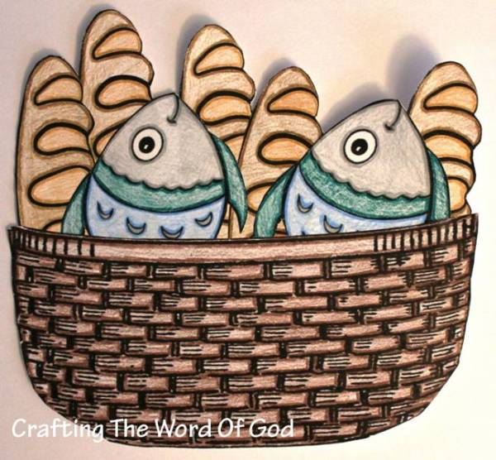
Feeding of 5,000 Food Baskets
(Ages 5+, 5-10 mins)

Supplies Needed:
- Printed Handout
- Scissors/Tape
- Markers/Crayons

Instructions:
- This craft will take a fair amount of cutting if you want the full 5 loaves and 2 fishes, but the idea is to create/color a reminder of this miracle!

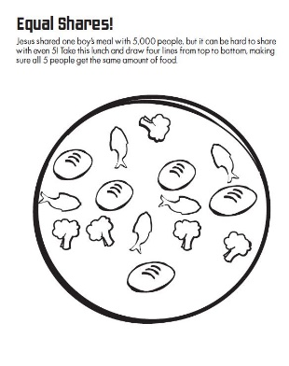
Feeding of 5,000 Picture Puzzle
(Ages 5+, 3-5 mins)

Supplies Needed:
- Printed Handout
- Pen/Pencil/Crayons

Instructions:
- This puzzle asks you to use 4 lines to divide the food into 5 piles of 3 items – it is deceptively difficult (impossible?) if straight lines are required!

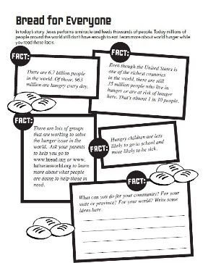
Feeding of 5,000 Food Facts
(Ages 7+, 5 mins)

Supplies Needed:
- Printed Handout
- Pen/Pencil/Crayons

Instructions:
- This activity isn’t really a craft; it’s a way to talk about hunger around the world today - and to brainstorm ways that we can help feed others.
Biblical Background – Feeding of the 5,000

Although the scripture passage listed today is from the Gospel of John, you might be surprised to learn that the Feeding of the 5,000 is the only miracle (aside from Jesus' resurrection) that appears in all four Gospels! John’s Gospel is the only one to record the wonderful detail about the young boy who shares the loaves and fishes – the others make no note about where they come from – but the vast majority of this passage is the same… which is equally surprising!

If you've ever read through the Gospel of John, you're aware of the ways in which it differs from the three "Synoptic" Gospels of Matthew, Mark, and Luke. In John, Jesus is abundantly clear about his divine identity, gives long speeches to the disciples, and has several encounters with individuals that don't appear in the other gospels (Nicodemus, Samaritan woman, etc.). Scholars have long identified that John clearly must have had access to written sources that the other Gospel writers did not – and one of these major sources is the "Signs" source. John occasionally notes that Jesus performed a certain miracle as a "sign" – this happens with miracles such as the famous 'water into wine' passage, as well as the 'raising of Lazarus'. However, while those miracles that were just named are unique to John, this feeding of 5,000 miracle is among those included in Jesus' seven central signs.

So, what is it about this miracle that is so fundamental to Jesus' identity that every single Gospel writer chose to include it in their Gospel? I'd obviously lift up the lesson takeaways on the first page as possible explanations, but for me it speaks to the intersection between human need and divine caring that all of us are called to. We are sometimes prone to making Jesus' ministry and teachings more abstract than they should be – I'm as guilty of that as anyone – but sometimes the best way for us to recognize God's divine presence is through connecting deeply with someone else's humanity. By feeding the multitude, Jesus demonstrated the very love and caring that he came to proclaim. The question for us is: what are our lives proclaiming? It's a question that gnaws at me every time I hear/read this miracle… how am I living out that abundance and generosity that Jesus so clearly proclaims?

Your ability to share this info with kids will vary depending on their age – this section is mainly written for teachers and parents to learn a bit more about the background to each week's passage!

