Maundy Thursday March 21, 2021

Bible Verses: John 13:1-15
Spark Story Bible: pages 462 to 467
--------------------------------------------------------------------------------------------------

Overall Lesson Takeaways

- Jesus’ washing of the disciples’ feet – a sign of humble service
Although it only appears in John’s account of Jesus’ final night with the disciples, Jesus’ washing of the disciples’ feet has come to be synonymous with the ‘new commandment’ that Jesus gives to “love one another just as I have loved you” in John 13:34. Feet in the ancient world would have been – in a word – gross. Most people travelled on dirt roads in footwear that paled in comparison to what we have today, and so it’s no wonder that people’s feet were considered ritually unclean. But despite the religious (and practical!) reasons why this shouldn’t have happened, Jesus – their leader and teacher – washed the disciples’ feet as a sign of humility and service. This example is a beautifully simple encapsulation of the sort of radical love that Jesus came into the world to witness to, though it would soon pale in comparison to the even larger sacrifice that he would make on the cross.
- Jesus breaks bread and shares a cup – a sign of shared community
Although downplayed a bit in John’s gospel, the Last Supper (aka Communion, Eucharist, Lord’s Supper, etc.) is central in Mark, Matthew, and Luke’s Gospels to understanding this evening. Jesus lifts up a loaf of bread as his body and a cup of wine as his blood, both as a symbol of his impending death, but more importantly a symbol of God’s impending kingdom and how all people are “one body and blood” through Christ. The Sacrament of Communion was practiced from the earliest days of the church and was understood to contain layered meanings about past (Last Supper), present (our unity), and future (coming of God’s kingdom) – understandings that continue to inspire us in our worship services today.
- Jesus prays in the garden and is arrested – a sign of self-giving love
John’s Gospel continues with Jesus’ final address to the disciples, but Mark, Matthew, and Luke’s Gospels recount Jesus praying in the Garden of Gethsemane before Judas arrives with a group of religious leaders and temple security to arrest him. Although heartbreaking, this part of the evening is important both for understanding Jesus’ betrayal by one of his own disciples, as well as how we arrive at the tragic trial and crucifixion of Jesus on Good Friday. Jesus’ willingness to be taken into custody is an example and witness of the depth and love that he had for the disciples and for us. Indeed, Maundy Thursday begins and ends with these incredible acts of service – and these acts can inspire us to serve others today!
Checking In

Before the reading:
- Check in with the kids – welcoming any newcomers warmly.
  - Younger kids: It’s first day of Spring… share Spring Break plans!
  - Older kids: Highs and Lows from the past week
- We are learning about Jesus’ last night with the disciples today – if you could pick one last meal, what would you eat?

Bible Lesson / Discussion

Reading the Bible:
- Jesus’ last night with the disciples was about the example he showed to them – both in how to serve one another, and in sharing Communion
- Read the text together, either in the Bible, or the Spark Story Bible.
  - You’ll need to screen share the passage for the day in Zoom.
  - Feel free to stop and ask questions during the reading, if helpful.
  - Afterwards, take time to explore what that passage might mean, and know there's no one correct way to read these passages!

Questions About the Passage (see next page for PreK/K questions)
- Why do you think Jesus washed the disciples’ feet? What was he trying to demonstrate to them?
- Why do you think Jesus shared the same loaf of bread and same cup with everyone? What does they say about how close they were?
- How do you think Jesus was feeling knowing that this was his final night with the disciples? Why did he choose to spend it this way?

Connections to Our Lives
- Have you ever taken Communion before? What do you remember about it? Why is it so important that we share Communion together at church?
- “Serving, Sharing, Loving” is an easy way to summarize what Maundy Thursday is – what are ways that we can does those things in our lives?

Biblical/Church Connections
- Our final Lenten theme as we get ready for Holy Week is the idea of “faithfulness” – a word meaning that someone/something will always be there. How can Communion or serving other people remind us that Jesus is always with us?
Alternate Preschool and K/1st Questions
Younger ages, particularly those in our preschool class, may have a hard time discussing the biblical text for very long (if at all). My hope is that these questions (and especially the activity) can help with engagement!

Opening Questions
- It was Jesus’ last night with the disciples so he had a big meal with them – what is one of your favorite meals?
- Jesus had a lot to talk about with the disciples over their dinner – what does dinner look like in your home? Who’s at the table and what do you talk about together?

Fun Activity
- Before we keep talking about Jesus’ last night with the disciples on Maundy Thursday, I thought it would be fun to play a game where we had to really good at noticing things: Spot the Differences
- (Explain that you’re going to put up a picture and give the kids one minute to look at it. After the minute is up, you’re going to switch to a similar picture but there are 3 things different about it):
  - Screen Share Original Picture 1
  - Screen Share Different Picture 1
    - There’s a sun in #2, Jesus has no mouth, and there’s no water
  - Screen Share Original Picture 2
  - Screen Share Different Picture 2
    - There’s no bread, no cups on the table, and one of the disciples is missing his body!
- Play as long as kids are having fun, then transition to the Bible questions.

Bible Discussion/Questions
- Jesus washing the disciples’ feet really surprised them! Pretend you were a disciple who was there – what would you have said if Jesus tried to wash your feet?
- Jesus shared the communion meal with the disciples to let them know how much he loved him. How does your family let you know that you are loved? How do you show love to other people?

People of Faith

In addition to reading our weekly Bible story, I'd love for our older grade school students to learn more about people whose lives were changed by their faith in Jesus. We'll lift up a new person each Sunday, trying to connect their story to our Bible passage as much as possible!

Jacqui Lewis
On a day when we are learning about Jesus’ final night with his disciples – and the simple, transformative meal that he shared with them – it’s important to remember that the message and meaning behind Communion is still just as powerful today… as evidenced by the way it changed Jacqui Lewis’ life!

Lewis grew up in South Chicago and her family attended a small Presbyterian church each week. When she was 8 years old, she was allowed to have Communion for the first time. Her mom was sitting beside her, helping to explain the meaning behind the sacrament – “this bread means God will always love you” and “this cup means that God will never leave you”.

From that moment on, Lewis felt a powerful sense of love in the church – but unfortunately she also became aware of the hate present in the world when Martin Luther King Jr. was assassinated just a few months later. Lewis decided that she would find a way to help fight against racism and poverty like Dr. King had – and she chose to become a pastor.

Unfortunately, her church had never had a female pastor before and she heard over and over that she wouldn’t be able to preach or to go through seminary. At the age of 30, though, she decided that she would follow her dream – and she not only became ordained, but she also earned a Ph.D writing about leadership and how multi-racial communities can fight against racism and poverty.

Amazingly, one of the congregations that she had been studying in her research – Middle Collegiate Church – was looking for a pastor and she joined their staff, eventually becoming the Senior Minister. Lewis regularly appears on TV, writes articles, does podcasts, and had written two books – both of which are about trying to grow multi-racial churches and demonstrating God’s love out in our communities. Lewis is trying to bring that same experience she had during Communion out into the entire world – helping them to know God’s love for all.
Crafts / Activities

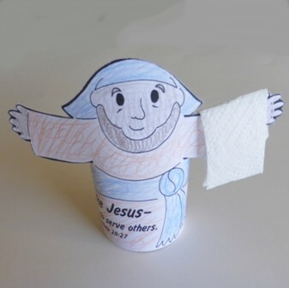
Maundy Thursday Jesus Tube
(Ages 5+, 5 mins)

Supplies Needed:
- Printed Handout
- Toilet Paper Tube
- Crayons/Markers/Colored Pencils
- Scissors and Tape

Instructions:
- Have kids print and color the handout, followed by cutting out the area around Jesus arms and head. You can then attach the bottom portion to a toilet paper tube for stability… and add a little paper towel for effect!

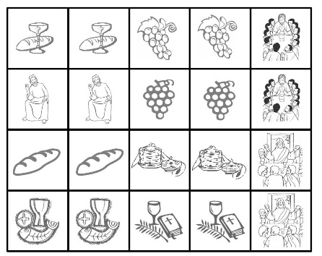
Maundy Thursday Card Match Game
(Ages 3+, 5-10 mins)

Supplies Needed:
- Printed Handout
- Crayons/Markers/Colored Pencils
- Scissors

Instructions:
- Kids can color the cards beforehand, or they can cut them out immediately and start playing – just a simple game of finding matches!

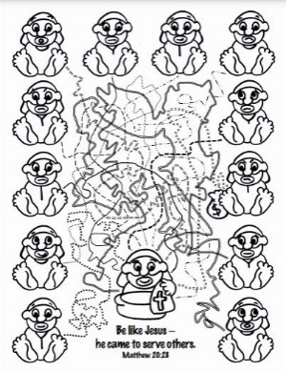
Maundy Thursday Follow the Lines
(Ages 5+, 5-10 mins)

Supplies Needed:
- Printed Handout
- Crayons/Markers/Colored Pencils

Instructions:
- Although not terribly complicated, you should encourage kids to use different colors for each of the lines – the end result is kind of a mess, but hopefully it will be entertaining along the way!
Biblical Background – Maundy Thursday

Although our lesson this week is fast-forwarding in time a bit, it’s important to touch on one of the most important days of our year: Maundy Thursday and Jesus’ Last Supper with the disciples. Although occasionally confused by kids as “Monday Thursday”, as well as being the subject of some etymological debates, the word maundy is widely believed to first have its roots in the Latin word mandatum or ‘commandment’ – connected to Jesus’ washing the disciples’ feet.
Maundy Thursday is defined by service and servant leadership, but perhaps no aspect of Jesus’ final night with his disciples is better known than the meal he shared with them – now known as Communion, Eucharist, or the Last Supper.

Although there has long been confusion around the Gospel of John’s timeline of events, all three Synoptic Gospels connect Jesus’ final meal with his disciples to the seder eaten at the start of every Passover. Passover was perhaps one of the most sacred days within Judaism – remembering the events of the Exodus from Egypt (and in particular the “passing over” of Jewish households with the tenth and final plague in Exodus 12) – and it was one of three “pilgrimage” festivals in which people were commanded to travel to the Temple in Jerusalem.

However, while the Passover seder plate has several highly specific foods that invoke memories of various aspects of the Exodus, the gospels show Jesus radically simplifying this meal of remembrance down to two elements: bread and wine. Both these elements did point towards Jesus’ imminent death – “my body given for you” and “the new covenant in my blood” – and a connection with the “Passover lamb” was not lost on the gospel writers (particularly John). Communion, though, rapidly evolved away from the meanings present in the seder meal – instead forming a new, complex tradition out of these two simple elements that reminded Christians not only of Jesus breaking bread that night, but of his death, resurrection, and future hope. Maundy Thursday, then, is both particular and universal – dealing both with mundane acts of service, as well as Jesus’ salvation for all humankind.

Your ability to share this info with kids will vary depending on their age – this section is mainly written for teachers and parents to learn a bit more about the background to each week's passage!

