Zacchaeus March 10, 2024

Bible Verses: Luke 19:1-10
Spark Story Bible: pages 400 to 405
--------------------------------------------------------------------------------------------------

Overall Lesson Takeaways

- Thinking about equity and fairness.
Most kids have fine-tuned sensors about what is “fair” and what is not – nothing will start an argument faster among a group of kids than taking something that doesn’t belong to you, or inequitably distributing something (especially between siblings)! Back in Jesus’ time, tax collectors were notorious for doing things that would not be considered fair: cheating, stealing, skimming money, and more. You can read more about what Zacchaeus and his fellow tax collectors likely would have been doing in the Biblical Background section, but this passage can serve as a conversation-starter about things in our society today that are not fair or equitable. Your mileage may vary on the topic that you explore – older students may talk about things that contribute to social inequality, while younger students may just focus on individual behavior.
- We should always believe that people can change.
Despite Zacchaeus’ profession and misdeeds, his conversations with Jesus do have a profound impact on him. After Jesus shares a meal with him, Zacchaeus states that he will give half his possessions to the poor, and pay back four times as much to anyone he stole from. This fourfold restitution is grounded in laws from Exodus 22, but it is clear that Zacchaeus recognizes the hurt and harm that he has caused over the years and wants to make it right. Often times we fall into the trap of viewing people through a single lens based off our initial experience of them, rather than giving them space to change and grow. Those in the crowd grumble that Jesus is going “to be the guest of one who is a sinner”, but Jesus reminds us at the end that “the Son of Man came to seek out and save the lost”. In his response to Jesus, Zacchaeus reminds us that it is possible for people to change – and we are asked to give that same sort of grace to others who our worst impulses would rather just write off.
  - This passage highlights the Lenten theme of “repentance”.
The season of Lent is often defined by prayer and fasting, but repentance is also a crucial aspect of this season. Repentance is sometimes a difficult concept for kids to wrap their minds around, but for older students it may be a window into talking about how our lives and actions affect ourselves and those around us – and that we are called to recognize when those actions are doing more harm than good. To repent is to turn away from ingrained patterns in our daily life that are hurting ourselves and others – and sometimes it means thinking about things we may not even be aware of.
Checking In

Before the reading:
- Check in with the kids – welcoming any newcomers warmly.
  - Younger kids: What is the best part about being a kid?
  - Older kids: Highs and Lows from the past week
- Has something ever happened to you that you thought was really unfair? What happened, and what made it so unfair?

Bible Lesson / Discussion

Reading the Bible:
- Today, we are learning about a man named Zacchaeus who was cheating people – and how Jesus helped him understand the hurt he was causing.
- Read the text together, either in the Bible, or the Spark Story Bible.
  - Feel free to stop and ask questions during the reading, if helpful.
  - Afterwards, take time to explore what that passage might mean, and know there's no one correct way to read these passages!

Questions About the Passage (see next page for PreK/K questions)
- If Zacchaeus had stolen money from you, what would you say to him? What would you say about Jesus having dinner with Zacchaeus?
- Do you think Zacchaeus saying he was sorry and giving the money back to people was good enough? Or would you have asked him to do more?

Connections to Our Lives
- Zacchaeus’ job as a tax collector allowed him to do things that weren’t fair – what are some things you’ve noticed at school or where you live that don’t seem very fair? Are there ways to change that?
- Do you think it’s possible for people to immediately change how they treat other people? Or do you think it takes time?

Biblical/Church Connections
- It’s not a word we use very often, but Lent is a time of “repentance” – meaning a time when we try to recognize when something we are doing is hurting ourselves and others, and we try to change it. Is it hard to change a bad habit? What could help you change?

Alternate Preschool and K/1st Questions
Younger ages, particularly those in our preschool class, may have a hard time discussing the biblical text for very long (if at all). My hope is that these questions (and especially the activity) can help with engagement!

Opening Questions / Activity
- Take some time to welcome / get to know the kids!
  - What is the best part about being a kid?
  - Our Bible story talks about someone being too short to see over the crowd. Have you ever gotten up on your parents’ shoulders to see over a crowd? What is it like being up that high?

Warm Up Game – Would You Rather?
- Explain that this will just be a simple game where everyone gets to vote on what they’d rather have/do by raising their hand:
  - If you could only eat one type of dessert for a year, would you rather have ice cream or cookies?
  - If you could go somewhere fun today, would you rather go to an indoor waterpark or a zoo?
  - If you could have a superpower, would you rather be really, really fast or really, really strong?
  - Would you rather be able to make up a new holiday, or make up a new language?
- Talk as long as kids are having fun, then transition to the Bible questions.

Bible Discussion/Questions
- Our Bible passage today is about Jesus helping teach someone to be fair. What does being fair mean? How would you feel if someone took something away from you without asking?
- Read the text together, either in the Bible, or the Spark Story Bible.
  - Feel free to stop and ask questions during the reading, if helpful.
  - Afterwards, take time to explore what that passage might mean, and know there's no one correct way to read these passages!

- Zacchaeus wasn’t being fair to others when he was taking their money – pretend that you are Jesus telling him that he shouldn’t do that. What would you say? Why is being fair so important?

People of Faith

In addition to reading our weekly Bible story, I'd love for our older grade school students to learn more about people whose lives were changed by their faith in Jesus. We'll lift up a new person each Sunday, trying to connect their story to our Bible passage as much as possible!

Kizzmekia Corbett
As we cross the two-year mark of the pandemic, it is important to celebrate people who have been heroes in the fight against Covid-19 – and one of them, professor/immunologist Kizzmekia Corbett, was inspired to do so by her faith!

Born in North Carolina in 1986, Kizzmekia “Kizzy” Corbett was recognized as an excellent student from an early age – soon being placed in advanced classes. In high school, she decided that she was interested in a career in science – and she was accepted into the Meyerhoff Scholars Program at UMBC in Maryland, a program intended to increase the representation of minority students in STEM (Science, Technology, Engineering, and Mathematics).

After graduating, Corbett became a biological sciences trainer at the National Institute of Health, where she would study antibody responses in SARS and dengue fever – the latter of which became the subject of her doctoral dissertation. By the age of 28, she had began work as a viral immunologist with the NIH – including work on coronavirus spike proteins several years before Covid-19 existed!

Her work in that area would prove to be vital as she helped lead a team of immunologists to develop a vaccine in just 66 days! In fact, Dr. Anthony Fauci would later reflect that Corbett had “been central to the development of the Moderna mRNA vaccine” and “her work will have a substantial impact on ending the worst respiratory-disease pandemic in more than 100 years.”

Despite her amazing work, Corbett has remained humble -- “Actually, before I’m a scientist, I’m a Christian” she has said in interviews, and reading about how Jesus cared for others was a big inspiration in her work. As she reflected at the start of the vaccine’s development “To be living in this moment where I have the opportunity to work on something that has imminent global importance…it's a surreal moment for me” and her work has helped millions, or perhaps billions!
Crafts / Activities

Zacchaeus Find The Match
(Ages 5+, 5 mins)

Supplies Needed:
- Printed Handout
- Pen/Pencil/Crayons

Instructions:
- Instruct kids to circle any item that has an identical match on the page (there are quite a few of them!) – and count the total matches at the end.

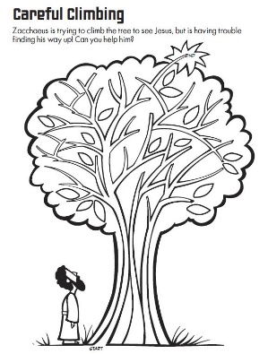
Zacchaeus Tree Maze
(Ages 5+, 2-3 mins)

Supplies Needed:
- Printed Handout
- Pen/Pencil/Crayons

Instructions:
- This maze is moderately challenging, but hopefully kids ages 5 and up will have fun with it.

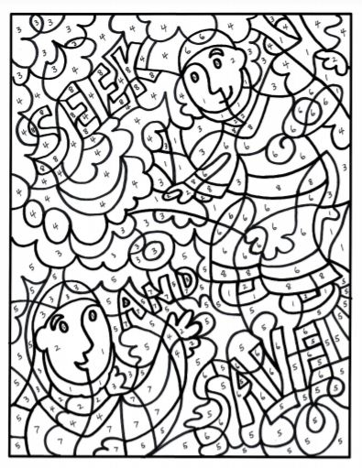
Zacchaeus Color By Number
(Ages 5+, 10 mins)

Supplies Needed:
- Printed Handout
- Crayons/Markers/Colored Pencils

Instructions:
- Although it could also just be used as a simple coloring sheet, the illustrator used a simple number code to list out eight different colors that should appear in the picture. This one will take some time to complete!
Biblical Background – Zacchaeus

Although the Zacchaeus passage can certainly be understood without additional context, learning more about the role that tax collectors played in society can help explain why they had such a bad reputation in the Bible – and can help kids understand why people really didn’t like Zacchaeus very much!

Like most empires throughout history, the Roman Empire was eager to receive taxes from the people and countries that they conquered. The logistics of doing this individually on an empire-wide scale, though, was too much for even the advanced Roman bureaucracy to handle. Instead, they devised a system in which tax collectors (publicani) would make bids about how much tax they could collect from a specific region, and then those tax collectors would be responsible for ensuring that they obtained those taxes from individuals – as well as being allowed to keep any extra cash they received beyond their bid.

It won’t shock you to learn that the system was abused by these tax collectors. Although the practice changed over time, publicani routinely charged people well more than what their tax bill should have been, in large part because they had the power to tell the Romans that someone wasn’t paying their taxes and it would get them in trouble!

To help kids understand, you could share the following scenario: you have a $20 allowance, but if you don’t pay $5 in taxes, then you’ll be thrown in jail. You might complain about it, but you’d pay. Now imagine that you knew the price was $5, but the tax collector asks for $8 – $5 for Rome and $3 for him… and if you refuse to pay, he’ll tell Rome that you didn’t pay your taxes at all. Not fair!!

The scenario above can help explain why people didn’t like Zacchaeus at all – and why it was really important for Jesus to help Zacchaeus acknowledge that what he was doing was hurting other people for his own benefit, and to help make things right by giving the money back to those that he stole from.

Your ability to share this info with kids will vary depending on their age – this section is mainly written for teachers and parents to learn a bit more about the background to each week's passage!

