The Boy Teacher January 9, 2022

Bible Verses: Luke 2:41-52
Spark Story Bible: pages 230 to 233
--------------------------------------------------------------------------------------------------

Overall Lesson Takeaways

- We can all teach others – kids included!
Jesus’ divine wisdom obviously gives him a bit of an advantage, but it’s safe to say that this passage can serve as a wonderful reminder that kids often do have a great deal to teach adults – even if we sometimes forget that important truth. From their incisive questions, their joy and optimism, and many other admirable qualities, kids are often able to see the world in a different way from adults – and that can be of great benefit. There is no doubting that the temple in Jerusalem would have contained some of the finest scholarly minds in Israel – but even from a young age Jesus had no compunction about taking on the views of the scribes and Pharisees. It’s an interesting reflection for those of us who have kids old enough to ask piercing questions about the world and how it works, such as: “Why are things so inequal and unfair in our world?” or in pointing out ways that we don’t always practice what we preach. Perhaps this passage is a reminder that we are called to listen and learn!
- What makes someone a good teacher?
I’m sure that all of us have been in a classroom with someone who we would consider to be a great teacher – and our passage today is the first time Jesus demonstrates in the Gospels that he is going to be a great teacher. There are obvious qualities like wisdom and being a good public speaker that help him – but the Bible also notes that Jesus listened to everyone there and asked questions as well. Part of being a great teacher is always being curious and continuing to learn, as well as having the humility to know that you don’t have all of the answers. This passage can be an entry point to talking about the way that both teaching/learning happens – and ways that all of us can be both good teachers and students.
- Have a plan if you ever get separated from your family!
This is perhaps a little in the weeds when it comes to drawing out themes from a Bible passage, but I’m guessing that most kids have had the experience of getting separated, lost, or being left behind from their family… although hopefully not for an entire day like Mary and Joseph! Those moments are really scary, but it can be a good reminder that we shouldn’t panic – and we can come up with plans about what to do in those types of scenarios: from remembering parents’ phone numbers, to looking for adults like teachers, leaders, police officers or others who can help you find your family.

Checking In

Before the reading:
- Check in with the kids – welcoming any newcomers warmly.
  - Younger kids: What was your favorite Christmas gift you received?
  - Older kids: Highs and Lows from their past week
- Have you ever wondered what Jesus would have been like as a child? Do you think he would have been easy to talk to?

Bible Lesson / Discussion

Reading the Bible:
- Today, we are reading the only story in the Bible about Jesus as a child – about a time his family made a visit to Jerusalem and he went missing!
- Read the text together, either in the Bible, or the Spark Story Bible.
  - Feel free to stop and ask questions during the reading, if helpful.
  - Afterwards, take time to explore what that passage might mean, and know there's no one correct way to read these passages!

Questions About the Passage (see next page for PreK/K questions)
- How would you have felt if you were Jesus and you were left behind? How about Mary/Joseph having lost track of Jesus?
- Even though he was a child, Jesus was teaching adults – surprising everyone! What does this passage tell us about who Jesus is?

Connections to Our Lives
- Jesus was teaching adults at the temple about the Torah, or first five books of the Bible… is there any subject you know a lot about? Would you ever feel comfortable teaching in a room full of adults?
- Are there things that kids are better at than adults? What could you teach adults? (My thoughts: asking questions, being joyful, trying new things)
- What makes someone a good teacher? What are ways that we can be teachers to others in our lives (adults, siblings, friends, etc.)?

Biblical/Church Connections
- Today is “Baptism of the Lord” Sunday – part of the wider season of Epiphany in which we are learning more about who Jesus is. Why do you think baptisms are so important at church? What do you think being baptized means? (Share that we’ll be learning all about it next Sunday!)
Alternate Preschool and K/1st Questions
Younger ages, particularly those in our preschool class, may have a hard time discussing the biblical text for very long (if at all). My hope is that these questions (and especially the activity) can help with engagement!

Opening Questions
- How did your family celebrate Christmas this year?
- What were some of your favorite presents that you received?

Fun Activity
- After Advent and Christmas, we begin an entirely new season of our church year called Epiphany. Epiphany is a time to learn more about Jesus – and in our passage today, we are reading the only story in the Bible from when Jesus was a child!
- Life would have been a lot different for kids back in Jesus’ time – they would have had to come up with silly games since there weren’t many toys or things to do. What is one of your favorite games?
- Play a game or two based on kids’ suggestions, or use the following:
  - Hot Potato
  - Simon Says
  - Duck, Duck, Goose

Bible Discussion/Questions
- In our Bible passage today, Jesus and his family were travelling… and his parents realized Jesus was missing! Have you ever been lost before? How do you think Jesus felt – and how did his parents feel?
- Even though he was a child, Jesus was teaching a room full of adults! Who are your teachers? What makes someone a good teacher?
- Have you ever taught someone how to do something (sibling, friend, etc.)? How did you teach them?

People of Faith

In addition to reading our weekly Bible story, I'd love for our older grade school students to learn more about people whose lives were changed by their faith in Jesus. We'll lift up a new person each Sunday, trying to connect their story to our Bible passage as much as possible!

Eugene Peterson
One of the gifts of Jesus’ ministry is that he tried to make his teachings known and heard by all people – and our person of faith today, Eugene Peterson, wanted to make sure that Jesus’ message continued to be known and heard.

Born in Washington in 1932, Peterson proved early on to be an excellent student – going on to receive multiple Bachelor’s degrees in philosophy and theology, followed by a Master’s degree in Semitic languages (the family of languages that Hebrew belongs to).

Despite his academic prowess and success, though, Peterson felt called into ministry rather than academia – and at the age of 30, he founded Christ Our King Presbyterian Church in Bel Air, Maryland. Peterson would serve that congregation for almost 30 years – finding great joy as a pastor and leader, while also writing several books as he neared the end of his pastorate.

After he “retired”, though, Peterson went on to produce the work that he is best known for: The Message, a Bible translation using more modern language while still trying to capture the original content and meaning of the Greek and Hebrew. In Peterson’s words: “When Paul of Tarsus wrote a letter, the people who received it understood it instantly, When the prophet Isaiah preached a sermon, I can't imagine that people went to the library to figure it out. That was the basic premise under which I worked. I began with the New Testament in the Greek — a rough and jagged language, not so grammatically clean. I just typed out a page the way I thought it would have sounded to the Galatians”.

Peterson worked on this translation for almost a decade, eventually translating the entire Bible into his particular brand of conversational English. The Message can sound strange at times for those used to reading other biblical translations, but it is a great example of someone using their abilities as a pastor and translator to make the biblical text accessible to all people.
Crafts / Activities

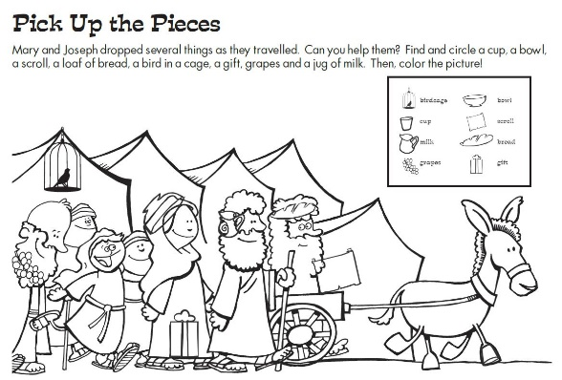
The Boy Teacher Image Search
(Ages 3+, 3-5 mins)

Supplies Needed:
- Printed handout
- Pen/Pencil/Crayons

Instructions:
- This activity should work for a variety of ages; kids will need to circle and locate the 8 “missing” items hidden in the picture – and younger children can also use this as a coloring page as well!

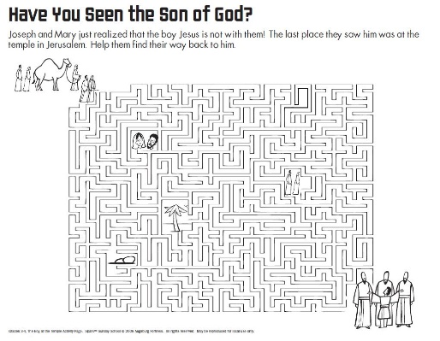
The Boy Teacher Maze
(Ages 7+, 5-10 mins)

Supplies Needed:
- Printed Handout
- Pen/Pencil/Crayons

Instructions:
- A fitting challenge for a Sunday in which Mary and Joseph think that Jesus is lost! This maze is very tricky, but hopefully older kids will have fun!

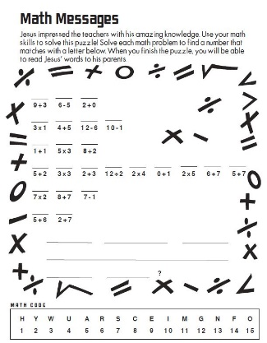
The Boy Teacher Number Puzzle
(Ages 7+, 5 mins)

Supplies Needed:
- Printed Handout
- Pen/Pencil/Crayons

Instructions:
- This puzzle requires kids to do a variety of mathematical equations, followed by translating those numbers into letters using the code at the bottom. Kids might scoff at doing math, but it will be fun for some!
Biblical Background – The Boy Teacher

As we dive deeper into some of the history behind today’s passage, we should address the major question that kids (and adults!) ask when we read about Jesus teaching at the temple as a child: Why aren’t there more stories about what Jesus was like as a child?!? As a child, I always wished that there was more information out there about who Jesus was growing up. Did he always know that he was the Messiah? What was it like to be God, but in a child’s body?

There are later writings that fill in these gaps with some, um, creative ideas – such as the “Infancy Gospel of Thomas” in which a young Jesus brings clay birds to life and curses both children and adults who interrupt his playtime. However, the fact that this “gospel” was written 150 years after Jesus and was unanimously rejected by early church writers means we shouldn’t put a lot of stock in its accuracy. Instead, what Jesus’ childhood was like will remain a mystery – albeit a fun point of reflection in our classes.

The lack of reference to Jesus as a child/youth in the Gospels almost certainly stems from a very simple fact: ancient biographies weren’t interested in what a person was like as a child. Modern biographies often explore formative events and relationships in a person’s childhood years as a way of explaining their teaching/actions; ancient biographies only care about their teachings/actions. Luke’s motivation in including this passage about Jesus’ childhood may have been to underscore who Jesus’ true father was (see Luke 2:48-49) – as well as foreshadowing his eventual return to Jerusalem and conflicts with authorities.

Regardless, there are a few details at the start of the text that can also help expand our understanding of the text. Luke specifically names Jesus as being 12 years old because that meant he would have been too young to have begun formal training in the Torah (bar and bat mitzvahs happen at age 13) – thus his teaching and interpretation therefore must come from a place of divine wisdom! There are also a few curious details – Jesus entering Jerusalem, the connection to Passover, Jesus’ family searching for him for three days – that bear enough resemblance to the Passion story to wonder if Luke was also including this passage as a subtle foreshadowing of Jesus’ death and resurrection.

Your ability to share this info with kids will vary depending on their age – this section is mainly written for teachers and parents to learn a bit more about the background to each week's passage!

