Jesus’ Baptism January 8, 2023

Bible Verses: Matthew 3:1-17
Spark Story Bible: pages 242 to 247
--------------------------------------------------------------------------------------------------

Overall Lesson Takeaways

- Baptism is God’s love and grace made visible.
I'll resist the urge to do a deep dive on the historic context/meaning of baptism (you can read more about on the final page) and instead focus on how we understand it today. Baptism is one of two universal sacraments within our Christian tradition (as in, every denomination practices it, along with Communion), so it is clearly holds deep meaning. The way that I typically explain it to kids is that baptism is a way for us to see God's love, grace, and promises in real life. Even though we know what love or promises are, they aren't usually physical or tangible things that we can see… but when that water is placed onto someone's head, it is a physical reminder of many things that we believe to be true: that God made and loves this person, that God will forgive them even when they make mistakes, and that God will always be with them. This day is a celebration of all of that and more.
- Baptism reminds us that we are part of a wider church family.
Baptism does remind us of God’s love and care for us, but it can also remind us that we are part of a wider community of Christians all over the world. Baptisms are done publicly in worship for that very reason – we want the entire congregation to get to see those baptized as part of our extended family! One way to talk about this might be that baptism helps remind us of both our vertical relationship (us and God) and our horizontal relationships (us and our neighbors)… and it is truly amazing that people around the world and throughout the ages have practiced this very thing. As Paul says in his letter to the Galatians (3:26) – “For in Christ Jesus you are all children of God through faith” – and so we are called to see everyone as our siblings in Christ.
- Sharing what we remember about our own baptisms!
While it's important to discuss the meaning of baptism held by our denomination and lifted up in the biblical text, for me it is vitally important in any discussion of baptism – whether with kids or adults – to remember the emotion and Spirit present in the baptism itself. Most of us will not remember our own baptisms, but what truly makes baptism a transcendent and holy moment is seeing people that we care about – whether it's a brother/sister, our own kids, our wider family, or our church family – be reminded of God's great promises and love for us, and claiming those promises as our own. Take the time to share memories of special baptisms with the kids – and, parents, share memories (and emotions!) around your children's baptisms with them.
Checking In

Before the reading:
- Check in with the kids – welcoming any newcomers warmly.
  - Younger kids: What was your favorite Christmas gift you received?
  - Older kids: Highs and Lows from their Christmas Break
- Have you ever seen a baptism at church? Who was being baptized and what do you remember about the baptism?

Bible Lesson / Discussion

Reading the Bible:
- Today, we are reading about the start of Jesus’ ministry, when he was baptized in the Jordan River by John the Baptist
- Read the text together, either in the Bible, or the Spark Story Bible.
  - Feel free to stop and ask questions during the reading, if helpful.
  - Afterwards, take time to explore what that passage might mean, and know there's no one correct way to read these passages!

Questions About the Passage (see next page for PreK/K questions)
- John was surprised that Jesus wanted to be baptized by him – but Jesus couldn’t baptize himself! What would you have said if you were John?
- What do you think it would have felt like to be fully immersed in a river? What type of baptism would you prefer: in a river or in a church?
- People sometimes say that baptism is a way to see God’s love – why would placing water on someone’s head remind them of that? Why do you think baptism is so important in our church and churches around the world?

Connections to Our Lives
- Baptism is a way that we welcome people into our church family… what do you usually do to welcome someone new into your family?
- Has anyone ever talked to you about your baptism? What did they share?

Biblical/Church Connections
- We are now in a season of our church year called Epiphany, which comes from a Greek word meaning “to appear”. What are some ways that Jesus’ appearance on Earth helped to change the world?

Alternate Preschool and K/1st Questions
Younger ages, particularly those in our preschool class, may have a hard time discussing the biblical text for very long (if at all). My hope is that these questions (and especially the activity) can help with engagement!

Opening Questions / Activity
- Take some time to welcome / get to know the kids!
  - There has been a lot of exciting things since we last met – both with Christmas and the start of a new year. What are some fun things you did with your families? What are you excited about this year?

Warm Up Game – Spot the Difference
- Today we are talking about baptism, which is one of two important sacraments that we have at church. A sacrament is a way that we can notice God, or notice God’s love – so we’re going to play a game that will help us practice recognizing and noticing things.
- Share two coloring pages with the kids – one regular, one with items edited out of it (no dove, no tongues, one less wave, no hairy arms) Hopefully kids will have fun trying to notice the differences!
- This can go on as long as kids are having fun, but eventually you can move on to questions about the Bible passage.

Bible Discussion/Questions
- Our Bible story today is about Jesus being baptized – which is something we still do each month here at our church!
- Read the text together, either in the Bible, or the Spark Story Bible.
  - Feel free to stop and ask questions during the reading, if helpful.
  - Afterwards, take time to explore what that passage might mean, and know there's no one correct way to read these passages!

- What does love look like? How do you know you are loved? There are lots of ways to show people you love them, but the water at baptism can remind us that God’s love is always with us!
- Baptism helps remind us that we are part of a big church family together through our baptisms, even though we don’t all live together. In what ways is church like a family? What would it be like having lots and lots of brothers and sisters living at your home?
People of Faith

In addition to reading our weekly Bible story, I'd love for our older grade school students to learn more about people whose lives were changed by their faith in Jesus. We'll lift up a new person each Sunday, trying to connect their story to our Bible passage as much as possible!

Mary Oliver
On a day when we are remembering and celebrating the beautiful, yet simple, sacrament of baptism, it feels fitting to also learn about a poet who has spent her career finding and describing simple beauty in the natural world.

Mary Oliver was born in the rural suburbs of Cleveland in 1935. She unfortunately had a difficult childhood – her parents were largely neglective and occasionally abusive, so Oliver tried to spend as much time out of the home as she could. It was during this time that she discovered the joy of long walks through nature, as well as poetry from a wide variety of authors. She began to seriously write poetry at age 14 and left her home at the age of 17 to pursue being a poet. The early stages of Oliver’s professional poetry career were difficult – it’s said that she occasionally had to forage for food in the woods because she was unable to afford groceries – but she eventually published her first collection of poems at the age of 28.

Although she wrote about nature, Oliver also reflected quite a bit about God and creation – just not using the language of church. From her poem “The Summer Day”: Who made the world? Who made the swan and the black bear? Who made the grasshopper – the one who has flung herself out of the grass? I don’t know exactly what a prayer is. I do know how to pay attention, how to fall down into the grass… how to be idle and blessed… tell me, what is it you plan to do with your one wild and precious life?

This poetic style of both relishing small details while asking big questions began to bring her a great deal of popularity – and she eventually won the Pulitzer Prize at age 49. Mary Oliver continued writing “words of wonder” all throughout her life, and she has inspired millions with her ability to find joy and beauty from the little things in life.

Crafts / Activities
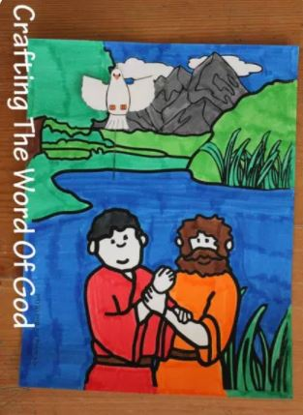

Jesus’ Baptism Descending Dove
(Ages 5+, 10 mins)

Supplies Needed:
- Template
- Scissors
- Glue/Tape
- Markers/Crayons

Instructions:
- This craft is mostly coloring, but kids can cut a small slit on the main coloring sheet and slide a paper dove up/down for the Holy Spirit!

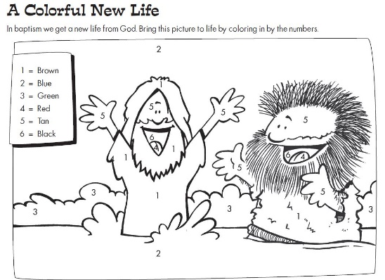
Jesus’ Baptism Color-By-Number
(Ages 5+, 5-10 mins)

Supplies Needed:
- Printed Handout
- Pen/Pencil/Crayons

Instructions:
- This worksheet will ask kids to color various sections of the picture according to the number listed in the upper left.

Jesus’ Baptism Maze
(Ages 5+, 5 mins)

Supplies Needed:
- Printed Handout
- Pen/Pencil/Crayons

Instructions:
- This maze is challenging, but not too difficult – most kids should be able to solve it after a handful of tries.
Biblical Background – Jesus’ Baptism

We’ll be spending a lot of time in the Gospels during the early part of this semester and – as you’ll see – each gospel has its own set of emphases and stories about Jesus. Today’s lesson, though, is one of just a handful of stories that appear in all four gospels – seemingly Jesus’ baptism by John was extremely well documented and was understood as the beginning of Jesus’ ministry.

Baptism is, of course, one of the two sacraments universally recognized across Christianity. But while it's easy to pinpoint the genesis of Communion (Jesus' last supper, memorialized by the early church), baptism's origins are a bit less clear. The Gospels don't offer further explanation when the verb "baptized" is used, so it was presumably a known practice within 1st century Judaism – however, there isn't a direct parallel within Jewish writings at the time. The closest parallel seems to be the Jewish practice of tvilah, which involves ritual immersion in sacred water for the purposes of cleanliness (such as after touching a corpse or having a skin condition) and was also an aspect of converting to Judaism. Unlike baptism, however, tvilah was something that would repeated – and it wasn't clearly connected to the repentance of sins in the way that it was with John the Baptist.

While John the Baptist may have had connections with a Jewish sect called the Essenes, or an early Gnostic group called the Mandaeans – both of whom practiced a daily immersion in water for ritual cleanliness reasons (a sort of ongoing tvilah) – it seems that John's practice of baptism represented something distinct and new. Within the few years of Jesus and John's ministry, baptism would be known as a one-time ritual, connected with the repentance (and forgiveness) of sins, connected to the presence of the Holy Spirit, and marked joining the wider Christian community as a follower of Jesus.

Debates around how baptism is administered (immersion vs. sprinkling) and who is eligible to be baptized (children vs. adults) have occurred over the years, but baptism’s centrality to the Christian faith has been present since the very beginning. To be baptized is to recognize and celebrate that we are known, loved, and claimed by God – and for that we give thanks this day!

Your ability to share this info with kids will vary depending on their age – this section is mainly written for teachers and parents to learn a bit more about the background to each week's passage!

