The Sower / Mustard Seed January 30, 2022

Bible Verses: Luke 8:4-15 + 13:8-9
Spark Story Bible: pages 292 to 293 + 320 to 321
--------------------------------------------------------------------------------------------------

Overall Lesson Takeaways

- What does it mean to be “good soil”?
The common reading of this passage is to figure out what type of soil we are (rocky, thorny, good) when we hear God’s word… I do think it’s important to expand that understanding for kids (see below), but there are still good discussions to be had around how we can be receptive to important things in our lives – whether listening to our parents, teachers, or God. This passage might be an opportunity to discuss what important lessons we’ve learned from school or our families – and to also think through the positive difference that those lessons have made in our lives. You can also engage with the central metaphor of growing, and how growing plants requires being very intentional about giving it water, sun, shade, etc. – carrying that into a conversation about what we might need to grow in our learning and in our faith.
- What does it mean to sow the seeds of God’s love?
While we typically read ourselves as being the ground in this parable, I think there is an even better case to be made that we are actually supposed to be the sower! If the seed is God’s Word, then each of us are called to share that with everyone in our lives – whether it is through our actions (kindness, generosity), our behavior (Fruits of the Spirit), or our words (talking about our faith, speaking words that build others up). Sharing this won’t always mean great changes in other people’s lives – in fact, most of the seed that the sower drops ultimately doesn’t grow. That does not mean that it was wasted, however – it is worth being kind to others even if they are not kind in return because we believe that is exactly what Jesus calls us to do. Our words, actions, and behavior all have an impact on others – so we choose to use that for the better.
- Sometimes small things have a really big impact.
A mustard seed is a very dramatic example of an important truth in our lives: sometimes things that are really small can still have a huge impact on us or on those around us! Kids may not be familiar with mustard seeds, but you can share that they are even smaller than a sesame seed – yet they grow into the size of a small tree over time. Similarly, there are lots of things in our lives that may feel or seem small – a kind or encouraging word, listening to someone, sharing something with them – that end up having changing lives. As adults, we can likely think back to small moments that shaped our careers, our families, or our faith – this can be an opportunity to share those with kids, as well as to listen to ways that kids have seen that sort of impact.
Checking In

Before the reading:
- Check in with the kids – welcoming any newcomers warmly.
  - Younger kids: What is something you’ve enjoyed this winter?
  - Older kids: Highs and Lows from the past week
- Have you ever grown something before: plant, vegetable, flower, etc? What did you do to help it? How long did it take to grow?

Bible Lesson / Discussion

Reading the Bible:
- Today, we are learning about two different parables, or teaching stories, that Jesus shared with people – and both of them talk about seeds.
- Read the text together, either in the Bible, or the Spark Story Bible.
  - Feel free to stop and ask questions during the reading, if helpful.
  - Afterwards, take time to explore what that passage might mean, and know there's no one correct way to read these passages!

Questions About the Passages (see next page for PreK/K questions)
- Jesus used parables in order to help teach people – but sometimes they could be a little surprising or confusing! What do you think this parable might mean? Who is the sower? Who are the different types of soil?
- Jesus also tells a very short parable about how a mustard seed is really small at first but grows to be a large tree – do you think he was talking about his message, the church, or something else?

Connections to Our Lives
- How are the words we say to others, or the actions we do with/for them, like seeds? Can you think of a time when someone said or did something for you that might have seemed small, but had a big impact on you?
- What is a message that you think is really important for others to hear/practice? Brainstorm ways that you might tell it in a parable!

Biblical/Church Connections
- We are still in the season of Epiphany – a time when we are learning more about who Jesus is and what that means for our lives. Why do you think Jesus used parables so much? Do you think people remember stories better than other types of teaching/speaking?
Alternate Preschool and K/1st Questions
Younger ages, particularly those in our preschool class, may have a hard time discussing the biblical text for very long (if at all). My hope is that these questions (and especially the activity) can help with engagement!

Opening Question
- Have you ever grown something before: plant, vegetable, flower, etc? What did you do to help it? How long did it take to grow?

Fun Activity
- In our Bible passages today, Jesus tells people two parables – a parable is a short story that helps teach people, but sometimes you really have to think about it! He told everyone they really needed to try to listen closely – so I thought it might be fun to play a game to test our listening skills.
- Have kids close their eyes and select several things that might make a sound – see if kids can identify them from the sounds being made:
  - Crumbling a piece of paper
  - Clap your hands
  - Snap your fingers
  - Use scissors to cut paper
  - Loudly draw on a piece of paper
  - Tap the wall / knock on a door
- Play as long as kids are having fun, then transition to the Bible questions.

Bible Discussion/Questions
- Jesus was telling a story that some people think is about how well we listen – what do you do when it’s time to be a good listener? What are things that make it hard to listen or pay attention?
- Jesus was also helping people understand even small things they said/did could make a big difference! Think of a time you said something nice to someone, or helped them – how do you think it made them feel?

People of Faith

In addition to reading our weekly Bible story, I'd love for our older grade school students to learn more about people whose lives were changed by their faith in Jesus. We'll lift up a new person each Sunday, trying to connect their story to our Bible passage as much as possible!

John Houghton
With all the plant/growing imagery used in our passages today, it feels fitting to learn about John Houghton, a Welsh physicist who felt it was his Christian duty to care for the Earth and warn others about the effects of climate change.

Born in Wales in 1931 to a deeply devout family, Houghton was taught from an early age that science and Christianity were not in conflict with one another but could instead be of benefit. Even from a young age, Houghton and his brothers excelled in science classes – and he would go on to receive a Bachelor’s, Master’s and Doctorate by the time he was 24 years old.

In the meantime, though, Houghton continued to invest deeply in his faith – becoming a church elder at Aberdovey Presbyterian Church in Wales, and getting heavily engaged in a Tearfund – a charity dedicated to addressing poverty and providing disaster relief.

Houghton soon became a well-known name in the growing field of atmospheric physics, going on to win an international award in 1979 and later being named to the Intergovernmental Panel on Climate Change in 1988. He quickly became a leading voice in the movement to raise awareness around climate change and the devastating effect that it would have not only on the planet, but those who inhabit it. “Looking after the Earth is a God-given responsibility,” he once wrote, “Not to look after the Earth is a sin.”

Houghton began to reach out to pastors around the globe to try to spread the message about climate change – unfortunately to mixed success. Nonetheless, Houghton would go on to be part of a group that received the Nobel Peace Prize in 2007 for raising the awareness of climate change – and his reports helped inform many future studies on the topic. Houghton unfortunately passed away from complications due to Covid-19 in 2020, but his spirit and deep desire to care for God’s creation continue to inspire many.
Crafts / Activities

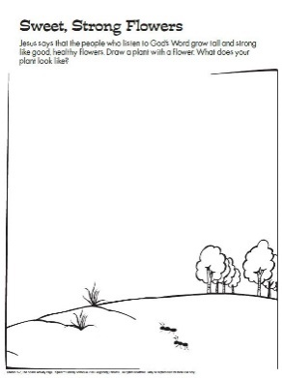
The Sower Plant Creator
(Ages 3+, 5 mins)

Supplies Needed:
- Printed Handout
- Markers/Crayons

Instructions:
- This craft is very similar to a coloring sheet, but you can encourage kids to draw/design their own plant in honor of our theme of growing!

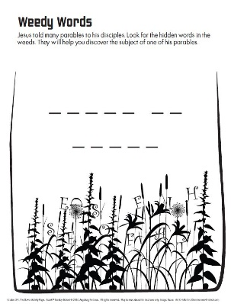
The Sower Word Puzzle
(Ages 5+, 3-5 mins)

Supplies Needed:
- Printed Handout
- Pen/Pencil/Crayons

Instructions:
- Even though you can see several additional letters, kids are supposed to only use the very clearly defined letters to spell out a secret message!

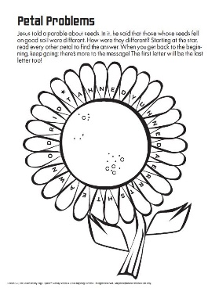
The Sower Word Puzzle (Hard)
(Ages 7+, 5 mins)

Supplies Needed:
- Printed Handout
- Pen/Pencil/Crayons

Instructions:
- This word puzzle probably looks more intimidating than it actually is – starting at the starred letter in the upper left, circle every other letter to help spell out a secret message.
Biblical Background – The Sower

In our passages today – and in a handful of others we’ll read later this Spring – we are introduced to a particular teaching tool that Jesus used called “parables”. Scholars differ on the number of parables that appear in the Gospels – some say 30 while others north of 40 – but it is clear that they were a common teaching tool for Jesus (at least in Matthew, Mark, and Luke!), comprising close to a third of Jesus’ recorded teachings.

The word “parable” comes from a combination of two Greek words meaning “throw alongside”, and it also seems to have connection to the Hebrew word mashal, which is akin to ‘fable’ or ‘allegory’. Unlike fables, though, which largely deal with anthropomorphized animals, parables tend to utilize simple, everyday actions with humans at the center. The themes and length of these parables vary greatly (the Parable of the Mustard Seed is much closer to a statement than a story such as the Parable of the Good Samaritan) but idea was for the listener to derive spiritual knowledge out of everyday things – as William Barclay once put it, parables are “an earthly story with a heavenly meaning”.
The most common themes of Jesus’ parables were indeed attempts to describe the Kingdom of Heaven (such as both passages today) or looking ahead to the end times. These topics comprise roughly half of Jesus’ parables – but other topics varied greatly: ranging from loss, love, forgiveness, prayer, and labor.

Despite how important parables seemed to be to Jesus, though, one of the elements that has long fascinated scholars is that the Gospels vary wildly in how frequently they appear. You see them all the time in Luke (24 parables, 18 unique) and Matthew (23 parables, 13 unique), but they are rarer in Mark (8 parables, 2 unique) and are downright absent from John’s Gospel (0 parables!!) Matthew and Luke’s sharing of parables was one of the elements that led to the “Q” hypothesis, which stated that perhaps Matthew and Luke were aware of a source that Mark/John did not have – a theory boosted with the discovery of the Gospel of Thomas (15 parables, 11 shared with Bible). Regardless, those parables that were included are now some of the best loved texts in the entire Bible – and they continue to inspire Christians all around the world today.

Your ability to share this info with kids will vary depending on their age – this section is mainly written for teachers and parents to learn a bit more about the background to each week's passage!

