Jesus and the Children January 24, 2021

Bible Verses: Mark 10:13-16
Spark Story Bible: pages 328 to 333
--------------------------------------------------------------------------------------------------

Overall Lesson Takeaways

- How were children seen back then? How are they seen now?
The short answer (see the Bible Background for a longer answer) is that there was little credence or attention paid to children’s views, other than seeing them as unfinished adults. One only needs to look at the biblical text’s relative silence about Jesus’ childhood – or to remember Paul’s famous words from 1 Corinthians 13: “when I was a child, I thought like a child… when I became an adult, I put an end to childish ways” – to better understand how children were thought of. Our society today certainly has a better understanding of children and their psychology today, but I think this lesson can also be a way to hear directly from kids about how/where they feel listened to and valued, and how/where they are disregarded. For us, Jesus’ embrace of children should be seen as an acknowledgement that children should indeed be listened to and valued – and that’s part of our call as parents and teachers!
- Jesus often tried to help those who society forgot about.
Over and over, particularly in Luke’s gospel, we hear that there will be a reversal of fortune in God’s coming kingdom between those in power and those who are powerless. This idea isn’t unique to Luke’s Gospel, but it certainly seems to be an integral part of what God’s kingdom in the world means. Jesus is constantly standing up for people who our society or culture try to put down – children, those experiencing poverty or homelessness, tax collectors and sinners, etc. Perhaps we can think about Jesus blessing the children as a reminder that we are called to care about those who are often forgotten about.
- What does it mean to “receive the kingdom of God as a little child”?
This short passage in Mark closes with the somewhat enigmatic phrase: “Whoever does not receive the kingdom of God as a little child will never enter it”. This is clearly something that is of utmost importance… but what does Jesus mean by it? Scholars and interpreters have mused over the years whether this has to do with our sense of innocence and wonder, or whether we give and love without reserve in the way that a child does. These are certainly plausible and helpful readings. In the wider context of the gospels, though, my guess is that Jesus’ words are far more about the humility of the recipient rather than their sense of innocence. To be a disciple, and to receive the kingdom of God, is to acknowledge that we will always fall short of God’s call – but that we remain committed to learning, growing, and imitating Christ in our lives.
Checking In

Before the reading:
- Check in with the kids – welcoming any newcomers warmly.
  - Younger kids: What is one of your favorite songs to sing along to?
  - Older kids: Highs and Lows from the past week
- What is your favorite part about being a kid? What is the hardest part about being a kid?

Bible Lesson / Discussion

Reading the Bible:
- Today, we are reading about Jesus welcoming and blessing children – even when his disciples tried to tell those kids to go away!
- Read the text together, either in the Bible, or the Spark Story Bible.
  - You’ll need to screen share the passage for the day in Zoom.
  - Feel free to stop and ask questions during the reading, if helpful.
  - Afterwards, take time to explore what that passage might mean, and know there's no one correct way to read these passages!

Questions About the Passage (see next page for PreK/K questions)
- Jesus’ disciples were trying to keep the children away from him – if you were one of those kids, what would you have said to the disciples?
- Jesus told the crowd that the kingdom of God belongs to children – what do you think he meant by that? What are things that kids are really good at that could help share God’s love?

Connections to Our Lives
- Children often weren’t listened to back in Jesus’ time – is that still an issue today? What do you wish adults remembered about being a kid?
- Can you think of other people today who sometimes aren’t listened to or treated with respect? How can we help change that?

Biblical/Church Connections
- This morning we talked about the Presbyterian Giving Catalog and supporting kids in other countries. What do you think it would be like living in another country? Why is it important to care what happens to people around the world, even if we’ll never meet them?

Alternate Preschool and K/1st Questions
Younger ages, particularly those in our preschool class, may have a hard time discussing the biblical text for very long (if at all). My hope is that these questions (and especially the activity) can help with engagement!

Opening Questions
- Adults often have rules about things you can and can’t do. What’s something that you really wish you could do, but often get told no?
- Is it more fun to be a kid or an adult? What’s special about being a kid?

Fun Activity
- Back in Jesus’ time, most kids were expected to do a lot of chores, to learn quietly, and to be a good listener. Today, we’re going to play a game where we switch between being silly and being a quiet listener!
- (You’ll have the kids play freeze dance – queue up a good dance song on your computer and play it when kids are ready! Kids should dance when the music is on but then stop when the music goes off)
  - Encourage silly dances and lots of craziness, but then try to catch the kids off guard with the stops. Sometimes its even fun to do some quick back-to-back stops
- Play as long as kids are having fun, then transition to the Bible questions.

Bible Discussion/Questions
- Jesus’ disciples tried to keep the kids away from Jesus because they thought they would bother him. What are some places that you go where you’re expected to be quiet? Is it hard to do sometimes?
- Unlike the disciples, Jesus is really excited to see the children and he both welcomes and blesses them (sort of like saying a prayer for them). Who are people in your life who show love to you? Remember that Jesus loves you too, and that you’re a special part of our church!

People of Faith

In addition to reading our weekly Bible story, I'd love for our older grade school students to learn more about people whose lives were changed by their faith in Jesus. We'll lift up a new person each Sunday, trying to connect their story to our Bible passage as much as possible!

Robert Raikes
On this Sunday when we remember Jesus’ embrace and blessing of children as a crucial part of the church, it also makes sense to learn about a man who helped establish something synonymous with children’s involvement in church: Robert Raikes, a.k.a. “The Father of Sunday School”.

The son of a newspaper publisher, Raikes inherited his father’s business at the age of 19. Having grown up in the Anglican Church, he hoped to use his newspaper to give voice to issues surrounding criminal justice and prisons. Raikes, however, soon came to believe that it would be more fruitful to prevent kids from going down a bad path rather than help those who were already in the criminal justice system – so in 1780, he began to advertise a weekly “Sunday School” in his newspaper where he would teach kids to read the Bible.

Sunday School as we know it is believed to have been started by Hannah Bell in 1769, but these schools largely took place in individual churches. The wider reach of Raikes’ paper soon led to the establishment of several of these Sunday Schools, as many children worked in factories the other six days of the week. While some kids might argue that Sunday School today is really boring (not here, I hope!), it should be noted that it would have been WAY worse back in Raikes’ time. According to Raikes: “Children are to come from 10 in the morning and stay until 12… go home, and return at 1 to read a lesson… go to Church… then repeat the catechism until after 5… going home without making a noise.” That means six hours of church on Sunday, after spending the rest of the week working in a factory… it was a hard time to be a kid!

And while it may sound strange, many pastors and faith leaders opposed Raikes’ school at the time, saying that parents should teach the Bible to their kids and that Sunday was to be a day for worship and Sabbath rest. Nonetheless, the “Sunday School” movement began to explode in popularity – growing from a handful of small schools to over 300,000 kids by the end of the decade!
Crafts / Activities

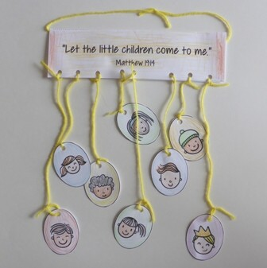
Jesus and the Children Mobile
(Ages 5+, 10 mins)

Supplies Needed:
- Printed Handout
- Markers/Crayons
- Yarn and Hole Punch
- Scissors

Instructions:
- This craft is time consuming, but cute – encourage kids to color and cut out each of the faces, attaching to the main sheet using yarn or string.

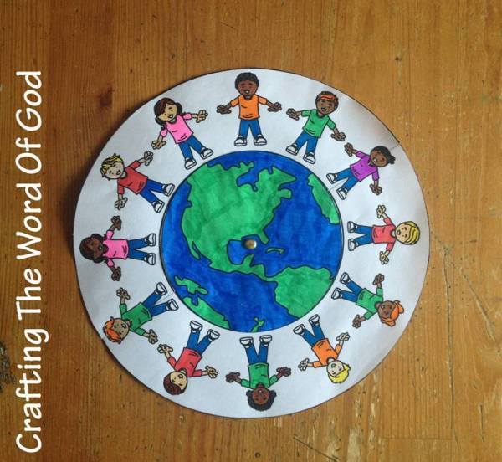
Jesus and the Children World Craft
(Ages 5+, 5-10 mins)

Supplies Needed:
- Printed Handout
- Pen/Pencil/Crayons
- Scissors and Tape

Instructions:
- This craft is essentially like three different partial coloring sheets combined into one – just color, cut, and combie!

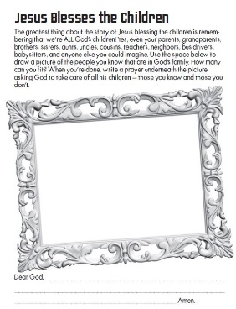
Jesus and the Children Family Picture
(Ages 5+, 5-10 mins)

Supplies Needed:
- Printed Handout
- Pencil/Crayons/Markers

Instructions:
- This is a simple craft that kids can make as elaborate as they want – encourage them to draw a picture of their family or friends, and to be reminded that everyone in that picture is loved deeply by God!
Biblical Background – Jesus and the Children

Although we often focus more on the biblical context of our lessons, what may be most interesting and helpful for kids this week is to learn more about what life would have been like for kids back in the 1st century! Much of what we know comes from careful study and inference by scholars – not only are our windows into the 1st century limited, but it was extremely rare for children to even be written about at all. A good example of this is how there is only one story about Jesus’ childhood in the Gospel – children were just not really of interest to most adults back then. Children were primarily thought of as unfinished adults – but Jesus’ attitude clearly marks a distinct break from that.

Most of what we know about childhood in the 1st century comes from Roman sources, which may or may not be similar to life in 1st century Judea. Nonetheless, it seems as though 5 or 6 was a common age when children began to receive responsibilities – they would be asked to care for animals, gather supplies, and take care of the house. School (or what little education there was) took place in family homes – there was no school system in the way that we have it today – and for the most part kids just stayed within their same neighborhood all the time. There are a handful of carvings of children playing games with balls, hoops, and sticks - but life likely would have been awfully slow and boring for most kids. From an early age, children were expected to be a dutiful and functional part of the family; typically learning the jobs and roles that their parents took on.

Jesus’ acceptance and blessing of the children in our passage today can be interpreted as something of a sharp break from the views of his day – at the very least he seems to be in conflict with the disciples who hold a view that children were not ready for the “adult” messages that Jesus was sharing. But to “receive the kingdom of God as a little child” has generally been seen as an openness and an eagerness to learn and grow, not to assume that one has perfected being a Christian and has learned all there is to know. No matter what age we are, we aspire to be like children in our desire and openness to learn how to be better disciples!

Your ability to share this info with kids will vary depending on their age – this section is mainly written for teachers and parents to learn a bit more about the background to each week's passage!

