The Disciples January 23, 2022

Bible Verses: Luke 5:1-11
Spark Story Bible: pages 258 to 263
--------------------------------------------------------------------------------------------------

Overall Lesson Takeaways

- What does it mean to be someone’s disciple?
Discipleship was a common practice in the ancient world, particularly in Greco-Roman contexts in which philosophers would have a group of students. Being a disciple, though, wasn’t just about understanding someone’s teachings – it was putting those teachings into practice and trying to emulate/copy the person you were following. Peter, James, John, and the other disciples certainly spent a great deal of time learning from Jesus, but their discipleship was rooted in their willingness and ability to apply those lessons to their lives – to truly follow Jesus as master and lord. (It should be noted that although we often use the terms "disciple" and "apostle" synonymously, the two actually are different terms. "Apostle" comes from a Greek word meaning "messenger" – someone who is sent out to proclaim the Good News more broadly, rather than someone who is simply practicing Jesus' teachings in their lives.)
- What does being Jesus’ disciple look like today?
This question is obviously more complex than a paragraph can answer, so I'll speak only for myself: I have always believed that one of the most important traits of being a disciple of Jesus maintaining a sense of humility. We should never believe that we have it all figured out and we should never claim more power and authority than we have; instead, we are called to put God and Jesus first in our lives, and to dedicate ourselves to figuring out what that means for how we live our lives. We must be willing to follow, learn, and grow – even as we humbly acknowledge that we will always fall short of who God is calling us to be.
- Anyone can be a disciple of Jesus.
If you were in charge of hiring someone for a job, you probably would look at candidates who had years of experience, quality education, or preferably both. As far as we're aware, the disciples had neither of those things! They were fishermen, likely because their fathers were fishermen. They weren't trained in public speaking, and likely weren't able to read or write when Jesus called them. And yet, as the biblical text often reminds us, God does not see as we see – we look at outward appearances, while God looks at the heart. So often we resist God's call because we don't consider ourselves worthy or qualified… but I think it's important that Jesus choose these particular individuals. As long as we are willing to follow, willing to learn, willing to grow through God's help – we are living up to our calling as Jesus' disciples.
Checking In

Before the reading:
- Check in with the kids – welcoming any newcomers warmly.
  - Younger kids: What’s your favorite thing to do when it snows?
  - Older kids: Highs and Lows from the past week
- Have you ever had a favorite teacher, or someone who you liked to learn from? What made them such a good teacher?

Bible Lesson / Discussion

Reading the Bible:
- Today, we are reading about Jesus calling the first disciples – and he would help teach them what it meant to follow God and serve others.
- Read the text together, either in the Bible, or the Spark Story Bible.
  - Feel free to stop and ask questions during the reading, if helpful.
  - Afterwards, take time to explore what that passage might mean, and know there's no one correct way to read these passages!

Questions About the Passage (see next page for PreK/K questions)
- Why do you think Jesus picked fishermen and tax collectors as his disciples? Who would you have picked if you were Jesus?
- All of the disciples said “yes” to following Jesus almost right away – why do you think they were so willing to follow him?

Connections to Our Lives
- The word “disciple” is connected to practicing something. What are some things that you practice (homework, sports, instrument, etc.)? Can you practice being a Christian and following Jesus?
- Is it easy to be one of Jesus’ disciples today? What are things that we do at church to help us better understand how to be a disciple?

Biblical/Church Connections
- We are in the season of Epiphany – a time when we are learning more about who Jesus is and what that means for our lives. What is your favorite way to learn: reading, hearing someone talk, watching a video, practicing it, or something else? How could you learn more about Jesus using your favorite method of learning?

Alternate Preschool and K/1st Questions
Younger ages, particularly those in our preschool class, may have a hard time discussing the biblical text for very long (if at all). My hope is that these questions (and especially the activity) can help with engagement!

Opening Questions
- Have you ever had a favorite teacher, or someone who you liked to learn from? What made them such a good teacher?
- Who are other people in your life that help to teach you things? What lessons do they help to teach you?

Fun Activity
- As a fun activity, you can ask the kids to play some variation of Simon Says (Simon Peter Says, Teacher Says, etc.) as we practice trying to listen to someone else and follow them.
- I’ve listed examples from previous sessions below, but you can also have kids take turns being the leader and making it their own:
  - Simon Peter says… cover your eyes!
  - Simon Peter says… jump up and down!
  - Simon Peter says… stand on one foot!
  - Touch your nose!
  - Simon Peter says… pat your head!
  - Simon Peter says… laugh out loud!
- Play as long as kids are having fun, then transition to the Bible questions.

Bible Discussion/Questions
- Jesus asked the fisherman to be his disciples, which is another way of saying they were students who would practice the lessons he was teaching them. Why do we practice things?
- We talked earlier about people in our life who help to teach us things. How can Jesus be one of your teachers? What lessons does Jesus teach that we could try out, or practice?

People of Faith

In addition to reading our weekly Bible story, I'd love for our older grade school students to learn more about people whose lives were changed by their faith in Jesus. We'll lift up a new person each Sunday, trying to connect their story to our Bible passage as much as possible!

Francis Collins
One of the great things about being a disciple of Jesus is that all of us bring different skills and abilities to the table, and many Christians believe the work they do during the week is an important way for them to live out their faith and help others. Our person of faith today, Francis Collins, is one such example.

Born in Virginia in 1950, Collins was raised on a farm and homeschooled through his grade school years. In middle and high school, though, he discovered a deep love for chemistry – eventually going on to earn doctorates in both physical chemistry and medicine by the time he was 27.

It was during this time that Collins began to wrestle with his faith – or, more accurately, his lack of it. An atheist through most of his time in medical school, Collins began to explore religious traditions and was helped by C.S. Lewis’ book Mere Christianity to believe in God. Collins eventually decided to become Christian and began to be an outspoken advocate that science and faith were not at odds with one another – but that both were essential to a full life.

Empowered and inspired by his faith and desire to help others, Collins became deeply invested in the new field of human genetics – and over the course of many years of research, Collins and his team was able to successfully identify several genes which caused diseases.

Collins’ work eventually led him to become the head of the Human Genome Project, which by 2003 would identify all of the 3.1 billion pairs which make up human DNA. In Collins’ words, “"It is humbling for me, and awe-inspiring to realize that we have caught the first glimpse of our own instruction book, previously known only to God." Collins would go on to become the Director of the National Institute of Health, and his work has continued to be vital in combatting diseases and rare syndromes – and he continues to be an example of how our faith and work can be combined to help the lives of others.
Crafts / Activities

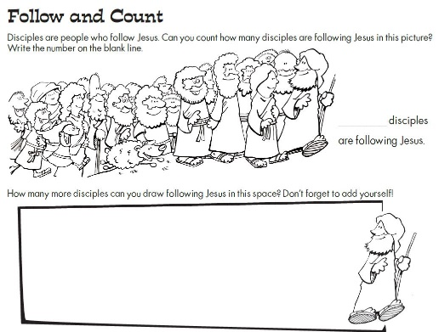
Calling Disciples Picture Puzzle
(Ages 5+, 5-10 mins)

Supplies Needed:
- Printed Handout
- Markers/Crayons

Instructions:
- This craft is primarily coloring, but there is a counting puzzle at the top to try to figure out how many disciples are following Jesus (it’s 22, FYI)

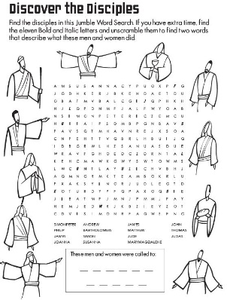
Calling Disciples Word Search
(Ages 7+, 5-10 mins)

Supplies Needed:
- Printed Handout
- Pen/Pencil/Crayons

Instructions:
- This word search is on the tougher end of things, but kids should enjoy the added challenge – along with a bonus puzzle at the bottom.

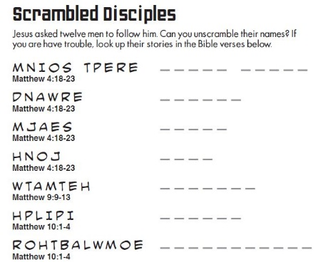
Calling Disciples Word Scramble
(Ages 7+, 5 mins)

Supplies Needed:
- Printed Handout
- Pen/Pencil/Crayons

Instructions:
- This word scramble will be much easier with a Bible, so you can encourage students to have one open as they work on this word scramble. Ultimately, this worksheet is a handy way to learn the disciples’ names!
Biblical Background – Calling Disciples

Although today’s passage focuses on just a handful of disciples being called, it’s useful to note (as the Spark Bible does) that Jesus’ followers were almost certainly more numerous than the twelve disciples that we typically think of. We know from small snippets of the biblical text that there were others who followed Jesus throughout his ministry, most clearly spelled out in Acts 1 when the disciples are choosing a replacement for Judas and the qualification spelled out is someone “who has accompanied us during all the time that the Lord Jesus went in and out among us, beginning from the baptism of John until the day when he was taken up from us” (Acts 1:21-22). The women at the tomb on Easter almost certainly didn’t decide to just look for Jesus that morning – they too must have been followers of Jesus.

Although we sometimes get hung up on the disciple/apostle terminology that was mentioned earlier, one of the important takeaways from the earliest days of the church is that absolutely anyone could be a disciple – something that was in direct contrast to the typical hierarchy found in within Greco-Roman culture (and the patriarchal hierarchy that developed within the church by the end of the 1st century). Jesus ate with sinners, called fishermen and tax collectors as part of his inner circle, and wanted to make disciples beyond the typical bounds of Israel. It didn’t matter if you were rich/poor, male/female, old/young – everyone was welcome to follow Jesus.

Ultimately, the key component to being a disciple is contained within the root of the Greek word itself: mathetes (ma-thay-tace). The word comes from being a student or pupil, but also carries the connotation of copying someone. Being a disciple, then, isn’t something that only a select twelve can do – it’s something that is possible for all of us. The early church thrived in no small part because of how accessible it was to be a disciple, growing from a small band of 120 in the earliest days, to perhaps 7,500 by the year 100 CE, and (amazingly) an estimated several million by the start of the fourth century! This initial call of the disciples was just the start of an amazing movement that Jesus began – and Jesus’ example continues to inspire billions today!

Your ability to share this info with kids will vary depending on their age – this section is mainly written for teachers and parents to learn a bit more about the background to each week's passage!

