Jesus’ Baptism January 16, 2022

Bible Verses: Matthew 3:1-17
Spark Story Bible: pages 242 to 247
--------------------------------------------------------------------------------------------------

Overall Lesson Takeaways

- Baptism is God’s love and grace made visible.
I'll resist the urge to do a deep dive on the historic context/meaning of baptism (you can read more about on the final page) and instead focus on how we understand it today. Baptism is one of two universal sacraments within our Christian tradition (as in, every denomination practices it, along with Communion), so it is clearly holds deep meaning. The way that I typically explain it to kids is that baptism is a way for us to see God's love, grace, and promises in real life. Even though we know what love or promises are, they aren't usually physical or tangible things that we can see… but when that water is placed onto someone's head, it is a physical reminder of many things that we believe to be true: that God made and loves this person, that God will forgive them even when they make mistakes, and that God will always be with them. This day is a celebration of all of that and more.
- Baptism reminds us that we are part of a wider church family.
Baptism does remind us of God’s love and care for us, but it can also remind us that we are part of a wider community of Christians all over the world. Baptisms are done publicly in worship for that very reason – we want the entire congregation to get to see those baptized as part of our extended family! One way to talk about this might be that baptism helps remind us of both our vertical relationship (us and God) and our horizontal relationships (us and our neighbors)… and it is truly amazing that people around the world and throughout the ages have practiced this very thing. As Paul says in his letter to the Galatians (3:26) – “For in Christ Jesus you are all children of God through faith” – and so we are called to see everyone as our siblings in Christ.
- Sharing what we remember about our own baptisms!
While it's important to discuss the meaning of baptism held by our denomination and lifted up in the biblical text, for me it is vitally important in any discussion of baptism – whether with kids or adults – to remember the emotion and Spirit present in the baptism itself. Most of us will not remember our own baptisms, but what truly makes baptism a transcendent and holy moment is seeing people that we care about – whether it's a brother/sister, our own kids, our wider family, or our church family – be reminded of God's great promises and love for us, and claiming those promises as our own. Take the time to share memories of special baptisms with the kids – and, parents, share memories (and emotions!) around your children's baptisms with them.
Checking In

Before the reading:
- Check in with the kids – welcoming any newcomers warmly.
  - Younger kids: What is your favorite thing about snowy weather?
  - Older kids: Highs and Lows from their past week
- Have you ever seen a baptism at church? Who was being baptized and what do you remember about the baptism?

Bible Lesson / Discussion

Reading the Bible:
- Today, we are reading about the start of Jesus’ ministry, when he was baptized in the Jordan River by John the Baptist
- Read the text together, either in the Bible, or the Spark Story Bible.
  - You’ll need to screen share the passage for the day in Zoom.
  - Feel free to stop and ask questions during the reading, if helpful.
  - Afterwards, take time to explore what that passage might mean, and know there's no one correct way to read these passages!

Questions About the Passage (see next page for PreK/K questions)
- John was surprised that Jesus wanted to be baptized by him – but Jesus couldn’t baptize himself! What would you have said if you were John?
- What do you think it would have felt like to be fully immersed in a river? What type of baptism would you prefer: in a river or in a church?
- People sometimes say that baptism is a way to see God’s love – why would placing water on someone’s head remind them of that? Why do you think baptism is so important in our church and churches around the world?

Connections to Our Lives
- Baptism is a way that we welcome people into our church family… what do you usually do to welcome someone new into your family?
- Has anyone ever talked to you about your baptism? What did they share?

Biblical/Church Connections
- As we celebrate Martin Luther King Jr. this weekend, we remember that we still have a lot to do to fight against racism in this country. What can we do help make sure that all people are treated fairly and equally? How could Jesus be an example for how we are called to treat people?

Alternate Preschool and K/1st Questions
Younger ages, particularly those in our preschool class, may have a hard time discussing the biblical text for very long (if at all). My hope is that these questions (and especially the activity) can help with engagement!

Opening Questions
- We’re going to be talking about baptism today, but what baptism is really all about is God’s love for us! What does love look like? How do you know when you are loved?

Fun Activity
- Baptism is one of two important sacraments that we have at church. A sacrament is a way that we can notice God, or notice God’s love – so we’re going to play a game that will help us practice recognizing and noticing things using our coloring pages for the day.
- Share two coloring pages with the kids – one regular, one with items edited out of it (no dove, no tongues, one less wave, no hairy arms) Hopefully kids will have fun trying to notice the differences!

Bible Discussion/Questions
- In our Bible reading today, John baptizes Jesus – and he sees God’s spirit and hear God say Jesus is God’s son! How do you think John felt about being a part of something so special?
- Have you ever seen someone be baptized before? What do you remember? Make sure to ask your parents about your baptism!
- Baptism helps remind us that we are part of a big church family together through our baptisms, even though we don’t all live together. In what ways is church like a family? What would it be like having lots and lots of brothers and sisters living at your home?

People of Faith

In addition to reading our weekly Bible story, I'd love for our older grade school students to learn more about people whose lives were changed by their faith in Jesus. We'll lift up a new person each Sunday, trying to connect their story to our Bible passage as much as possible!

Rosa Parks
This weekend is a fantastic opportunity to remember and celebrate not only Martin Luther King Jr., but other remarkable people who pushed the civil rights movement forward – and Rosa Parks certainly did that through her courage!

Born in 1913 in Tuskegee, Alabama, Parks was small and sickly as a child. Her father and mother separated when she was still young, so Parks and her mother went to live with her grandmother and grandfather near Mobile, Alabama. Her grandparents began bringing Parks with them to their African Methodist Episcopal (AME) church, and her faith would become a central aspect of her life. She later reflected that it was in her church that “I learned people should stand up for their rights, just as the Children of Israel stood up to the Pharaoh.”

Parks’ town was heavily segregated when she was growing up and one of her earliest experiences of discrimination and inequality involved busing. White students in the neighborhood were allowed to take the bus to school, while black students were forced to walk – Parks later shared: “The bus was among the first ways I realized there was a black world and a white world.” As she got older, Parks became heavily involved in groups such as the NAACP and the League of Women Voters – repeatedly advocating for fairness and justice within the legal system – and she would later attend the Highlander Folk School, which provided training for social justice leaders.

All of this training was put into action, though, on December 1, 1955. Parks had finished a long day of work and boarded a bus to go home, sitting in the first row of the “colored” section. After an influx of white passengers boarded, the driver told Parks that she needed to move further back to make room, but she refused – not because she was tired, but because she “was tired of giving in.” She was arrested for this and lost her job, but her spirit and courage helped spark the bus boycott in Montgomery a few days later – leading to some calling her the “first lady of civil rights”.
Crafts / Activities
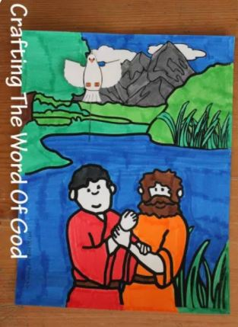

Jesus’ Baptism Descending Dove
(Ages 5+, 10 mins)

Supplies Needed:
- Template
- Scissors
- Glue/Tape
- Markers/Crayons

Instructions:
- This craft is mostly coloring, but kids can cut a small slit on the main coloring sheet and slide a paper dove up/down for the Holy Spirit!

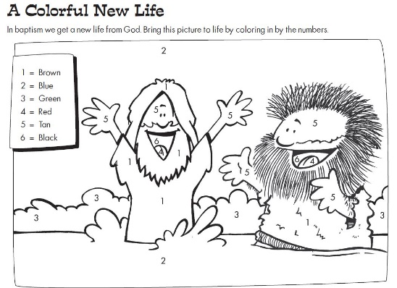
Jesus’ Baptism Color-By-Number
(Ages 5+, 5-10 mins)

Supplies Needed:
- Printed Handout
- Pen/Pencil/Crayons

Instructions:
- This worksheet will ask kids to color various sections of the picture according to the number listed in the upper left.

Jesus’ Baptism Maze
(Ages 5+, 5 mins)

Supplies Needed:
- Printed Handout
- Pen/Pencil/Crayons

Instructions:
- This maze is challenging, but not too difficult – most kids should be able to solve it after a handful of tries.
Biblical Background – Jesus’ Baptism

We’ll be spending a lot of time in the Gospels during the early part of this semester and – as you’ll see – each gospel has its own set of emphases and stories about Jesus. Today’s lesson, though, is one of just a handful of stories that appear in all four gospels – seemingly Jesus’ baptism by John was extremely well documented and was understood as the beginning of Jesus’ ministry.

Baptism is, of course, one of the two sacraments universally recognized across Christianity. But while it's easy to pinpoint the genesis of Communion (Jesus' last supper, memorialized by the early church), baptism's origins are a bit less clear. The Gospels don't offer further explanation when the verb "baptized" is used, so it was presumably a known practice within 1st century Judaism – however, there isn't a direct parallel within Jewish writings at the time. The closest parallel seems to be the Jewish practice of tvilah, which involves ritual immersion in sacred water for the purposes of cleanliness (such as after touching a corpse or having a skin condition) and was also an aspect of converting to Judaism. Unlike baptism, however, tvilah was something that would repeated – and it wasn't clearly connected to the repentance of sins in the way that it was with John the Baptist.

While John the Baptist may have had connections with a Jewish sect called the Essenes, or an early Gnostic group called the Mandaeans – both of whom practiced a daily immersion in water for ritual cleanliness reasons (a sort of ongoing tvilah) – it seems that John's practice of baptism represented something distinct and new. Within the few years of Jesus and John's ministry, baptism would be known as a one-time ritual, connected with the repentance (and forgiveness) of sins, connected to the presence of the Holy Spirit, and marked joining the wider Christian community as a follower of Jesus.

Debates around how baptism is administered (immersion vs. sprinkling) and who is eligible to be baptized (children vs. adults) have occurred over the years, but baptism’s centrality to the Christian faith has been present since the very beginning. To be baptized is to recognize and celebrate that we are known, loved, and claimed by God – and for that we give thanks this day!

Your ability to share this info with kids will vary depending on their age – this section is mainly written for teachers and parents to learn a bit more about the background to each week's passage!

