Calling Disciples January 15, 2023

Bible Verses: Luke 5:1-11
Spark Story Bible: pages 258 to 263
--------------------------------------------------------------------------------------------------

Overall Lesson Takeaways

- What does it mean to be someone’s disciple?
Discipleship was a common practice in the ancient world, particularly in Greco-Roman contexts in which philosophers would have a group of students. Being a disciple, though, wasn’t just about understanding someone’s teachings – it was putting those teachings into practice and trying to emulate/copy the person you were following. Peter, James, John, and the other disciples certainly spent a great deal of time learning from Jesus, but their discipleship was rooted in their willingness and ability to apply those lessons to their lives – to truly follow Jesus as master and lord. (It should be noted that although we often use the terms "disciple" and "apostle" synonymously, the two actually are different terms. "Apostle" comes from a Greek word meaning "messenger" – someone who is sent out to proclaim the Good News more broadly, rather than someone who is simply practicing Jesus' teachings in their lives.)
- What does being Jesus’ disciple look like today?
This question is obviously more complex than a paragraph can answer, so I'll speak only for myself: I have always believed that one of the most important traits of being a disciple of Jesus maintaining a sense of humility. We should never believe that we have it all figured out and we should never claim more power and authority than we have; instead, we are called to put God and Jesus first in our lives, and to dedicate ourselves to figuring out what that means for how we live our lives. We must be willing to follow, learn, and grow – even as we humbly acknowledge that we will always fall short of who God is calling us to be.
- Anyone can be a disciple of Jesus.
If you were in charge of hiring someone for a job, you probably would look at candidates who had years of experience, quality education, or preferably both. As far as we're aware, the disciples had neither of those things! They were fishermen, likely because their fathers were fishermen. They weren't trained in public speaking, and likely weren't able to read or write when Jesus called them. And yet, as the biblical text often reminds us, God does not see as we see – we look at outward appearances, while God looks at the heart. So often we resist God's call because we don't consider ourselves worthy or qualified… but I think it's important that Jesus choose these particular individuals. As long as we are willing to follow, willing to learn, willing to grow through God's help – we are living up to our calling as Jesus' disciples.
Checking In

Before the reading:
- Check in with the kids – welcoming any newcomers warmly.
  - Younger kids: What’s your favorite thing to do when it snows?
  - Older kids: Highs and Lows from the past week
- Have you ever had a favorite teacher, or someone who you liked to learn from? What made them such a good teacher?

Bible Lesson / Discussion

Reading the Bible:
- Today, we are reading about Jesus calling the first disciples – and he would help teach them what it meant to follow God and serve others.
- Read the text together, either in the Bible, or the Spark Story Bible.
  - Feel free to stop and ask questions during the reading, if helpful.
  - Afterwards, take time to explore what that passage might mean, and know there's no one correct way to read these passages!

Questions About the Passage (see next page for PreK/K questions)
- Why do you think Jesus picked fishermen and tax collectors as his disciples? Who would you have picked if you were Jesus?
- All of the disciples said “yes” to following Jesus almost right away – why do you think they were so willing to follow him?

Connections to Our Lives
- The word “disciple” is connected to practicing something. What are some things that you practice (homework, sports, instrument, etc.)? Can you practice being a Christian and following Jesus?
- Is it easy to be one of Jesus’ disciples today? What are things that we do at church to help us better understand how to be a disciple?

Biblical/Church Connections
- As we celebrate Martin Luther King Jr. this weekend, we remember that we’ve made progress against racism in our country, but we still have a long way to go. What can we do help make sure that all people are treated fairly and equally? How could Jesus be an example for us and the way we are called to treat every single person?

Alternate Preschool and K/1st Questions
Younger ages, particularly those in our preschool class, may have a hard time discussing the biblical text for very long (if at all). My hope is that these questions (and especially the activity) can help with engagement!

Opening Questions / Activity
- Take some time to welcome / get to know the kids!
  - Have you ever had a favorite teacher, or someone who you liked to learn from? What made them such a good teacher?
  - Who are other people in your life that help to teach you things? What lessons do they help to teach you?

Warm Up Game – Simon Peter Says
- As a fun activity, you can ask the kids to play a variation of Simon Says as we practice trying to listen to someone else and follow them.
  - Simon Peter says… cover your eyes!
  - Simon Peter says… jump up and down!
  - Simon Peter says… stand on one foot!
  - Touch your nose!
  - Simon Peter says… pat your head!
  - Simon Peter says… laugh out loud!
- Play as long as kids are having fun, then transition to the Bible questions.

Bible Discussion/Questions
- Our Bible story today is about Jesus asking people to be his disciples – disciples learned about Jesus and tried to practice what he taught them!
- Read the text together, either in the Bible, or the Spark Story Bible.
  - Feel free to stop and ask questions during the reading, if helpful.
  - Afterwards, take time to explore what that passage might mean, and know there's no one correct way to read these passages!

- Jesus asked the fisherman to be his disciples, which is another way of saying they were students who would practice the lessons he was teaching them. Why do we practice things?
- We talked earlier about people in our life who help to teach us things. How can Jesus be one of your teachers? What lessons does Jesus teach that we could try out, or practice?

People of Faith

In addition to reading our weekly Bible story, I'd love for our older grade school students to learn more about people whose lives were changed by their faith in Jesus. We'll lift up a new person each Sunday, trying to connect their story to our Bible passage as much as possible!

Martin Luther King Jr.
More than perhaps any other person in this series, my guess is that most kids will be familiar with Martin Luther King Jr. – but since MLK Day is tomorrow, it feels like a perfect time to talk about the ways that his faith helped to inspire his incredible ministry and the wider Civil Rights struggle that he was a leader in.

Although his birth name was Michael King Jr., King’s father (himself a pastor) was deeply moved after a trip to Berlin where he saw several sites from the Reformation. Shortly after that trip, King’s father began referring to himself as Martin Luther King Sr. and his five-year-old son as Martin Luther King Jr. His family would read the Bible together every night, and his father would constantly preach to him that it was his Christian duty to love everyone, even while standing up against the racism they encountered each day.

When he was a teenager, King began to be resentful of his father’s church and was disinterested in attending Sunday School. After he went off to college, though, King travelled with friends to Connecticut and began to experience a far more integrated society – King marveled at blacks and whites attending the same church where he visited. By the age of 18, King decided to become a pastor because it was the best way for him to “serve humanity”.

Over the next several years, King would graduate from college, seminary, and earn his doctorate – as well as become the pastor of a church in Alabama – all by the age of 25. Within a year, a handful of racist incidents on Alabaman bus line (including the famous Rosa Parks incident) led King to help organize a wide bus boycott, as well as co-creating the Southern Christian Leadership Conference. King would go on to be an instrumental leader in the Civil Rights Movement, drawing inspiration from his father’s insistence on loving everyone, while also advocating for change through “extreme love” and non-violence. King saw himself as a devoted disciple of Jesus Christ – and his commitment to living out Christ’s teachings helped him create lasting change in our country and world.
Crafts / Activities

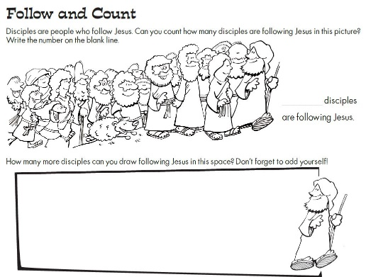
Calling Disciples Picture Puzzle
(Ages 5+, 5-10 mins)

Supplies Needed:
- Printed Handout
- Markers/Crayons

Instructions:
- This craft is primarily coloring, but there is a counting puzzle at the top to try to figure out how many disciples are following Jesus (it’s 22, FYI)

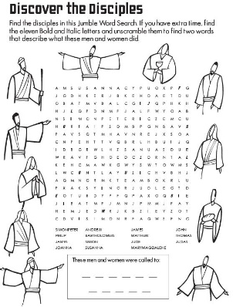
Calling Disciples Word Search
(Ages 7+, 5-10 mins)

Supplies Needed:
- Printed Handout
- Pen/Pencil/Crayons

Instructions:
- This word search is on the tougher end of things, but kids should enjoy the added challenge – along with a bonus puzzle at the bottom.

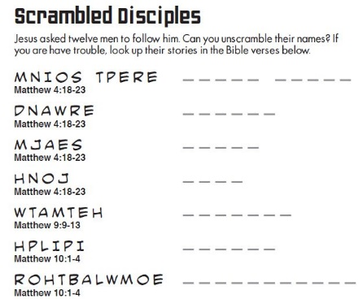
Calling Disciples Word Scramble
(Ages 7+, 5 mins)

Supplies Needed:
- Printed Handout
- Pen/Pencil/Crayons

Instructions:
- This word scramble will be much easier with a Bible, so you can encourage students to have one open as they work on this word scramble. Ultimately, this worksheet is a handy way to learn the disciples’ names!
Biblical Background – Calling Disciples

Although today’s passage focuses on just a handful of disciples being called, it’s useful to note (as the Spark Bible does) that Jesus’ followers were almost certainly more numerous than the twelve disciples that we typically think of. We know from small snippets of the biblical text that there were others who followed Jesus throughout his ministry, most clearly spelled out in Acts 1 when the disciples are choosing a replacement for Judas and the qualification spelled out is someone “who has accompanied us during all the time that the Lord Jesus went in and out among us, beginning from the baptism of John until the day when he was taken up from us” (Acts 1:21-22). The women at the tomb on Easter almost certainly didn’t decide to just look for Jesus that morning – they too must have been followers of Jesus.

Although we sometimes get hung up on the disciple/apostle terminology that was mentioned earlier, one of the important takeaways from the earliest days of the church is that absolutely anyone could be a disciple – something that was in direct contrast to the typical hierarchy found in within Greco-Roman culture (and the patriarchal hierarchy that developed within the church by the end of the 1st century). Jesus ate with sinners, called fishermen and tax collectors as part of his inner circle, and wanted to make disciples beyond the typical bounds of Israel. It didn’t matter if you were rich/poor, male/female, old/young – everyone was welcome to follow Jesus.

Ultimately, the key component to being a disciple is contained within the root of the Greek word itself: mathetes (ma-thay-tace). The word comes from being a student or pupil, but also carries the connotation of copying someone. Being a disciple, then, isn’t something that only a select twelve can do – it’s something that is possible for all of us. The early church thrived in no small part because of how accessible it was to be a disciple, growing from a small band of 120 in the earliest days, to perhaps 7,500 by the year 100 CE, and (amazingly) an estimated several million by the start of the fourth century! This initial call of the disciples was just the start of an amazing movement that Jesus began – and Jesus’ example continues to inspire billions today!

Your ability to share this info with kids will vary depending on their age – this section is mainly written for teachers and parents to learn a bit more about the background to each week's passage!

