Jesus Calms a Storm February 20, 2022

Bible Verses: Luke 8:22-25
Spark Story Bible: pages 390 to 393
--------------------------------------------------------------------------------------------------

Overall Lesson Takeaways

- God is with us in the “storms” of our life.
Although this passage was one of the first major hints to the disciples that Jesus was far more than a mere teacher or prophet (see below), this passage can also be an entry point into talking about frightening moments/times in our lives and how we can trust that God is there for us as well. Younger students may not be able to wrap their minds around the “storm” metaphor, but everyone can likely remember times in their lives when they felt afraid… perhaps even in a literal storm! One of the cornerstones of our faith, though, is that we believe that God’s love and presence are always with us no matter what else is going on around us – and that fact can give us a sense of peace and calm, even when we are feeling scared or uncertain about what is next.
- Jesus is more than just a teacher.
Even though the disciples have already seen Jesus heal people at this point of the Gospels, the ability to heal was not viewed in the ancient world as making someone divine – healers were merely acting as conduits for God’s power rather than possessing that power for themselves. The ability to control the weather, on the other hand, was something that God alone could do. When Jesus commands the winds to be silent and the waves cease, Luke’s gospel states that the disciples were afraid – not because they were worried for their safety, but because they realized that Jesus was God. Imagine being the disciples and discovering that God was in your midst… how might this change how you acted around Jesus?
- Jesus is fully human and fully divine… how does that work?
For many kids, learning about how Jesus demonstrated abilities that belonged to God alone can lead to one of the more confusing – but important! – questions of our faith: how was Jesus both human and divine? Why do we refer to God and Jesus separately, even though we also say that they’re the same? The short answer (which won’t be satisfying to kids) is that it’s a paradox – it’s doesn’t make sense for Jesus to be fully human and fully divine! But I always start by saying that God is bigger than our ability to understand – and if we’re confused then that means that we’re thinking about God the right way! Because God is so much bigger than us, though, Jesus was the way that God could help us understand – understand how to live our lives, what God wants from us, and how deeply each of us are known and loved.

Checking In

Before the reading:
- Check in with the kids – welcoming any newcomers warmly.
  - Younger kids: What is your favorite game to play?
  - Older kids: Highs and Lows from the past week
- Have you ever been in a bad storm before (rain, wind, or snow)? Where were you and your family? What did you do?

Bible Lesson / Discussion

Reading the Bible:
- Today, we are learning about a time that Jesus surprised the disciples with a miracle – stopping a storm around them when they were in a boat!
- Read the text together, either in the Bible, or the Spark Story Bible.
  - Feel free to stop and ask questions during the reading, if helpful.
  - Afterwards, take time to explore what that passage might mean, and know there's no one correct way to read these passages!

Questions About the Passage (see next page for PreK/K questions)
- Pretend you were a disciple in the boat… how would you have felt during the storm? What about after Jesus had stopped the storm?
- Jesus stopping the storm showed the disciples that Jesus was more than just a teacher or healer… he was also “God with us”! How do you think about Jesus being both human and God? Does it make sense to you, or is it hard to wrap your mind around?

Connections to Our Lives
- Think back to a time when you felt really afraid – whether because of a storm or something else. What helps you feel better when you’re afraid? How does it make you feel knowing that God is always with you?
- Jesus asks the disciples where their faith is – what does having faith mean to you? Can you have faith and still be scared? (I’d argue yes!)

Biblical/Church Connections
- Reading this passage about storms is a good opportunity for kids to learn about the work of Presbyterian Disaster Assistance – either viewing images or reading stories from their website: https://pda.pcusa.org/.
There are lots of ways we can support those who experience hardship!
Alternate Preschool and K/1st Questions
Younger ages, particularly those in our preschool class, may have a hard time discussing the biblical text for very long (if at all). My hope is that these questions (and especially the activity) can help with engagement!

Opening Questions
- Our Bible passage today is about Jesus helping the disciples during a really bad storm. Have you ever been in a bad storm before (rain, wind, or snow)? Where were you and your family? What did you do?

Fun Activity
- In our Bible passage, Jesus gives some commands to the wind – and, amazingly, the wind and the storm stop. We can’t control the weather, but we thought it might be fun to play a game where we try to follow some commands too: Simon Says!
- I’ve listed a few examples from previous sessions below, but you can also have kids take turns being the leader and making it their own:
  - Simon says… pretend you’re on a boat!
  - Simon says… pretend a strong wind is blowing you around
  - Cover your eyes!
  - Simon says… jump up and down!
  - Simon says… stand on one foot!
  - Touch your nose!
  - Simon says… pat your head!
  - Simon says… laugh out loud!
- When you’re ready to be done, you can transition to the Bible passage and the discussion questions.

Bible Discussion/Questions
- Pretend you were in the boat with the disciples… what would your face have looked like during the storm? What would your face look like after Jesus stopped the storm??
- Think back to a time when you felt really afraid – whether because of a storm or something else. What helps you feel better when you’re afraid? Know that even when you’re feeling scared God is with you and loves you very much!

People of Faith

In addition to reading our weekly Bible story, I'd love for our older grade school students to learn more about people whose lives were changed by their faith in Jesus. We'll lift up a new person each Sunday, trying to connect their story to our Bible passage as much as possible!

Richard Allen
As we continue learning about important leaders in Black History Month, today we highlight and celebrate Richard Allen – an incredibly influential and courageous leader in early America who founded a new church denomination!

Allen was born into slavery in February 1760 and he was tragically split up from his mother and two of his siblings when he was younger. He began attending a Methodist church with his two remaining older siblings, primarily because it was one of the few places that treated him like a human being. At the age of 17, he decided to officially join the Methodist church.

Around this same time, a local pastor visited the plantation where Allen was enslaved and convinced his slaveholder that Allen and others should be allowed to buy their freedom – which he was finally able to do at the age of 20. Allen began studying to become a pastor and was eventually accepted by the Methodist Episcopal Church – although he was restricted to holding worship services at 5 a.m. and speaking only to Black people.

Frustrated by the church’s practice of segregation, Allen was eventually able to buy a piece of land for his own church – moving the congregation that he had built up over the previous few years. Along with his friend and colleague, Rev. Absalom Jones, Allen began a new congregation called the African Methodist Episcopal (AME) Church – which would later be declared an independent denomination from the Methodist church.

Freed from the discrimination and segregation that he and his congregants had experienced at other churches, his congregation – Bethel AME Church – continued to flourish, growing to over 1,272 members by 1813. The church was a lifeline to the community, providing access to education and engaging in political advocacy – stemming from Allen’s deep faith in God and his understanding God had called him to work against discrimination and prejudice.
Crafts / Activities
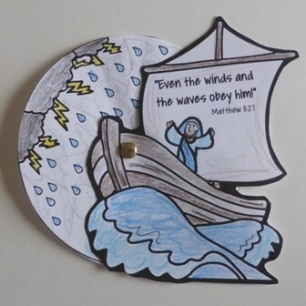

Jesus Calms a Storm Wheel
(Ages 5+, 5-10 mins)

Supplies Needed:
- Printed Handout
- Scissors
- Brad/Fastener
- Markers/Crayons

Instructions:
This craft requires a bit of cutting and a brad for assembly, but it is a neat way to capture the changing weather in the passage!

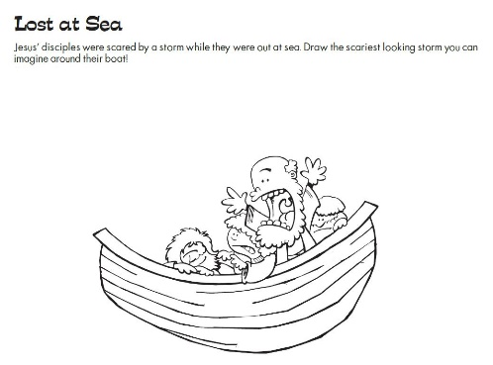
Jesus Calms a Storm Drawing Waves
(Ages 3+, 3-5 mins)

Supplies Needed:
- Printed Handout
- Pen/Pencil/Crayons

Instructions:
This handout is essentially a coloring page, but you can invite kids to draw the waves of the storm really, really high!

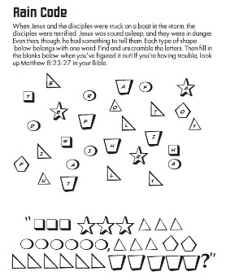
Jesus Calms a Storm Word Puzzle
(Ages 7+, 5 mins)

Supplies Needed:
- Printed Handout
- Pen/Pencil/Crayons

Instructions:
This puzzle asks kids to unscramble words based on the letters found in similar shapes – kids should have fun once they get the hang of it!
Biblical Background – Jesus Calms a Storm

Passages like Jesus calming a storm or walking on water are quite memorable, but we should note from the outset that passages involving large bodies of water are rare in the biblical text. Jesus’ ministry mostly took place out on the road and in small towns throughout Galilee – and most Israelite towns and cities were located away from major bodies of water (Mediterranean and Dead Sea).

Although the perception may not have been as strong in Jesus’ time, there is a clear association in Old Testament texts between large bodies of water and chaos – an idea that Luke and the other gospel writers are surely picking up with this passage. Examples of this include:

- Genesis 1:2 – “The earth was a formless void and darkness covered the face of the deep”. A key aspect of God’s creation was bringing order to this primordial chaos and separating the waters.

- Genesis 8:1-2 – “God made a wind blow over the earth, and the waters subsided; the fountains of the deep and the windows of the heavens were closed”. Repeating language from creation, God ceases the great flood by bringing order to the chaos.

- Exodus 14:21 – “The Lord drove the sea back by a strong east wind all night, and turned the sea into dry land”. The parting of the Red Sea is an act of God’s power and authority – leading the people to trust God.

- Jonah 1:4 – “But the Lord hurled a great wind upon the sea, and such a mighty storm came upon the sea that the ship threatened to break”. This is the opposite of Jesus calming the storm – God is trying to steer Jonah!

The ability to control or manipulate weather was an authority that solely belonged to God in the biblical text, and the Gospel writers’ audience would have immediately recognized these parallels and understood what Jesus did as God’s handiwork – “rebuking” the wind much as God did!

Your ability to share this info with kids will vary depending on their age – this section is mainly written for teachers and parents to learn a bit more about the background to each week's passage!

