The Lord’s Prayer February 18, 2024

Bible Verses: Matthew 6:5-15
Spark Story Bible: pages 278 to 281
--------------------------------------------------------------------------------------------------

Overall Lesson Takeaways

- Thinking about the different ways that we pray.
Giving thanks to God – Most kids will be familiar with this type of prayer. We give thanks to God for something specific in our lives – or maybe we just give God praise!
Asking for something for ourselves or for others – There are a lot of things we might ask for: healing, patience, understanding, strength… the list goes on and on! Asking for things – even though they may not happen! – is part of how we all pray.
Saying we’re sorry to God – Sometimes we hurt ourselves, God, or others through our words or actions, so sometimes we pray to say sorry to God and change our ways.
Sharing our sadness or pain – Although it’s not often lifted up, I think it’s important to be able to share times when we are sad or hurt with God. Sometimes it’s important to just tell God that we’re hurt or angry or sad – a prayer known as “lament”.
- The Lord’s Prayer unites all Christians.
I’d imagine many adults were forced to learn the Lord’s Prayer during Sunday School, but the emphasis on learning the prayer actually comes from the earliest days of the church. In the Didache, an important document thought to have been written by an early church community in the late 1st century CE, the author states that Christians should say this prayer three times per day! Because of this emphasis – and the fact that this prayer came directly from Jesus – that it continues to be (along with baptism and communion) one of the few points of unity among all denominations. This unity is a true gift in a world that sometimes feels increasingly divided.
- The Lord’s Prayer is intentionally simple.
Jesus shares the Lord’s Prayer as a contrast to the long-winded prayers of his day, in which there is more of a focus placed on how beautiful the language is than on the prayer itself. Later in the chapter, Jesus makes clear that God already knows what we need before we ask it – our prayers aren’t heard because of how fancy or beautiful they are, but because of the heart that is behind it! Many of us often struggle with not wanting to pray in public – or even with our families – because we don’t feel like we have the skills or training to pray like we hear on Sunday morning, but Jesus is telling us that we don’t need to! The prayers lifted up by our students in Chapel are heard exactly the same as the prayers shared during the Prayers of the People in worship – so we should never fall into the trap of thinking our prayers need to be complicated or perfect. This is a conversation with God and we should speak from the heart!
Checking In

Before the reading:
- Check in with the kids – welcoming any newcomers warmly.
  - Younger kids: What does it mean to pray? What do people do?
  - Older kids: Highs and Lows from the past week
- Does your family have a particular time of day when you usually pray? Do you pray as a family, as individuals, or both?

Bible Lesson / Discussion

Reading the Bible:
- Today, we are learning about a short prayer that Jesus taught to the disciples, that is now perhaps the best-known prayer in the entire world.
- Read the text together, either in the Bible, or the Spark Story Bible.
  - Feel free to stop and ask questions during the reading, if helpful.
  - Afterwards, take time to explore what that passage might mean, and know there's no one correct way to read these passages!

Questions About the Passage (see next page for PreK/K questions)
- Why do you think Jesus thought it was important to teach this prayer to the disciples? How is it similar or different to prayers that you’ve heard at home or at church?

Connections to Our Lives
- Does your family have a special prayer that you say each time, or do your prayers change each time you say them?
- It’s sometimes said there are four ways to pray: giving thanks, asking for something, saying sorry, and letting God know how we feel. Which of these ways do you usually pray?
- Have you ever been in church and hear the Lord’s Prayer recited by everyone there? What is special about all knowing the same prayer?

Biblical/Church Connections
- This is the first Sunday of Lent, which is a 40 day period of trying to prepare our hearts and listen to God before the events of Holy Week. How can praying help us get ready? What changes in us when we take the time to try to stop and listen to God?

Alternate Preschool and K/1st Questions
Younger ages, particularly those in our preschool class, may have a hard time discussing the biblical text for very long (if at all). My hope is that these questions (and especially the activity) can help with engagement!

Opening Questions / Activity
- Take some time to welcome / get to know the kids!
  - What does it mean to pray? What do people usually do?
  - Are there times of day when you usually pray? (Meals, before bed?)
  - Does your family have a special prayer that you say each time, or do your prayers change each time you say them?

Warm Up Game – I Spy!
- We’re going to keep talking about prayer when we get to our Bible passage for the day, but prayer sometimes requires us to be good at listening and noticing things – so I thought it would be fun to play a game that is all about noticing things: I Spy!
  - You can be the one naming colors at first, but then anyone who wants to should have a chance to be the one “spying” things
- Play as long as kids are having fun, then transition to the Bible questions.

Bible Discussion/Questions
- There were lots of different ways to pray, but Jesus taught the disciples this prayer to help them think about four ways to pray: Saying thank you, asking for something, saying sorry, and sharing things we’re sad about.
- Read the text together, either in the Bible, or the Spark Story Bible.
  - Feel free to stop and ask questions during the reading, if helpful.
  - Afterwards, take time to explore what that passage might mean, and know there's no one correct way to read these passages!

- What do you usually talk to God about in your prayers?
- Why do you think that it’s important to pray?
- Close by sharing some prayers with one another! If you need help, you can use this simple prayer: God, everyday is a gift from you – help us be a gift to others too. Amen.

People of Faith

In addition to reading our weekly Bible story, I'd love for our older grade school students to learn more about people whose lives were changed by their faith in Jesus. We'll lift up a new person each Sunday, trying to connect their story to our Bible passage as much as possible!

Jackie Robinson
Although his courage and character are certainly well known, one of the lesser known aspects of Jackie Robinson’s life was his deep faith in God and the way that carried him through many of the challenges that he faced!

Robinson was initially born in Georgia in 1919, although his mother moved the family to Pasadena, California when he was only 6 months old. Growing up poor in a relatively wealthy area, Robinson faced a great deal of racial and class discrimination during his childhood – and his anger and resentment at that led him to join a neighborhood gang in his youth.

Thankfully, Robinson got to know a minister named Rev. Karl Downs at his family’s United Methodist Church – and Downs convinced Robinson to leave the gang and invest himself into athletics. Robinson was a phenomenal athlete, playing football, basketball, baseball, and track in both high school and college – evening winning the NCAA Championship Long Jump in 1940. Through college, though, Robinson stayed close to church – he even taught Sunday School!

After serving during WWII, Robinson began to try out for Major League Baseball teams – eventually signing with the Brooklyn Dodgers and making his major league debut in 1947 as the first African-American player in MLB. Robinson received a great deal of hate and verbal abuse, not only from fans but from opposing players and managers as well. Robinson’s wife would later reflect that he would pray every single night before he went to bed for strength.

"I can testify to the fact that it was a lot harder to turn the other cheek and refuse to fight back than it would have been to exercise a normal reaction," Robinson later said, "But it works, because sooner or later it brings a sense of shame to those who attack you.” Robinson not only went on to become one of the best players of all time – his courage paved the way for hundreds of other athletes who had been denied a chance to play because of their race.
Crafts / Activities
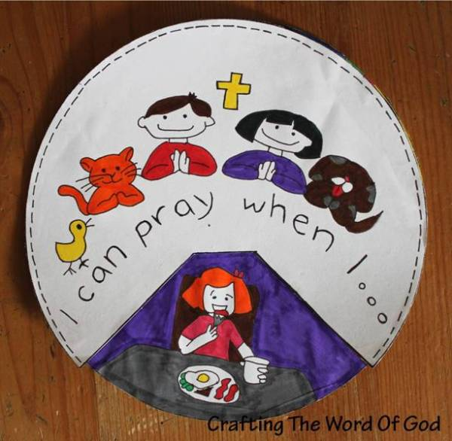

Lord’s Prayer Wheel
(Ages 5+, 5-10 mins)

Supplies Needed:
- Printed Handout
- Markers/Crayons
- Scissors and a brad/fastener

Instructions:
- This craft is mostly coloring, but if you have a brad/fastener you can cut it out to form a spinning wheel that shows common times that we pray.

Lord’s Prayer Draw-Your-Prayer
(Ages 5+, 5 mins)

Supplies Needed:
- Printed Handout
- Pen/Pencil/Crayons

Instructions:
- This craft can be used by most ages – you can just encourage kids to draw/write any prayers that they might have.

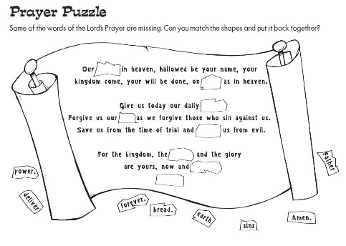
Lord’s Prayer Word Puzzle
(Ages 6+, 5 mins)

Supplies Needed:
- Printed Handout
- Pen/Pencil/Crayons

Instructions:
- This is a pretty simple reconstruction of the words of the Lord’s Prayer, but will require kids to be able to read in order to complete the puzzle.
Biblical Background – The Lord’s Prayer

Although the Lord’s Prayer is rightly described as Christianity’s one universal prayer, anyone who has ever worshipped in a new congregation has had that awkward moment when you wonder: does this congregation say “debts”, “trespasses”, or “sins” when we all recite the Lord’s Prayer?

Many of us likely grew up in a church that had its own particular “right” way… my church growing up would never even dream of deviating from “sins”, much in the same way that Fourth Church has been a “debts” congregation for years, and Roman Catholic congregations use “trespasses”. So, why is there this disagreement over word choice on a universal prayer!?

The short answer is that the biblical text uses three different words in the first place! In Luke’s account of the Lord’s Prayer, the Greek word used is hamartia, which very clearly translates to ‘sins’ – however, in Matthew’s account of the Lord’s Prayer the Greek word is opheilayma, a word that means ‘debts’ (literally translating to “that which is owed”). To add to the confusion, Matthew 6:14-15 also uses the word paraptomah with reference to forgiveness, a word that is similar to ‘sins’ but that is better translated as ‘trespasses’. There is also evidence that the early church used the term ‘trespasses’ in the 3rd century CE, and the language of “trespasses” became one of the aspects of Roman Catholic church tradition that was re-examined during the Reformation.

It’s comforting on some level to know that no one is “right” or “wrong” in this infamous debate (not that it makes that portion of the Lord’s Prayer any less awkward when you’re at an ecumenical gathering…). However, I’ve also wondered if there is some small bit of wisdom in Matthew and Luke choosing different words for the language of Jesus’ best-known prayer. So often we stress about finding the right words to say in our prayers -- but if our clearest example of what it means to pray doesn’t seem overly concerned with it, perhaps we are called to focus more on the heart and spirit behind our prayers rather than trying to say just the right thing!

Your ability to share this info with kids will vary depending on their age – this section is mainly written for teachers and parents to learn a bit more about the background to each week's passage!

