Ten Outcasts February 13, 2022

Bible Verses: Luke 17:11-19
Spark Story Bible: pages 390 to 393
--------------------------------------------------------------------------------------------------

Overall Lesson Takeaways

- Giving God thanks for blessings in our lives.
On an initial reading of this passage, the first two things that jump out are Jesus’ healing these ten men and one man’s thanks to Jesus for this healing. While some lessons choose to focus on the ingratitude demonstrated by the nine men who left after being healed, most children’s Bibles use this passage as an opportunity to talk about the importance of gratitude and thanksgiving in our lives. We all know that a sincere “thank you” or praise for someone is a powerful thing, but we often don’t say thank you as much as we should! This passage can be an opportunity to reflect on the many blessings that God has given us in our lives – as well as the many ways that people in our lives help us – and to think about ways that we can say thanks.
- We are called to tear down divisions between people.
Although it flies under the radar a bit, there is a detail in verse 16 about the man who stopped to give Jesus thanks that is clearly important to Luke and his audience: this man was a Samaritan. In a context in which Samaritans were viewed with suspicion or outright derision (a topic which we’ll obviously explore further with the Parable of the Good Samaritan), this praise of Samaritans would mark a sharp break in how Jesus and early Christians viewed those who were “foreigners”. Luke spends a great deal of his gospel trying to tear down the idea of insiders and outsiders in God’s kingdom – something that continues to be reflected in the Book of Acts as Christianity spreads outside of Jerusalem. All people are part of God’s family.
- Wrestling with who we as individuals, and as a society, make outcasts.
The social implications of having leprosy within the 1st century are explored further in the Biblical Background, but I believe that this passage can also serve as a reminder of the ways in which we treat others, whether intentionally or unintentionally, as social outcasts. Many of us have likely wrestled with this when we’ve walked past individuals experiencing homeless on Michigan Avenue or other areas of the city, but we can certainly think of many others whom our society pushes to the margins: the elderly, those with mental health challenges, or those living in extreme poverty. Our separation from these individuals may come from our inability or uncertainty of how we can help “heal” their situations – but perhaps we are called, first and foremost, to recognize our shared humanity, to treat every person as deserving of dignity and respect, and to advocate for those who aren’t often given a voice.
Checking In

Before the reading:
- Check in with the kids – welcoming any newcomers warmly.
  - Younger kids: What’s your favorite way to show you love someone?
  - Older kids: Highs and Lows from the past week
- Valentine’s Day, a day we celebrate love, is tomorrow. Some say there are 5 ways to show love: kind words, hugs, gifts, helping them, or spending time together. What is your favorite way to show love?

Bible Lesson / Discussion

Reading the Bible:
- Today, we are learning about a time that Jesus showed love to people when they were both sick and lonely – the healing of ten outcasts.
- Read the text together, either in the Bible, or the Spark Story Bible.
  - Feel free to stop and ask questions during the reading, if helpful.
  - Afterwards, take time to explore what that passage might mean, and know there's no one correct way to read these passages!

Questions About the Passage (see next page for PreK/K questions)
- The Bible talks about how the person who stayed to thank Jesus was a Samaritan – which may have surprised people since Jews and Samaritans didn’t usually get along. What was Jesus trying to teach people by not only healing this man but by celebrating his gratitude?

Connections to Our Lives
- Jesus noticed that only one of the ten people healed stopped to say thank you – have you ever forgotten to thank someone when they’ve done something kind for you? Why do you think it’s an important thing to say?
- People were afraid of lepers back in Jesus’ time – and many people would have treated these men very poorly, even though the disease wasn’t their fault. Can you think of examples of people who aren’t treated fairly today?

Biblical/Church Connections
- Today in worship, Fourth Church is ending its 150th anniversary as a congregation! 150 years is a long time and the church has seen a lot… what do you think life would have been like back then? What about church would have been different, and what would have been the same?
Alternate Preschool and K/1st Questions
Younger ages, particularly those in our preschool class, may have a hard time discussing the biblical text for very long (if at all). My hope is that these questions (and especially the activity) can help with engagement!

Opening Questions
- Valentine’s Day is tomorrow, which is a day when we celebrate love. Some say there are 5 ways to show love: kind words, hugs, gifts, helping them, or spending time together. What is your favorite way to show love?

Fun Activity
- Jesus showed love to people in a lot of different ways – and that’s part of what our Bible passage is about today. So to warm up, we thought it might be fun to play a quick game celebrating love!
- Invite kids to do the following – going around the circle and sharing answers to each question:
  - Who is someone in your life that you love?
  - What is something you love about them?
  - What is one way you can show them love after this class?
- You can either do this once or a few times depending on interest level.
- When you’re ready to be done, you can transition to the Bible passage and the discussion questions.

Bible Discussion/Questions
- Jesus healing these ten people meant that they could go back home and see their families! Have you ever been away from your family before? Was it hard / did you miss them? What was exciting about going back?
- One of the men said “thank you” to Jesus – why it is important to thank people if they do something nice for you? How do you feel if someone says “thank you” to you?

People of Faith

In addition to reading our weekly Bible story, I'd love for our older grade school students to learn more about people whose lives were changed by their faith in Jesus. We'll lift up a new person each Sunday, trying to connect their story to our Bible passage as much as possible!

Mary Elizabeth Lange
Although not as well-known as many of the other names we typically learn about, Mary Elizabeth Lange is an amazing example of how someone’s faith and empathy can make a difference in the lives of many!

Born in what is known today as the Dominican Republic around 1789, Lange moved with her family to Santiago de Cuba at a young age. She grew up in a primarily French-speaking community and received a strong education, eventually emigrating to the United States and settling in Baltimore around the time that she was 24 years old.

Baltimore in 1813 had a larger free African-American population than enslaved, but it would be over 50 years before the city would provide public education to African-American children. In addition, there was a large population of French-speaking Haitian immigrants who had moved to Baltimore following the Haitian Revolution – and the population was tremendously underserved. To address both of these issues, Lange began to teach students out of her home for the next decade, along with her good friend Marie Magdaleine Balas.

Word of Lange’s school eventually reached a local Catholic priest named James Joubert. Joubert had also fled the Haitian Revolution and he encouraged Lange, a devout Catholic herself, to found a religious order dedicated to teaching young African-American girls. On July 2, 1829, Lange helped co-found the Oblate Sisters of Providence – becoming the first religious order for African-American women in Catholic history.

For the next three decades, Lange would serve in a wide variety of roles in this growing order – but each of them sought to serve the wider community in Baltimore through education for both children and adults, along with housing for orphaned youth. Lange was recently inducted into the Maryland Women’s Hall of Fame, and her commitment to education continues to reverberate today!
Crafts / Activities
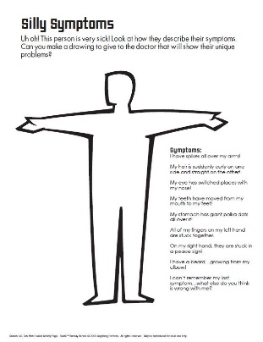

Ten Outcasts Drawing Activity
(Ages 5+, 5 mins)

Supplies Needed:
- Printed Handout
- Markers/Crayons

Instructions:
- You may need to read the directions out loud to younger students, but kids are encouraged to draw the “symptoms” listed on the person.

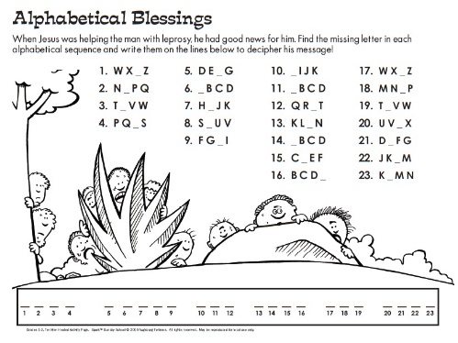
Ten Outcasts Word Puzzle
(Ages 5+, 5 mins)

Supplies Needed:
- Printed Handout
- Pen/Pencil/Crayons

Instructions:
- This puzzle might look confusing at first – kids need to fill in the missing letter in the sequence, followed by copying that letter on the blanks below.

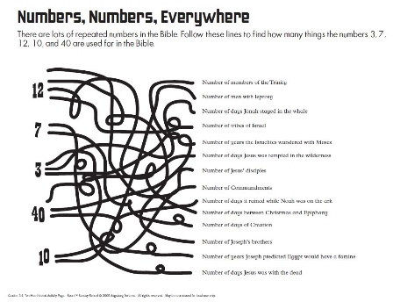
Ten Outcasts Number Puzzle
(Ages 5+, 5 mins)

Supplies Needed:
- Printed Handout
- Pen/Pencil/Crayons

Instructions:
- The tangled mess of lines does look confusing, but kids just need to follow them to find out answers to several interesting biblical numbers!
Biblical Background – Ten Outcasts

This passage about Jesus healing ten men is probably on the lesser-known end of the spectrum, but it is simultaneously a healing story, a story about gratitude, and a story tearing down the Jewish-Samaritan divide. In this season of self-examination and contemplation, it can also lead to deeper reflections about the ways in which we make others “outcasts” within our society.

First, though: What does the term “leper” mean, and why was it such a big deal? Leprosy in the biblical text, as best we know, seems to refer to a variety of infectious skin diseases that lead to disfigurement. While not fatal, there was no known cure for these diseases and those afflicted would often be forced to live as outcasts on the margins of society because of Jewish law. In Leviticus 13, those with leprosy were commanded to leave communities – presumably since the disease was highly contagious – and there were cultural and social expectations that those with leprosy would not interact with healthy individuals.

However, while the physical implications of the disease were certainly real and serious, it could be argued that the social implications were as bad or worse. This isolation kept those with leprosy from their family and friends, kept them from most jobs or ways to earn money, and often forced them to rely on begging for their livelihood. Leper communities were quite common so that those afflicted were not completely socially isolated, but there would be no doubt that someone with leprosy would have felt lonely and cast out. Jesus’ healing, then, wasn’t just physical – it was an opportunity for these ten men to be welcomed back by their family and friends!

This fact, along with Jesus praising the Samaritan, continues an ongoing theme in Luke in which Jesus’ teaching and healing has a direct benefit on those who have been marginalized or mistreated by society. For Luke, this is one more instance in which Jesus’ arrival has upended the social order of the day – and that we, in turn, should also tear down the false boundaries that divide us.

Your ability to share this info with kids will vary depending on their age – this section is mainly written for teachers and parents to learn a bit more about the background to each week's passage!

