Mary and Elizabeth December 5, 2021

Bible Verses: Luke 1:39-56
Spark Story Bible: pages 202 to 207
--------------------------------------------------------------------------------------------------

Overall Lesson Takeaways

- Continuing to prepare ourselves for Jesus’ arrival.
The candle for the Second Sunday of Advent is known as the candle of "preparation" – though sometimes the candle of "peace" as well – and our passage today sees both Mary and Elizabeth speaking words of preparation. Last week, we briefly touched on the theme of "active waiting" vs. "passive waiting"; active waiting involves preparing our hearts for Jesus' arrival by examining ourselves and our lives – making sure they align with what Jesus has come to bring into the world. Throughout the first chapter of Luke, all three of our major figures (Mary, Elizabeth, and Zechariah) are filled with words from the Holy Spirit which help paint a beautiful picture about how we are to prepare our hearts in this season: we are to celebrate what God has done in the past and understand that we are empowered and blessed through the Holy Spirit to live into the future that Jesus is bringing.
- Big changes are coming… AKA “The Great Reversal”.
As you read through the Gospel of Luke, you will notice a theme that scholars have dubbed “The Great Reversal". Over and over throughout Luke, we hear variations of "the last shall be first, and the first shall be last" – and this reversal first appears through Mary's prophetic words that she speaks to Elizabeth. In verses 52 and 53, she says: "[God] has brought down the powerful from their thrones, and lifted up the lowly; [God] has filled the hungry with good things, and sent the rich away empty". Mary's words also connect this back to God's covenant with Abraham and Abraham's descendants (a Genesis callback from earlier in our semester!) in verses 54 and 55 – Jesus' arrival is continuation of the covenantal relationship but will also lead to big changes in who is lifted up in the coming Kingdom of God.
- Music is a gift that helps inspire us.
Mary’s song – often called the Magnificat – is a beautiful text that almost reads like a cross between a psalm and prophecy, and serves as a great window into some of what Luke interprets Jesus’ arrival to mean (see above). But even moving beyond the words and the echoes that Mary’s song has to Hannah’s song back in 1 Samuel 2, one of the great gifts of this text is a reminder of the power that music has – particularly in this season. Music can inspire hope, imagination, and a sense of awe and wonder – and all throughout this season we sing familiar hymns and carols to remember that we need all three of those things in our world today.
Checking In

Before the reading:
- Check in with the kids – welcoming any newcomers warmly.
  - Younger kids: What is one of your favorite Christmas songs?
  - Older kids: Highs and Lows from their past week
- Is there a Christmas album that your family listens to every year? What are your favorite songs to sing at home? What about at church?

Bible Lesson / Discussion

Reading the Bible:
- Today, we’re reading about Mary and her relative Elizabeth sharing the good news that they’re both pregnant – and Mary is so happy she sings!
- Read the text together, either in the Bible, or the Spark Story Bible.
  - You’ll need to screen share the passage for the day in Zoom.
  - Feel free to stop and ask questions during the reading, if helpful.
  - Afterwards, take time to explore what that passage might mean, and know there's no one correct way to read these passages!

Questions About the Passage (see next page for PreK/K questions)
- Mary and Elizabeth have really exciting news to share – when was the last time that you had good news? Who were you excited to share it with?
- Mary’s song is about how God will help transform the world through Jesus – what are some big changes that you think Jesus helped bring?
- The Bible talks about God lifting up those who are feeling low, or giving food to those who are hungry – how can we help do those things too?

Connections to Our Lives
- Both Elizabeth and Mary were going to have new babies… what are things you might need to do to get ready for a baby? Do you think taking care of Jesus would have been the same or different from other babies?
- Mary’s song is almost like a prayer for the world – what are things that you would pray could change in our world today?

Biblical/Church Connections
- The candle for the second Sunday of Advent is called both the candle of “peace” and also “preparation” – but one of those things is calm, while the other sounds busy! Does this time of year feel more calm or busy to you? Do you wish it was different, or do you like it the way it is?
Alternate Preschool and K/1st Questions
Younger ages, particularly those in our preschool class, may have a hard time discussing the biblical text for very long (if at all). My hope is that these questions (and especially the activity) can help with engagement!

Opening Questions (same as last week)
- What has your family been doing to get ready for Christmas?
- What are some of your favorite Christmas songs?
- What are your favorite songs to sing at home? What about at church?

Fun Warm-Up Activity – Carol Singing
- If you’re familiar with the songs that kids were naming, it can be a good opportunity to sing some of these songs together! Music is one of the special things that brings us closer together – and our Bible passage is partly about Mary singing her thanks and praise to God.

Reading the Bible:
- Today is the second Sunday of Advent, the season when we are waiting for Jesus to arrive on Christmas Eve and Christmas Day. And in our Bible passage, we’ll hear about Mary and Elizabeth sharing the good news that they’re going to have a baby – and Mary is so excited she sings!
- Read the text together, either in the Bible, or the Spark Story Bible.

Bible Discussion/Questions
- Mary and Elizabeth have really exciting news to share – what do you do when you’re really excited?
- Mary’s song is about how God will help the world through Jesus – can you think of people who need help sometimes? How could you help them?
- The candle for the Second Sunday of Advent can mean either “peace” or “preparation” (a word meaning to be busy getting ready). What’s nice about being busy? What’s nice about being quiet?

People of Faith

In addition to reading our weekly Bible story, I'd love for our older grade school students to learn more about people whose lives were changed by their faith in Jesus. We'll lift up a new person each Sunday, trying to connect their story to our Bible passage as much as possible!

Gloria Tang Sze-wing
Mary’s song is an important part of our lesson today, so it feels fitting that our person of faith today is one of the biggest singers in the world: Gloria Tang Sze-wing, who is better known by her stage name G.E.M. or Get Everybody Moving.

G.E.M. was born in Shanghai, China in 1991 before moving to Hong Kong at the age of 4. Several members of her family were professional musicians and G.E.M. began writing her own songs and music by the time she reached middle school – eventually going on to win a televised singing competition and becoming a professional singer at the age of 16.

Over the next several years, she would release a new album every year – steadily growing in popularity and eventually growing to become an international star – and one of the biggest pop-stars in China – with 4 of her music videos recording over 100 million views on Youtube. After being featured as one of the 30 most important people in music under 30, she also gained popularity in the United States – becoming known as the “Taylor Swift of China”

It was in the midst of this success that she decided to become a Christian in 2011 – being baptized and later reflecting “I believe my life has a purpose, as I know I was created by God.” Christianity was not part of her family life growing up – and it is still somewhat rare to be a practicing Christian in China – but G.E.M. has included quotations of Bible verses in her lyrics and regularly thanks God in interviews, making her faith an important part of her celebrity.

She has also regularly used her platform for good – speaking out on behalf of important causes like anti-bullying or stopping tobacco use, and raising money for orphanages and other charitable causes. “If we want this world to become a better place with more love and hope, every one of us has to work hard together every day” she once said, “I believe this world really needs you, especially you who believes in yourself” – and her faith continues to inspire her career.
Crafts / Activities

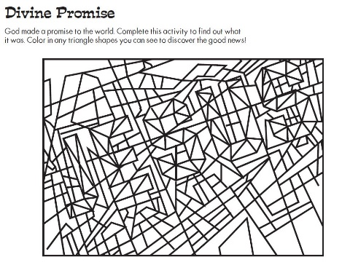
Mary and Elizabeth Picture Puzzle
(Ages 5+, 3-5 mins)

Supplies Needed:
- Printed Handout
- Pen/Pencil/Crayons

Instructions:
- Crafts are a little more limited this week; you may want to consider making Christmas cards for our Meals Ministry program, but if you need a handful of other puzzles and activities, there are three here!

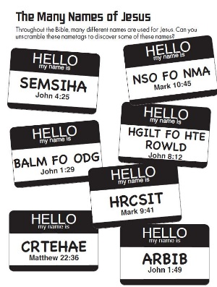
Mary and Elizabeth Word Scramble
(Ages 7+, 5 mins)

Supplies Needed:
- Printed Handout
- Pen/Pencil/Crayons

Instructions:
- Encourage kids to unscramble the words to find names/titles for Jesus – using the Bible verses listed if they are having trouble.

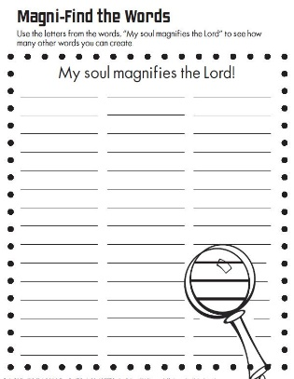
Mary and Elizabeth Word Puzzle
(Ages 7+, 5 mins)

Supplies Needed:
- Printed Handout
- Pen/Pencil/Crayons

Instructions:
- This word puzzle will require kids to exercise a fair amount of creativity – but can also be used as a class-wide game. Give kids a set amount of time to use letters listed to form new words – see who has the most!
Biblical Background – Mary and Elizabeth

Although we began last week with the angel’s visit to Mary in the Gospel of Luke, we should note that Elizabeth and her husband Zechariah are surprisingly prominent in the first chapter of Luke – in fact, there are more passages about them in the first chapter then there are about Mary and Joseph! Elizabeth and Zechariah are best known as John the Baptist's parents, but they are also important for Luke in creating a bridge between past, present, and future. Elizabeth and Zechariah’s difficulty conceiving and “advanced years”, combined with an angelic announcement of conception, is a clear echo of Abraham and Sarah – and Zechariah’s role as priest and prophet (and the numerous scriptural allusions that he offers in the prophecy which closes Luke’s first chapter) also helps establish this bridge between prophetic hopes for Israel and Jesus’ arrival.

Elizabeth and Zechariah aren’t the only ones creating this bridge though; Mary's Magnificat very clearly contains a great deal of scriptural allusion to the Old Testament – connecting the work that God has been doing with the work that God is about to do through Jesus. Mary explicitly names of the covenant promise that God made to Abraham and Abraham's descendants (Isaac, Jacob, Joseph, etc.), but scholars have also noted similarities with the following texts:

Psalm 34:1-3 – "O bless the Lord with me… my soul makes its boast in the Lord"
Psalm 103:17 – "The steadfast love of the Lord is from everlasting to everlasting"
Habakkuk 3:18 – "I will rejoice in the Lord; I will exult in the God of my salvation"
1 Samuel 2:7-8 – "The Lord makes poor and makes rich; he brings low, he also exalts. God raises up the poor from the dust; he lifts the needy from the ash heap, to make them sit with princes and inherit a seat of honor"

There is also a great deal of similarity between Mary's Magnificent and Hannah's Prayer in 1 Samuel; Hannah was the mother of Samuel, one of the great prophets of the Old Testament and someone who was intimately connected with David's rise to be king. When combined with Matthew's depiction of Jesus' early life as similar to that of Moses' early life, we see both gospel writers both invoking Jesus' role as prophet and leader… but also making clear that Jesus' importance will exceed that of Samuel and Moses.

Your ability to share this info with kids will vary depending on their age – this section is mainly written for teachers and parents to learn a bit more about the background to each week's passage!

