Wise Men December 12, 2021

Bible Verses: Matthew 2:1-12
Spark Story Bible: pages 218 to 223
--------------------------------------------------------------------------------------------------

Overall Lesson Takeaways

- Having joy in Jesus’ birth!
The candle for this third Sunday of Advent is the pink candle of “joy” – traditionally a break in the midst of the Advent season of contemplation to allow ourselves to fully embrace the joy present at Christmas… and even though it technically takes place after Christmas, this account of the Wise Men/Magi is a vital part of how we understand the Christmas season and the ways we respond to the hope, love, and joy contained within this small child! Today’s lesson is in many ways built around gratitude and giving – the gratitude that the Wise Men felt at Jesus’ arrival, the generosity that they show with those unique gifts they share, but ultimately the generosity that God showed by sending Jesus into the world so that we might better know who God is!
- What are the gifts that we share with others?
The wise men are probably best known for their gifts of gold, frankincense, and myrrh – in fact, it may be the only time that we ever hear about frankincense and myrrh throughout our entire year! It should be noted that they were a bizarre choice of gift even back in those days – some scholars have speculated that those were items used during ancient ceremonies with new kings, but it’s not really clear. What is clear, though, is that these Wise Men/Magi were so moved by the Baby Jesus that they felt a need to respond through sharing a gift. There is obviously a lot of gift-sharing in the form of presents this time of year, but it can also be an opportunity to talk about other gifts we can give to others: kind words, smiles, food/clothing for those who don’t have it, thoughtful cards, helping our parents… the list goes on and on!
- The Wise Men also remind us that Jesus has come for all people.
The distinction may be lost on younger students, but the Wise Men signal an important shift for Matthew’s audience about who Jesus will be and who he has come for. Their arrival begins to fulfill prophecies that had been delivered towards the end of Isaiah as well as other prophets – “nations shall come to your light, and kings to the brightness of your dawn” (Isaiah 60:3) – and clearly establishes Jesus as someone who will usher in a new age for Israel. As noted in the “Bible Background” section, though, it was extremely important that these wise men were from outside of Israel – Jesus was sent into this world to be a Savior for all people, not just those in Jerusalem or Israel. And because we believe that Jesus has come into this world for everyone and loves everyone equally, that means that we are called to do the same.
Checking In

Before the reading:
- Check in with the kids – welcoming any newcomers warmly.
  - Younger kids: What is a gift you’re really hoping to get this year?
  - Older kids: Highs and Lows from their past week
- What is something that makes you feel incredibly happy or joyful? How would you describe what it feels like to be joyful?

Bible Lesson / Discussion

Reading the Bible:
- Today, we’re reading about the Wise Men visiting the Baby Jesus from a long ways away – and they came with special gifts for him too!
- Read the text together, either in the Bible, or the Spark Story Bible.
  - You’ll need to screen share the passage for the day in Zoom.
  - Feel free to stop and ask questions during the reading, if helpful.
  - Afterwards, take time to explore what that passage might mean, and know there's no one correct way to read these passages!

Questions About the Passage (see next page for PreK/K questions)
- The wise men brought gifts of gold, frankincense, and myrrh to the Baby Jesus – what gifts would you choose to bring to Jesus and why?
- The wise men would have been on a really long journey, following only a star – why do you think they kept going, even when they got tired? What would it be like to see the Baby Jesus in person?
- King Herod was worried about the Baby Jesus - why do you think the wise men wanted a king like Jesus, rather than King Herod or other rulers?

Connections to Our Lives
- This is a time of year when we think a lot about presents and giving – it’s definitely fun to receive presents, but how does it feel to give them to someone else? What are other things we can give besides presents?
- Going through the Advent season can feel long – kind of like the Wise Men’s long journey! Where do you find joy, even with the waiting?

Biblical/Church Connections
- The candle for the third Sunday of Advent is the pink candle – the candle of joy! Do you think it’s strange that this Sunday’s candle is pink while the others are purple? Or does it make it feel more special?
Alternate Preschool and K/1st Questions
Younger ages, particularly those in our preschool class, may have a hard time discussing the biblical text for very long (if at all). My hope is that these questions (and especially the activity) can help with engagement!

Opening Questions
- What are things that you do when you’re feeling really happy or joyful?
- What are some of your favorite decorations?
- What are some of your favorite Christmas songs?

Fun Activity
- Today is the third Sunday of Advent – the Sunday we light the pink candle of joy! One of the things that make us all really happy and joyful this time of year is singing Christmas carols and songs together.
- (Doing this will require you to have a way to stream music on your computer… just click on the “share audio” option on your share screen button in order to play your computer sound. Alternatively, just invite kids to sing along!)
- Have kids sing/dance along to favorite Christmas hymns:
  - Go Tell It on the Mountain
  - Away in a Manger
  - Angels We Have Heard on High
- This can go on as long as kids are having fun, but eventually you can move on to questions about the Bible passage.

Bible Discussion/Questions
- In our Bible reading today, we’re learning about some wise men who journeyed a long time – hundreds – or maybe even thousands! – of miles to see the baby Jesus. Have you ever travelled somewhere really far away? What did you pack on your journey?
- The wise men gave Jesus gifts of gold, frankincense and myrrh. What gifts would you get for the Baby Jesus?
- Along with those gifts, we’re reminded of the greatest gift of all: love! Sending the Baby Jesus into the world shows us how much God loves us - how do you show other people that you love them?

People of Faith

In addition to reading our weekly Bible story, I'd love for our older grade school students to learn more about people whose lives were changed by their faith in Jesus. We'll lift up a new person each Sunday, trying to connect their story to our Bible passage as much as possible!

Henri Nouwen
The Advent season is a time filled with contemplation, expectation, and hope – and each of those things can be seen clearly in the writings of one of the great spiritual authors and thinkers of the 20th century: Henri Nouwen.

Born in 1932 in the Netherlands, Nouwen was interested in religion early – deciding to become a Catholic priest shortly after graduating from high school. Interestingly, though, his primary interest did not lie in studying theology – he instead focused much of his time on the intersection of psychology and religion, desiring to learn how to be a better pastor to people in times of trouble. This desire eventually led him to the Menninger Institute in Kansas, famed for its Religion and Psychology program, and Nouwen used this to launch himself into a successful career in academia – serving as a professor at Notre Dame, Yale Divinity School, and eventually Harvard Divinity School.

Despite this great success, though, Nouwen felt spiritually unfulfilled and disconnected from what he felt truly at the center of Christianity – and so in 1985 he surprised his colleagues at Harvard by resigning his position and moving to a small community named L’Arche Daybreak in Toronto, Canada which was focused on serving adults with intellectual and physical disabilities.

Nouwen went through a great deal of self-doubt at this decision, but it ended up being exactly what he needed. Nouwen found a sense of connection in this community and, as a result, his writing flourished. He would write almost 40 books before he died, many of which dealt with psychological issues of depression, loneliness, and uncertainty – unflinchingly talking about how these things existed in him. “I was always trying to articulate what I was dealing with,” he once wrote, “I thought that if it was very deep, it might also be something other people were struggling with. It was based on the idea that what is most personal might be the more universal.” Nouwen’s work continues to inspire millions – including numerous essays on the subject of Advent as well.
Crafts / Activities
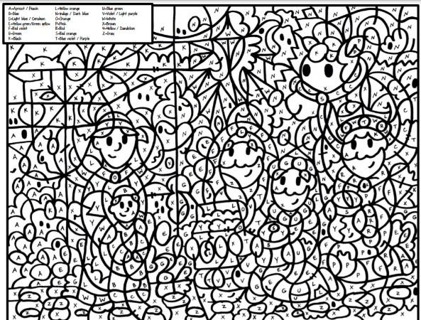

Wise Men Color by Number
(Ages 5+, 10-15 mins)

Supplies Needed:
- Printed Handout
- Pen/Pencil/Crayons

Instructions:
- Although this color by number craft should be accessible for anyone who can read, it will take kids of all ages a loonngg time to complete! Good challenge for anyone who wants to create an elaborate picture.

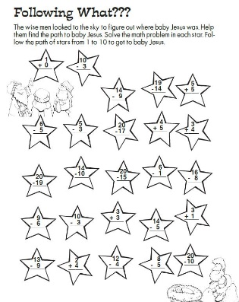
Wise Men Math Puzzle
(Ages 6+, 5 mins)

Supplies Needed:
- Printed Handout
- Pen/Pencil/Crayons

Instructions:
- A worksheet that will ask kids to do some addition and subtraction to find a path for the wise men to visit Jesus!

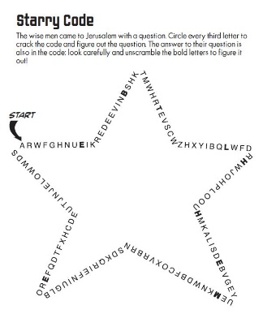
Wise Men Word Puzzle
(Ages 6+, 5-10 mins)

Supplies Needed:
- Printed Handout
- Pen/Pencil/Crayons

Instructions:
- This word puzzle will take a bit of time to complete, but the basic process of cracking the code should be simple enough. Kids count and write down every third letter, leading to a hidden message in the star!
Biblical Background – Wise Men

Although the story of the wise men visiting Jesus is well-known and beloved, we don’t know terribly much about who they were! Nativity scenes and pageants have depicted them as three kings for ages, but it is never explicitly stated that there are three (only three gifts) or that they are royalty. The association with kings seems to have come from Isaiah 60:3 (“nations shall come to your light, and kings to the brightness of your dawn”), but that too remains a guess. The word used – magi – is a plural form of magus, a Persian loan word connected to Zoroastrian priests, so the most likely scenario is that they were priests from the wider Parthian Empire. Ultimately, though, the key piece is that they were not Israelites – they were “gentiles” who were coming to Israel to worship God.

That “gentiles” would be coming to worship God plays into another one of the major themes of the early chapters of Matthew, namely that Jesus is being depicted as a second Moses. Note the many similarities in the early chapters:

  - Joseph and Dreams – In contrast to an angel appearing to Mary in Luke, an angel appears to Joseph in a dream. Joseph and a dream… Genesis?
  - Saving the Hebrew people – The angel tells Joseph that Jesus will save the people from their sins; Moses would save the people from Pharaoh.
  - Joseph and his family escape to Egypt – having been warned in a dream, Joseph flees with Mary and Jesus to Egypt; in Genesis, Joseph helps his family re-settle in Egypt.
  - The killing of infants – While the above connections aren't exactly 1-to-1, this one is! Both Pharaoh and Herod kill off children aged 2 and under as they try to ensure the death of Moses and Jesus, respectively.
  - From Egypt to Israel – after Herod's death, Joseph is told to leave Egypt and go to the land of Israel… where have we heard that before??

Combining the depiction of Jesus as a second Moses with an account of “gentiles” coming to pay homage and worship him gives us a clearer picture of who Matthew understood Jesus to be: Jesus was like a second Moses, but rather than saving the Israelites, he would be the Savior to the entire world!

Your ability to share this info with kids will vary depending on their age – this section is mainly written for teachers and parents to learn a bit more about the background to each week's passage!

