Philip and the Ethiopian April 28, 2024

Bible Verses: Acts 8:26-40
Spark Story Bible: pages 510 to 513
--------------------------------------------------------------------------------------------------

Overall Lesson Takeaways

- Thinking about how we talk about our faith.
In the early days of the church, the disciples were tasked with a really difficult mission: explaining who Jesus was to someone who almost certainly would never have heard of him! We likely take this fact for granted today since virtually everyone we meet has at least heard about who Jesus is, even if they themselves are not Christian – but how could you possibly sum up who Jesus in just a few words?? Perhaps the early disciples said a lot more to those they talked to beyond what we read in the biblical text – the Spark Bible sums it up as “Jesus was the Son of God. He come to earth and saved us” while the biblical text merely says Philip “proclaimed to him the good news about Jesus”. Nonetheless, thinking through how we talk about our faith is important – not specifically for the purpose of converting them to Christianity, but for witnessing to the impact it has in our lives and demonstrated the difference that it makes.
- Remembering how special baptism is.
After hearing Philip’s profession of faith in Jesus, the Ethiopian eunuch responds by immediately wanting to be baptized – he even poses the question “What is to prevent me from being baptized?” From the earliest days of the church, baptism was seen as the entry point into being a part of a church community – and it was also a sign and symbol of God’s love and faithfulness in a person’s life. While the church has occasionally used baptism as the end point of a weeks-long training process, our denomination has embraced the spirit of the Ethiopian eunuch – wanting to make sure we are not putting up barriers to anyone who wishes to be baptized, and instead celebrating that their trust and faith has led them to witness to God’s love and grace. As part of this lesson, kids should have an opportunity to reflect on their own baptisms and to be reminded of the presence of God’s love and grace in their lives.
- Sharing about how the early church grew.
Finally, this lesson can be an opportunity to think about the many ways and places the early church grew (a topic covered further in the Biblical Background) – both in the interest of history, but also in what that history means for us today. Disciples like Philip and Peter, as well as converts like Paul, not only sharing their faith but living it out was vital to how people learned what following Jesus meant. For us today, perhaps that means following the wise words of St. Francis of Assisi: “Preach the Gospel at all times. Use words when necessary”. May we indeed put our faith into practice!
Checking In

Before the reading:
- Check in with the kids – welcoming any newcomers warmly.
  - Younger kids: It’s gardening season! Favorite plant/flower?
  - Older kids: Highs and Lows from the past week
- What was the last trip or vacation you took? Did you meet anyone new while you were travelling?

Bible Lesson / Discussion

Reading the Bible:
- In our passage today, Philip – one of Jesus’ disciples – is out travelling when he meets a man who really wants to learn more about Jesus.
- Read the text together, either in the Bible, or the Spark Story Bible.
  - Feel free to stop and ask questions during the reading, if helpful.
  - Afterwards, take time to explore what that passage might mean, and know there's no one correct way to read these passages!

Questions About the Passage (see next page for PreK/K questions)
- The Ethiopian man asked Philip to tell him more about Jesus… how would you describe Jesus to someone who never have heard of him before?
- The man is excited and wants to become a follower of Jesus too, so he asks to be baptized right there. What does it mean to be baptized? Why do you think that’s an important part of our church tradition?

Connections to Our Lives
- Think back to your baptism, or to the baptism of a brother/sister/friend… what do you remember from that baptism? How did you feel during it?
- The early church grew because of people like Philip sharing who Jesus was with others. Is that something we should be doing today? How can we be Christians through our words and actions -- or even both?

Biblical/Church Connections
- Our Kindergarteners received Bibles from the church today – do you remember receiving a Bible when you were that age? How did it feel to be able to read the Bible yourself? What are some of your favorite parts of the Bible to read?

Alternate Preschool and K/1st Questions
Younger ages, particularly those in our preschool class, may have a hard time discussing the biblical text for very long (if at all). My hope is that these questions (and especially the activity) can help with engagement!

Opening Questions / Activity
- Take some time to welcome / get to know the kids!
  - Have you and your family ever travelled somewhere new? What did you like about travelling? Was anything about it hard?

Warm Up Game – I Spy!
- In our Bible passage today, a disciple named Philip is travelling to a new place – and if you’ve ever been to a new place, you know there’s lots of new things to see! I thought it might be fun to play a game about trying to notice things called “I Spy!”
- One person will name the color of an object in the room and kids have the chance to try to guess what the object is
  - Try to make sure that everyone who wants to play has a turn – some kids will be more active in guessing than others!
- Play as long as kids are having fun, then transition to the Bible reading.

Bible Discussion/Questions
- Our Bible story today is about someone who is excited to learn more about Jesus – and he gets baptized by one of the disciples.
- Read the text together, either in the Bible, or the Spark Story Bible.
  - Feel free to stop and ask questions during the reading, if helpful.
  - Afterwards, take time to explore what that passage might mean, and know there's no one correct way to read these passages!

- The Ethiopian man asked Philip to tell him more about Jesus because he had never heard about Jesus before. What would you tell him about Jesus and who Jesus is?
- The man is excited and wants to become a follower of Jesus too, so he asks to be baptized right there. What does it mean to be baptized? Have you ever seen someone be baptized before?
- Make sure to ask your parents about when you were baptized and what it was like!

People of Faith

In addition to reading our weekly Bible story, I'd love for our older grade school students to learn more about people whose lives were changed by their faith in Jesus. We'll lift up a new person each Sunday, trying to connect their story to our Bible passage as much as possible!

Letty Russell
As we think about the ways in which the early church tried to grow and expand, it is fitting to celebrate Letty Russell, a pioneer within our denomination and someone who dedicated her life to empower women around the world.

Born in New Jersey in 1929, Russell and her family were deeply involved in their local Presbyterian church growing up and she graduating college with a degree in biblical history and philosophy. Russell dreamed of going to Harvard’s Divinity School to continue her studies, but the school was male-only at the time of her graduation. After serving as both a teacher and church leader for a few years, Russell and seven other women successfully appealed Harvard’s male-only policy in 1955 – going on to graduate with honors in 1958!

Upon graduation, Russell became the first woman to be ordained as a minister in her local presbytery and would serve a church in Harlem for the next decade.
She continued to feel called to academia, however, and in 1969 she graduated with a Doctorate in Theology – later becoming a theology professor at Yale Divinity School, where she would work for the next 28 years!

Russell’s scholarship, though, was not merely academic – she would soon become a pioneer in both feminist theology and the burgeoning ecumenical movement, emphasizing students having direct experiences with people and churches in other areas of the world as a means of building authentic relationships. As Russell once said: “Our struggle is to overcome the fear of difference and to break the bars that keep us apart”.

Her commitment to lifting up underrepresented voices in the church made her beloved among colleagues. As one later remarked: “There is perhaps no other feminist theologian who has been more dedicated to ecumenical, interfaith, and international theological dialogue… her work has challenged everyone, not only because of its substance but because of her own commitment to making the world both more just and more hospitable.”
Crafts / Activities

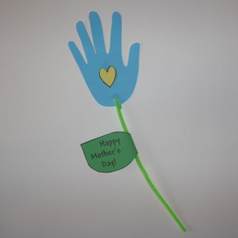
Mother’s Day Craft
(Ages 3+, 5 mins)

Supplies Needed:
- Printed Handout – on green paper
- Pipe Cleaner
- Construction Paper
- Scissors/Tape
- Crayons/Markers/Colored Pencils

Instructions:
- Today is Mother’s Day so we definitely wanted to include at least one craft for that! Have kids trace their hands onto a piece of paper and cut them out, using the hand as a flower and pipe cleaner as the stem!

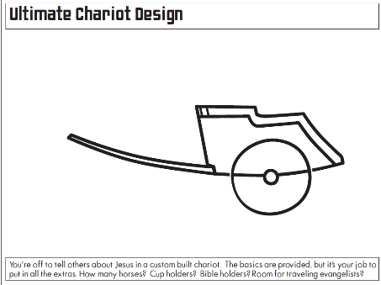
Philip and the Ethiopian Chariot Design
(Ages 5+, 2-4 mins)

Supplies Needed:
- Printed Handout
- Pen/Pencil/Marker

Instructions:
- This handout can be used as a basic coloring sheet, but encourage kids to spend time designing their own chariot with lots of special features.

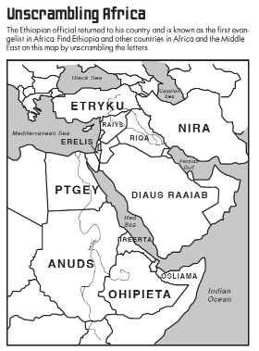
Philip and the Ethiopian Map Puzzle
(Ages 7+, 5 mins)

Supplies Needed:
- Printed Handout
- Pen/Pencil/Marker

Instructions:
- This word puzzle might require some help from adults, but kids can unscramble words to learn where Ethiopia and its neighbors are.
Biblical Background – Philip and the Ethiopian

During the season of Eastertide, we often focus on two things: post-resurrection stories and the growth of the early church… and for these next two Sundays we’ll be covering that latter topic. However, while we tend to highlight Christianity’s spread throughout the Roman Empire (usually through the lens of Paul), it is important to note early Christianity had a much wider spread then most people realize – particularly in Africa.

Philip’s evangelism and baptism of the Ethiopian eunuch is one of the few biblical examples we have of Christianity’s entrance into Africa – but there is a wealth of information from outside the biblical text about how quickly the church spread there. Eusebius – one of the early church historians – states that Mark the Evangelist travelled to Alexandria (a major city in Egypt) in the early 40’s, founding a church there.

Alexandria, along with Rome and Antioch, would become one of the three major centers in early Christianity after Jerusalem’s destruction in 70 CE – with a rich tradition of copying biblical manuscripts and its own particular liturgy written in Coptic (a form of ancient Egyptian). Many of the earliest surviving biblical manuscripts come from Egypt, including the discovery of unknown Gnostic writings in Nag Hammadi and the oldest New Testament papyrus fragment.

From Alexandria, the church spread into Nubia, Sudan, and Ethiopia – and by the end of the second century the church in Alexandria was arguably second only to Rome in authority. Early Christian writers like Origin, Augustine, and Tertullian were African and had an indelible impact on early Christian thought, and the first two ecumenical councils (Nicaea and Constantinople) were presided over by the Patriarchs of Alexandria!

Less than a century later, though, significant disputes over the nature of Christ’s divinity led to a split that ultimately resulted in the Coptic Orthodox Church largely separating from the Eastern Orthodox and Roman Catholic Churches. Coptic Christianity continues today, although it has largely been overtaken by other denominations expanding rapidly throughout Africa.

Your ability to share this info with kids will vary depending on their age – this section is mainly written for teachers and parents to learn a bit more about the background to each week's passage!

