Easter April 17, 2022

Bible Verses: Luke 24:1-12
Spark Story Bible: pages 482 to 487
--------------------------------------------------------------------------------------------------

Overall Lesson Takeaways

- Celebrating the joy of this day!
While there is certainly a lot that kids can take away from hearing the Gospels’ various accounts of Easter morning (and Jesus’ subsequent resurrection appearances), perhaps nothing is more important for kids than trying to capture the joy of this day. The miracle of the resurrection isn’t easy to wrap our minds around – both for kids and adults – but the feeling of gratitude, excitement, and joy that the earliest disciples were experiencing is central to this day. We do not need to understand resurrection – we only need to know what it means: God loves us more than we even know – and nothing, not even death, can separate us from God’s love.
- Remembering how shocked the women and disciples were.
A way to underscore that joy and excitement, though, can come from placing ourselves in the shoes (er, sandals) of Jesus’ disciples on that Easter morning. The Gospels record a scattering of the disciples following Jesus’ arrest and crucifixion, with Peter going so far as to deny even knowing who Jesus was. We don’t know for sure, but we would have to assume that they were scared, defeated, and devastated about Jesus’ death. When the women went to Jesus’ tomb that morning, they were going there to mourn and to honor him – surely not expecting what would come next! But reading about the way that they respond – in Mark, they are so shocked that they don’t say a word! – and the similar stages of disbelief that many of the other disciples go through, it’s easy to put ourselves in their position and think “How would I have responded?”
- Thinking about what Jesus’ resurrection means for our lives.
Finally, it’s worth spending a little bit of time talking about what the good news of this day means for us – particularly in the context of a time in which there has been so much pain, hurt, and uncertainty in the world. Jesus’ resurrection and the enduring promise of God’s love does not mean that we will be immune to the difficulties and challenges that face us in life. There will still be sickness. There will still be pandemics. There will still be wars and violence. But what this day reminds us is that we believe that those things will not have the final word. We believe that love has the final word. We believe that God has the final word. The optimism that most kids inherently have should be present in all of us this day – we believe that Jesus has shown us God’s better future, and for that we are eternally grateful!

Checking In

Before the reading:
- Check in with the kids – welcoming any newcomers warmly.
  - Younger kids: How is your family celebrating Easter this year?
  - Older kids: Highs and Lows from the past week
- What are some of your favorite Easter traditions? Are there things you get to do this year that you weren’t able to do the last few years?

Bible Lesson / Discussion

Reading the Bible:
- Today we’re remembering the surprise that some of Jesus’ disciples felt when they went to the tomb on Easter morning… only to find it empty!
- Read the text together, either in the Bible, or the Spark Story Bible.
  - Feel free to stop and ask questions during the reading, if helpful.
  - Afterwards, take time to explore what that passage might mean, and know there's no one correct way to read these passages!

Questions About the Passage (see next page for PreK/K questions)
- How would you have felt if you were one of the women walking to Jesus’ tomb that morning? How would you have felt after you saw that the stone had been rolled away?
- The angel lets the women knew that Jesus is alive – do you think they believed the angel at first? How might they have responded?

Connections to Our Lives
- What is the difference (if there is one) between being ‘happy’ and being ‘joyful’? What are things that make you happy? What gives you joy?
- Every year we say “Alleluia” at Easter – a word that means “praise God”. What are things that you are grateful/praise God for today?

Biblical/Church Connections
- Easter has been called the most important day in the entire church calendar. What makes it so important? What does Jesus’ resurrection show and tell us about God’s love?

Alternate Preschool and K/1st Questions
Younger ages, particularly those in our preschool class, may have a hard time discussing the biblical text for very long (if at all). My hope is that these questions (and especially the activity) can help with engagement!

Opening Questions
- What are some things that your family does for Easter every year? Have you had to change things this year, or are they still similar?
- Easter is a day that is really joyful and happy – who has had a good day with their family so far? What are some things that you like to do when you’re happy?

Fun Activity
- Well, one of the many ways that we can be joyful is by dancing – so I wanted to play a game of Freeze Dance as a way to practice the joy and excitement that Jesus’ disciples must have been feeling.
- You’ll need to be able to share music – (Youtube on iPad or phone, etc. )
- Play as long as kids are having fun, then transition to the Bible questions.

Bible Discussion/Questions
- The women who went to the tomb on Easter morning were some of Jesus’ disciples – but they definitely didn’t expect to see an angel telling them that Jesus was alive! What kind of face do you make when you’re surprised? What do you say when you’re surprised?
- We say the word “Alleluia” a lot on Easter – it’s a word that means “Praise God”, kind of like saying ‘thank you’ to God. What are things that you are really grateful for? Close with a prayer together – and give thanks to God for this Easter morning miracle!

People of Faith

In addition to reading our weekly Bible story, I'd love for our older grade school students to learn more about people whose lives were changed by their faith in Jesus. We'll lift up a new person each Sunday, trying to connect their story to our Bible passage as much as possible!

Helen Prejean
On a day when we are celebrating life winning out over death, it is a great opportunity to also share the story of Helen Prejean, a nun who has dedicated her life and career to advocating against the death penalty in the United States.

Born in Louisiana in 1939, Prejean was deeply involved in her church growing up – both of her parents were Catholic and the family would attend Mass weekly. Despite this, Prejean has noted that she didn’t always connect what was going on in the world to her faith; the South was deeply segregated and she was largely unaware of the mistreatment that people of color in her town received.
When she was 18, though, Prejean decided to become a nun – joining a local order with the expectation that she would serve there for the rest of her career. A few years later, though, Vatican II provided new opportunities for women in the church – including roles that had been closed to women for centuries.

In 1980, her religious order joined other orders across the world in making a concerted effort to engage directly in areas of high poverty. Prejean moved to a public housing project in New Orleans that was considered one of the most dangerous in the city – and she was soon overwhelmed by the struggles that so many were experiencing. As she would later reflect: “I saw the suffering and I let myself feel it… I saw the injustice and was compelled to do something about it. I changed from being a nun who only prayed for the suffering world to a woman with my sleeves rolled up, living my prayer.”

Later that year, though, she received a request to visit an inmate on death row that would change the course of her ministry. She spent months meeting with a man who was sentenced to die despite being adamant that he did not commit the crime. Prejean would write a book about this experience – which later went on to become a movie and a 30-week bestseller – and she soon began travelling across the country speaking out against the death penalty, a role that she continues to this very day.
Crafts / Activities

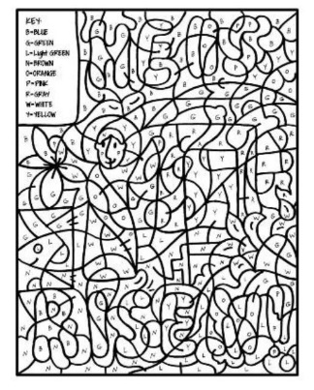
Easter Color-By-Letter
(Ages 5+, 10 mins)

Supplies Needed:
- Printed Handout
- Crayons/Markers/Colored Pencils

Instructions:
- If you’re looking for an activity that will take kids quite a bit of time (but isn’t terribly complex) this color-by-letter sheet should do the trick. Using the color code in the upper left, encourage kids to complete the drawing.

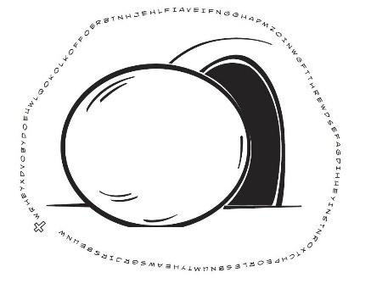
Easter Word Puzzle
(Ages 5+, 5 mins)

Supplies Needed:
- Printed Handout
- Pen/Pencil/Marker

Instructions:
- This word puzzle is fairly simple (recording every other letter) but the end result is learning the core of the Easter story!

Easter Word Search
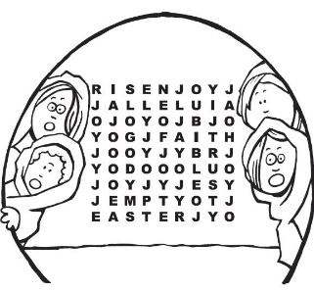
(Ages 5+, 5 mins)

Supplies Needed:
- Printed Handout
- Pen/Pencil/Marker

Instructions:
- This word search is fairly simple as far as word searches go, but can be a fun way to wrap up your lesson time. In addition, you can challenge kids to see who can find the word “joy” the most in the word search – I counted 11 total, but I might have missed one or two!
Biblical Background – Easter

Although we typically spend time diving into the historical context of our Bible passages, it’s worth taking a little bit of time today reviewing how Easter as we know it came into being!

Records are not extensive, but the earliest Christians seem to have connected the celebration of Jesus’ resurrection with the timing of the Jewish Passover –explicitly stated in the 2nd century as being on the 14th day of Nisan (the first month in the Hebrew calendar, coinciding with March/April). Easter became fixed on a Sunday after the Council of Nicaea in 325 CE, but there continued to be extensive debates about this in the following centuries which remain unresolved to this day! Western and Eastern churches still follow completely different calendars (Gregorian vs. Julian) and have different dates for Easter.

The name “Easter” also has unclear origins. One 8th century monk connected the name with Ēostre, the name of a Germanic goddess of Spring – while other scholars have noted linguistic similarity to a proto-Germanic word meaning “Dawn”. Nonetheless, the name “Easter” stuck within English and German speaking countries – even as the rest of the world used “Pascha” (Passover).

Indeed, many of the quasi-religious traditions that we lump in with Easter (eggs, bunnies, fancy clothing) have a similarly puzzling history – at least in their connection to Jesus’ resurrection. The idea of eggs representing life coming from a tomb is the closest that we get – and there is some evidence that some early Christians dyed eggs red as a reminder of Jesus’ sacrifice – but that wasn’t officially adopted in Christianity until 1610 CE. The easter bunny comes from a 15th century German tradition of an “osterhase” (Easter hare) who brings colored eggs to good children – bizarre since rabbits do not lay eggs.

However, while the date/name/traditions surrounding Easter certainly have some mysterious aspects to them – we should not forget the actual importance of this day. The miracle of Jesus’ resurrection is a reminder of how deeply God loves us – and how nothing, not even death, can separate us from God’s love. For that, we give thanks today!

Your ability to share this info with kids will vary depending on their age – this section is mainly written for teachers and parents to learn a bit more about the background to each week's passage!

